1.20 The student can design, and/or interpret data from, an experiment that uses titration to determine the concentration of an analyte in a solution.

6.13 The student can interpret titration data for monoprotic or polyprotic acids involving titration of a weak or strong acid by a strong base (or a weak or strong base by a strong acid) to determine the concentration of the titrant and the p*Ka* for a weak acid, or the p*Kb* for a weak base.

6.15The student can identify a given solution as containing a mixture of strong acids and/or bases and calculate or estimate the pH (and concentrations of all chemical species) in the resulting solution.

6.16 The student can identify a given solution as being the solution of a monoprotic weak acid or base (including salts in which one ion is a weak acid or base), calculate the pH and concentration of all species in the solution, and/or infer the relative strengths of the weak acids or bases from given equilibrium concentrations.

6.17 The student can, given an arbitrary mixture of weak and strong acids and bases (including polyprotic systems), determine which species will react strongly with one another (i.e., with *K* > 1) and what species will be present in large concentrations at equilibrium.

6.18 The student can design a buffer solution with a target pH and buffer capacity by selecting an appropriate conjugate acid-base pair and estimating the concentrations needed to achieve the desired capacity.

6.19 The student can relate the predominant form of a chemical species involving a labile proton (i.e., protonated/deprotonated form of a weak acid) to the pH of a solution and the p*Ka* associated with the labile proton.

6.20 The student can identify a solution as being a buffer solution and explain the buffer mechanism in terms of the reactions that would occur on addition of acid or base.

6.21 The student can predict the solubility of a salt, or rank the solubility of salts, given the relevant *Ksp* values.

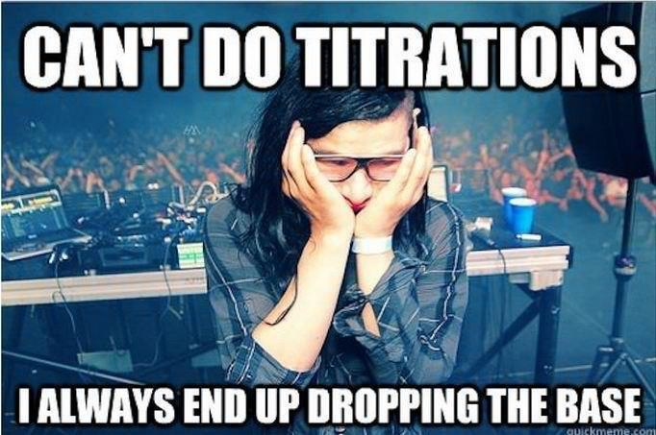6.22 The student can interpret data regarding solubility of salts to determine, or rank, the relevant *Ksp* values.

6.23 The student can interpret data regarding the relative solubility of salts in terms of factors (common ions, pH) that influence the solubility.

6.24 The student can analyze the enthalpic and entropic changes associated with the dissolution of a salt, using particulate level interactions and representations.

**Acid Base Titrations Review**

Titrations are procedures used to determine the concentration (M) of an acid or a base. You combine together an acid and a base knowing the volume of each and the concentration of only one of them.

1. What number would be at the top of the buret?
2. Read the volume of the base in the buret.
3. If the buret holds 50mL, how much base is actually in the buret?
4. If a student started at 2.0mL and released base until it was at the level shown, how much bases was added?
5. Why is it not necessary to subtract all your volumes from 50mL?

**Titration setup**

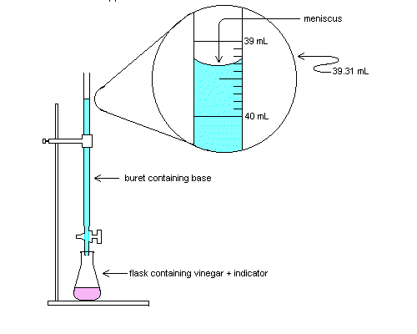

buret containing BASE

Erlenmeyer flask containing ACID AND an indicator

buret containing BASE

Using the equation from last year, you can solve for either the molarity/concentration (M) or a volume added (V).

MA VA = MB VB

MA= molarity of H+ VA = volume of acid

MB = molarity of OH– VB = volume of base

1. A 25.0-milliliter sample of HNO3 (aq) is neutralized by 32.1 milliliters of 0.150 M KOH (aq). What is the concentration of the acid?

2. How many milliliters of 0.200 M NaOH are needed to neutralize 100. mL of 0.100 M HCl?

3. In a titration, 20.0 milliliters of 0.15 M HCl(aq) is exactly neutralized by 18.0 milliliters of KOH(aq).

**Titration Curve Introduction**

Consider a 10. L sample of 0.10 M HCl.

_____ a) What is the pH of the solution?

_____ b) How many mL of 0.10 M NaOH would be required to neutralize it?

_____ c) What is the pH of the neutralized solution?

_____ d) What would the pH of the solution be if you added 20. L of NaOH?

|  |  |  |  |  |  |  |  |
| --- | --- | --- | --- | --- | --- | --- | --- |
| **liters of**  **0.10 M HCl** | **liters of**  **0.10 M NaOH** | **moles**  **of H+** | **moles**  **of OH-** | **moles of XS H+ or OH-** | **total**  **volume** | **[H+] or [OH-]** | **pH** |
| **10.** | **20.** |  |  |  |  |  |  |

Let’s do this more carefully:

|  |  |  |  |  |  |  |  |
| --- | --- | --- | --- | --- | --- | --- | --- |
| **liters of**  **0.10 M HCl** | **liters of**  **0.10 M NaOH** | **moles**  **of H+** | **moles**  **of OH-** | **moles of XS H+ or OH-** | **total**  **volume** | **[H+] or [OH-]** | **pH** |
| **10.** | **0.0** |  |  |  |  |  |  |
| **10.** | **1.0** |  |  |  |  |  |  |
| **10.** | **2.0** |  |  |  |  |  |  |
| **10.** | **3.0** |  |  |  |  |  |  |
| **10.** | **4.0** |  |  |  |  |  |  |
| **10.** | **5.0** |  |  |  |  |  |  |
| **10.** | **6.0** |  |  |  |  |  |  |
| **10.** | **7.0** |  |  |  |  |  |  |
| **10.** | **8.0** |  |  |  |  |  |  |
| **10.** | **9.0** |  |  |  |  |  |  |
| **10.** | **10.** |  |  |  |  |  |  |
| **10.** | **11** |  |  |  |  |  |  |
| **10.** | **12** |  |  |  |  |  |  |
| **10.** | **13** |  |  |  |  |  |  |
| **10.** | **14** |  |  |  |  |  |  |
| **10.** | **15** |  |  |  |  |  |  |
| **10.** | **16** |  |  |  |  |  |  |
| **10.** | **17** |  |  |  |  |  |  |
| **10.** | **18** |  |  |  |  |  |  |
| **10.** | **19** |  |  |  |  |  |  |
| **10.** | **20.** |  |  |  |  |  |  |

Graph this data: x = **Volume of NaOH added** and y = **pH**. This is called a “**titration curve**.”

|  |  |  |  |  |  |  |  |  |  |  |  |  |  |  |  |  |  |  |  |  |  |  |  |  |  |
| --- | --- | --- | --- | --- | --- | --- | --- | --- | --- | --- | --- | --- | --- | --- | --- | --- | --- | --- | --- | --- | --- | --- | --- | --- | --- |
|  |  |  |  |  |  |  |  |  |  |  |  |  |  |  |  |  |  |  |  |  |  |  |  |  |  |
|  |  |  |  |  |  |  |  |  |  |  |  |  |  |  |  |  |  |  |  |  |  |  |  |  |  |
|  |  |  |  |  |  |  |  |  |  |  |  |  |  |  |  |  |  |  |  |  |  |  |  |  |  |
|  |  |  |  |  |  |  |  |  |  |  |  |  |  |  |  |  |  |  |  |  |  |  |  |  |  |
|  |  |  |  |  |  |  |  |  |  |  |  |  |  |  |  |  |  |  |  |  |  |  |  |  |  |
|  |  |  |  |  |  |  |  |  |  |  |  |  |  |  |  |  |  |  |  |  |  |  |  |  |  |
|  |  |  |  |  |  |  |  |  |  |  |  |  |  |  |  |  |  |  |  |  |  |  |  |  |  |
|  |  |  |  |  |  |  |  |  |  |  |  |  |  |  |  |  |  |  |  |  |  |  |  |  |  |
|  |  |  |  |  |  |  |  |  |  |  |  |  |  |  |  |  |  |  |  |  |  |  |  |  |  |
|  |  |  |  |  |  |  |  |  |  |  |  |  |  |  |  |  |  |  |  |  |  |  |  |  |  |
|  |  |  |  |  |  |  |  |  |  |  |  |  |  |  |  |  |  |  |  |  |  |  |  |  |  |
|  |  |  |  |  |  |  |  |  |  |  |  |  |  |  |  |  |  |  |  |  |  |  |  |  |  |
|  |  |  |  |  |  |  |  |  |  |  |  |  |  |  |  |  |  |  |  |  |  |  |  |  |  |
|  |  |  |  |  |  |  |  |  |  |  |  |  |  |  |  |  |  |  |  |  |  |  |  |  |  |
|  |  |  |  |  |  |  |  |  |  |  |  |  |  |  |  |  |  |  |  |  |  |  |  |  |  |
|  |  |  |  |  |  |  |  |  |  |  |  |  |  |  |  |  |  |  |  |  |  |  |  |  |  |
|  |  |  |  |  |  |  |  |  |  |  |  |  |  |  |  |  |  |  |  |  |  |  |  |  |  |
|  |  |  |  |  |  |  |  |  |  |  |  |  |  |  |  |  |  |  |  |  |  |  |  |  |  |
|  |  |  |  |  |  |  |  |  |  |  |  |  |  |  |  |  |  |  |  |  |  |  |  |  |  |
|  |  |  |  |  |  |  |  |  |  |  |  |  |  |  |  |  |  |  |  |  |  |  |  |  |  |

**Questions:**

1. At what point on this curve is the acid neutralized?

2. What would a graph of the **slope of this curve** vs. **Volume of NaOH added** look like?

Sketch it over your titration curve.

3. Identify the “equivalence point” on your titration curve and on the sketch of the slope vs. NaOH.

4. Phenolphthalein is an acid-base indicator that changes color at pH of 8. It is commonly used for this titration. Indicate on your graph when the phenolphthalein will change color.

**Titration Curves**

For the following titration curves identify which of the following it can be defined as:

1. Strong acid titrated with strong base
2. Strong acid titrated with weak base
3. Weak acid titrated with strong base
4. Weak acid titrated with weak base
5. Strong base titrated with a strong acid
6. Strong base titrated with a weak acid
7. Weak base titrated with strong acid
8. Weak base titrated with weak acid
9. A di- or tri-protic acid titrated with a strong base

In addition, find and label the equivalence point(s), predict an indicator that can be used in this titration, and circle any buffer regions. Then, determine the concentration of the sample being titrated. For weak acids and/or bases, determine the Ka or Kb value.

1. _____________________________________ 2. ______________________________________

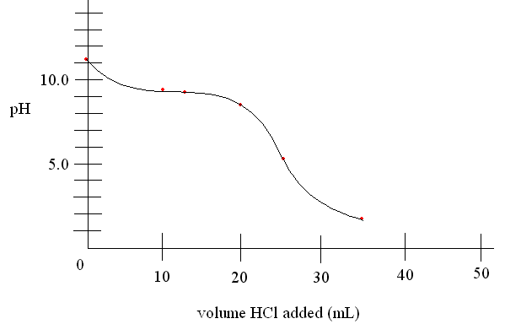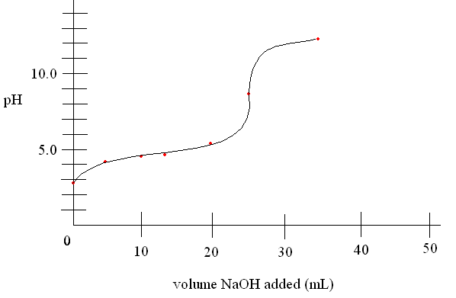

3. ________________________________________ 4. __________________________________________

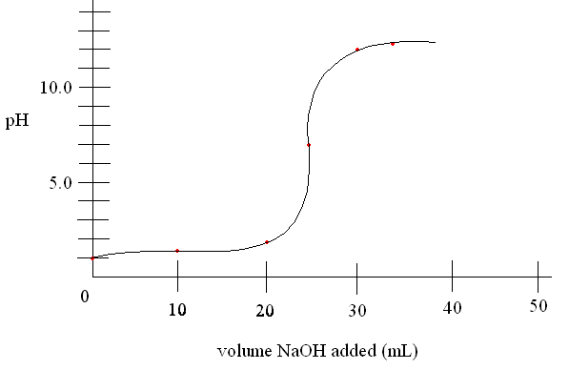 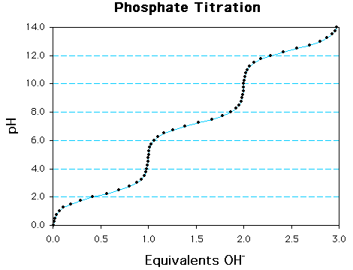

5. _______________________________________ 6. ___________________________________________

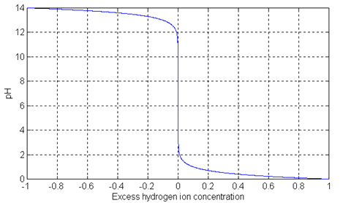 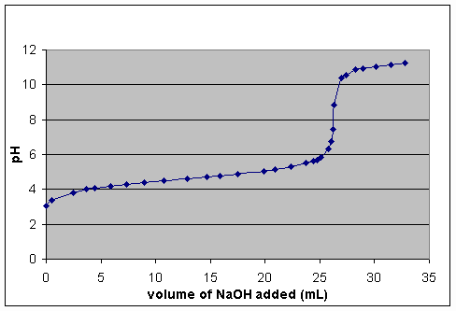

**Titration Curve Review**

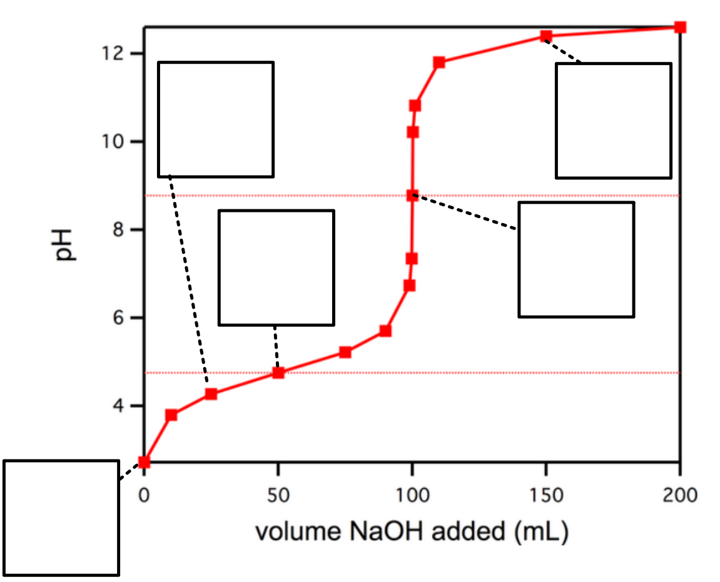

**Titration Calculations Ka acetic acid = 1.8x10-5**

1. Determine the pH of the following strong solutions:

a) 0.200 moles of HCl is reacted with 0.150 moles of NaOH. Final volume is 250. mL.

b) 0.200 moles of HCl is reacted with 0.250 moles of NaOH. Final volume is 250. mL.

c) 25.0 mL of 0.450 M HNO3 is reacted with 15.0 mL of 0.380 M NaOH.

d) 25.0 mL of 0.450 M HNO3 is reacted with 30.0 mL of 0.380 M NaOH.

2. Determine the pH of the following solutions:

a) 0.200 moles of HC2H3O2 reacted with 0.075 moles of NaOH. Final volume is 250. mL.

b) 0.200 moles of HC2H3O2 reacted with 0.125 moles of NaOH. Final volume is 250. mL.

c) 0.200 moles of HC2H3O2 reacted with 0.175 moles of NaOH. Final volume is 250. mL.

d) 0.200 moles of HC2H3O2 reacted with 0.225 moles of NaOH. Final volume is 250. mL.

3. Determine the pH of the following solutions:

a) 25.0 mL of 0.450 M HC2H3O2 reacted with 15.0 mL of 0.380 M NaOH.

b) 25.0 mL of 0.450 M HC2H3O2 reacted with 20.0 mL of 0.380 M NaOH.

c) 25.0 mL of 0.450 M HC2H3O2 reacted with 25.0 mL of 0.380 M NaOH.

d) 25.0 mL of 0.450 M HC2H3O2 reacted with 29.6 mL of 0.380 M NaOH.

e) 25.0 mL of 0.450 M HC2H3O2 reacted with 35.0 mL of 0.380 M NaOH.

4. When 25.0mL of 0.200M perchloric acid is titrated with 0.100M sodium hydroxide:

A. What is the initial pH?

B. What is the pH after 49.0mL sodium hydroxide is added?

C. What is the pH after 50.0mL sodium hydoxide is added?

D. What is the pH after 60.0omL sodium hydroxide is added?

5. When 25.0mL of 0.10M hypochlorous acid (Ka is 2.9x10-8) is titrated with 0.10M NaOH:

1. What is the initial pH?
2. What is the pH after the addition of 24.0mL NaOH?

C. What is the pH after the addition of 25.0mL NaOH?

6. If exactly 50 mL of a 0.050M solution of hydrochloric acid is added to exactly 50 mL of 0.050M ammonia, what is the pH of the resulting solution?

7. Benzoic acid is a weak monoprotic acid (Ka = 6.3 x 10-5). Calculate the pH of the solution at the equivalence point when 25.0 mL of a 0.100 M solution of benzoic acid is titrated against 0.050 M sodium hydroxide.

8. When 50.0mL of 0.100M nitric acid is titrated with 0.050M NaOH:

A. Calculate the initial pH of the above solution.

B. Calculate the pH after 95.0mL NaOH is added.

9. Calculate the pH of the solution formed by adding 10.0mL of 0.050M NaOH to 40.0mL of 0.250M

benzoic acid (Ka= 6.3x10-5).

**Additional pH Calculations**

**1. strong acid solution** – determine [H+], calculate pH

Calculate the pH of 0.00125M HNO3

**2. strong base solution** – determine [OH-], calculate pOH, calculate pH

Calculate the pH of 0.00125M KOH

**3. weak acid solution** – determine [H+] using ICE box, calculate pH

Calculate the pH of 0.00125M HOCl Ka = 3.5 x 10-8

**4. weak base solution** – determine [OH-] using ICE box, calculate pOH, calculate pH

Calculate the pH of 0.00125M NH3 Kb = 1.8 x 10-5

**5. salt of a weak acid** – write hydrolysis, calc Kb, determine [OH-] using ICE box, calc pOH, calc pH

Calculate the pH of 0.00125M NaOCl

**6. salt of a weak base** – write hydrolysis, calc Ka, determine [H+] using ICE box, calc pH

Calculate the pH of 0.00125M NH4Cl

**7. diprotic acid solution** – assume all [H+] from first ionization, determine [H+] using ICE box, calculate pH

Calculate the pH of 0.00125M H2CO3 Ka1 = 4.2 x 10-7 Ka2 = 4.8 x 10-11

**8. mixture of acid and base** – calculate moles of H+ and OH-, determine moles of excess H+ or OH-, determine total volume, calculate [H+] or [OH-], calculate pH

Calculate the pH of 20.0 mL of 0.00125M HNO3 + 30.0 mL of 0.00125M KOH

**9. pH of a buffer with equal concentrations of donor [HA] and acceptor [A-]-** pH = pKa or pOH = pKb

Calculate the pH of a solution of 2.5M 26.8mL NaOH and 1.89M 35.4mL acetic acid (Ka=1.8x10-5)

**10. pH of a buffer with unequal concentrations of donor [HA] and acceptor [A-]**-Hasselbach equation

Calculate the pH of a solution of 2.5M 26.8mL NaOH and 1.89M 45.0mL acetic acid (Ka=1.8x10-5)

**Answers:**

|  |  |  |  |  |  |  |  |  |  |
| --- | --- | --- | --- | --- | --- | --- | --- | --- | --- |
| 1 | 2 | 3 | 4 | 5 | 6 | 7 | 8 | 9 | 10 |
| 2.903 | 11.097 | 5.18 | 10.15 | 9.28 | 6.08 | 4.64 | 10.398 | 4.74 | 5.31 |

**Buffers**

1. a. Calculate the pH of a 0.20M solution of formic acid HCO2H. (Ka=2.0x10-4)

b. Now suppose sufficient sodium formate is added to make the solution 0.10M in formate ion. Would you expect the pH to increase or decrease?

c. Calculate the pH of the new solution.

d. What would the pH be if the concentration of formate ion was increased to 0.20M?

e. What do you notice about the pH of this solution?

2. Calculate the pH of a buffer solution composed of 0.20M ammonia and 0.20M ammonium chloride.

Kb = 1.8x10-5

3. A solution contains KH2PO4 and K2HPO4 and has a pH of 7.10. What is the mole ratio of K2HPO4 to KH2PO4? (Ka=6.2x10-8)

4. A buffer solution contains 0.10mol of acetic acid and 0.13 mol of sodium acetate in 1.00l. The Ka of

the acid is 1.8 x 10-5.

1. Calculate the pH of this buffer.
2. What is the pH of the buffer after 0.050mol potassium hydroxide is added.

C. What is the pH of the buffer after the addition of 0.0500 mol of nitric acid.

5. A buffer solution is 0.405 M formic acid and 0.326M sodium formate. The Ka is 1.8 x 10-4. Calculate the pH of this buffer.

6. Calculate the pH of a buffer composed if 0.12M benzoic acid (Ka=6.3x10-5) and 0.20M sodium

benzoate.

7. A buffer solution contains 0.020mol acetic acid and 0.230mol sodium acetate in 1.00L. Ka = 1.8x10-5

A. What is the pH of the buffer?

B. What is the pH after the addition of 0.00100 mol of KOH?

1. What is the pH after the addition of 0.000100 mol nitric acid?

**Most Missed AP Acid Base Questions**

___1. An aqueous solution was prepared by mixing the same number of moles of acetic acid and acetate ions. If hydroxide ions are added to the solution which of the following is false?

a. pH will increase

b. more acetic acid will form

c. the hydrogen ion concentration will decrease

d. the acetate ion concentration will increase

___2. The distinction between strong acids and weak acids is most closely related to:

a. the number of moles present per liter

b. the pH of the solutions

c. the extent of the dissociation of the electrolytes

d. interionic attractions

___3. Which of the following is most closely related to the distinction between concentrated and dilute acid solutions?

a. the number of moles present per liter

b. pH of the solutions

c. extent of the dissociation

d. interionic attractions

___4. What is the pH of a solution made by adding 400 ml of distilled water to 100 ml of .050 M HNO3?

a. 2.0 b. 2.30 c. 2.70 d. 3.0 e. 1.7

___5. If the dissociation of water is **endothermic** and some room temperature water is heated to boiling, which of the following is true?

a. The pH will be 7, the solution will be acidic.

b. The pH will be greater than 7, but the solution will be neutral.

c. The pH will be less than 7, but the solution will be neutral.

d. The pH will be less than 7, the pOH will be less than 7, and the solution will be acidic.

___6. Which statement is true?

a. The outer limits of the pH scale are 0 and 14.

b. The weaker the acid, the more strongly its salts hydrolyze.

c. The pH of a neutral solution is always 7.

d. A solution of HCl can be made basic if enough water is added.

___7. Consider the species Cu+2, F-, HOH, NH4+. Which will result in **acidic** solutions in water?

a. F- and NH4+ b. Cu2+ and NH4+ c. Cu2+ and F- d. all four

___8. The gas whose water solution will be acidic is:

a. N2 b. SO3 c. NH3 d. all of the above

___9. 1. Lewis I. electron donor, acceptor

2. Bronsted Lowry II. Containing H+ or OH-

3. General Solvent III. Increasing H+ or OH-

4. Arrhenius IV. H+ acceptor or donor

Which of the following sequences of definitions matches the acid-base theories one through four in order listed?

a. I, IV, III, II

b. I, III, IV, II

c. III, IV, I, II

d. III, IV, II, I

___10. " ______1______ freed us from water, _____2_____ freed us from hydrogen."

The acid- base theories which would correspond to 1 and 2 are:

a. Bronsted, Lewis b. Arrhenius Bronsted

c. Bronsted, Lowry d. Lewis, Bronsted

___11. The acid base theory which is used to describe the equation below is:

AlCl3 + Cl- ---> AlCl4-

a. Behavioral Theory b. Arrhenius

c. Bronsted-Lowry d. Lewis

**AP Acid Base FRQ**

***------------------------------------------------------------Solid Acid Questions-----------------------------------------------------------***

1. A NaOH solution was standardized against oxalic acid dihydrate, H2C2O4.2H2O (molecular weight: 126.066 gram mol–1). The volume of NaOH solution required to neutralize 1.2596 grams of oxalic acid dihydrate was 41.24 millilitres.

(a) Calculate the molarity of the NaOH solution.

(b) The molecular weight of a monoprotic acid HX was to be determined. A sample of 15.126 grams of HX was dissolved in distilled water and the volume brought to exactly 250.00 millilitres in a volumetric flask. Several 50.00 millilitre portions of this solution were titrated against NaOH solution, requiring an average of 38.21 millilitres of NaOH. Calculate the number of moles of HX in a 50.00 millilitre portion used for titration.

(c) Calculate the molecular weight of HX.

(d) Discuss the effect of the calculated molecular weight of HX if the sample of oxalic acid dihydrate contained a nonacidic impurity.

2. A 0.682 gram sample of an unknown weak monoprotic organic acid, HA was dissolved in sufficient water to make 50 milliliters of solution and was titrated with a 0.135 molar NaOH solution. After the addition of 10.6 milliliters of base, a pH of 5.65 was recorded. The equivalence point (end point) was reached after the addition of 27.4 milliliters of the 0.135 molar NaOH.

(a) Calculate the number of moles of acid in the original sample.

(b) Calculate the molecular weight of the acid HA.

(c) Calculate the number of moles of unreacted HA remaining in solution when the pH was 5.65.

(d) Calculate the [H3O+] at pH = 5.65

(e) Calculate the value of the ionization constant, Ka, of the acid HA.

3. The percentage by weight of nitric acid, HNO3, in a sample of concentrated nitric acid is to be determined.

(a) Initially a NaOH solution was standardized by titration with a sample of potassium hydrogen phthalate, KHC8H4O4, a monoprotic acid often used as a primary standard. A sample of pure KHC8H4O4 weighing 1.518 grams was dissolved in water and titrated with the NaOH solution. To reach the equivalence point, 26.90 millilitres of base was required. Calculate the molarity of the NaOH solution. (Molecular weight: KHC8H4O4 = 204.2)

(b) A 10.00 millilitre sample of the concentrated nitric acid was diluted with water to a total volume of 500.00 millilitres. Then 25.00 millilitres of the diluted acid solution was titrated with the standardized NaOH solution prepared in part (a). The equivalence point was reached after 28.35 millilitres of the base had been added. Calculate the molarity of the concentrated nitric acid.

4. Answer the following questions about acetylsalicylic acid, the active ingredient in aspirin.

(a) The amount of acetylsalicylic acid in a single aspirin tablet is 325 mg, yet the tablet has a mass of 2.00 g. Calculate the mass percent of acetylsalicylic acid in the tablet.

(b) The elements contained in acetylsalicylic acid are hydrogen, carbon, and oxygen. The combustion of 3.000 g of the pure compound yields 1.200 g of water and 3.72 L of dry carbon dioxide, measured at 750. mm Hg and 25°C. Calculate the mass, in g, of each element in the 3.000 g sample.

(c) A student dissolved 1.625 g of pure acetylsalicylic acid in distilled water and titrated the resulting solution to the equivalence point using 88.43 mL of 0.102 *M* NaOH*(aq)*. Assuming that acetylsalicylic acid has only one ionizable hydrogen, calculate the molar mass of the acid.

(d) A 2.00×10–3 mole sample of pure acetylsalicylic acid was dissolved in 15.00 mL of water and then titrated with 0.100 *M* NaOH*(aq)*. The equivalence point was reached after 20.00 mL of the NaOH solution had been added. Using the data from the titration, shown in the table below, determine

(i) the value of the acid dissociation constant, *Ka*, for acetylsalicylic acid and

(ii) the pH of the solution after a total volume of 25.00 mL of the NaOH solution had been added (assume that volumes are additive).

|  |  |
| --- | --- |
| Volume of 0.100M NaOH Added (mL) | pH |
| 0.00 | 2.22 |
| 5.00 | 2.97 |
| 10.00 | 3.44 |
| 15.00 | 3.92 |
| 20.00 | 8.13 |
| 25.00 | ? |

***-------------------------------------------------------------------Buffer Questions---------------------------------------------------------***

*5*. (a) Specify the properties of a buffer solution. Describe the components and the composition of effective buffer solutions.

(b) An employer is interviewing four applicants for a job as a laboratory technician and asks each how to prepare a buffer solution with a pH close to 9.

Archie A. says he would mix acetic acid and sodium acetate solutions.

Beula B. says she would mix NH4Cl and HCl solutions.

Carla C. says she would mix NH4Cl and NH3 solutions.

Dexter D. says he would mix NH3 and NaOH solutions.

Which of these applicants has given an appropriate procedure? Explain your answer, referring to your discussion in part (a). Explain what is wrong with the erroneous procedures.

(No calculations are necessary, but the following acidity constants may be helpful: acetic acid,

Ka= 1.8×10–5; NH4+, Ka = 5.6×10–10)

6. Given a solution of ammonium chloride. What additional reagent or reagents are needed to prepare a buffer from the ammonium chloride solution?

Explain how this buffer solution resists a change in pH when:

1. Moderate amounts of strong acid are added.
2. Moderate amounts of strong base are added.

(c) A portion of the buffer solution is diluted with an equal volume of water.

7. The equations and constants for the dissociation of three different acids are given below.

HCO3– ↔ H+ + CO32–  Ka = 4.2×10–7

H2PO4– ↔ H+ + HPO42– Ka = 6.2×10–8

HSO4– ↔ H+ + SO42– Ka = 1.3×10–2

1. From the systems above, identify the conjugate pair that is best for preparing a buffer with a pH of 7.2. Explain your choice.
2. Explain briefly how you would prepare the buffer solution described in (a) with the conjugate pair you have chosen.
3. If the concentrations of both the acid and the conjugate base you have chosen were doubled, how would the pH be affected? Explain how the capacity of the buffer is affected by this change in concentrations of acid and base.
4. Explain briefly how you could prepare the buffer solution in (a) if you had available the solid salt of the only one member of the conjugate pair and solution of a strong acid and a strong base.

8. A buffer solution contains 0.40 mole of formic acid, HCOOH, and 0.60 mole of sodium formate, HCOONa, in 1.00 litre of solution. The ionization constant, Ka, of formic acid is 1.8×10–4.

(a) Calculate the pH of this solution.

(b) If 100. millilitres of this buffer solution is diluted to a volume of 1.00 litre with pure water, the pH does not change. Discuss why the pH remains constant on dilution.

(c) A 5.00 millilitre sample of 1.00 molar HCl is added to 100. millilitres of the original buffer solution. Calculate the [H3O+] of the resulting solution.

(d) A 800.–milliliter sample of 2.00–molar formic acid is mixed with 200. milliliters of 4.80–molar NaOH. Calculate the [H3O+] of the resulting solution.

9. The value of the ionization constant, Ka, for hypochlorous acid, HOCl, is 3.1×10–8.

(a) Calculate the hydronium ion concentration of a 0.050 molar solution of HOCl.

(b) Calculate the concentration of hydronium ion in a solution prepared by mixing equal volumes of 0.050 molar HOCl and 0.020 molar sodium hypochlorite, NaOCl.

10. In water, hydrazoic acid, HN3, is a weak acid that has an equilibrium constant, Ka, equal to 2.8×10–5 at 25ºC. A 0.300 litre sample of a 0.050 molar solution of the acid is prepared.

(a) Write the expression for the equilibrium constant, Ka, for hydrazoic acid.

(b) Calculate the pH of this solution at 25ºC.

(c) To 0.150 litre of this solution, 0.80 gram of sodium azide, NaN3, is added. The salt dissolved completely. Calculate the pH of the resulting solution at 25ºC if the volume of the solution remains unchanged.

(d) To the remaining 0.150 litre of the original solution, 0.075 litre of 0.100 molar NaOH solution is added. Calculate the [OH–] for the resulting solution at 25ºC.

***--------------------------------------------------Titration Questions-----------------------------------------------------------***



11. A 30.00 millilitre sample of a weak monoprotic acid was titrated with a standardized solution of NaOH. A pH meter was used to measure the pH after each increment of NaOH was added, and the curve above was constructed.

(a) Explain how this curve could be used to determine the molarity of the acid.

(b) Explain how this curve could be used to determine the dissociation constant Ka of the weak monoprotic acid.

(c) If you were to repeat the titration using a indicator in the acid to signal the endpoint, which of the following indicators should you select? Give the reason for your choice.

Methyl red Ka = 1×10–5

Cresol red Ka = 1×10–8

Alizarin yellow Ka = 1×10–11

(d) Sketch the titration curve that would result if the weak monoprotic acid were replaced by a strong monoprotic acid, such as HCl of the same molarity. Identify differences between this titration curve and the curve shown above.

12. Sodium benzoate, C6H5COONa, is the salt of a the weak acid, benzoic acid, C6H5COOH. A 0.10 molar solution of sodium benzoate has a pH of 8.60 at room temperature.

(a) Calculate the [OH–] in the sodium benzoate solution described above.

(b) Calculate the value for the equilibrium constant for the reaction: C6H5COO– + H2O ↔ C6H5COOH + OH–

(c) Calculate the value of Ka, the acid dissociation constant for benzoic acid.

(d) A saturated solution of benzoic acid is prepared by adding excess solid benzoic acid to pure water at room temperature. Since this saturated solution has a pH of 2.88, calculate the molar solubility of benzoic acid at room temperature.

13. A chemical reaction occurs when 100. milliliters of 0.200–molar HCl is added dropwise to 100. milliliters of 0.100–molar Na3P04 solution.

(a) Write the two net ionic equations for the formation of the major products.

(b) Identify the species that acts as both a Brønsted acid and as a Brønsted base in the equation in (a), Draw the Lewis electron–dot diagram for this species.

(c) Sketch a graph using the axes provided, showing the shape of the titration curve that results when 100. milliliters of the HCl solution is added slowly from a buret to the Na3PO4 solution. Account for the shape of the curve.



(d) Write the equation for the reaction that occurs if a few additional milliliters of the HCl solution are added to the solution resulting from the titration in (c).

14. HOBr*(aq)* ↔ H+*(aq)* + OBr–*(aq)* *Ka* = 2.3  10–9

Hypobromous acid, HOBr, is a weak acid that dissoci­ates in water, as represented by the equation above.

1. Calculate the value of [H+] in an HOBr solution that has a pH of 4.95.
2. Write the equilibrium constant expression for the ionization of HOBr in water, then calculate the concentration of HOBr*(aq)* in an HOBr solution that has [H+] equal to 1.8  10–5 *M*.

(c) A solution of Ba(OH)2 is titrated into a solution of HOBr.

(i) Calculate the volume of 0.115 *M* Ba(OH)2*(aq)* needed to reach the equivalence point when titrated into a 65.0 mL sample of 0.146 *M* HOBr*(aq)*.

(ii) Indicate whether the pH at the equivalence point is less than 7, equal to 7, or greater than 7.

(d) Calculate the number of moles of NaOBr*(s)* that would have to be added to 125 mL of 0.160 *M* HOBr to produce a buffer solution with [H+] = 5.00  10–9 *M*. Assume that volume change is negligible.

(e) HOBr is a weaker acid than HBrO3. Account for this fact in terms of molecular structure.

15. An approximately 0.1–molar solution of NaOH is to be standardized by titration. Assume that the following materials are available.

• Clean, dry 50 mL buret

• 250 mL Erlenmeyer flask

• Wash bottle filled with distilled water

• Analytical balance

• Phenolphthalein indicator solution

• Potassium hydrogen phthalate, KHP, a pure solid monoprotic acid (to be used as the primary standard)

1. Briefly describe the steps you would take, using the materials listed above, to standardize the NaOH solution.

(b) Describe (*i.e.*, set up) the calculations necessary to determine the concentration of the NaOH solution.

(c) After the NaOH solution has been standardized, it is used to titrate a weak monoprotic acid, HX. The equivalence point is reached when 25.0 mL of NaOH solution has been added. In the space provided at the right, sketch the titration curve, showing the pH changes that occur as the volume of NaOH solution added increases from 0 to 35.0 mL. Clearly label the equivalence point on the curve.



(d) Describe how the value of the acid–dissociation constant, *Ka,* for the weak acid HX could be determined from the titration curve in part (c).

16. HF*(aq)* + H2O*(l)* ↔ H3O+*(aq)* + F–*(aq) Ka =* 7.2×10–4

Hydrofluoric acid, HF*(aq)*, dissociates in water as represented by the equation above.

1. Write the equilibrium-constant expression for the dissociation of HF*(aq)* in water.

(b) Calculate the molar concentration of H3O+ in a 0.40 *M* HF*(aq)* solution.

HF*(aq)* reacts with NaOH*(aq)* according to the reaction represented below.

HF*(aq)* + OH–*(aq)* → H2O*(l)* + F–*(aq)*

A volume of 15 mL of 0.40 *M* NaOH*(aq)* is added to 25 mL of 0.40 *M* HF*(aq)* solution. Assume that volumes are additive.

(c) Calculate the number of moles of HF*(aq)* remaining in the solution.

(d) Calculate the molar concentration of F–*(aq)* in the solution.

(e) Calculate the pH of the solution.

***----------------------------------------------------Salt Question --------------------------------------------------------***

HOCl ↔ OCl– + H+

17. Hypochlorous acid, HOCl, is a weak acid commonly used as a bleaching agent. The acid–dissociation constant, *Ka,* for the reaction represented above is 3.2×10–8.

(a) Calculate the [H+] of a 0.14–molar solution of HOCl.

(b) Write the correctly balanced net ionic equation for the reaction that occurs when NaOCl is dissolved in water and calculate the numerical value of the equilibrium constant for the reaction.

(c) Calculate the pH of a solution made by combining 40.0 milliliters of 0.14–molar HOCl and 10.0 milliliters of 0.56–molar NaOH.

(d) How many millimoles of solid NaOH must be added to 50.0 milliliters of 0.20–molar HOCl to obtain a buffer solution that has a pH of 7.49? Assume that the addition of the solid NaOH results in a negligible change in volume.

(e) Household bleach is made by dissolving chlorine gas in water, as represented below.

Cl2*(g)* + H2O → H+ + Cl– + HOCl*(aq)*

Calculate the pH of such a solution if the concentration of HOCl in the solution is 0.065 molar.

AS

BS

SB

WB

Salt

WA

SA

**TWO SOLUTIONS**

Find moles of acid and base separately (M times L). Subtract to find what is left over.

**pH=-log[mol/L]**

*use total volume!

**pH=14-(-log[mol/L])**

*use total volume!

**pH=pKa + log (S/A)**

*Salt=Basic Limiter, keep in moles

**pOH=pKb + log (S/B), pH = 14-pOH**

*Salt=Acidic Limiter, keep in moles

Strong acid + Strong Base

**pH=7**

Strong Acid + Weak Base 🡪 Acidic Salt

**Hydrolyze salt, icebox, pH=-log(x)**

Ex: NH4+ 🡪 NH3 + H+

*Remember to use a Ka value (Ka x Kb = Kw)

Weak Acid + Strong Base 🡪 Basic Salt

**Hydrolyze salt, icebox, pH=14-(-log(x))**

Ex: C2H3O2- 🡪 HC2H3O2 + OH-

*Remember to use a Kb value (Ka x Kb = Kw)

SB

WB

WA

SA

**ONE SOLUTION**

**pH=-log[mol/L]**

**pH=14-(-log[mol/L])**

**Ice box**

**pH= -log[H+]**

**Ice Box**

**pOH= -log (OH-), pH = 14-pOH**

**AB Review**

1) An acid is titrated with NaOH. The following beakers are illustrations of the contents of the beaker at various times during the titration. There are presented out of order. (Water and spectator ions have been omitted)

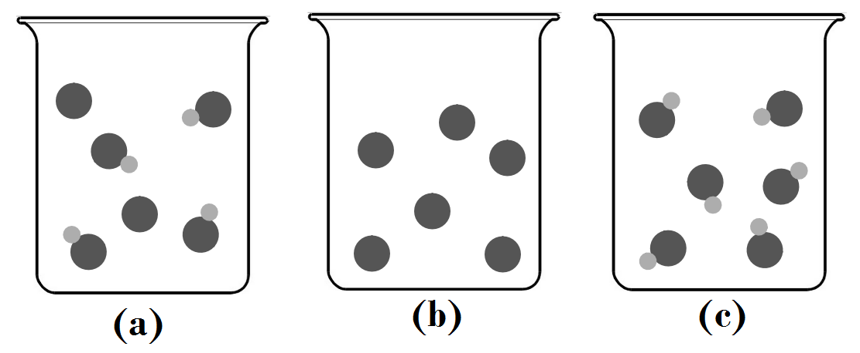

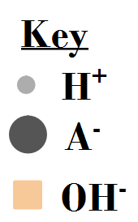

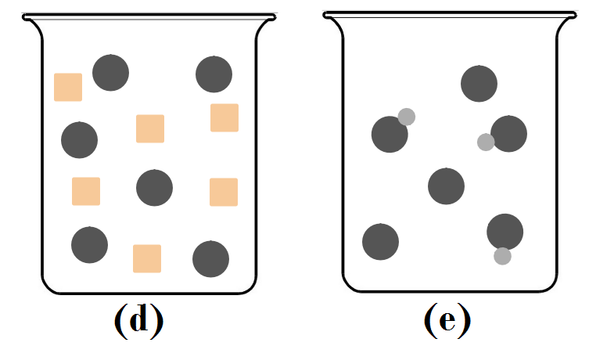

1. Is the acid a weak or strong acid? How can you tell?
2. Arrange the beakers in order of what the contents would look like as the titration progresses.
3. For which beaker would pH=pKa? Explain your answer.
4. Which beaker represents the equivalence point of the titration, explain your answer.
5. For which beaker would the Ka value for the acid not be necessary to determine the pH? Explain your answer.
6. This is the titration of a _____ by a ______.
7. Which point does the container contain a buffer?

________

1. What does the pH depend on at point A?
2. What does the pH depend on at point B?
3. What does the pH depend on at point C?
4. What does the pH depend on a point D?
5. Draw a dot on the graph, where pH = pKa.

2)

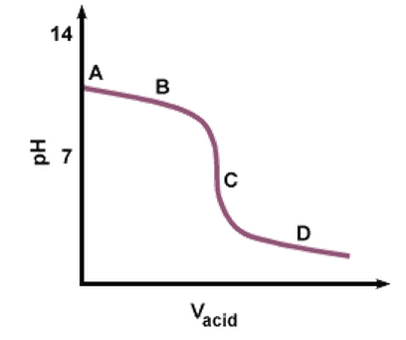

3) The following plot shows the pH curves for the titration of various acids by 0.10M NaOH (all of the acids were 50.0mL samples of 0.10M concentration.)

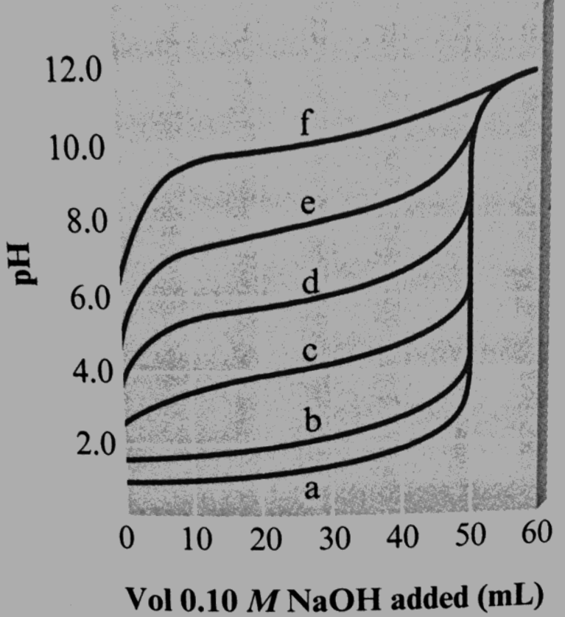

1. Which pH curve corresponds to the weakest acid? ________
2. Which pH curve corresponds to the strongest acid? Which point on the pH curve would you examine to see if this acid is a strong acid or a weak acid (assuming you did not know the initial concentration of the acid)
3. Which pH curve corresponds to an acid with Ka = 1 x 10-6?

a)How many hydrogens does this acid have? ______

b) Indicate the two points when the solution is at maximum buffering?

______ and ______

b) Indicate the 1st equivalence point. ______

c) Indicate the 2nd equivalence point ______

d) At what pH would you want your indicator color change to occur at in order to titrate to the first equivalence point?

______________

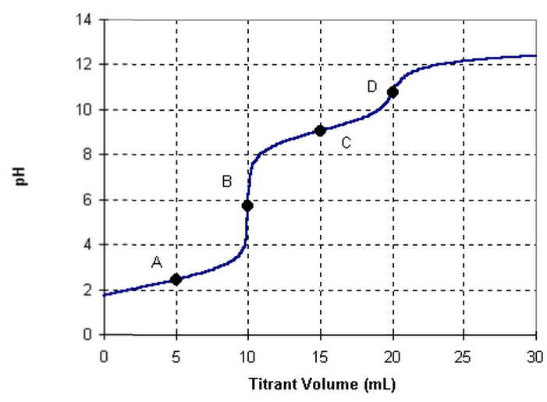

4)

5) Three unknown acid samples are studied by titration with a 0.1 *M* sodium hydroxide solution. One sample is vitamin C (ascorbic acid, p*K*a = 4.10), one is aspirin (acetylsalicylic acid, p*K*a = 3.52), and one is vinegar (acetic acid, p*K*a = 4.74). Which titration curve corresponds to which acid?



**Titration graphing Problems**

1) A student titrates 50.0 mL of 0.50 M hydrobromic acid with 0.33M potassium hydroxide.

a. Write the net ionic equation for the reaction between aqueous hydrobromic acid and aqueous potassium hydroxide.

b. What is the initial pH before the titration begins?

c. What is the pH at the half-way to equivalence point?

d. What is the pH at the equivalence point?

e. What is the pH 1.0mL after the equivalence point?

f. Accurately sketch the titration curve on the graph below.

2) A student titrates 75.0mL of 1.00M benzoic acid, C6H5COOH, with 0.50 M lithium hydroxide. The Ka for benzoic acid is 6.30 x 10-5.

a. Write the net ionic equation for the reaction between aqueous benzoic acid and aqueous lithium hydroxide

b. What is the initial pH before the titration begins?

c. What is the pH at the half-way to equivalence point?

d. What is the pH at the equivalence point?

e. Accurately sketch the titration curve on the graph below.

f. When the pH of the solution is 3.42, which substance has a higher concentration: benzoic acid, lithium benzoate or lithium hydroxide? Justify your answer.

AP Chemistry: Acids & Bases

Multiple Choice

|  |  |  |  |  |  |  |  |  |  |  |  |  |
| --- | --- | --- | --- | --- | --- | --- | --- | --- | --- | --- | --- | --- |
| 33. The pH of 0.1-molar ammonia is approximately… | | | | | | | | | | | | |
| (A) 1 (B) 4 (C) 7 (D) 11 (E) 14 | | | | | | | | | | | | |
|  | | | | | | | | | | | | |
| 48. Which of the following ions is the strongest Lewis acid? | | | | | | | | | | | | |
| (A) Na+ (B) Cl− (C) CH3COO− (D) Mg2+ (E) Al3+ | | | | | | | | | | | | |
|  | | | | | | | | | | | | |
| 49. Each of the following can act as both a Brönsted acid and a Brönsted base EXCEPT… | | | | | | | | | | | | |
| (A) HCO3− (B) H2PO4− (C) NH4+ (D) H2O (E) HS− | | | | | | | | | | | | |
|  | | | | | | | | | | | | |
| 53. Which, if any, of the following species is in the greatest concentration in a 0.100-molar solution of H2SO4 in water? | | | | | | | | | | | | |
| (A) H2SO4 molecules (B) H3O+ ions (C) HSO4− ions | | | | | | | | | | | | |
| (D) SO42− ions (E) All species are in equilibrium and therefore have the same concentrations. | | | | | | | | | | | | |
|  | | | | | | | | | | | | |
| 71. Which of the following reactions does NOT proceed significantly to the right in aqueous solutions? | | | | | | | | | | | | |
| (A) H3O+ + OH− 🡪 2 H2O (B) HCN + OH− 🡪 H2O + CN− | | | | | | | | | | | | |
| (C) Cu(H2O)42+ + 4 NH3 🡪 Cu(NH3)42+ + 4H2O (D) H2SO4 + H2O 🡪 H3O+ + HSO4− | | | | | | | | | | | | |
| (E) H2O + HSO4− 🡪 H2SO4 + OH− | | | | | | | | | | | | |
|  | | | | | | | | | | | | |
| 75. If the acid dissociation constant, Ka, for an acid HA is 8 x 10−4 at 25 °C, what percent of the acid is dissociated in a 0.50-molar solution of HA at 25 °C? | | | | | | | | | | | | |
| (A) 0.08% (B) 0.2% (C) 1% (D) 2% (E) 4% | | | | | | | | | | | | |
|  | | | | | | | | | | | | |
| 34. All of the following species can function as Brönsted-Lowry bases in solution EXCEPT… | | | | | | | | | | | | |
| (A) H2O (B) NH3 (C) S2− (D) NH4+ (E) HCO3− | | | | | | | | | | | | |
|  | | | | | | | | | | | | |
| 46. As the number of oxygen atoms increases in any series of oxygen acids, such as HXO, HXO2, HXO3, ...., which of the following is generally true? | | | | | | | | | | | | |
| (A) The acid strength varies unpredictably. | | | | | | | | | | | | |
| (B) The acid strength decreases only if X is a nonmetal. | | | | | | | | | | | | |
| (C) The acid strength decreases only if X is a metal. | | | | | | | | | | | | |
| (D) The acid strength decreases whether X is a nonmetal or a metal. | | | | | | | | | | | | |
| (E) The acid strength increases. | | | | | | | | | | | | |
|  | | | | | | | | | | | | |
| 50. Which of the following acids can be oxidized to form a stronger acid? | | | | | | | | | | | | |
| (A) H3PO4 (B) HNO3 (C) H2CO3 (D) H3BO3 (E) H2SO3 | | | | | | | | | | | | |
| 54. Which of the following is the correct equilibrium expression for the hydrolysis of CO32− ? | | | | | | | | | | | | |
| (A) K = [HCO3− ] / ( [CO32− ] [H3O+] ) (B) K = ( [HCO3−] [OH−] ) / [CO32−] | | | | | | | | | | | | |
| (C) K = ( [CO32− ] [OH−] ) / [HCO3−] (D) K = [CO32− ] / ( [CO2] [OH−]2 ) | | | | | | | | | | | | |
| (E) K = ( [CO32− ] [H3O+] ) / [HCO3−] | | | | | | | | | | | | |
|  | | | | | | | | | | | | |
| 55. The equilibrium constant for the reaction represented by the equation below is greater than 1.0. Which of the following gives the correct relative strengths of the acids and bases in the reaction? | | | | | | | | | | | | |
| H2PO4− + HBO32− ⇄ HPO42− + H2BO3− | | | | | | | | | | | | |
|  | Acids | |  | | | Bases | | | |  |  |  |
| (A) | H2PO4− > H2BO3− | | and | | | HBO32− > HPO42− | | | |  |  |  |
| (B) | H2BO3− > H2PO4− | | and | | | HBO32¯ > HPO42− | | | |  |  |  |
| (C) | H2PO4− > H2BO3− | | and | | | HPO42− > HBO32− | | | |  |  |  |
| (D) | H2BO3− > H2PO4− | | and | | | HPO42− > HBO32− | | | |  |  |  |
| (E) | H2PO4− = H2BO3− | | and | | | HPO42− = HBO32− | | | |  |  |  |
|  | | | | | | | | | | | | |
| 56. A 0.20-molar solution of a weak monoprotic acid, HA, has a pH of 3.00. The ionization constant of this acid is… | | | | | | | | | | | | |
| (A) 5.0 x 10−7 (B) 2.0 x 10−7 (C) 5.0 x 10−6 (D) 5.0 x 10−3 (E) 2.0 x 10−3 | | | | | | | | | | | | |
|  | | | | | | | | | | | | |
| 22. HSO4− + H2O ⇄ H3O+ + SO42− In the equilibrium represented above, the species that act as bases include which of the following? | | | | | | | | | | | | |
| I. HSO4− II. H2O III. SO42− | | | | | | | | | | | | |
| (A) II only (B) III only (C) I and II (D) I and III (E) II and III | | | | | | | | | | | | |
|  | | | | | | | | | | | | |
| 31. H2C2O4 + 2 H2O ⇄ 2 H3O+ + C2O42− Oxalic acid, H2C2O4, is a diprotic acid with K1 = 5 x 10−2 and K2 = 5 x 10−5. Which of the following is equal to the equilibrium constant for the reaction represented above? | | | | | | | | | | | | |
| (A) 5 x 10−2 (B) 5 x 10−5 (C) 2.5 x 10−6 (D) 5 x 10−7 (E) 2.5 x 10−8 | | | | | | | | | | | | |
|  | | | | | | | | | | | | |
| 61. A 1-molar solution of which of the following salts has the highest pH? | | | | | | | | | | | | |
| (A) NaNO3 (B) Na2CO3 (C) NH4Cl (D) NaHSO4 (E) Na2SO4 | | | | | | | | | | | | |
|  | | | | | | | | | | | | |
| 66. What is the pH of a 1.0 x 10−2-molar solution of HCN? (Ka = 4.0 x 10 −10 ) | | | | | | | | | | | | |
| (A) 10 (B) Between 7 and 10 (C) 7 (D) Between 4 and 7 (E) 4 | | | | | | | | | | | | |
|  | | | | | | | | | | | | |
| 45. What is the H+(aq) concentration in 0.05 M HCN(aq) ? (The Ka for HCN is 5.0 x 10−10) | | | | | | | | | | | | |
| (A) 2.5 x 10−11 (B) 2.5 x 10−10 (C) 5.0 x 10−10 (D) 5.0 x 10−6 (E) 5.0 x 10−4 | | | | | | | | | | | | |
|  | | | | | | | | | | | | |
| 38. A molecule or an ion is classified as a Lewis acid if it… | | | | | | | | | | | | |
| (A) accepts a proton from water (B) accepts a pair of electrons to form a bond | | | | | | | | | | | | |
| (C) donates a pair of electrons to form a bond (D) donates a proton to water | | | | | | | | | | | | |
| (E) has resonance Lewis electron-dot structures | | | | | | | | | | | | |
|  | | | | | | | | | | | | |
| 64. The net ionic equation for the reaction that occurs during the titration of nitrous acid with sodium hydroxide is… | | | | | | | | | | | | |
| (A) HNO2 + Na+ + OH− 🡪 NaNO2 + H2O | | | | | | | | | | | | |
| (B) HNO2 + NaOH 🡪 Na+ + NO2− + H2O | | | | | | | | | | | | |
| (C) H+ + OH− 🡪 H2O | | | | | | | | | | | | |
| (D) HNO2 + H2O 🡪 NO2− + H3O+ | | | | | | | | | | | | |
| (E) HNO2 + OH− 🡪 NO2− + H2O | | | | | | | | | | | | |
|  | | | | | | | | | | | | |
| 16. Commercial vinegar was titrated with NaOH solution to determine the content of acetic acid, HC2H3O2. For 20.0 milliliters of the vinegar, 32.0 milliliters of 0.500-molar NaOH solution was required. What was the concentration of acetic acid in the vinegar if no other acid was present? | | | | | | | | | | | | |
| (A) 1.60 M (B) 0.800 M (C) 0.640 M (D) 0.600 M (E) 0.400 M | | | | | | | | | | | | |
|  | |  | |  |  | |  |  |  | | | |
| Acid | | Acid Dissociation | |  |  | |  |  |  | | | |
| Constant, Ka | |  |  | |  |  |  | | | |
| H3PO4 | | 7 x 10−3 | |  |  | |  |  |  | | | |
| H2PO4− | | 8 x 10−8 | |  |  | |  |  |  | | | |
| HPO42− | | 5 x 10−13 | |  |  | |  |  |  | | | |
|  | | | | | | | | | | | | |
| 63. On the basis of the information above, a buffer with a pH = 9 can best be made by using… | | | | | | | | | | | | |
| (A) pure NaH2PO4 (B) H3PO4 + H2PO4− (C) H2PO4− + PO43− | | | | | | | | | | | | |
| (D) H2PO4− + HPO42− (E) HPO42− + PO43− | | | | | | | | | | | | |
|  | | | | | | | | | | | | |
| 19. In the titration of a weak acid of unknown concentration with a standard solution of a strong base, a pH meter was used to follow the progress of the titration. Which of the following is true for this experiment? | | | | | | | | | | | | |
| (A) The pH is 7 at the equivalence point. | | | | | | | | | | | | |
| (B) The pH at the equivalence point depends on the indicator used. | | | | | | | | | | | | |
| (C) The graph of pH versus volume of base added rises gradually at first and then much more rapidly. | | | | | | | | | | | | |
| (D) The graph of pH versus volume of base added shows no sharp rise. | | | | | | | | | | | | |
| (E) The [H+] at the equivalence point equals the ionization constant of the acid. | | | | | | | | | | | | |
|  | | | | | | | | | | | | |
| 55. What volume of 0.150-molar HCl is required to neutralize 25.0 milliliters of 0.120-molar Ba(OH)2? | | | | | | | | | | | | |
| (A) 20.0 mL (B) 30 0 mL (C) 40.0 mL (D) 60.0 mL (E) 80.0 mL | | | | | | | | | | | | |
| 35. When phenolphthalein is used as the indicator in a titration of an HCl solution with a solution of NaOH, the indicator undergoes a color change from clear to red at the end point of the titration. This color change occurs abruptly because… | | | | | | | | | | | | |
| (A) phenolphthalein is a very strong acid that is capable of rapid dissociation | | | | | | | | | | | | |
| (B) the solution being titrated undergoes a large pH change near the end point of the titration | | | | | | | | | | | | |
| (C) phenolphthalein undergoes an irreversible reaction in basic solution | | | | | | | | | | | | |
| (D) OH− acts as a catalyst for the decomposition of phenolphthalein | | | | | | | | | | | | |
| (E) phenolphthalein is involved in the rate-determining step of the reaction between H3O+ and OH− | | | | | | | | | | | | |
|  | | | | | | | | | | | | |
| 8. Use these answers for questions 8 - 10. | | | | | | | | | | | | |
| (A) a solution with a pH less than 7 that is not a buffer solution | | | | | | | | | | | | |
| (B) a buffer solution with a pH between 4 and 7 | | | | | | | | | | | | |
| (C) a buffer solution with a pH between 7 and 10 | | | | | | | | | | | | |
| (D) a solution with a pH greater than 7 that is not a buffer solution | | | | | | | | | | | | |
| (E) a solution with a pH of 7 | | | | | | | | | | | | |
| Ionization Constants | | | | | | | | | | | | |
| CH3COOH = 1.8 x 10−5 | | | | | | | | | | | | |
| NH3 = 1.8 x 10−5 | | | | | | | | | | | | |
| H2CO3; K1 = 4 x 10−7 | | | | | | | | | | | | |
| H2CO3; K2 = 4 x 10−11 | | | | | | | | | | | | |
| 8. A solution prepared to be initially 1 M in NaCl and 1 M in HCl. | | | | | | | | | | | | |
| 9. A solution prepared to be initially 1 M in Na2CO3 and 1 M in CH3COONa | | | | | | | | | | | | |
| 10. A solution prepared to be initially 0.5 M in CH3COOH and 1 M in CH3COONa | | | | | | | | | | | | |
|  | | | | | | | | | | | | |
| 74. A solution of calcium hypochlorite, a common additive to swimming-pool water, is… | | | | | | | | | | | | |
| (A) basic because of the hydrolysis of the OCl− ion (B) basic because Ca(OH)2 is a weak and insoluble base | | | | | | | | | | | | |
| (C) neutral if the concentration is kept below 0.1 molar | | | | | | | | | | | | |
| (D) acidic because of the hydrolysis of the Ca2+ ions (E) acidic because the acid HOCl is formed | | | | | | | | | | | | |
|  | | | | | | | | | | | | |
| 62. HC2H3O2(aq) + CN− (aq) ⇄ HCN(aq) + C2H3O2− (aq) | | | | | | | | | | | | |
| The reaction represented above has an equilibrium constant equal to 3.7 x 104. Which of the following can be concluded from this information? | | | | | | | | | | | | |
| (A) CN− (aq) is a stronger base than C2H3O2− (aq) (B) HCN(aq) is a stronger acid than HC2H3O2(aq) | | | | | | | | | | | | |
| (C) The conjugate base of CN− (aq) is C2H3O2− (aq) | | | | | | | | | | | | |
| (D) The equilibrium constant will increase with an increase in temperature. | | | | | | | | | | | | |
| (E) The pH of a solution containing equimolar amounts of CN− (aq) and HC2H3O2 (aq) is 7.0 | | | | | | | | | | | | |
|  | | | | | | | | | | | | |
| 52. When dilute nitric acid was added to a solution of one of the following chemicals, a gas was evolved, This gas turned a drop of limewater, Ca(OH)2, cloudy, due to the formation of a white precipitate. The chemical was… | | | | | | | | | | | | |
| (A) household ammonia, NH3 (B) baking soda, NaHCO3 (C) table salt, NaCl | | | | | | | | | | | | |
| (D) epsom salts, MgSO4 . 7H2O (E) bleach, 5% NaOCl | | | | | | | | | | | | |
| Questions 9-12 refer to aqueous solutions containing 1:1 mole ratios of the following pairs of substances. Assume all concentrations are 1 M. | | | | | | | | | | | | |
| (A) NH3 and NH4Cl (B) H3PO4 and NaH2PO4 (C) HCl and NaCl | | | | | | | | | | | | |
| (D) NaOH and NH3 (E) NH3 and HC2H3O2 (acetic acid) | | | | | | | | | | | | |
|  | | | | | | | | | | | | |
| 9. The solution with the lowest pH | | | | | | | | | | | | |
| 10. The most nearly neutral solution | | | | | | | | | | | | |
| 11. A buffer at a pH > 8 | | | | | | | | | | | | |
| 12. A buffer at a pH <6 | | | | | | | | | | | | |

|  |
| --- |
| 69. Correct procedures for a titration include which of the following? |
| I. Draining a pipet by touching the tip to the side of the container used for the titration |
| II. Rinsing the buret with distilled water just before filling it with the liquid to be titrated |
| III. Swirling the solution frequently during the titration |
| (A) I only (B) II only (C) I and III only (D) II and III only (E) I, II, and III |
|  |
| 70. To determine the molar mass of a solid monoprotic acid, a student titrated a weighed sample of the acid with standardized aqueous NaOH. Which of the following could explain why the student obtained a molar mass that was too large? |
| I. Failure to rinse all acid from the weighing paper into the titration vessel |
| II. Addition of more water than was needed to dissolve the acid |
| III. Addition of some base beyond the equivalence point |
| (A) I only (B) III only (C) I and II only (D) II and III only (E) I, II, and III |
|  |
| 24. The safest and most effective emergency procedure to treat an acid splash on skin is to do which of the following immediately? |
| (A) Dry the affected area with paper towels |
| (B) Sprinkle the affected area with powdered Na2SO4(s) |
| (C) Flush the affected area with water and then with a dilute NaOH solution |
| (D) Flush the affected area with water and then with a dilute NaHCO3 solution |
| (E) Flush the affected area with water and then with a dilute vinegar solution |
|  |
| 32. The net ionic equation for the reaction between silver carbonate and hydrochloric acid is… |
| (A) Ag2CO3(s) + 2 H+ + 2 Cl− 🡪 2 AgCl(s) + H2O + CO2 (g) |
| (B) 2 Ag+ + CO32− + 2 H+ + 2 Cl− 🡪 2 AgCl(s) + H2O + CO2(g) |
| (C) CO32− + 2 H+ 🡪 H2O + CO2(g) |
| (D) Ag+ + Cl¯ 🡪 AgCl(s) |
| (E) Ag2CO3(s) + 2 H+ 🡪 2Ag+ + H2CO3 |

|  |
| --- |
| 22. 2 NH3 ⇄ NH4+ + NH2−  In liquid ammonia, the reaction represented above occurs. In the reaction NH4+ acts as…  (A) a catalyst (B) both an acid and a base (C) the conjugate acid of NH3 (D) the reducing agent (E) the oxidizing agent |
|  |
| 30. At 25°C, aqueous solutions with a pH of 8 have a hydroxide ion concentration, [OH−], of…  (A) 1 × 10−14 M (B) 1 × 10−8 M (C) 1 × 10−6 M (D) 1M (E) 8M |
|  |
| Questions 33-34 The graph below shows the titration curve that results when 100. mL of 0.0250 M acetic acid is titrated with 0.100 M NaOH.  33. Which of the following indicators is the best choice for this titration?  pH Range of  Color Change (A) Methyl orange 3.2 - 4.4 (B) Methyl red 4.8 - 6.0 (C) Bromthymol blue 6.1 - 7.6 (D) Phenolphthalein 8.2 - 10.0 (E) Alizarin 11.0 - 12.4  34. What part of the curve corresponds to the optimum buffer action for the acetic acid/acetate pair?  (A) Point V (B) Point X (C) Point Z (D) Along all of section WY (E) along all of section YZ |
|  |
| 61. How can 100. mL of sodium hydroxide solution with a pH of 13.00 be converted to a sodium hydroxide solution with a pH of 12.00?  (A) By diluting the solution with distilled water to a total volume of 108 mL (B) By diluting the solution with distilled water to a total volume of 200 mL (C) By diluting the solution with distilled water to a total volume of 1.00 L (D) By adding 100. mL of 0.10 M HCl (E) By adding 100. mL of 0.10 M NaOH |
|  |
| 63. Mixtures that would be considered buffers include which of the following?  I. 0.10 M HCl + 0.10 M NaCl  II. 0.10 M HF + 0.10 M NaF  III. 0.10 M HBr + 0.10 M NaBr  (A) I only (B) II only (C) III only (D) I and II (E) II and III |
|  |
| 64. Ascorbic acid H2C6H6O6(s), is a diprotic acid with K1 = 7.9 × 10−5 and K2 = 1.6 × 10−12. In a 0.005 M aqueous solution of ascorbic acid, which of the following species is present in the lowest concentration?  (A) H2O(l) (B) H3O+(aq) (C) H2C6H6O6(aq) (D) HC6H6O6−(aq) (E) C6H6O62−(aq) |
|  |
| 74. A pure white crystalline solid dissolves in water to yield a basic solution that liberates a gas when excess acid is added to it. On the basis of this information, the solid could be…  (A) KNO3 (B) K2CO3 (C) KOH (D) KHSO4 (E) KCl |
|  |
| 74. Equal volumes of 0.10-molar H3PO4 and 0.20-molar KOH are mixed. After equilibrium is established, the type of ion a solution in largest concentration, other than the K+ ion, is… |
| (A) H2PO4−  (B) HPO42−  (C) PO43−  (D) OH−  (E) H3O+ |

**Ksp**

Write the Equilibrium expression for each question and then solve:

1. If the molar solubility of CaF2 is 1.24 x 10-3 M, then what is the Ksp?
2. The Ksp for LaF3 is 2 x 10-19. What is the solubility of LaF3 in M? in g/L?
3. The Ksp for Cr(OH)3 is 1.6 x 10-30. What is the molar solubility of Cr(OH)3 and the ion concentrations?
4. The Ksp for Calcium Phosphate is 2.0 x 10-29. What are the molar solubility and ion concentrations?
5. A 1.00L solution is saturated at 25C with Lead (II) Iodide containing 0.54g of PbI2. Calculate the Ksp.
6. Calculate the molar solubility of Barium Fluoride in water. Ksp =1.7x10-7
7. Soluble barium compounds are poisonous; however, barium sulfate is routinely ingested as a suspended solid to improve the contrast in x-ray images. Calculate the concentration of dissolved barium per liter of water in equilibrium with solid barium sulfate. The Ksp is 1.1x10-10.
8. A solution of NaF is added drop-wise to a solution that is 0.0144M Ba2+. At what concentration will BaF2 precipitate? Ignore changes in volume.
9. Calculate the molar solubility of Mn(OH)2 at pH=7 and again at pH=9.5. (Ksp=1.6x10-13)
10. A solution of Barium chromate is prepared by dissolving 6.3x10-3 g of this yellow solid in 1.00L of hot water. Will solid barium chromate precipitate upon cooling according to the Ksp? If so, how much will precipitate? Ksp=2.1x10-10.

**AP Solubility FRQ**

1. At 25ºC the solubility product constant, Ksp, for strontium sulfate, SrSO4, is 7.6×10-7. The solubility product constant for strontium fluoride, SrF2, is 7.910-10.

(a) What is the molar solubility of SrSO4 in pure water at 25ºC?

1. What is the molar solubility of SrF2 in pure water at 25ºC?

(c) An aqueous solution of Sr(NO3)2 is added slowly to 1.0 litre of a well-stirred solution containing 0.020 mole F- and 0.10 mole SO42- at 25ºC. (You may assume that the added Sr(NO3)2 solution does not materially affect the total volume of the system.)

i. Which salt precipitates first?

ii. What is the concentration of strontium ion, Sr2+, in the solution when the first precipitate begins to form?

2. H2S + H2O ↔ H3O+ + HS– K1 = 1.0×10–7

HS– + H2O ↔ H3O+ + S2– K2 = 1.3×10–13

H2S + 2 H2O ↔ 2 H3O+ + S2– K = 1.3×10–20

Ag2S*(s)* ↔ 2 Ag+ + S2– Ksp= 5.5×10–51

1. Calculate the concentration of H3O+ of a solution which is 0.10 molar in H2S.
2. Calculate the concentration of the sulfide ion, S2–, in a solution that is 0.10 molar in H2S and 0.40 molar in H3O+.
3. Calculate the maximum concentration of silver ion, Ag+, that can exist in a solution that is 1.5×10–17 molar in sulfide ion, S2–.

3. Methylamine CH3NH2, is a weak base that ionizes in solution as shown by the following equation.

CH3NH2 + H2O ↔ CH3NH3+ + OH–

1. At 25ºC the percentage ionization in a 0.160 molar solution of CH3NH2 is 4.7%. Calculate [OH–], [CH3NH3+], [CH3NH2], [H3O+], and the pH of a 0.160 molar solution of CH3NH2 at 25ºC
2. Calculate the value for Kb, the ionization constant for CH3NH2, at 25ºC.

4. NH3 + H2O ↔ NH4+ + OH– Ammonia is a weak base that dissociates in water as shown above. At 25ºC, the base dissociation constant, Kb, for NH3 is 1.8×10–5.

(a) Determine the hydroxide ion concentration and the percentage dissociation of a 0.150 molar solution of ammonia at 25ºC.

(b) Determine the pH of a solution prepared by adding 0.0500 mole of solid ammonium chloride to 100. millilitres of a 0.150 molar solution of ammonia.

(c) If 0.0800 mole of solid magnesium chloride, MgCl2, is dissolved in the solution prepared in part (b) and the resulting solution is well–stirred, will a precipitate of Mg(OH)2 form? Show calculations to support your answer. (Assume the volume of the solution is unchanged. The solubility product constant for Mg(OH)2 is 1.5×10–11.

5. Answer each of the following using appropriate chemical principles. When NH3 gas is bubbled into an aqueous solution of CuCl2, a precipitate forms initially. On further bubbling, the precipitate disappears. Explain these two observations. In each case, justify your choice.

Acids & Bases

1999

1. Which oxide forms a basic solution when mixed with water?

(A) K2O (C) CO2  
(B) Al2O3 (D) SO3

35. Which 0.1 M solution has the highest pH?

(A) sodium carbonate  
(B) sodium chloride  
(C) ammonium carbonate  
(D) ammonium chloride

36. Which is the strongest acid?

(A) acetic acid - (Ka = 1.8 x 10¯5)  
(B) benzoic acid - (Ka = 6.3 x 10¯5)  
(C) formic acid - (Ka = 1.8 x 10¯4)  
(D) nitrous acid - (Ka = 6.0 x 10¯4)

37. What is the order of concentration of the ions and molecules in a nitrous acid solution? Nitrous acid, HNO2, is a weak acid.

(A) H3O+ = NO2¯ > HNO2 > OH¯  
(B) H3O+ = NO2¯ = HNO2 = OH¯  
(C) HNO2 > H3O+ = NO2¯ > OH¯  
(D) HNO2 > NO2¯ > H3O+ > OH¯

1998

33. A water solution of sodium carbonate, Na2CO3, has a pH greater than 7 because

(A) it contains more carbonate ions than water molecules.  
(B) it contains more sodium ions than carbonate ions.  
(C) sodium ions react with water.  
(D) carbonate ions react with water.

34. Which species dissociates most completely in water solution?

(A) NH4+ (C) HNO3  
(B) H2CO3 (D) HSO4¯

37. According to Brønsted -Lowry Theory, which of these species cannot be amphoteric?

(A) NH4+(aq) (C) NH2¯(aq)  
(B) NH3(aq) (D) NH2¯(aq)

1997

34. Which acid reacts with NaOH to form sodium hypochlorite (the ingredient in household bleach)?

(A) HOCl (C) HOClO2  
(B) HOClO (D) HOClO3

35. Which of these acids is the strongest in aqueous solution?

(A) H3PO4 (C) HClO3  
(B) H2SO3 (D) HOCl

37. Normal rain water has a pH of 5.6. This is best explained by the presence of

(A) nitrogen oxides.  
(B) carbon dioxide.  
(C) sulfur oxides.  
(D) particulates.

38. In a 0.050 M solution of a weak monoprotic acid, [H+]= 1.8 x 10¯3. What is its Ka?

(A) 3.6 x 10¯2 (C) 6.7 x 10¯5  
(B) 9.0 x 10¯5 (D) 1.6 x 10¯7

1996

5. What is the pH of a 0.02 M solution of KOH?

(A) 12.3 (C) 2.0  
(B) 12.0 (D) 1.7

36. Which couple is not a conjugate acid-base pair?

(A) HCO3¯ and CO32¯  
(B) H3O+ and H2O  
(C) H2PO4¯ and PO43¯  
(D) NH3 and NH2¯

37. These acids are listed in order of decreasing acid strength in water.

HI > HNO2 > CH3COOH > HCN

According to the Brønsted-Lowry theory, which anion is the weakest base?

(A) I¯ (C) CH3COO¯  
(B) NO2¯ (D) CN¯

38. What is the [H+] in a 0.40 M solution of HOCl?

|  |  |
| --- | --- |
| Substance | Equilibrium Constant, Ka |
| HOCl | 3.5 x 10¯8 |

(A) 1.4 x 10¯8 M (C) 1.9 x 10¯4 M  
(B) 1.2 x 10¯4 M (D) 3.7 x 10¯4 M

39. Which of these salts will give a basic solution when added to water?

(A) NH4NO3 (C) Ca(NO3)2  
(B) NH4C2H3O2 (D) Ca(C2H3O2)2

1995

2. When sodium oxide, Na2O, is added to water, the major products expected are

(A) Na+ and OH¯ ions  
(B) Na+ ions and H2O  
(C) Na+ and O2¯ ions  
(D) Na+ and OH¯ ions, and O2 gas

36. At 0 °C the ion product constant of water, Kw, is 1.2 x 10¯15. The pH of pure water at this temperature is

(A) 6.88 (C) 7.46  
(B) 7.00 (D) 7.56

37. What is the [H+] in a 0.010 M solution of

HCN? The equilibrium constant, Ka, for

HCN equals 6.2 x 10¯10

(A) 3.6 x 10¯3 M (C) 1.0 x 10¯7 M  
(B) 2.5 x 10¯6 M (D) 6.2 x 10¯10 M

38. HCN(aq) + HCO3¯(aq)

 CN¯(aq) + H2CO3(aq)

If the value of the equilibrium constant, K, is less than 1, what is the strongest base in this system?

(A) HCN (C) CN¯  
(B) HCO3¯ (D) H2CO3

40. The conjugate acid of the bicarbonate ion, HCO3¯, in H2O is

(A) H3O+ (C) OH¯  
(B) CO32¯ (D) H2CO3

43. When 0.10 M solutions of the solutes; HClO4, NH4Br, KOH, KCN, are arranged in order in increasing [H+], the correct order is

(A) KOH < KCN < NH4Br < HClO4   
(B) KCN < KOH < HClO4 < NH4Br  
(C) HClO4 < NH4Br < KCN < KOH  
(D) NH4Br < HClO4 < KOH < KCN

A Few Others

1. What is the [H+] when [OH-] = 8.1 x 10-5?

a) 8.1 x 10-5 M d) 3.6 x 10-6 M

b) 1.0 x 10-7 M e) 8.1 x 10-5 M

c) 1.2 x 10-10 M

2. What is the [H+] when [OH-] = 3.3 x 10-9?

a) 3.0 x 10-6 M d) 6.6 x 10-5 M

b) 1.0 x 10-7 M e) 3.3 x 10-9 M

c) 3.3 x 10-5 M

3. What is the [H+] in a 0.0025 M HCl solution?

a) 1.0 x 10-7 M d) 3.6 x 10-5 M

b) 4.0 x 10-12 M e) need more info

c) 2.5 x 10-3 M

4. What is the [OH-] in a 0.0050 M HCl solution?

a) 5.0 x 10-3 M d) 6.6 x 10-5 M

b) 1.0 M e) 2.0 x 10-12 M

c) 1.0 x 10-7 M

5. A solution in which [H+] = 10-8 has a pH of ___ and is _______.

a) 8, acidic d) -8, neutral

b) 6, basic e) 8, basic

c) -6, basic

6. What is the pH of a 0.00030 M HNO3 solution?

a) 8.11 d) 4.48

b) 3.00 e) none of these

c) 3.52

7. What is the pH of a 0.0060 M KOH solution?

a) 5.12 d) 8.88

b) 2.22 e) 7.00

c) 11.78

8. A sample of lemon juice is found to have a pH of 2.55. What is the H+ concentration of the juice?

a) 0.0035 M d) 0.0080 M

b) 0.0028 M e) 355 M

c) 11.6 M

9. A sample of milk is found to have a pH of 6.60. What is the OH- concentration of the milk?

a) 2.5 x 10-21 M d) 4.0 x 10-8 M

b) 1.0 x 10-7 M e) 2.5 x 10-7 M

c) 5.0 x 10-7 M

10. What is the concentration of OCl- in a 0.60 M solution of HOCl? Ka = 3.1 x 10-8.

a) 1.8 x 10-4 M d) 1.4 x 10-4 M

b) 7.1 x 10-11 M e) 1.1 x 10-4 M

c) 0.40 M

11. What is the pH of a 0.020 M solution of hydrosulfuric acid, a diprotic acid?

Ka1 = 1.1 x 10-7 Ka2 = 1.0 x 10-14

a) 7.00 d) 4.33

b) 9.67 e) 3.05

c) 7.84

12. What is the concentration of CO32- in a 0.010 M solution of carbonic acid? The relevant equilbria are,

H2CO3  H+ + HCO3- Ka1 = 4.3 x 10-7

HCO3-  H+ + CO32- Ka2 = 5.6 x 10-11

a) 6.6 x 10-5 M d) 7.5 x 10-7 M

b) 5.6 x 10-11 M e) 7.9 x 10-7 M

c) 6.7 x 10-11 M

13. Which of the following salts will result in a

basic solution when it is dissolved in water?

a) KCl d) MgBr2

b) NH4I e) none of these

c) NaCN

14. What is the pH of a 0.50 M solution of NaNO2? For HNO2, Ka = 4.5 x 10-4.

a) 12.18 d) 8.52

b) 5.48 e) 7.00

c) 1.82

15. What is the pH of a 1.0 M solution of NaOCl? For HOCl, Ka = 3.1 x 10-8.

a) 10.75 d) 10.25

b) 3.25 e) 7.00

c) 3.75

1999

38. Which acid, together with its sodium salt, would be best for preparing a buffer with a pH = 4.5?

(A) HCN (Ka = 4.9 x 10¯10)  
(B) C3H5O2H (Ka = 1.3 x 10¯5)  
(C) HF (Ka = 6.8 x 10¯4)  
(D) ClC2H2O2H (Ka = 1.4 x 10¯3)

39. What is the pH of a solution that contains 0.50 M sodium benzoate and 0.75 M benzoic acid? (Ka= 6.8 x 10¯5)

(A) 3.99 (C) 4.57  
(B) 4.34 (D) 5.22

1997

36. Which pair of chemicals would produce a buffer solution when equal numbers of moles of each are mixed?

(A) HF and NaF (C) HCl and NH3  
(B) HF and HC2H3O2 (D) HNO2 and NaOH

39. Which titration will have an equivalence point at the lowest pH?

(A) HCl and KOH (C) HF and NH3  
(B) HF and NaOH (D) HCl and NH3

1995

39. A 0.100 M solution of acetic acid (Ka = 1.8 x 10¯5) is titrated with a 0.1000 M solution of NaOH. What is the pH when 50% of the acid has been neutralized?

(A) 2.38 (C) 5.70  
(B) 4.74 (D) 7.00

44. Which indicator is most appropriate for titrating a 0.100 M solution of NH3 with 0.100 M HNO3? The equilibrium constant, Ka, for NH3 equals 1.8 x 10¯5

|  |  |
| --- | --- |
| Indicator pH color transition range | |
| (A) cresol red | 1-2 |
| (B) methyl red | 4-6 |
| (C) phenolphthalein | 8-10 |
| (D) alizarin yellow | 10-12 |

1992

29. When 50.0 mL of 0.200 M HCl is mixed with 150.0 mL of 0.100 M NaOH, the reaction is as shown.

NaOH(aq) + HCl(aq) → NaCl(aq) + H2O(l)

What is the concentration of the resulting solution?

(A) 0.0500 M NaCl  
(B) 0.100 M NaCl  
(C) 0.0500 M NaCl and 0.0250 M NaOH  
(D) 0.0500 M NaCl and 0.0500 M NaOH

1991

26. Which pair constitutes a buffer ?

(A) HCl and KCl  
(B) NaOH and NaCl  
(C) HNO2 and NaNO2  
(D) HNO3 and NH4NO3

32. The best acid for preparing a buffer of pH = 3.2 has a Ka near

(A) 2.0 x 10¯5 (C) 3.2 x 10¯2  
(B) 6.0 x 10¯4 (D) 4.0 x 10¯6

A Few Others

1. HCN is a weak acid (Ka = 6.2 x 10¯10). NH3 is a weak base (Kb = 1.8 x 10¯5). A 1.0 M solution of NH4CN would be

(A) strongly acidic (C) neutral  
(B) weakly acidic (D) weakly basic

2. How many moles of HCOONa must be added to 1.0 L of 0.10 M HCOOH to prepare a buffer solution with a pH of 3.4? (Ka = 2 x 10¯4)

(A) 0.01 (C) 0.1  
(B) 0.05 (D) 0.2

3. The acid-base indicator methyl red has a Ka of 1 x 10-4. Its acidic form is red while its alkaline form is yellow. If methyl red is added to a solution with pH = 7, the color is

(A) pink (B) orange (C) red (D) yellow

4. Which mixture forms a buffer?

(A) 0.2 mol NaOH + 0.2 mol HBr  
(B) 0.2 mol NaCl + 0.3 mol HCl  
(C) 0.4 mol HNO2 + 0.2 mol NaOH  
(D) 0.5 mol NH3 + 0.5 mol HCl

5. A buffer solution is prepared in which the concentration of NH3 is 0.30 M and the NH4 is 0.20 M. What is the pH of this solution? (Kb for NH3 equals 1.8 x 10¯5. )

(A) 8.73 (C) 9.43  
(B) 9.08 (D) 11.72

6. For which titration would the use of phenolphthalein introduce a significant error? (Kindicator for phenolphthalein = 1 x 10¯9 )

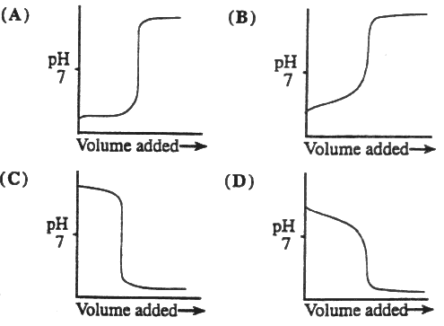

7. The titration curves labeled 1 and 2 were obtained by titrating equal volumes of two different acid samples with portions of the same sodium hydroxide solution.

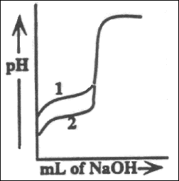

What conclusions can be drawn about the relative concentrations and strengths of acids 1 and 2 from these curves?

(A) The concentrations are the same but acid 1 is weaker than acid 2.

(B) The concentrations are the same but acid 1 is stronger than acid 2.

(C) Acid 1 is the same strength as acid 2, but it is less concentrated.

(D) Acid 1 is the same strength as acid 2, but it is more concentrated.

8. A 0.100 M solution of acetic acid (Ka = 1.8 x 10¯5) is titrated with a 0.1000 M solution of NaOH. What is the pH when 50% of the acid has been neutralized?

(A) 2.38 (B) 5.70 (C) 4.74 (D) 7.00

9. The pKa values for several acid-base indicators are given in the table. Which indicator should be used in the titration of a weak base with a strong acid?

|  |  |
| --- | --- |
| Indicator, pKa | |
| 2,4-dintrophenol | 3.5 |
| bromthymol blue | 7.0 |
| cresol red | 8.0 |
| alizarin yellow R | 11.0 |

(A) 2,4-dintrophenol  
(B) bromthymol blue  
(C) cresol red  
(D) alizarin yellow R