**Learning Objectives:**

2.1 Students can predict properties of substances based on their chemical formulas, and provide explanations of their properties based on particle views.

2.2 The student is able to explain the relative strengths of acids and bases based on molecular structure, interparticle forces, and solution equilibrium.

3.7 The student is able to identify compounds as Brønsted-Lowry acids, bases, and/or conjugate acid-base pairs, using proton-transfer reactions to justify the identification.

6.11 The student can generate or use a particulate representation of an acid (strong or weak or polyprotic) and a strong base to explain the species that will have large versus small concentrations at equilibrium.

6.12 The student can reason about the distinction between strong and weak acid solutions with similar values of pH, including the percent ionization of the acids, the concentrations needed to achieve the same pH, and the amount of base needed to reach the equivalence point in a titration.

6.13 The student can interpret titration data for monoprotic or polyprotic acids involving titration of a weak or strong acid by a strong base (or a weak or strong base by a strong acid) to determine the concentration of the titrant and the p*Ka* for a weak acid, or the p*Kb* for a weak base.

6.14 The student can, based on the dependence of *Kw* on temperature, reason that neutrality requires [H+] = [OH–] as opposed to requiring pH = 7, including especially the applications to biological systems.

6.15 The student can identify a given solution as containing a mixture of strong acids and/or bases and calculate or estimate the pH (and concentrations of all chemical species) in the resulting solution.

6.16 The student can identify a given solution as being the solution of a monoprotic weak acid or base (including salts in which one ion is a weak acid or base), calculate the pH and concentration of all species in the solution, and/or infer the relative strengths of the weak acids or bases from given equilibrium concentrations.

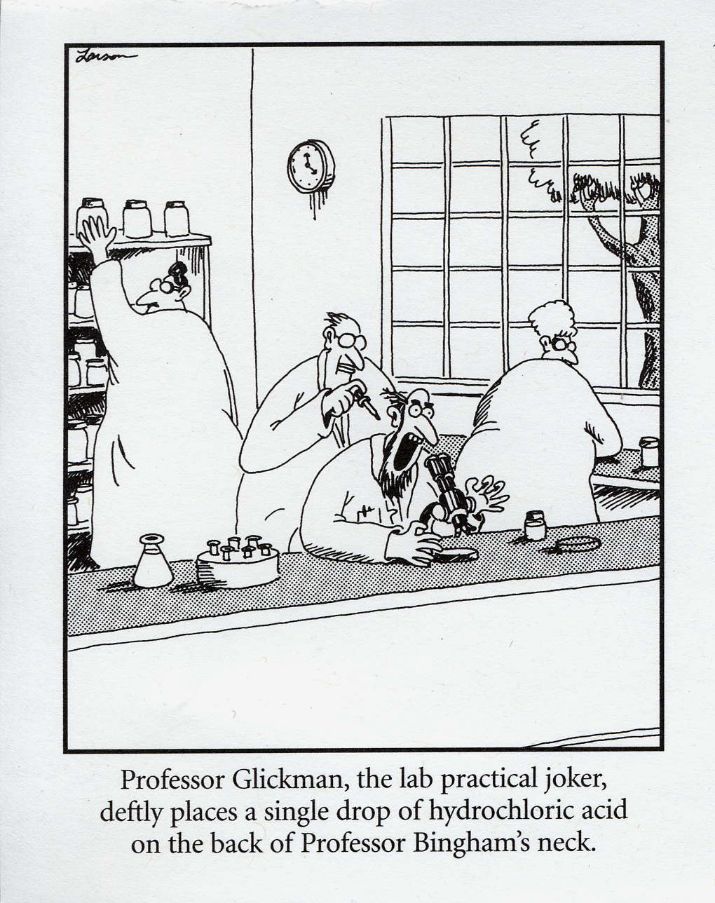

**Acid Base Equilibrium Review**

1. Identify the rules for determining whether a substance is an acid, a base, or a salt based on the formula. Underline all the acids, circle bases, and box in salts. Leave the covalent substances alone.

NH3 NaCl CH3OH H2SO4 Ca(OH)2 CH4

NH4Br HCl Na2SO4 HNO3 CH3COOH NaOH

H3PO4 LiOH CH2(OH)2 NH4OH Ca(NO3)2 HC2H3O2

* All acids have the ____________ ion in common.
* All bases have the _____________ ion in common.
* All salts have formulas: _________________________________________________________________
* All other compounds have formulas: ______________________________________________________
* Organic acids have the general formula: ________________
* Draw ethanoic acid and circle which H+ ion is lost:

2. Which formula represents a hydronium ion?

(1) H3O+ (2) OH– (3) NH4+ (4) HCO3–

3. Which compound is an Arrhenius acid?

(1) H2SO4 (2) NaOH (3) KCl (4) NH3

4. Which compound releases hydroxide ions in an aqueous solution?

(1) CH3COOH (2) HCl (3) CH3OH (4) KOH

5. Given the equation: HCl(g) + H2O(l)→X(aq) + Cl−(aq) Which ion is represented by X?

(1) hydroxide (2) hypochlorite (3) hydronium (4) perchlorate

6. Which substance, when dissolved in water, forms a solution that conducts an electric current?

(1) C2H5OH (2) C12H22O11 (3) C6H12O6 (4) CH3COOH

**Strength versus Concentration**

Directions: For each case, decide if the picture shows a weak or strong, and concentrated or dilute solution.

Acid: H+ ion: Anion A-:

|  |  |  |  |
| --- | --- | --- | --- |
|  |  | **W/S and C/D** | **Example** |
| Case 1 |  |  |  |
| Case 2 |  |  |  |
| Case 3 |  |  |  |
| Case 4 |  |  |  |

5. What does concentrated mean in terms of amount of particles? ____________________________________

6. What does dilute mean in terms of amount of particles?__________________________________________

7. What does strong mean in terms of ions? ______________________________________________________

8. What does weak mean in terms of ions? _______________________________________________________

**Reactions with Acids**

**1. Neutralization Reactions**: If equal mole amounts of acid and base are added together, the resulting solution is NEUTRAL! )

Acid + Base → Salt + Water

Example: HCl (aq) + NaOH (aq) → NaCl (aq) + H2O (l)

Predict the products of and balance the following reactions:

___ HF (aq) + ___ LiOH (aq) → __________ (aq) + ___ HOH (l)

___ HCl (aq) + ___ Ca(OH)2 (aq) → __________(aq) + ___ HOH (l)

___ HClO3 (aq) + ___ Mg(OH)2 (aq) → __________(aq) + ___ HOH (l)

___ H2CO3 (aq) + ___ NaOH (aq) → __________(aq) + ___ HOH (l)

___ H2SO4 (aq) + ___ LiOH (aq) → __________ (aq) + ___ HOH (l)

___ H2SO3 (aq) + ___ Ca(OH)2 (aq) → __________(aq) + ___ HOH (l)

___ H3PO3 (aq) + ___ KOH (aq) → __________(aq) + ___ HOH (l)

___ H3PO4 (aq) + ___ Ca(OH)2 (aq) → __________(s) + ___ HOH (l)

**2. Reactions of Acids with Metals** (only 3 metals do NOT react with acids: Cu, Au, Ag)

*acid + more active metal 🡪 H2(g) + a salt*

Predict the products of the following reactions:

Zn (s) + 2HCl (aq) → _______ + _________

Ag (s) + H2SO4 (aq) → _______ + _________

Ca (s) + H2SO4 (aq) → _______ + _________

**Bronsted Lowry Theory**

1. When an acid dissolved it dissociates or ionizes (breaking up into two ions). The ions are separated due to the polarity of water, as shown below. Draw what happens to the other acid, base, and salt in water.

NaCl(s) + H2O(l) 🡪 NaCl(aq)



NaOH(s) + H2O(l) 🡪 NaOH(aq)



HNO3(g) + H2O(l) 🡪 HNO3(aq)



HCl(g) + H2O(l) 🡪 HCl(aq)

**Cl-**

+

+

-

**H+**

1. Explain why they are known as electrolytes when in solution but not when they are in solid or gas phases.

Acids are defined as proton (H+) donators. They donate protons to the base. Bases are defined as proton

acceptors. They accept protons from the acid. **HBr + NH3 ↔NH4+ + Br-**

According to Bronsted-Lowry theory, acid-base reactions involve a transfer of a proton. Above, the acid on

the left, ___________, transfers (donates) a proton (H+) and becomes a base on the right, __________.

The donating acid and the base it becomes are called *conjugate acid - base pairs.* The base on the left, __________, accepts a proton (H+) and becomes an acid on the right, _________. This is also a conjugate pair.

**HF(aq) + H2O (l) H3O+(aq) + F-(aq) (1)**

**HI(aq) + NH3(aq) NH4+(aq) + I-(aq) (2)**

**NH4+(aq) + OH-(aq) NH3(aq) + H2O (l) (3)**

**H2SO4(aq) + H2O (l) HSO4-(aq) + H3O+(aq) (4)**

1. In the reactions above, list the acids in the reactants and explain what they all have in common.
2. In the reactions, list the bases in the first half of the equation and explain what they all have in common.
3. If you reverse the equations, list the new acids and bases.

Acids: Bases:

1. Now you can see, that each acid on the left hand side produces a corresponding base on the right hand side. The base is called the **conjugate base**. Similarly, a base on the right hand side will produce a **conjugate acid**. These pairs are known as **conjugate acid-base pairs**. List the conjugate acid-base pairs for equations (1) and (2).

5. Write the acid-base reaction for NH3 reacting with HClO2 and identify the acid, the base, the conjugate acid and the conjugate base.

___6. One acid-base theory defines a base as an

(1) H+ donor (2) H donor (3) H+ acceptor (4) H acceptor

___7. One alternate acid-base theory states that an acid is a(n)

(1) H+ donor (2) OH− donor (3) H+ acceptor (4) OH− acceptor

___8. According to one acid-base theory, a water molecule acts as an acid when the water molecule

(1) accepts an H+ (2) accepts an OH– (3) donates an H+ (4) donates an OH–

___9. Given the equation representing a reaction at equilibrium:

**NH3(g) + H2O(l) 🡨🡪 NH4+(aq) + OH–(aq)**

The H+ acceptor for the forward reaction is

(1) H2O (l) (2) NH4+ (aq) (3) NH3 (g) (4) OH– (aq)

___10. Given the balanced equation representing a reaction:

**NH3(g) + H2O (l) 🡨🡪 NH4+(aq) + OH–(aq)**

According to one acid-base theory, the NH3(g) molecules act as

(1) an acid because they accept H+ ions

(2) an acid because they donate H+ ions

(3) a base because they accept H+ ions

(4) a base because they donate H+ ions

**pH scale**

The pH scale is a measure of the H+ or H3O+ concentration in a solution. “pH” stands for “potential to ATTRACT Hydrogen ions” “potential to ATTRACT Hydrogen ions

* Acids have a LOW pH (a LOW potential to attract H+ ions (release/DONATE H+)
* Bases have a HIGH pH (a HIGH potential to attract H+ ions (bases are H+ acceptors)

The pH scale is logarithmic, which means that a change of *one* pH unit will change the concentration of H+ by a factor of 10.

1. What is the relationship between pH value and hydrogen ion concentration?

2. Which substance is 10000 times more acidic than seawater?

3. What substance is 100 times more basic than lemon juice?

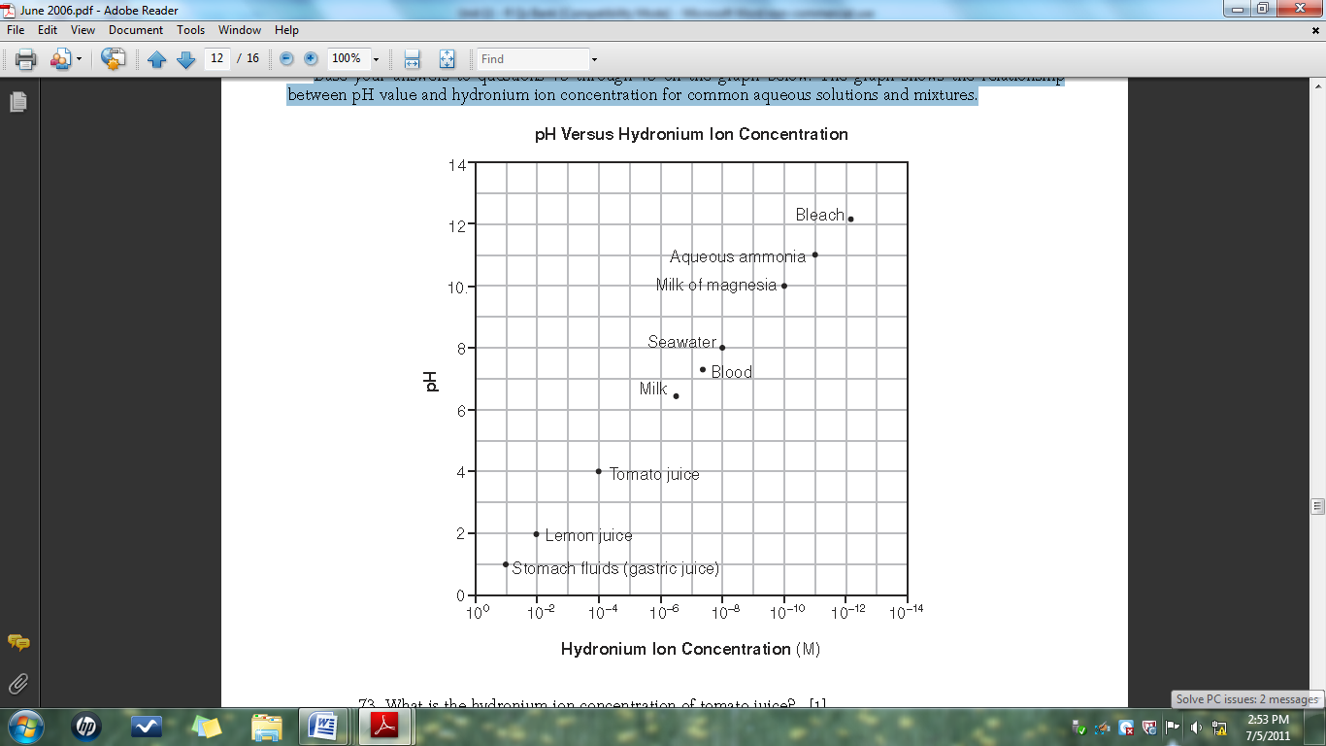

Complete the table below using the grid above:

|  |  |  |  |
| --- | --- | --- | --- |
|  | **Hydronium Ion Concentration (M)** | **pH** | **Acid or Base?** |
| Stomach fluids |  |  |  |
| Lemon Juice |  |  |  |
| Tomato Juice |  |  |  |
| Milk |  |  |  |
| Blood |  |  |  |
| Seawater |  |  |  |
| Milk of Magnesia |  |  |  |
| Aqueous Ammonia |  |  |  |
| Bleach |  |  |  |

Using the table you created, complete the rules for pH of acids and bases:

1. Acids have pH values in the range of ___ to ___ and hydronium ion concentrations between _____________ and ________________.
2. Bases have pH values in the range of ___ to ___ and hydronium ion concentrations between _____________ and ________________.
3. To obtain the pH of an acid or base, find the _______________ of the hydronium concentration. Therefore, pH can also be known as the “power” of the hydronium concentration.

Find the pH of the following solutions and determine if its acidic or basic:

|  |  |  |
| --- | --- | --- |
| **Acid Concentration** | **pH** | **Acid or Base? (or neutral ☺)** |
| [H3O+] = 1x10-2 |  |  |
| [H3O+] = 1x10-7 |  |  |
| [H3O+] = 1x10-10 |  |  |
| [H+] = 1x10-11 |  |  |
| [H+] = 1x10-5 |  |  |
| [H3O+] = 0.0010 |  |  |
| [H3O+] = 0.0000010 |  |  |
| [H+] = 0.0000000010 |  |  |

Circle one to complete the table:

|  |  |  |
| --- | --- | --- |
|  | **If an ACID is added…** | **If a BASE is added…** |
| **pH** | Increases or Decreases | Increases or Decreases |
| **[H+] or [H3O+]** | Increases or Decreases | Increases or Decreases |
| **[OH–]** | Increases or Decreases | Increases or Decreases |
| **Solution becomes more** | Acidic or Basic | Acidic or Basic |

**pH Activity**

Directions: Report the solutions in order from most to least acidic. No work needed but repost answers with proper significant figures and units.

|  |  |  |  |  |
| --- | --- | --- | --- | --- |
| **Solution** | **pH** | **pOH** | **[H+]** | **[OH-]** |
|  |  |  |  |  |
|  |  |  |  |  |
|  |  |  |  |  |
|  |  |  |  |  |
|  |  |  |  |  |
|  |  |  |  |  |
|  |  |  |  |  |
|  |  |  |  |  |
|  |  |  |  |  |
|  |  |  |  |  |

1. Described the relationship between the strength of acids, concentration, and pH.
2. Described the relationship between the strength of bases, concentration, and pH.
3. Described the relationship between pH and pOH.
4. Described the relationship between the concentration on hydroxide and hydrogen ions.

**More pH**

Recall the following:

* + - * increasing or decreasing the pH by 1 changes the [H+] by a factor of 101 (10 times, ten-fold)
      * increasing or decreasing the pH by 2 changes the [H+] by a factor of 102(100 times, hundred-fold)
      * increasing or decreasing the pH by 3 changes the [H+] by a factor of 103 (1000, thousand-fold)

1. Describe what happens to the concentration of hydrogen ions in a solution if the pH is changed from 7 to 5.

1. Describe what is happening to the concentration of hydrogen ions in a solution if the pH is changed from 5 to 8.
2. Complete the table below:

|  |  |  |  |  |
| --- | --- | --- | --- | --- |
| pH Change | [H3O+] increase or decrease? | [OH-] increase or decrease? | Does the solution become more acidic or basic? | By a factor of… |
| 6 to 8 |  |  |  |  |
| 8 to 5 |  |  |  |  |
| 3 to 7 |  |  |  |  |
| 11 to 9 |  |  |  |  |
| 14 to 13 |  |  |  |  |
| 4 to 8 |  |  |  |  |

Amphoterism: Amphoteric (amphiprotic) substances can behave as both acids and bases depending on what they are reacting with. If they are reacting with a base, they react like a weak acid. If they react with an acid they react like a weak base. Write a reaction for the following substance reaction with both NaOH and HCl:

1. HCO3- ____________________________________________________________________________

____________________________________________________________________________

2. HSO4- ____________________________________________________________________________

____________________________________________________________________________

**Indicators**

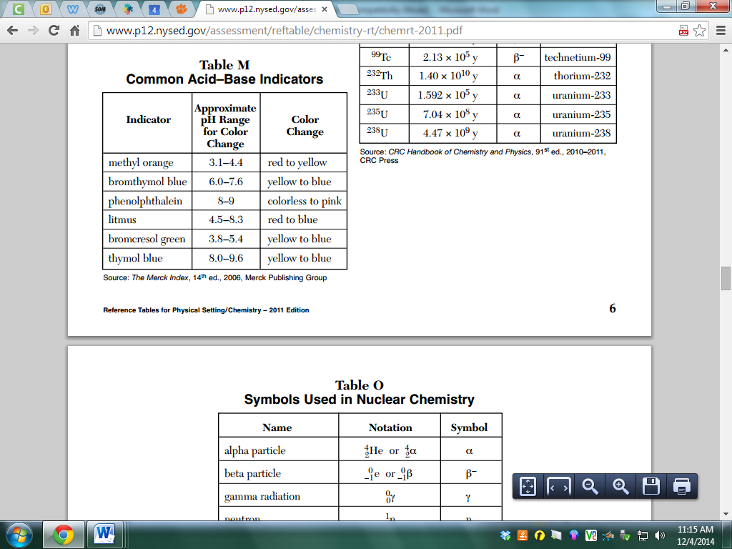

1. Which indicator, when added to a solution, changes color from yellow to blue as the pH of the solution is changed from 5.5 to 8.0?

(1) bromcresol green (2) bromthymol blue (3) litmus (4) methyl orange

2. Which indicator would best distinguish between a solution with a pH of 3.5 and another with a pH of 5.5?

(1) bromthymol blue (2) litmus (3) bromcresol green (4) thymol blue

3. In which solution will bromcresol green appear blue?

(1) 1 M NaCl (2) 1 M NH3 (3) 1 M H2CO3 (4) 1 M CH3COOH

4. In which solution will thymol blue indicator appear blue?

(1) 0.1 M CH3COOH (2) 0.1 M KOH (3) 0.1 M HCl (4) 0.1 M H2SO4

5. What is the color of the indicator methyl orange in a solution that has a pH of 2?

(1) blue (2) yellow (3) orange (4) red

6. In a solution with a pH of 3, what color is bromcresol green?

(1) yellow (2) green (3) blue (4) red

7. At what pH will bromothymol blue be yellow and bromocrescol green be blue?

(1) 10.5 (2) 5.7 (3) 7.0

**Acid Base Equilibrium**

1. Of the following acids, determine

a. The strongest acid

b. The acid that produces the lowest concentration of hydronium ions per mole of acid

c. The acid with the strongest conjugate base

d. The diprotic acid

e. The strong acid

f. The acid with the weakest conjugate base

HNO3(aq) + H2O(l) 🡪 H3O+(aq) + NO3-(aq) Ka = very large

HSO4-(aq) + H2O(l) arrow H3O+(aq) + SO4-2(aq) Ka = 1.2 x 10-2

HCN(aq) + H2O(l) arrow H3O+(aq) + CN- (aq) Ka = 4.0 x 10-10

H2CO3(aq) + H2O(l) arrow H3O+(aq) + HCO3-(aq) Ka = 4.2 x 10-7

NH4+(aq) + H2O(l) arrow H3O+(aq) + NH3(aq) Ka = 5.6 x 10-10

HF(aq) + H2O(l) arrow H3O+(aq) + F- (aq) Ka = 7.2 x 10-4

**Find the pH of an Acid**

2. Suppose you dissolved benzoic acid in water to make a 0.15 M solution. What is:

a. the concentration of benzoic acid? Ka for benzoic acid = 6.3 x 10-5 at 25°C

b. the concentration of hydronium ion?

c. the concentration of benzoate anion?

d. the pH of the solution?

3. Calculate the pH of a 0.20 M solution of HCN. (Ka HCN = 4.9 x 10 -10)

4. What is the pH of a 0.0037 M solution of H2CO3? (*Treat this as if it’s monoprotic). Ka1 = 4.3 x 10 -7

5. Calculate the pH of a 0.020M solution of HCN. The Ka is 4.9x10-10. Compare to question 3.

6. The Ka for niacin is 1.6x10-5. Calculate the pH of 0.0100M solution.

7. Calculate the concentrations of all the species and the pH in 0.10 M hypochlorous acid, HOCl.

For HOCl, Ka = 3.5 x 10-8.

**Find the Ka**

8. A 0.12 M solution of an unknown weak acid has a pH of 4.26 at 25°C. What is the hydronium ion concentration in the solution and what is the value of its Ka?

9. Aspirin, a commonly used pain reliever, is a weak organic acid whose molecular formula is HC9H7O4. An

aqueous solution of aspirin has total volume 350.0 mL and contains 1.26 g of aspirin. The pH of the

solution is found to be 2.60. Calculate Ka for aspirin.

10. The pH of a 0.115M solution of chloroacetic acid, ClCH2COOH, is measured to be 1.92. Calculate Ka.

11. Niacin (nicotinic acid) is one of the B vitamins. It has a molecular formula HC5H4NO2. A 0.020M solution of

niacin has a pH of 3.26. What is the Ka? What percent is ionized?

**Find the pH of a Base**

12. Calculate the concentration of OH- in a 0.15M solution of NH3. Kb = 1.8x10-5

13. Hydroxylamine is a weak base with a Kb = 6.6 x 10-9. What is the pH of a 0.36 M solution of hydroxylamine in water at 25°C?

14. Calculate the pOH, pH and percent ionization of 0.15M NH3 solution if the Kb is 1x10-5.

15. Consider sodium hypochlorite, NaOCl, the main component in household bleach. The hypochlorite ion, OCl, has Kb = 3.6 x 10 -7. A solution is prepared by dissolving 12.0g of NaOCl (mm = 74.45 g/mol) in enough water to make 835 mL of solution. What is the pH?

16. Kb of ethylamine (C2H5NH2) is 6.4x10-4. What is the concentration of OH- of a 0.75M solution? What is the pH?

**More Properties of Acids and Bases**

1. Arrange the following in order of increasing acid strength: H2SeO3, H2SeO4, H2O

2. Choose the compound that leads to a more acidic solution and explain:

* 1. HBr, HF
  2. PH3, H2S
  3. H2SO3, H2SeO3
  4. HNO3, HNO2
  5. CH3COOH, CCl3COOH

3. Identify the Lewis acid and base:

1. Fe(ClO4)3 + 6H2O 🡪 Fe(H2O) 63+ + 3ClO4-
2. CN- + H2O 🡪 HCN + OH-
3. (CH3)3N + BF3 🡪 (CH3) 3NBF3
4. HIO + NH2-  🡪 NH3 + IO-

4. Which of the following salts, when dissolved in water to produce 0.10 M solutions, would have the lowest pH?

a. sodium acetate d. magnesium nitrate

b. potassium chloride e. potassium cyanide

c. sodium bisulfate

5. For each of the following salts, predict whether an aqueous solution would be acidic, basic, or neutral.

a. sodium nitrate NaNO3

b. ammonium iodide NH4I

c. sodium bicarbonate NaHCO3

d. ammonium cyanide NH4CN

e. sodium hypochlorite NaOCl

f. potassium acetate KCH3CO2

6. Give a general rule to determine if an oxide is acidic or basic.

7. Are the following acidic or basic? NO SO2 CaO Na2O SiO2

**Practice with Scientific Notation**

Rules: When working with scientific notation treat the base number separately from the exponent.

Multiply, divide, or take the square root of the base number and then tag on the “x10 to the” part.

If your base number is no longer between 1 and 10 you must move the decimal point over.

If you are dividing two numbers in scientific notation, divide the bases and subtract exponents.

If you are multiplying two numbers in scientific notation, multiply the bases and add exponents.

If you are squaring number in scientific notation, square the base and double the exponent.

If you are taking the square root of a number in scientific notation, square root the base and half the exponent.

When moving the decimal to the right to make the base larger, you must decrease the exponent.

When moving the decimal to the left to make the base smaller, you must increase the exponent.

Worst case scenario, take it out of scientific notation and put it back in ☹

Tricks: Ka = [H+]2/[HA] Kb= [OH-]2/[Base] Kw = KaxKb = 1.0x10-14

[H+] = √(Kax[HA]) [OH-] = √(Kbx[Base]) pH or pOH is the power of that [value]!

Examples: Do NOT use a calculator!

1. A 0.50M solution of a weak monoprotic acid, HA, has a pH of 3.00. Calculate the acid dissociation constant of the acid.
2. A 2.0M solution of a weak monoprotic acid has a pH of 4.00. Calculate the Ka.
3. Calculate the Ka value of a 2.0M solution of a weak monoprotic acid with a pH of 3.00
4. Determine the value of the acid dissociation constant for a 0.50M solution of a weak monoprotic acid with a pH of 4.00
5. Oxalic acid, H2C2O4, is a diprotic acid with K1 = 5.0x10-2 and K2 = 5.0x10-5. Calculate the value of the equilibrium constant for oxalic acid completely dissociating.
6. Arsenic acid, H3AsO4, is a triprotic acid with the following dissociation constants: Ka1 = 5.0x10-5; Ka2 = 8.0x10-8, Ka3 = 6.0x10-10. Calculate the value of the value of the equilibrium constant for arsenic acid completely dissociating.
7. Sulfuric acid, H2SO4, has the following successive ionization reactions:

H2SO4 ↔ H+ + HSO4- Ka = 7.4x10-3

HSO4- ↔ H+ + SO4-2 Ka = 3.1x10-11

Calculate the equilibrium constant value for sulfuric acid.

1. What is the [H+] in 0.050M HCN? Ka= 5.0x10-10
2. Determine the [OH-] in 1.0M aniline (C6H5NH2) solution. Kb=4.0x10-10
3. What is the value of [H+] in 2.0M CH3COOH(aq)? Ka=1.8x10-5
4. Calculate the value of [OH-] in 0.030M diethylamine, (CH3CH2)2NH(aq). Kb=3.0x10-8
5. The Ka for an acid is 4.0x10-6 at room temperature. What is the approximate percent dissociation of the acid in a 0.010M solution?
6. If the acid dissociation constant for an acid HA is 8.0x10-4 at 25C, what percent of the acid is dissociated in a 0.50M solution of HA?
7. The base dissociation constant is 1.60x10-10. What percent of the base is dissociated in a 0.10M solution?

**Acid Strength**

Objective I: Prove the relationships between acid strength, Ka, pH, and percent ionization.

1. Sample calculation: Find the pH of 1.00M of a strong acid. Include the reaction, icebox, set up, and significant figures. Calculate the percent ionization.
2. Your calculation: Find the pH of 1.00M of an acid with the Ka value of 1.00x10___. Include the reaction, icebox, set up, and significant figures. Calculate the percent ionization.
3. Post your work and answer on a whiteboard and take down the class combined data:

|  |  |  |
| --- | --- | --- |
| **Ka** | **pH** | **Percent Ionization** |
| 1.00x10-1 |  |  |
| 1.00x10-2 |  |  |
| 1.00x10-3 |  |  |
| 1.00x10-4 |  |  |
| 1.00x10-5 |  |  |
| 1.00x10-6 |  |  |
| 1.00x10-7 |  |  |
| 1.00x10-8 |  |  |
| 1.00x10-9 |  |  |
| 1.00x10-10 |  |  |
| 1.00x10-11 |  |  |
| 1.00x10-12 |  |  |
| 1.00x10-13 |  |  |
| 1.00x10-14 |  |  |

1. Sketch a graph of the relationship between Ka and pH of the 1.0M weak acid.
2. If 10 molecules of a 1.0M strong acid were dissolved completely in water, diagram how many would ionize below:

H2O

1. If 10 molecules of a 1.0M weak acid were dissolved completely in water, diagram how many would ionize at the most below:

H2O

1. As the strength of various acids decreases, how is the percent ionization affected?
2. Describe the relationship between acid strength, Ka, pH, and percent ionization.

1. How do you predict this relationship will change if the molarity of the acid were changed?

Objective II: Prove the relationships between Molarity, pH, and percent ionization.

1. Sample calculation: Find the pH of 0.100M of a weak acid with a Ka value of 1.00x10-5. Include the reaction, icebox, set up, and significant figures. Calculate the percent ionization.
2. Your calculation: Find the pH of 0.0100M of a weak acid with a Ka value of 1.00x10-5. Include the reaction, icebox, set up, and significant figures. Calculate the percent ionization.
3. Sketch a graph of the relationship between Molarity and pH of the weak acid.
4. If 100 molecules of a 0.0100M of the weak acid were dissolved completely in water, identify how many would ionize.
5. As the concentration of the weak acid decreases, how is the percent ionization affected? What scientific explanation could justify this phenomenon?
6. What **two** factors affect the pH of a solution? Describe their relationships with pH.

**pH Practice**

Calculate the pH of the following solutions. Compare each odd answer with the following even answer to describe why they are similar or different pH values.

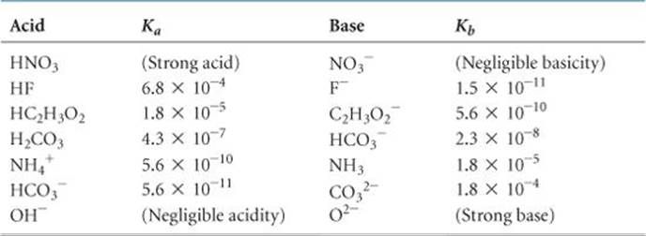

1. 1.00M HNO3
2. 1.00M HF

Compare:

1. 1.00x10-3M HC2H3O2
2. 1.00x10-3M HF

Compare:

1. 2.50x10-3M NaOH
2. 2.50x10-3M NH3

Compare:

1. 5.00x10-2M HC2H3O2
2. 5.00x10-2M NH3

Compare:

1. 3.75x10-3M HCO3-
2. 3.75x10-3M CO3-2

Compare: