**AP Learning Objectives**

* Explain the relationship between the type of bonding and the properties of the elements participating in the bond. (2.1)
* Represent the relationship between potential energy and distance between atoms, based on factors that influence the interaction strength.(2.2)
* Represent an ionic solid with a particulate model that is consistent with Coulomb’s law and the properties of the constituent ions. (2.3)
* Represent a molecule with a Lewis diagram. (2.5)
* Represent a molecule with a Lewis diagram that accounts for resonance between equivalent structures or that uses formal charge to select between nonequivalent structures. (2.6)
* Based on the relationship between Lewis diagrams, VSEPR theory, bond orders, and bond polarities:
  + a. Explain structural properties of molecules.
  + b. Explain electron properties of molecules.(2.7)
* Explain the relationship between the chemical structures of molecules and the relative strength of their intermolecular forces when:
  + a. The molecules are of the same chemical species.
  + b. The molecules are of two different chemical species (3.1)
* Explain the relationship among the macroscopic properties of a substance, the particulate-level structure of the substance, and the interactions between these particles.(3.2)
* Explain the relationship between macroscopic characteristics and bond interactions for: a. Chemical processes. b. Physical processes. (4.4)

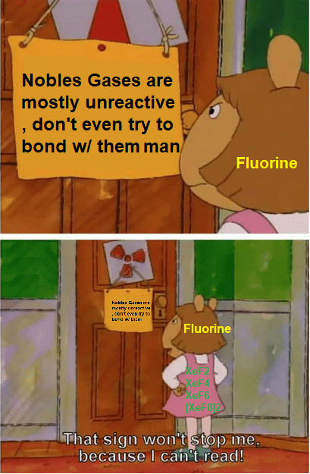

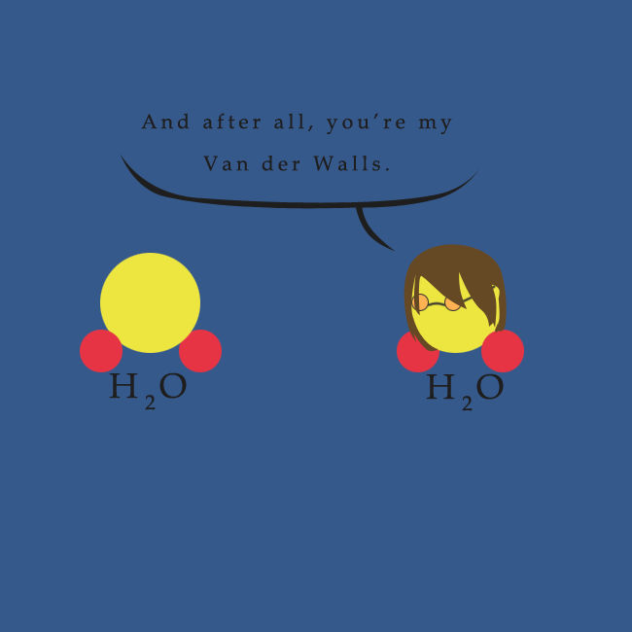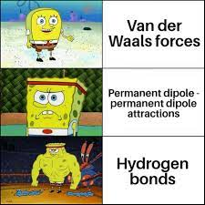

**EXCEPTIONS TO THE OCTET**

Draw the following Lewis diagrams and fill in the corresponding questions:

| **Name the compound below the formula** | **Lewis Diagram** | **Central Atom’s configuration** | **Central atom, metal, nonmetal or metalloid?** | **Why doesn’t it obey the octet rule?** | **Formula if it had obeyed the octet** |
| --- | --- | --- | --- | --- | --- |
| BCl3 |  |  |  |  |  |
| PCl5 |  |  |  |  |  |
| XeF6 |  |  |  |  |  |
| AlF3 |  |  |  |  |  |
| RnCl4 |  |  |  |  |  |
| SF6 |  |  |  |  |  |
| ICl3 |  |  |  |  |  |
| AsF5 |  |  |  |  |  |

**RESONANCE**

1. Draw ozone, O3, in as many bond arrangements as allowed by the octet rule.
2. Resonance structures are two or more valid structures of a molecule where the atom placement is fixed, but the bonds seem to move. This is apparent in the drawing for ozone. When two or more resonance structures can be drawn it implies that electrons are delocalized. Explain what is meant by delocalized:
3. Draw 2 resonance structures for the following examples.

| CO3-2 |  |  |
| --- | --- | --- |
| XeO4 |  |  |
| OCN- |  |  |
| HCO2- |  |  |
| NNO |  |  |
| HN3 |  |  |
| CH2NO2- |  |  |



V**SEPR**

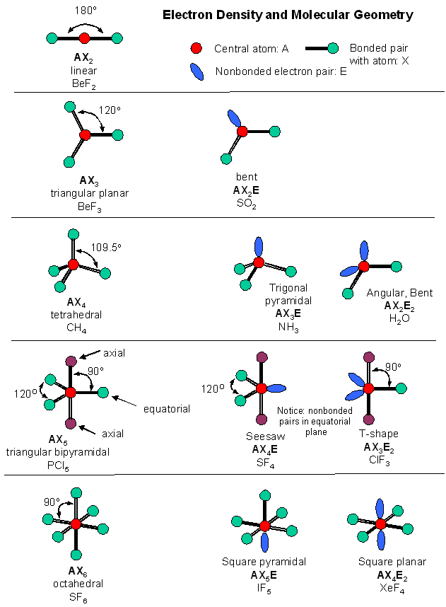

**HYBRIDIZATION**

1. Answer the following questions about the structures of ions that contain only sulfur and fluorine.

(a) The compounds SF4 and BF3 react to form an ionic compound according to the following equation.

SF4 + BF3 🡪 SF3BF4

1. Draw a complete Lewis structure for the SF3+ cation in SF3BF4.
2. Identify the type of hybridization exhibited by sulfur in the SF3+ cation.
3. Identify the geometry of the SF3+ cation that is consistent with the Lewis structure drawn in part (a)(i).
4. Predict whether the F—S—F bond angle in the SF3+ cation is larger than, equal to, or smaller than 109.50˚. Justify your answer.

(b) The compounds SF4 and CsF react to form an ionic compound according to the following equation.

SF4 + CsF 🡪 CsSF5

1. Draw a complete Lewis structure for the SF5– anion in CsSF5.
2. Identify the type of hybridization exhibited by sulfur in the SF5– anion.
3. Identify the geometry of the SF5– anion that is consistent with the Lewis structure drawn in part (b)(i).
4. Identify the oxidation number of sulfur in the compound CsSF5.

2. NO2 NO2- NO2+  Nitrogen is the central atom in each of the species.

1. Draw the Lewis electron-dot structure for each of the three species.
2. List the species in order of increasing bond angle. Justify your answer.

(c) Select one of the species and give the hybridization of the nitrogen atom in it.

**REVIEW**

*Resonance and Formal Charge*

1. Which of the following is polar? (not multiple choice)
   1. BF3 b. XeF4 c. BeF2 d. XeF2 e. ICl5
2. A molecule with the formula AX4 is nonpolar, which of the following shapes can it have? (not multiple choice)
   1. Tetrahedral b. seesaw c. square planar d. square pyramidal
3. Show the dipole moments of:
   1. H2O b. NF3 c. SCl4 d. IF3
4. Predict the geometry and bond angles:
   1. CHCl3 b. SCl6 c. RnF5+ d. XeF4 e. SeI3-
5. Draw at least 2 resonance structures for the following and choose the better structure:
   1. NCS- b. SO2 c. SO42- d. NO3-

*Hybridization*

1. A pi bond…
   1. Is stronger than a sigma bond
   2. Results from orbital overlap
   3. Are parallel to one another above and below the bond axis
   4. Is the same strength as a sigma bond
2. Describe single, double, and triple bonds in terms of sigma and pi bonds.
3. Predict the hybridization and bond angles of:
   1. PH3 b. CO2 c. SF4 d. PO2Cl e. SeOCl2
4. What is the bond order of F2, N2, O2, and CN-?
5. Azidothymidine was one of the first drugs to treat the AIDs disease. Complete the Lewis structure (add lone pairs) and designate the hybridization of each carbon. Then count the sigma and pi bonds. Remember: each angle represents a carbon molecule.

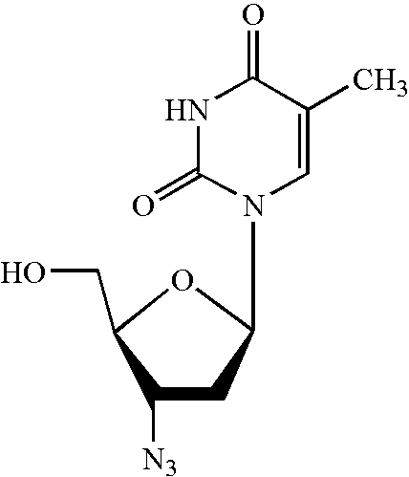

**Bonding Review**

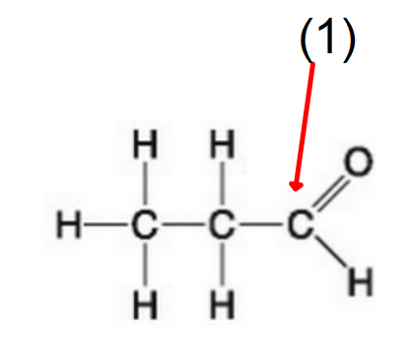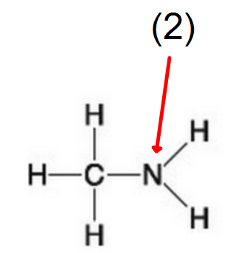

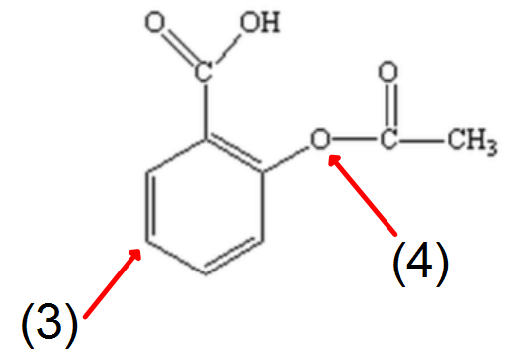

**AP Questions for BONDING REVIEW**

1. The conductivity of several substances was tested using the apparatus represented by the diagram below.

|  | AgNO3 | Sucrose | Na | H2SO4 (98%) |
| --- | --- | --- | --- | --- |
| Melting Point (ºC) | 212º | 185º | 99º | Liquid at Room Temp. |
| Liquid (fused) | ++ | - | ++ | + |
| Water Solution | ++ | - | ++(1) | ++(2) |
| Solid | - | - | ++ | Not Tested |
| Key: | ++ Good conductor | | | | |
|  | + Poor conductor | | | | |
|  | - Nonconductor | | | | |
| (1) Dissolves, accompanied by evolution of flammable gas | | | | | | |
| (2) Conduction increases as the acid is added slowly and carefully to water | | | | | | |



The results of the tests are summarized in the following data table. Using models of chemical bonding and atomic or molecular structure, account for the differences in conductivity between the two samples in each of the following pairs.

1. Sucrose solution and silver nitrate solution.
2. Solid silver nitrate and solid sodium metal.
3. Liquid (fused) sucrose and liquid (fused) silver nitrate.
4. Liquid (concentrated) sulfuric acid and sulfuric acid solution.
5. Experimental data provide the basis for interpreting differences in properties of substances.

| TABLE 1 | | |
| --- | --- | --- |
| Compound | Melting Point (ºC) | Electrical Conductivity of Molten State (ohm-1) |
| BeCl2 | 405 | 0.086 |
| MgCl2 | 714 | > 20 |
| SiCl4 | -70 | 0 |
| MgF2 | 1261 | > 20 |
| TABLE 2 | |
| Substance | Bond Length (angstroms) |
| F2 | 1.42 |
| Br2 | 2.28 |
| N2 | 1.09 |

Account for the differences in properties given in Tables 1 and 2 above in terms of the differences in structure and bonding in each of the following pairs.

(a) MgCl2 and SiCl4 (c) F2 and Br2

(b) MgCl2 and MgF2 (d) F2 and N2

4. Use simple structure and bonding models to account for each of the following.

1. The bond length between the two carbon atoms is shorter in C2H4 than in C2H6.
2. The H-N-H bond angle is 107.5º, in NH3.
3. The bond lengths in SO3 are all identical and are shorter than a sulfur-oxygen single bond.

(d) The I3- ion is linear.

5. Answer the following questions using principles of chemical bonding and molecular structure.

(a) Consider the carbon dioxide molecule, CO2, and the carbonate ion, CO32–.

(i) Draw the complete Lewis electron-dot structure for each species.

(ii) Account for the fact at the carbon-oxygen bond length in CO32– is greater than the carbon-oxygen bond length in CO2.

(b) Consider the molecules CF4 and SF4.

(i) Draw the complete Lewis electron-dot structure for each molecule.

(ii) In terms of molecular geometry, account for the fact that the CF4 molecule is nonpolar, whereas the SF4 molecule is polar.

**AP Intermolecular Forces Worksheet**

Define the words to complete the following chart:





**INTERMOLECULAR FORCES OF ATTRACTION**

1. Substance Melting Point, ºC

H2 -259

C3H8 -190

HF -92

CsI 621

LiF 870

SiC >2,000

1. Discuss how the trend in the melting points of the substances tabulated above can be explained in terms of the types of attractive forces and/or bonds in these substances.
2. For any pairs of substances that have the same kind(s) of attractive forces and/or bonds, discuss the factors that cause variations in the strengths of the forces and/or bonds.

2. Using principles of chemical bonding and/or intermolecular forces, explain each of the following.

(a) Xenon has a higher boiling point than neon has.

1. Solid copper is an excellent conductor of electricity, but solid copper chloride is not.
2. SiO2 melts at a very high temperature, while CO2 is a gas at room temperature, even though Si and C are in the same chemical family.

(d) Molecules of NF3 are polar, but those of BF3 are not.

3. The melting points of the alkali metals decrease from Li to Cs. In contrast, the melting points of the halogens increase from F2 to I2.

(a) Using bonding principles, account for the decrease in the melting points of the alkali metals.

(b) Using bonding principles, account for the increase in the melting points of the halogens.

(c) What is the expected trend in the melting points of the compounds LiF, NaCl, KBr, and CsI? Explain this trend using bonding principles.

4. Explain each of the following observations in terms of the electronic structure and/or bonding of the compounds involved.

(a) At ordinary conditions, HF (normal boiling point = 20ºC) is a liquid, whereas HCl (normal boiling point = -114ºC) is a gas.

(b) Molecules of AsF3 are polar, whereas molecules of AsF5 are nonpolar.

(c)The N-O bonds in the NO2- ion are equal in length, whereas they are unequal in HNO2.

(d) For sulfur, the fluorides SF2, SF4, and SF6 are known to exist, whereas for oxygen only OF2 is known to exist.

5. Account for each of the following observations about pairs of substances. In your answers, use appropriate principles of chemical bonding and/or intermolecular forces. In each part, your answer must include references to both substances.

1. Even though NH3 and CH4 have similar molecular masses, NH3 has a much higher normal boiling point (-33°C) than CH4 (-164°C).
2. At 25°C and 1.0 atm, ethane (C2H6) is a gas and hexane (C6H14) is a liquid.
3. SiC melts at a much higher temperature (1,410°C) than Cl2 (-101°C).

(d) MgO melts at a much higher temperature (2,852°C) than NaF (993°C).

6. Explain each of the following in terms of atomic and molecular structures and/or intermolecular forces.

1. Solid K conducts an electric current, whereas solid KNO3 does not.
2. SbCl3 has measurable dipole moment, whereas SbCl5 does not.
3. The normal boiling point of CCl4 is 77ºC, whereas that of CBr4 is 190ºC.

(d) NaI(s) is soluble in water, whereas I2(s) has a solubility of only 0.03 gram per 100 grams of water.

**AP Chemistry: Bonding Multiple Choice**

| 41. Which of the following molecules has the shortest bond length? | | | | | | |
| --- | --- | --- | --- | --- | --- | --- |
| (A) N2 (B) O2 (C) Cl2 (D) Br2 (E) I2 | | | | | | |
|  | | | | | | |
| 51. Pi bonding occurs in each of the following species EXCEPT… | | | | | | |
| (A) CO2 (B) C2H4 (C) CN− (D) C6H6 (E) CH4 | | | | | | |
|  | | | | | | |
| 60. Which of the following has a zero dipole moment? | | | | | | |
| (A) HCN (B) NH3 (C) SO2 ( D) NO2 (E) PF5 | | | | | | |
|  | | | | | | |
| 8. Use the following answers for questions 8 - 9. | | | | | | |
| (A) A network solid with covalent bonding | | | | | | |
| (B) A molecular solid with zero dipole moment | | | | | | |
| (C) A molecular solid with hydrogen bonding | | | | | | |
| (D) An ionic solid | | | | | | |
| (E) A metallic solid | | | | | | |
| 8. Solid ethyl alcohol, C2H5OH | | | | | | |
| 9. Silicon dioxide, SiO2 | | | | | | |
|  | | | | | | |
| 80. For which of the following molecules are resonance structures necessary to describe the bonding satisfactorily? | | | | | | |
| (A) H2S (B) SO2 (C) CO2 (D) OF2 (E) PF3 | | | | | | |
|  |  |  |  |  |  |  |
| Hydrogen Halide | Normal Boiling Point, °C |  |  |  |  |  |
| HF | 19 |  |  |  |  |  |
| HCl | −85 |  |  |  |  |  |
| HBr | −67 |  |  |  |  |  |
| HI | −35 |  |  |  |  |  |
|  | | | | | | |
| 18. The liquefied hydrogen halides have the normal boiling points given above. The relatively high boiling point of HF can be correctly explained by which of the following? | | | | | | |
| (A) HF gas is more ideal. (C) HF molecules have a smaller dipole moment. | | | | | | |
| (B) HF is the strongest acid. (D) HF is much less soluble in water. | | | | | | |
| (E) HF molecules tend to form hydrogen bonds. | | | | | | |
|  | | | | | | |
| 42. The SbCl5 molecule has trigonal bipyramid structure. Therefore, the hybridization of Sb orbitals should be... | | | | | | |
| (A) sp2 (B) sp3 (C) sp2d (D) sp3d (E) sp3d2 | | | | | | |
| 11. Use these answers for questions 11 - 14. | | | | | | |
| (A) hydrogen bonding (B) hybridization (C) ionic bonding | | | | | | |
| (D) resonance (E) van der Waals forces (London dispersion forces) | | | | | | |
|  | | | | | | |
| 11. Is used to explain why iodine molecules are held together in the solid state | | | | | | |
| 12. Is used to explain why the boiling point of HF is greater than the boiling point of HBr | | | | | | |
| 13. Is used to explain the fact that the four bonds in methane are equivalent | | | | | | |
| 14. Is used to explain the fact that the carbon-to-carbon bonds in benzene, C6H6, are identical | | | | | | |
|  | | | | | | |
| 17. The Lewis dot structure of which of the following molecules shows only one unshared pair of valence electron? | | | | | | |
| (A) Cl2 (B) N2 (C) NH3 (D) CCl4 (E) H2O2 | | | | | | |
|  | | | | | | |
| 31. The structural isomers C2H5OH and CH3OCH3 would be expected to have the same values for which of the following? (Assume ideal behavior.) | | | | | | |
| (A) Gaseous densities at the same temperature and pressure | | | | | | |
| (B) Vapor pressures at the same temperature (C) Boiling points | | | | | | |
| (D) Melting points (E) Heats of vaporization | | | | | | |
|  | | | | | | |
| 47. CCl4, CO2, PCl3, PCl5, SF6  Which of the following does not describe any of the molecules above? | | | | | | |
| (A) Linear (B) Octahedral (C) Square planar (D) Tetrahedral (E) Trigonal pyramidal | | | | | | |
|  | | | | | | |
| 59. Which of the following compounds is ionic and contains both sigma and pi covalent bonds? | | | | | | |
| (A) Fe(OH)3 (B) HClO (C) H2S (D) NO2 (E) NaCN | | | | | | |
|  | | | | | | |
| 15. In a molecule in which the central atom exhibits sp3d2 hybrid orbitals, the electron pairs are directed toward the corners of… | | | | | | |
| (A) a tetrahedron (B) a square-based pyramid (C) a trigonal bipyramid | | | | | | |
| (D) a square (E) an octahedron | | | | | | |
|  | | | | | | |
| 32. CH3CH2OH boils at 78 °C and CH3OCH3 boils at − 24 °C, although both compounds have the same composition. This difference in boiling points may be attributed to a difference in… | | | | | | |
| (A) molecular mass (B) density (C) specific heat | | | | | | |
| (D) hydrogen bonding (E) heat of combustion | | | | | | |
|  | | | | | | |
| 34. X = CH3-CH2-CH2-CH2-CH3 Y = CH3-CH2-CH2-CH2-OH Z = HO-CH2-CH2-CH2-OH | | | | | | |
| Based on concepts of polarity and hydrogen bonding, which of the following sequences correctly lists the compounds above in the order of their increasing solubility in water? | | | | | | |
| (A) Z < Y < X (B) Y < Z < X (C) Y < X < Z (D) X < Z < Y (E) X < Y < Z | | | | | | |
|  | | | | | | |
| 57. Molecules that have planar configurations include which of the following? | | | | | | |
| I. BCl3  II. CHCl3 III. NCl3 | | | | | | |
| (A) I only (B) III only (C) I and II only (D) II and III only (E) I, II, and III | | | | | | |
|  | | | | | | |
| 62. The electron-dot structure (Lewis structure) for which of the following molecules would have two unshared pairs of electrons on the central atom? | | | | | | |
| (A) H2S (B) NH3 (C) CH4 (D) HCN (E) CO2 | | | | | | |
|  | | | | | | |
| 68. Which of the following molecules has a dipole moment of zero? | | | | | | |
| (A) C6H6 (benzene) (B) NO (C) SO2 (D) NH3 (E) H2S | | | | | | |
|  | | | | | | |
| 8. Questions 8-10 refer to the following diatomic species. | | | | | | |
| (A) Li2 (B) B2 (C) N2 (D) O2 (E) F2 | | | | | | |
| 8. Has the largest bond-dissociation energy | | | | | | |
| 9. Has a bond order of 2 | | | | | | |
| 10. Contains 1 sigma (σ) and 2 pi (π) bonds | | | | | | |
|  |  |  |  |  |  |  |
| Bond | Average Bond Energy (kJ/mole) |  |  |  |  |  |
| I---I | 150 |  |  |  |  |  |
| Cl---Cl | 240 |  |  |  |  |  |
| I---Cl | 210 |  |  |  |  |  |
|  | | | | | | |
| 60. I2(g) + 3 Cl2(g) 🡪 2 ICl3(g) | | | | | | |
| According to the data in the table above, what is the value of ∆ H° for the reaction represented above? | | | | | | |
| (A) −870 kJ (B) −390 kJ (C) +180 kJ (D) +450 kJ (E) +1,260 kJ | | | | | | |
|  | | | | | | |
| 28. The melting point of MgO is higher than that of NaF. Explanations for this observation include which of the following? | | | | | | |
| I. Mg2+ is more positively charged than Na+ | | | | | | |
| II. O2− is more negatively charged than F− | | | | | | |
| III. The O2− ion is smaller than the F− ion | | | | | | |
| (A) II only (B) I and II only (C) I and III only (D) II and III only (E) I, II, and III | | | | | | |
|  | | | | | | |
| 32. Types of hybridization exhibited by the C atoms in propene, CH3CHCH2, include which of the following? | | | | | | |
| I. sp II. sp2  III. sp3 | | | | | | |
|  | | | | | | |
| (A) I only (B) III only (C) I and II only (D) II and III only (E) I, II, and III | | | | | | |
| 40. Of the following molecules, which has the largest dipole moment? | | | | | | |
| (A) CO (B) CO2 (C) O2 (D) HF (E) F2 | | | | | | |
|  | | | | | | |
| 68. In which of the following processes are covalent bonds broken? | | | | | | |
| (A) I2(s) 🡪 I2(g) (B) CO2(s) 🡪 CO2(g) (C) NaCl(s) 🡪 NaCl(l) | | | | | | |
| (D) C(diamond) 🡪 C(g) (E) Fe(s) 🡪 Fe(l) | | | | | | |
|  | | | | | | |
| 40. The geometry of the SO3 molecule is best described as… | | | | | | |
| (A) trigonal planar (B) trigonal pyramidal (C) square pyramidal | | | | | | |
| (D) bent (E) tetrahedral | | | | | | |

| Questions 3-5 refer to the following molecules:  (A) CO2 (B) H2O (C) CH4 (D) C2H4 (E) PH3  3. The molecule with only one double bond. 4. The molecule with the largest dipole moment. 5. The molecule that has trigonal pyramidal geometry. |
| --- |
| 28. Of the following compounds, which is the most ionic? (A) SiCl4 (B) BrCl (C) PCl3 (D) Cl2O (E) CaCl2 |
| 53. According to the VSEPR model, the progressive decrease in the bond angles in the series of molecules CH4, NH3, and H2O is best accounted for by the… (A) increasing strength of the bonds (B) decreasing size of the central atom (C) increasing electronegativity of the central atom (D) increasing number of unshared pairs of electrons (E) decreasing repulsion between hydrogen atoms |
| 56. The boiling points of the elements helium, neon, argon, krypton, and xenon increase in that order. Which of the following statements accounts for this increase?  (A) The London (dispersion) forces increase. (B) The hydrogen bonding increases. (C) The dipole-dipole forces increase. (D) The chemical reactivity increases. (E) The number of nearest neighbors increases. |

