Unit 3: Drug Identification & Toxicology

Vocabulary
- Toxicology: The study of poisons, identification of drugs a person may have used, and effects of drugs on the body.
- Controlled Substance: a drug or chemical compound that is regulated and controlled by the legal system.
- Drug (including alcohol): a chemical substance that effects the mind or body (used in the treatment or prevention of a disease) or used recreationally for its effect on the mind or body.
- Narcotic: a class of drug that is used to relieve pain but may be habit forming (causes euphoria, sleep, or feeling of mental numbness).
- Poison: a substance that can cause health problem or death if ingested, absorbed into the skin, or inhaled.
- Toxicity: the degree to which a poison can cause injury.
- Toxin: a poisonous substance (usually natural) that is produced by plants, animals, or bacteria that can harm/kill humans.
- Botulism: most common poisonous substance known to humans. May be ingested from contaminated food (canned vegetables, raw fish). Can be destroyed by cooking and heating.
  - Pure botulism toxin is commonly referred to as “Botox” – used to treat muscle spasms, eye conditions, etc.
  - Tetanus – bacteria that causes a potentially deadly nervous system disease. “Lockjaw” – begins with spasms in the jaw.

Controlled Substances Act: Federal Law established 5 schedules of classification of controlled substances based on:
- Drug’s potential for abuse
- Potential to physical and psychological dependence
- Medical Value
  - Note: Federal law also controls materials that are used in making drugs and those that are manufactured to resemble drugs

Drug Schedules
- Schedule I: Drugs with high potential for abuse and addiction, NO medical value:
Ex: Heroin, LSD, Ecstasy, Marijuana
- Schedule II: Drugs with high potential for abuse and addiction, have some medical value with restrictions
Ex: PCP, Cocaine, Amphetamines, Most Opiates, Some Barbiturates
- Schedule III: Drugs with less potential for abuse and addiction, currently acceptable for medical use
Ex: Some Barbiturates, Codeine, Steroids
- Schedule IV: Drugs with low potential for abuse and addiction, currently acceptable for medical use
Ex: Tranquilizers like Valium, Xanax, Librium
- Schedule V: Drugs with low potential abuse, medical use, lowest potential dependency
Ex: Some Opiates with Non-Narcotic Ingredients, Robitussin AC

Exposure to Toxic Substances
- Accidental/Unintentional – overdose
- Intentional – medical or recreational purposes
- Deliberate – suicide or criminal actions

Role of the Forensic Toxicologist: Determines cause and effect between exposure to drug or other substances and the lethal effects of exposure to humans. Questions a Forensic Toxicologist can answer:
1. Are drugs involved?
2. What did the person take?
3. When did they take it?
4. How much did they take?
5. How did it affect them?
6. How certain are you?

Types of Drugs
- Illicit or illegal drugs that have no accepted medical use in the US
- Controlled substances: legal drugs whose sale, possession, and use are restricted because of their effects and the potential for abuse.
- Drugs can fall into one of several different classes: narcotics, hallucinogens, depressants, stimulants, club drugs, and steroids
  - Narcotics
    - Opiates: derived from the Asian Poppy
    - Heroine, morphine, codeine
    - Synthetic opiates: man-made
    - Methadone: given to heroine addicts to try and break their addiction
    - Oxycodone (OxyContin or Percocet)
    - Hydrocodone (Vicodin)
    - Overdose on narcotics can result in difficulty breathing, low blood pressure, loss of consciousness, and possibly coma and death.
  - Hallucinogens
    - Hallucinogens alter the user’s perceptions, thinking, self-awareness, and emotions.
    - Some hallucinogens can cause panic attacks, seizures, headaches, and sometimes psychosis that can last for weeks.
    - Many hallucinogens, particularly PCP, increase the user’s heart rate, which could lead to heart failure.
    - Marijuana (from cannabis plant) is the most widely used illicit drug in the U.S. It contains tetrahydrocannabinol (THC) and has medical uses such as treating glaucoma and relieving nausea due to chemotherapy
    - MDMA (“Ecstacy”)
    - Mescaline (from Peyote cactus)
    - LSD (Lysergic Acid, or simply “Acid”)
    - PCP (phencyclidine or “Angel Dust”)
    - Mushrooms (contain psilocybin)
  - Depressants
    - Depressants are used to relieve anxiety and produce sleep.
    - Depressants reduce body functions such as heart rate.
    - Overdose can cause coma and death.
    - Mixing depressants with other drugs or alcohol can increase their effects and health risks.
    - Alcohol
    - Barbiturates: “downers” such as Phenobarbital and Methaqualone (also called Quaaludes, illegal)
    - Anti-psychotic and anti-anxiety drugs including benzodiazepines such as Diazepam (Valium)
    - Inhalants (“huffing”)
    - Sedatives, muscle relaxers, etc.
    - Marijuana and opiates (like morphine) are also considered depressants.
  - Stimulants
    - Stimulants increase feelings of energy and alertness while suppressing fatigue and appetite.
    - Also called “uppers.”
    - Depression often results as the drug wears off.
    - Stimulants are highly addictive.
    - Overdose can result in irregular heart beat, heart attack, stroke, seizures, coma, and death.
    - Amphetamines, also called “speed.”
    - Cocaine, including crack cocaine
    - Derived from the South American coca plant
    - Addictions to cocaine are very difficult to overcome
    - Methamphetamines, also called “meth.”
    - Typically methamphetamines are more potent and dangerous than amphetamines

  - “Club Drugs”
    - Club drugs are called such because they are most often used at nightclubs, bars, and raves (all night dance parties)
    - Methylenedioxymethamphetamine (aka MDMA or Ecstasy)
    - Chronic use can cause body system breakdown, severe brain damage, memory loss, and seizures
    - Ketamine or “Special K” is an animal anesthetic used by veterinarians
    - Date Rape Drugs are called that because they are often associated with drug-facilitated sexual assault, rape, and robbery.
    - These drugs can produce increased libido and depress the central nervous system, resulting in loss of consciousness and memory.
    - Varieties include GHB and Rohypnol (also called “Roofies”)
  - Anabolic Steroids
    - Anabolic Steroids promote cell division and tissue growth
    - Athletes take steroids to increase muscle mass
    - Anabolic steroids are chemically related to testosterone
    - Side effects include liver malfunction, cancer, breast development in males, masculinizing effects in females, diminished sex drive in males, unpredictable moods (“roid rage”), personality changes, depression, hypertension, and high cholesterol

Types of Drug Tests
- Tests for drugs usually include:
    - Marijuana – from the hemp plant - hallucinogenic
    - Amphetamines - stimulant
    - Cocaine – illegal drug used for its stimulant and euphoric properties
    - Opiates – narcotic sedative used for sleep or relieving pain
    - Phencyclidines – used as a tranquilizer or illegal hallucinogen
  - What samples can be analyzed for toxins?
    - Urine
    - Saliva
    - Blood
    - Hair
    - Sweat
    - Vitreous humor – (fluid from eye)
    - Stomach contents
    - Other samples can be collected during an autopsy such as:
    - Brain, liver and spleen samples may also be analyzed.

Forensic Labs can identify unknown powders, liquids and pills (legal or illegal)
- Presumptive Tests: Color test to determine what substances are present but cannot specifically identify the substance.
  - Spot or color tests
  - Microcrystalline test
  - A reagent is added that produces a crystalline precipitate which is unique for a certain drug
  - Chromatography (colors)
  - Spot or Color Tests
  - Marquis: Turns purple in the presence of most opium derivatives and orange-brown with amphetamine
  - Dillie-Koppanyi: Turns violet-blue in the presence of barbiturates
  - Duquenois-Levine: Turns a purple color in the presence of marijuana
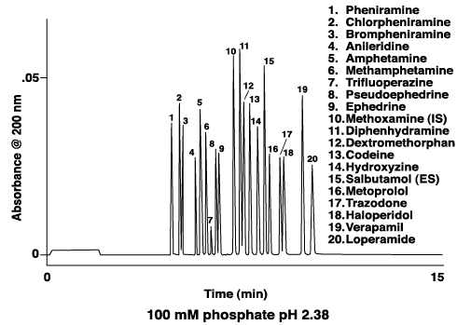
  - Van Urk: Turns blue-purple in the presence of LSD
  - Scott test: Turns blue in the presence of cocaine
- Confirmatory Test: Can identify substance (mass spectrometer or gas chromatography).
  - Confirmatory Tests
  - Spectrophotometry
  - Ultraviolet (UV)
  - Visible
  - Infrared (IR)
  - Mass spectrometry
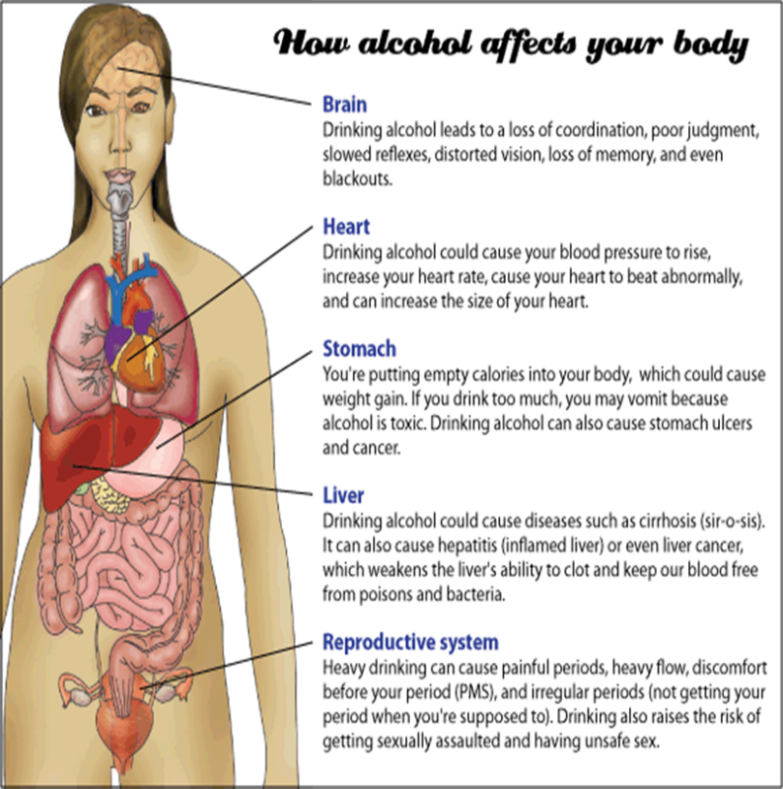
Toxicology of Alcohol” Alcohol (the form found in many beverages is ethanol) is absorbed through the stomach and intestines. Once absorbed, alcohol is Metabolized in the liver, converted to acetaldehyde and then turned into acetic acid. When too much acetaldehyde accumulates in the blood it produces dehydration and classic symptoms of a hangover (headache, nausea, weakness, etc.). Alcohol is excreted by breath, perspiration, and kidneys.
- How is Alcohol Content Measured?
  - Field Sobriety Test used to assess if further testing is needed
  - Breath analysis – Most commonly measured through the use of a portable breathalyzer, this test indirectly measures blood alcohol concentration by estimating the amount of alcohol on the subject’s breath. A formula is used to convert breath alcohol level to an approximate blood alcohol level.
  - Urine analysis – A urine sample can be analyzed to determine alcohol content, although it can take up to two hours for alcohol to show up in urine. This test is also an indirect measurement of blood alcohol concentration through an estimate of the amount of alcohol in the urine that is used to determine the overall blood alcohol concentration.
  - Blood analysis – A sample of blood is drawn from the subject to directly determine the blood alcohol concentration in the body. Although the amount of alcohol is at its highest level about an hour after drinking, alcohol is quickly absorbed into the blood and can easily be measured through a blood sample.

Poisons
- A poison is any substance that causes disturbance to an organism
- More specifically, a toxin is poison produced naturally by an organism
- Examples: snake venom, poison ivy
- Poisons enter and affect the body in different ways:
  - Ingestion (poisons are eaten)
  - 90% of all poisonings involve children swallowing household products or medicine
  - Inhaled
    - Example: carbon monoxide, sarin nerve gas
  - Injected (Heroine)
  - Absorbed (through skin, eyes, or mucous membranes): Poison sumac
- Murder by Poison:
  - Accidental Death – usually from a drug overdose
  - Deliberate- poisoning deaths
  - Intentional- Food poisoning
- Acute poisoning – high doses of poisoning over a short period of time (cyanide).
- Chronic poisoning – lower doses over a long period of time (mercury or lead poisoning).
- Types of Poisons include pesticides, heavy Metals(are stored in soft body tissues and damage organs for example: Lead, Mercury, Arsenic)

Bioterrorism
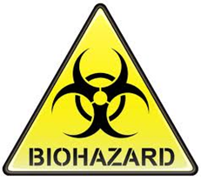
- Terrorist acts involving the use of harmful agents and products of biological origin, as disease-producing microorganisms or toxins.
- Bioterrism examples include:
  - Ricin
  - Anthrax
  - Mustard Gas
  - used in World War I
  - A man-made gas
  - Forms large blisters on exposed skin and the lungs

