AP Learning Objectives
- Explain the relationship between trends in atomic properties of elements and electronic structure and periodicity (1.7).
- Explain the relationship between trends in the reactivity of elements and periodicity(1.8).
- Explain the relationship between the type of bonding and the properties of the elements participating in the bond (2.1).

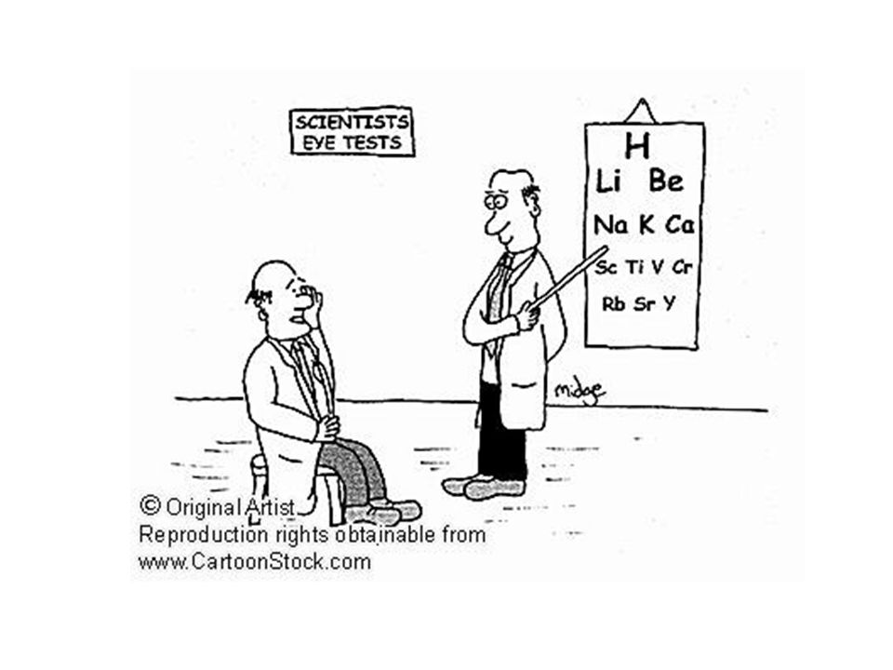

PERIODIC TABLE REVIEW

- Define and name the periodic groups (alkali, alkaline earth, transition metals, noble gasses) with properties. Explain what property each element in a specific group has in common with each other.

- Define the periodic periods and explain what elements in the same period have in common with each other.

- Put a check in each box that correctly describes the element given.
 | Metal | Metalloid | Nonmetal | Alkali  Metal | Alkaline  Earth  Metal | Transition  metal | Halogen | Noble  gas | Monatomic | Diatomic
Sb
Sr
Rn
P
Pt
Cs
S
Fe
Br
Ar
H
Si
B
F
He
Se
Zn
Ra

4. Write in the space, “metals”, “metalloids”, or “nonmetals” to indicate which type of element.
 |  | Located on the left side of the P.T.
b. |  | Located on the right side of the P.T.
c. |  | Solids are brittle
d. |  | Majority of the elements
e. |  | Gain electrons to form negative ions
f. |  | Located along the “staircase”
g. |  | Have luster
h. |  | Malleable
i. |  | Lose electrons to form positive ions
j. |  | Ductile
k. |  | Excellent conductors of heat & electricity
l. |  | Poor electrical & heat conductors
m. |  | Low electronegativity values
n. |  | Low ionization energy
o. |  | High ionization energy
p. |  | High electronegativity values
q. |  | Ions are larger than their atoms
r. |  | Ions are smaller than their atoms

5. Check all the boxes which describe the element.

 | Physical Properties |  |  |  |  | Chemical Properties
 | State at STP  (s, l, or g) | Brittle | Malleable  /ductile | Conductor |  | Ionization  energy |  | Electro-  negativity |  | Electrons
 |  |  |  | Good | Poor | Low | High | Low | High | Lose | Gain
C
Ag
Mg
I
S
Au
Fe
Br
Ar
H
Hg

ATOMIC RADIUS

Trends:
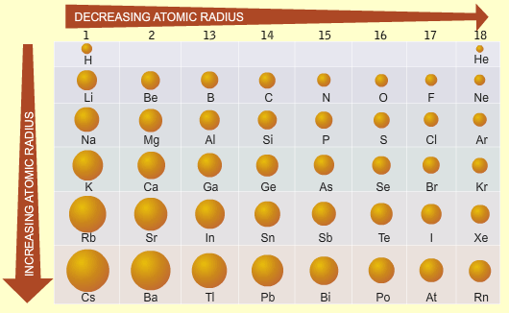
Across a period atomic radius _________________________

due to ____________________________________________________

____________________________________________________________

Down a group atomic radius _________________________

due to ____________________________________________________

1. Identify and explain the trend in atomic size for the following transitions in the periodic table.
(a) Moving vertically from Ar to He

(b) Moving horizontally from Na to Ar

2. In each of the following pairs, pick the larger species. Explain you answer in each case.
(a) Cu and Cu²⁺

(b) F and F-

(c) Na⁺ and K⁺

3. Only one of the following statements is correct. Which one?
(a) All cations are larger than their corresponding atoms
(b) All anions are smaller than their corresponding atoms
(c) Atomic size increases on transitioning from left to right across period 2 of the periodic table
(d) The most common ion of chlorine is smaller than a chlorine atom
(e) The most common ion of strontium is larger than a strontium atom
(f) The most common potassium ion is larger than the most common sodium ion
(g) The ions most commonly formed by group 16 elements are smaller than their corresponding atoms

4. Consider the plot below that shows atomic and ionic radii of the most commonly formed ion (in units
of pm) for selected elements, plotted against atomic number. (Blue line is first, red line is second in each case.)

- Which color represents the plot for atomic radii? Explain your answer by using any element as an example.

(b) What do the elements that have smaller ionic radii than their corresponding atomic radii have in
common?

(c) Suggest a reason for the absence of comparative atomic and ionic radii data for elements with
atomic numbers of 2, 10 and 18.

(d) Identify the element with atomic number 19, identify the formula of the ion that it commonly
forms, and convert the radii of both the atom and the ion to units of cm.

(e) What common feature can be identified for all of the non-metals on the plot?

(f) What accounts for the sharp increase in height of the blue lines that occurs at elements with
atomic numbers 3, 11 and 19 respectively?

(g) Make a prediction about the relative heights of the blue line and red line if data were added to the plot for the element with an atomic number of 15. Explain.

(h) The element with atomic number 1 has a red line that is significantly taller than its blue line. Under what circumstance would the red line be shorter than the blue line for this element?

(i) If data were added to the plot for the element with atomic number 7, which would be taller, the
blue or the red line? Explain.
IONIZATION ENERGY (and more radii)

- Using the metal magnesium as an example, write two separate equations to show the first and second ionization energy of magnesium. (Remember state symbols are important as they from part of the definition).
First Ionization: ______________________________________________________________________

Second Ionization: ____________________________________________________________________

- Which of the following elements (one from each pair) would you expect to have the highest first ionization energy? Explain your answers.
Ca or Be: ___________________________________________________________________________

Na or Ar: ___________________________________________________________________________

- Consider the table:
IE | 1st | 2nd | 3rd | 4th
 | 578 | 1817 | 2745 | 11580

(a) In which group does this element appear on the periodic table?

(b) Predict the formula of the compound that this element forms with fluorine.

(c) What is the minimum number of electrons that this element must have?

- Arrange the following species in order of increasing size. Rb⁺, Y³⁺, Br⁻, Kr, Sr²⁺ and Se^{2-.}

- Are there any atoms for which the second ionization energy is greater than the first? Explain your answer.

- Is it possible for two different atoms to be isoelectronic? If so give examples.

- Is it possible for two different anions to be isoelectronic? If so give examples.

- Consider the table below:
IE | 1st | 2nd | 3rd | 4th | 5th | 6th
 | 737 | 1450 | 7732 | 10540 | 13360 | 17995

(a) In which group will X be found? Explain.

(b) Predict the formula of X’s bromide.

- Explain carefully why rubidium tends only to form a +1 ion?

- Explain carefully why elements in the same group react in similar ways?

- Identify any (and all) isoelectronic species in the following list; Fe²⁺, Sc³⁺, Ca²⁺, F⁻, Co²⁺, Co^{3+,}Sr²⁺, Cu⁺, Zn²⁺ and Al³⁺.

- Arrange the following atoms into order of increasing first ionization energy. Sr, Cs, S, F and As.

- Explain each of the following observations.

- Sodium has a lower first-ionization energy than lithium.

- Oxygen has a lower first-ionization energy than nitrogen.

- There is a general increase in the first ionization energy from sodium to argon.

- Boron has a lower first ionization energy than beryllium.

- The first ionization energy of neon (atomic number 10) is significantly higher than that of argon (atomic number 18) but significantly lower than the first ionization energy of helium (atomic number 2), despite all three elements being in the same group.

(f) Helium has the highest first ionization of all the elements shown.

- Consider the ionization energies of elements X and Y shown below in kJmol-1. X and Y are in the same period of the periodic table and are adjacent to one another in the table.
IE | 1st | 2nd | 3rd | 4th | 5th | 6th | 7th | 8th | 9th
x | 1680 | 3375 | 6050 | 8409 | 11022 | 15165 | 17868 | 92038 | 106440
y | 2080 | 3950 | 6122 | 9370 | 12180 | 15239 | 20000 | 23068 | 115375

(a) In which group would one find element X? Explain.

- Does element X lie to the right or the left of element Y in the periodic table? Explain.

- Which is the first period on the periodic table that these elements could be in? Explain.

- Why are the second ionization energies of both elements larger than their respective first ionization energies?

- It is found that Y has the largest first ionization energy in the period that it is found. What does this tell us about Y?

- It is found that element Q, which is in the same period as X and Y but lies to the left of element X in the periodic table, only has values for its first four ionization energies. Suggest a reason for this observation.

- (a) Define first ionization.

(b) Write an equation to show the second ionization energy of calcium.

- Why does N have a higher first IE than O? Explain using orbital notations.

- Why does Be have a higher IE than B? Explain using orbital notations.
BONDING REVIEW

1. Use information in the table below to identify each compound as Ionic or Covalent Compounds.
Compound | Phase at Room Temperature | Conductivity as a pure solid | Conductivity as a liquid  (aq or molten) | Melting Point | Ionic or Covalent
A | solid | no | yes | 1049ºC
B | solid | no | no | 223ºC
C | liquid | no | no | 20ºC
D | solid | no | yes | 378ºC
E | liquid | no | no | -94ºC
F | solid | no | yes | 650ºC

List the properties of Ionic compounds: _________________________________________________________

List the properties of Covalent compounds: ______________________________________________________

2. For each example, check if it describes breaking or forming bonds:
 | Breaking bonds | Forming bonds
The stability of the system increases
N₂ 🡪 N + N
Endothermic
I + I 🡪 I₂
The stability of the system decreases
Exothermic

3. For each statement check if it describes ionic, polar covalent, nonpolar covalent, or metallic bonds:
 | Ionic | Polar Covalent | Nonpolar Covalent | Metallic
A transfer of electrons between two atoms
Positive nuclei dispersed in a sea of mobile electrons
Metals and nonmetals bonding
One atom loses, and another atom gains electrons
Two atoms share electrons equally
Metals bonding only
Electronegativity differences under 0.4
A bond resulting from electrostatic charges between oppositely charged particles
Two atoms share electrons unequally
Nonmetals bonding only
Electronegativity differences over 1.7

- For each example provide the molecule, bond and determine when and if it conducts electricity:
 | Type of Bond  (Metallic, ionic, polar covalent, nonpolar covalent, both ionic and covalent) | Conducts electricity?  (check all that apply)  No (s) (l) (aq)
- Li2O
- AlCl3
- F2
- CH4
- HI
- Fe
- Na3PO4
- CaO
- C (diamond)
- C (graphite)
- H2
- Na
- NH4Br
- KNO3
- O3
- SiO2
- NH3
- FeBr2

ELECTRONEGATIVITY AND POLARITY
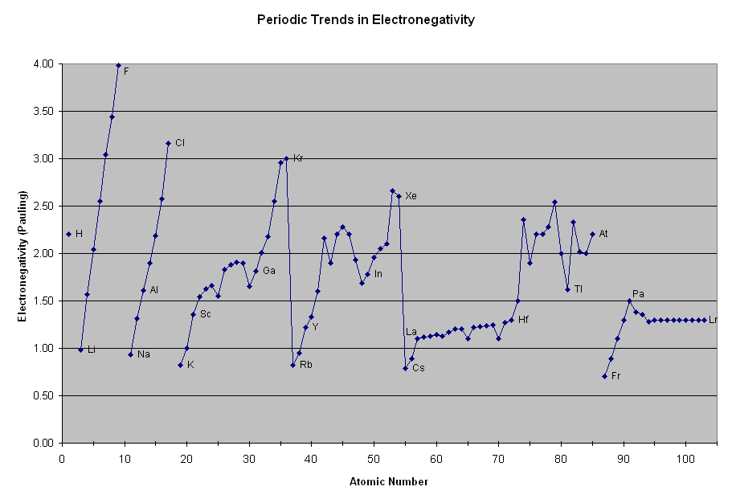
Across a period electronegativity _________________________ due to

Down a group electronegativity _________________________ due to

- Which element has the highest electronegativity? Why?

- Explain the trend in EN from P to S to Cl.

- Explain the trend in electronegativity from Cl to Br to I.

LATTICE ENERGY

- Rationalize the following Lattice energies:
CaSe | -2862 kJ/mol
Na₂Se | -2130 kJ/mol
CaTe | -2721 kJ/mol
Na₂Te | -2095 kJ/mol

- Estimate the heat of formation of potassium chloride: K(s) + ½ Cl₂(g) 🡪 KCl (s)
Lattice Energy | -690 kJ/mol
Ionization Energy | 419 kJ/mol
Electron Affinity | -349 kJ/mol
Bond Energy of Cl₂ | 239 kJ/mol
Enthalpy of sublimation of K | 64 kJ/mol

- Find the heat of formation of NaCl showing all steps: Na_{(s)} + ½ Cl_{2(g)} 🡪 NaCl_{(s)}
Lattice Energy: -786 kJ
IE of Na: 495 kJ
EA of Cl: -349 kJ
Bond Energy of Cl₂ 239 kJ
Sub of Na: 109 kJ

- Find the heat of formation of BaCl₂ showing all steps: Ba(s) + Cl₂(g) 🡪 BaCl₂(s)
Lattice Energy: -2056 kJ
First IE of Ba: 503 kJ
Second IE of Ba: 965 kJ
EA of Cl: -349 kJ
Bond Energy of Cl₂ 239 kJ
Sub of Ba: 178 kJ

- Find the heat of formation of LiCl showing all steps: Li(s) + ½ Cl₂(g) 🡪 LiCl(s)
Lattice Energy: -834 kJ
First IE of Li: 520 kJ
EA of Cl: -349 kJ
Bond Energy of Cl₂ 239 kJ
Sub of Li: 161 kJ

- LiI(s) has a heat of formation of -272 kJ/mol and a lattice energy of -753kJ/mol. The ionization energy of Li(g) is 520kJ/mol, the bond energy of I₂(g) is 151 kJ/mol and the electron affinity of I(g) is -295kJ/mol. Determine the heat of sublimation of Li(s).

BOND ENERGY

For each of the reactions, draw the structure of the compounds and then find the change in enthalpy of reaction (ΔHrxn). Assume all elements and compounds are in the gas phase unless noted otherwise.

- H₂ + Cl₂ 🡪 2HCl

- N₂ + 3H₂ 🡪 2NH₃

- HCN + 2H₂ 🡪 CH₃NH₂

- N₂H₄ + 2F₂ 🡪 N₂ + 4HF

- CH₃OH + CO 🡪 CH₃COOH(l)

- C₂H₂ + 5/2 O₂ 🡪 2CO₂ + H₂O

- H₂O₂ + CH₃OH 🡪 H₂CO + 2H₂O(l)

- In the reaction C₂H₄ + F₂ 🡪 C₂H₄F₂, the ΔHrxn = -549 kJ/mol. Estimate the C-F bond enthalpy give C-C is 347, C=C is 614, and F-F is 154 kJ/mol respectively.

SIMPLE MOLECULAR STRUCTURES

Compound | Total valence electrons | Lewis diagram | Shape | Shared pairs | Unshared pairs
H₂
F₂
O₂
H₂O
OF₂
NH₃
PCl₃
CH₄
SiF₄
SCl₂
CCl₄
AsF₃
N₂
SeBr₂
H₂S
SiBr₄
PH₃
Cl₂
AsCl₃
HF
H₂Te
I₂
CI₄
CO₂
HCN

