**Learning Objectives:**

3.8 The student is able to identify redox reactions and justify the identification in terms of electron transfer.

3.9 The student is able to design and/or interpret the results of an experiment involving a redox titration.

3.12 The student can make qualitative or quantitative predictions about galvanic or electrolytic reactions based on half-cell reactions and potentials and/or Faraday's laws.

3.13 The student can analyze data regarding galvanic or electrolytic cells to identify properties of the underlying redox reactions.



**Redox Review**

Oxidation numbers are very important in this chapter “Redox Reactions.” Without the complete understanding of how to assign these numbers, we cannot move ahead with this chapter. They are much like ionic charges, except that every element will be assigned a number. The most important rules that cannot be broken are:

* Free elements are zero.
* Group 1 is +1
* Group 2 is +2
* Fluorine is -1

Assign oxidation numbers to each element in the following:

1. NaCl Na___ Cl___
2. H2S H___ S___
3. H2O H___ O ___
4. CO2 C ___ O___
5. H2SO4 H ___ S___ O___
6. FeCO3 Fe___ C___ O___
7. AgI Ag___ I___
8. H2 H___
9. PbCl2 Pb___ Cl___
10. BaCO3 Ba___ C ___ O___
11. Fe2O3 Fe___ O___
12. I2 I____
13. BeO Be____ O____
14. CaF2 Ca____ F ____
15. FeCl3 Fe____ Cl____
16. PF5 P____ F____
17. H3PO4 H____ P____ O___
18. KCl K ____ Cl____
19. K2O K ____ O____
20. O3 O ____
21. LiH Li ____ H____
22. HBr H ____ Br____
23. Li+ Li____
24. PO43- P____ O___
25. CaH2 Ca___ H___
26. Cr2O3 Cr___ O___
27. KClO K___ Cl___ O___
28. KClO2 K___ Cl___ O___
29. KClO3  K___ Cl___ O___
30. KClO4 K___ Cl___ O___
31. Na2SO4 Na___ S___ O___
32. Ca(OH)2 Ca___ O___ H___
33. Na2SO4 Na___ S___ O___
34. B2(Cr2O7)3 B___ Cr___ O___
35. Al2(SO4)3 Al___ S___ O___
36. Al(NO3)3 Al___ N___ O___
37. (NH4)3PO4 N___ H___ P___ O____

**Redox Reactions**

A redox reaction is a reaction in which electrons are transferred from one element to another. The reaction involves at least two elements, one that will give up an electron, and one that will receive that electron. The term redox comes from two words, “oxidation” and “reduction.” If something is oxidized, it “burns” in oxygen, as shown below:

Mg + O 🡪 Mg+2 + O-2

Take a moment to write out their Lewis dot structures. As you can see, Mg is being oxidized and it loses its two valence electrons, while oxygen gains them. **Oxidation is defined as the loss of electrons**.

Considering the name of this reaction, if something is being oxidized, the other element must be reducing. Neither reduction nor oxidation can happen alone. That means that oxygen, in this example, is being reduced because it gains the electrons. **Reduction is defined as the gain of electrons**.

A simple way to remember this is to remember that **LEO the lion goes GER**.

**LEO** = loss of electrons is oxidation.

**GER** = gain of electrons is reduction.

Also, Mg and O are “free” elements, which means their oxidation numbers are both 0. Now you can see that **if and element’s oxidation number increases, that element is being oxidized. If an element’s oxidation number decreases it is being reduced (the number is reducing).**

_____________________________________________________________________________

EXAMPLES: Indicate which element is being oxidized, and which is being reduced.

1. Cr3+ + Fe2+  🡪 Cr2+  + Fe3+
2. F2 + O2-  🡪 F1-  + O2
3. Sn + N5+  🡪 Sn4+ + N4+
4. NaCl 🡪 Na+ + Cl-
5. Cu2O 🡪 Cu + O2
6. Cl2 + KBr 🡪 KCl + Br2
7. CH4 + O2 🡪 CO2 + H2O
8. H3PO4 + Ca(OH) 2 🡪 Ca3(PO4) 2 + H2O

Redox reactions are usually synthesis reactions, decomposition, combustion or single replacement reactions. Double replacement and neutralization reactions are NOT redox reactions. Usually they are easy to spot because if an element goes from being “free” (with an oxidation number of 0) to being in a compound (with a new oxidation number) it shows there was an exchange of electrons. In the following examples, identify what type of reaction they are and then state if they are redox reactions.

1. N2 + O2  🡪 2NO _________________________ ____________
2. Cl2 + 2NaBr 🡪 NaCl + Br2 _________________________ ____________
3. 2NaOH + HCl 🡪 H2O + NaCl _________________________ ____________

**Are these redox?**

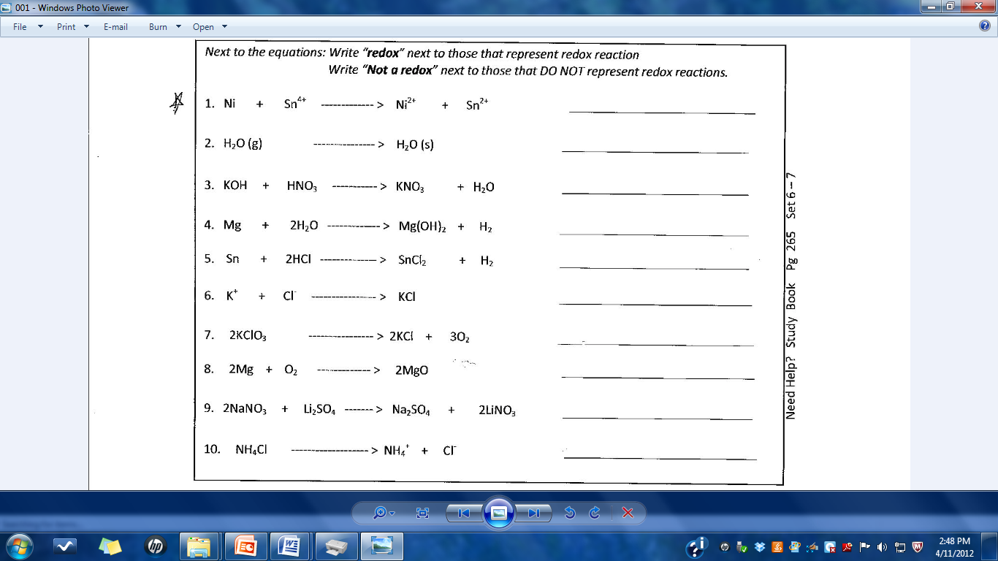

What type of reaction (S, D, C, SR, or DR) is NEVER redox? ______________________________

**Balancing Redox Reactions**

**Balance in an acidic solution:**

1. Cr2O72- + I-  🡪 Cr3+ + IO3-

2. MnO4- + CH3OH 🡪 Mn2+ + HCO2H

3. I2 + OCl- 🡪 IO3-  + Cl-

4. As2O3 + NO3- 🡪 H3AsO4 + N2O3

**Balance in a basic solution:**

5. MnO4- + Br- 🡪 MnO2 + BrO3–

6. Pb(OH)42- + ClO- 🡪 PbO2 + Cl-

7. Al + MnO4 - 🡪 MnO2 + Al(OH)4–

8. Cl2 🡪 Cl-  + OCl–

9. NO2- + Al 🡪 NH3 + AlO2-

**Electrochemical Cells**

Directions: In each of the following, determine which element oxidized easier. Then label the anode, cathode, direction of e- flow, and the half reactions. Then find the voltage.

1. 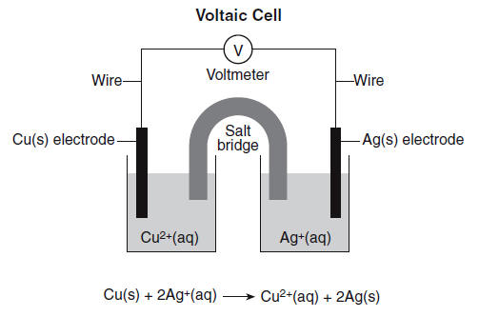 2. 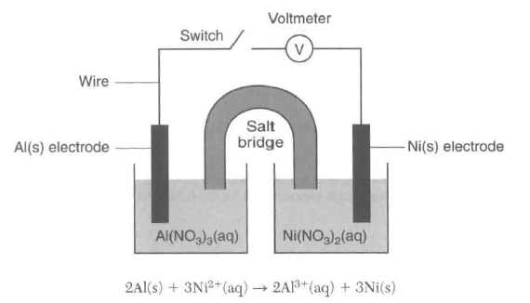3. 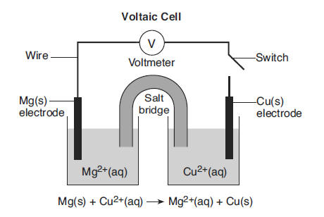 4. 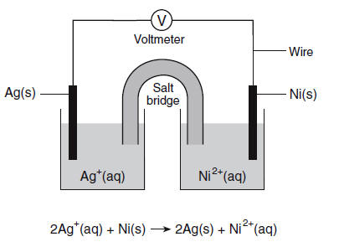

Additional Questions:

1. On diagram 1, which way will anions travel through the salt bridge? ____________
2. On diagram 2, towards which electrode will cations travel through the salt bridge? ____________
3. On diagram 3, how many e- are exchanged per mole of Mg? ____________
4. On diagram 4, how many e- are transferred between Ag and Ni? ____________
5. On all diagrams, at which electrode does oxidation occur? ____________
6. On all diagrams, at which electrode does reduction occur? ____________
7. On all diagrams, from which electrode will electrons travel? ____________
8. What is the purpose of the salt bridge? ____________________________________________________
9. Describe the change in energy that occurs in voltaic cells in terms of electric and chemical energies:

**EKG**

1. Given a battery using 1.0M Cu+2 and 1.0M Zn+2, calculate the E, K, and ΔG at 298K.
2. Given 1.0M Fe+3 and element 1.0M Co+2, calculate the E, K, and ΔG at 298K.
3. If a cell is formed with the reaction Zn + Al+3 🡪 Al + Zn+2 is it spontaneous? Calculate the E, K and G at 298K.
4. If a cell is formed with the reaction Ag + Ca+2 🡪 Ca + Ag+ is it spontaneous? Calculate the E, K and G at 298K.

**Redox Titrations**

Like acids and bases, redox reactions can represent titrated substances. When an oxidizing agent or reducing agent is added to a solution the oxidation numbers will change and often color changes can be seen. For example, when copper changes from Cu+2 to Cu+3 the color changes from blue to colorless. A list of color changes are below. Either dimensional anaylysis or titration equations can be used to determine the conenctration of species in the reaction.

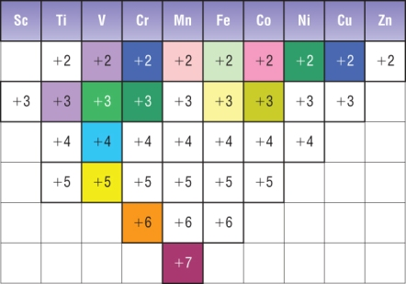

Ti+3 and V+2 are purple

V+3 Cr+3, Fe+2, Co+3, and Ni+2 are bright, dark,

aqua, olive, and blue-green

V+4, Cr+2, Cu+2 are bright, dark, and navy blue

V+5 and Fe+3 are bright and light yellow

Mn+7 is magenta

Mn+2 and Co+2 are light and dark pink

Cr+6 is orange

1. (a) CrCl2 solution is oxidized by AgNO3. Write a reaction between the two solutions.

(b) How did the student know to end the titration?

(c) When 300.0 milliliters of a solution of 0.200 molar AgNO3 is mixed with 100.0 milliliters of CrCl2 solution, the student ends the titration. What is the molarity of the CrCl2 solution?

(d) Write the net cell reaction for a cell formed by placing a silver electrode in the solution remaining from the reaction above and connecting it to a standard hydrogen electrode.

(e) Calculate the voltage of a cell of this type in which the concentration of silver ion is 410-2 M.

(f) Calculate the value of the standard free energy change *G* for the following half reaction:

Ag+ (1M) + e- → A*g*

2. Answer parts (a) through (e) below, which relate to reactions involving silver ion, Ag+.

The reaction between silver ion and solid zinc is repre­sented by the following equation.

2 Ag+*(aq)* + Zn*(s)*  Zn2+*(aq)* + 2 Ag*(s)*

(a) A 1.50 g sample of Zn is combined with 250. mL of 0.110 *M* AgNO3 at 25˚C.

(i) Identify the limiting reactant. Show calcula­tions to support your answer.

(ii) On the basis of the limiting reactant that you identified in part (i), determine the value of [Zn2+] after the reaction is complete. Assume that volume change is negligible.

(iii) What color change will be seen as this cell operates?

(b) Determine the value of the standard potential, *E˚*, for a galvanic cell based on the reaction between AgNO3*(aq)* and solid Zn at 25˚C.

Another galvanic cell is based on the reaction between Ag+*(aq)* and Cu*(s)*, represented by the equation below. At 25˚C, the standard potential, *E˚*, for the cell is 0.46 V.

2 Ag+*(aq)* + Cu*(s)*  Cu2+*(aq)* + 2 Ag*(s)*

(c) Determine the value of the standard free-energy change, ∆*G*˚, for the reaction between Ag+*(aq)* and Cu*(s)* at 25˚C.

(d) The cell is constructed so that [Cu2+] is 0.045 *M* and [Ag+] is 0.010 *M*. Calculate the value of the potential, *E*, for the cell.

(e) Under the conditions specified in part (d), is the reaction in the cell spontaneous? Justify your an­swer.

**Electrolysis Review**

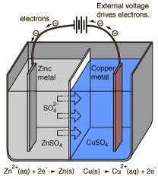

1. Which element is oxidizing in the diagram to the left?

2. According to E Tables, should that element oxidize?

3. Is this reaction spontaneous?

4. What type of cell is it?

5. Label the anode and the cathode with charges on the diagram to the left.

6. Write the overall reaction for this cell.

7. Water is being decomposed using a battery in the diagram to the right. Write the equation for the decomposition of water.

8. Which element is being oxidized?

9. How many e- are lost?

10. Should that element oxidize?

11. Is this reaction spontaneous?

12. What type of cell is it?

13. Label where oxidation and reduction on the diagram.

14. Why is more H2 gas being formed that O2 gas?

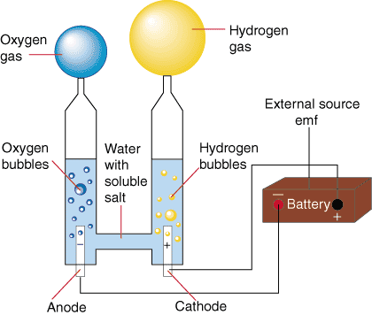

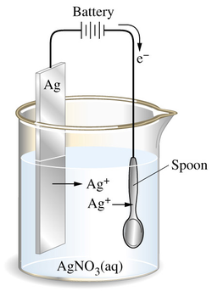

15. Only one element is being used in the diagram to the left. The silver plate ionizes and the ions attach to the spoon. Show a half reaction for silver oxidizing.

16. Label the anode and cathode with charges on the diagram.

17. Explain the direction of e- flow through the wire.

18. Is this reaction spontaneous? _____ How can you tell?

**AP Electrolysis**

1. All of the equations on you reference table are written as (oxidations/reductions).

2. The chemicals at the upper left (Cl2 and O2) are the most likely to be (oxidized/reduced) and therefore the best (oxidizing agents/reducing agents).

3. The chemicals at the lower right (Na and K) are the most likely to be (oxidized/reduced) and therefore the best (oxidizing agents/reducing agents).

4. In an electrolytic cell, the () electrode is negative because it has (too many/too few) electrons. Chemicals that come into contact with the () electrode will (gain/lose) electrons and be (oxidized/reduced). The () electrode in electrolysis is called the (cathode/anode).

5. Write the change that water goes through at the () electrode.

6. In an electrochemical cell, the (+) electrode is positive because it has (too many/too few) electrons. Chemicals that come into contact with the (+) electrode will (gain/lose) electrons and be (oxidized/reduced). The (+) electrode in electrolysis is called the (cathode/anode).

7. Write the change that water goes through at the () electrode.

8. Add these two reactions together and write the overall reaction for the electrolysis of water.

9. We will perform this electrolysis using an aqueous solution of sodium sulfate.  
Both the Na+ and H2O will be near the () electrode. Which chemical is more likely to be reduced?

10. Both the SO42 and H2O will be near the (+) electrode. Which chemical will be oxidized?

11. In the electrolysis of KI(aq)

Both the K+ and H2O will be near the () electrode. Which chemical is more likely to be reduced?

Both the I and H2O will be near the (+) electrode. Which chemical is more likely to be oxidized?

Write the reactions at each electrode and the overall reaction:

Cathode:

Anode:

Overall:

12. In the electrolysis of CuSO4(aq)

Both the Cu2+ and H2O will be near the () electrode. Which chemical will be reduced?

Both the SO42 and H2O will be near the (+) electrode. Which chemical will be oxidized?

Write the reactions at each electrode and the overall reaction:

Cathode:

Anode:

Overall:

13. Silver plating occurs when electrolysis of a Ag2SO4 solution is used because silver metal is formed at the (cathode/anode). This is the ( + /  )electrode. The reaction at this electrode is:

Recall that 1 amp·sec = 1 Coulomb and 96,500 Coulombs = 1 mole e‘s (Faraday’s constant).  
If a cell is run for 200. seconds with a current of 0.250 amps, how many grams of Ag° will be deposited?

14. A current of 10.0 amperes flows for 2.00 hours through an electrolytic cell containing a molten salt of metal X. This results in the decomposition of 0.250 mole of metal X at the cathode. The oxidation state of X in the molten salt is (X+, X2+, X3+, X4+)

15. Solutions of Ag+, Cu2+, Fe3+ and Ti4+ are electrolyzed with a constant current until 0.10 mol of metal is deposited. Which will require the greatest length of time?

**AP Questions**

1. (a) Calculate the value of *G* for the standard cell reaction Zn + Cu2+(1M) → Zn2+(1M) + Cu

1. One half cell of an electrochemical cell is made by placing a strip of pure zinc in 500 milliliters of 0.10 molar ZnCl2 solution. The other half cell is made by placing a strip of pure copper in 500 milliliters of 0.010 molar Cu(NO3)2 solution. Calculate the initial voltage of this cell when the two half cells are joined by a salt bridge and the two metal strips are joined by a wire.

(c) Calculate the final concentration of copper ion, Cu2+, in the cell described in part (b) if the cell were allowed to produce an average current of 1.0 ampere for 3 minutes 13 seconds.

2. When a dilute solution of H2SO4 is electrolyzed, O2(g) is produced at the anode and H2(g) is produced at the cathode.

(a) Write the balanced equations for the anode, cathode, and overall reactions that occur in this cell.

1. Compute the coulombs of charge passed through the cell in 100. minutes at 10.0 amperes.
2. What number of moles of O2 is produced by the cell when it is operated for 100. minutes at 10.0 amperes?
3. The standard enthalpy of formation of H2O(g) is -242 kilojoules per mole. How much heat is liberated by the complete combustion, at 298K and 1.00 atmospheres, of the hydrogen produced by the cell operated as in (c)?

3. Ti3+ + HOBr → TiO2+ + Br- (in acid solution)

(a) Write the correctly balanced half-reactions and net ionic equation for the skeletal equation shown above.

(b) Identify the oxidizing agent and the reducing agent in this reaction.

1. A galvanic cell is constructed that utilizes the reaction above. The concentration of each species is 0.10 molar. Compare the cell voltage that will be observed with the standard cell potential. Explain your reasoning.
2. Give one example of a property of this reaction, other than the cell voltage, that can be calculated from the standard cell potential, *E*. State the relationship between *E* and the property you have specified.

4. (a) Titanium can be reduced in an acid solution from TiO2+ to Ti3+ with zinc metal. Write a balanced equation for the reaction of TiO2+ with zinc in acid solution.

(b) What mass of zinc metal is required for the reduction of a 50.00 millilitre sample of a 0.115 molar solution of TiO2+?

(c) Alternatively, the reduction of TiO2+ to Ti3+ can be carried out electrochemically. What is the minimum time, in seconds, required to reduce another 50.000 millilitre sample of the 0.115 molar TiO2+ solution with a direct current of 1.06 amperes?

(d) The standard reduction potential, *E*, for TiO2+ to Ti3+ is +0.060 volt. The standard reduction potential, *E*, for Zn2+ to Zn(s) is -0.763 volt. Calculate the standard cell potential, *E*, and the standard free energy change, *G*, for the reaction described in part (a).

5. A direct current of 0.125 ampere was passed through 200 millilitres of a 0.25 molar solution of Fe2(SO4)3 between platinum electrodes for a period of 1.100 hours. Oxygen gas was produced at the anode. The only change at the cathode was a slight change in the color of the solution.

At the end of the electrolysis, the electrolyte was acidified with sulfuric acid and was titrated with an aqueous solution of potassium permanganate. The volume of the KMnO4 solution required to reach the end point was 24.65 millilitres.

1. How many faradays were passed through the solution?
2. Write a balanced half-reaction for the process that occurred at the cathode during the electrolysis.
3. Write a balanced net ionic equation for the reaction that occurred during the titration with potassium permanganate.

(d) Calculate the molarity of the KMnO4 solution.

6. An electrochemical cell consists of a tin electrode in an acidic solution of 1.00 molar Sn2+ connected by a salt bridge to a second compartment with a silver electrode in an acidic solution of 1.00 molar Ag+.

(a) Write the equation for the half–cell reaction occurring at each electrode. Indicate which half–reaction occurs at the anode.

(b) Write the balanced chemical equation for the overall spontaneous cell reaction that occurs when the circuit is complete. Calculate the standard voltage, *E*, for this cell reaction.

(c) Calculate the equilibrium constant for this cell reaction at 298K.

7. Explain each of the following.

(a) When an aqueous solution of NaCl is electrolyzed, Cl2(g) is produced at the anode, but no Na(s) is produced at the cathode.

(b) The mass of Fe(s) produced when 1 faraday is used to reduce a solution of FeSO4 is 1.5 times the mass of Fe(s) produced when 1 faraday is used to reduce a solution of FeCl3.

(c) Zn + Pb2+ (1–molar) → Zn2+ (1–molar) + Pb

The cell that utilizes the reaction above has a higher potential when [Zn2+] is decreased and [Pb2+] is held constant, but a lower potential when [Pb2+] is decreased and [Zn2+] is held constant.

1. The cell that utilizes the reaction given in (c) has the same cell potential as another cell in which [Zn2+] and [Pb2+] are each 0.1–molar.

8. An unknown metal M forms a soluble compound, M(NO3)2.

(a) A solution of M(NO3)2 is electrolyzed. When a constant current of 2.50 amperes is applied for 35.0 minutes, 3.06 grams of the metal M is deposited. Calculate the molar mass of M and identify the metal.

(b) The metal identified in (a) is used with zinc to construct a galvanic cell, as shown below. Write the net ionic equation for the cell reaction and calculate the cell potential, *E*.



1. Calculate the value of the standard free energy change, *G*, at 25C for the reaction in (b).

(d) Calculate the potential, *E*, for the cell shown in (b) if the initial concentration of ZnSO4 is 0.10-molar, but the concentration of the M(NO3)2 solution remains unchanged.

9. Sr*(s)* + Mg2+ → Sr2+ + Mg*(s)*

Consider the reaction represented above that occurs at 25C. All reactants and products are in their standard states. The value of the equilibrium constant, *Keq*, for the reaction is 4.2×1017 at 25C.

1. Predict the sign of the standard cell potential, *E*, for a cell based on the reaction. Explain your prediction.
2. Identify the oxidizing agent for the spontaneous reaction.
3. If the reaction were carried out at 60C instead of 25C, how would the cell potential change? Justify your answer.

(d) How would the cell potential change if the reaction were carried out at 25C with a 1.0-molar solution of Mg(NO3)2 and a 0.10-molar solution of Sr(NO3)2 ? Explain.

(e) When the cell reaction in (d) reaches equilibrium, what is the cell potential?

10. In an electrolytic cell, a current of 0.250 ampere is passed through a solution of a chloride of iron, producing Fe*(s)* and Cl2*(g)*.

(a) Write the equation for the half-reaction that occurs at the anode.

(b) When the cell operates for 2.00 hours, 0.521 gram of iron is deposited at one electrode. Determine the formula of the chloride of iron in the original solution.

(c) Write the balanced equation for the overall reaction that occurs in the cell.

1. How many liters of Cl2*(g)*, measured at 25C and 750 mm Hg, are produced when the cell operates as described in part (b) ?

(e) Calculate the current that would produce chlorine gas from the solution at a rate of 3.00 grams per hour.

11. 

Answer the following questions regarding the electrochemical cell shown.

1. Write the balanced net-ionic equation for the spontaneous reaction that occurs as the cell operates, and determine the cell voltage.

(b) In which direction do anions flow in the salt bridge as the cell operates? Justify your answer.

(c) If 10.0 mL of 3.0-molar AgNO3 solution is added to the half-cell on the right, what will happen to the cell voltage? Explain.

(d) If 1.0 gram of solid NaCl is added to each half-cell, what will happen to the cell voltage? Explain.

(e) If 20.0 mL of distilled water is added to both half-cells, the cell voltage decreases. Explain.



12. Answer the following questions that refer to the galvanic cell shown in the diagram above.

(a) Identify the anode of the cell and write the half reaction that occurs there.

1. Write the net ionic equation for the overall reaction that occurs as the cell operates and calculate the value of the standard cell potential, *E°cell* .
2. Indicate how the value of *Ecell*  would be affected if the concentration of Ni(NO3)2*(aq)* was changed from 1.0 *M* to 0.10 *M* and the concentration of Zn(NO3)2*(aq)* remained at 1.0 *M*. Justify your answer.
3. Specify whether the value of *Keq* for the cell reaction is less than 1, greater than 1, or equal to 1. Justify your answer.

13. AgNO3*(s)*  Ag+*(aq)* + NO3–*(aq)*

The dissolving of AgNO3*(s)* in pure water is rep­resented by the equation above..

1. Is ∆*G* for the dissolving of AgNO3*(s)* positive, negative, or zero? Justify your answer.
2. Is ∆*S* for the dissolving of AgNO3*(s)* positive, negative, or zero? Justify your answer.

(c) The solubility of AgNO3*(s)* increases with increas­ing temperature.

(i) What is the sign of ∆*H* for the dissolving pro­cess? Justify your answer.

(ii) Is the answer you gave in part (a) consistent with your answers to parts (b) and (c) (i)? Ex­plain.

The compound NaI dissolves in pure water according to the equation NaI*(s)*  Na+*(aq)* + I–*(aq)*. Some of the information in the table of standard reduction potentials given below may be useful in answering the questions that follow.

|  |  |
| --- | --- |
| Half-reaction | *E˚* (V) |
| O2*(g)* + 4 H+ + 4 *e*-  2 H2O*(l)* | 1.23 |
| I2*(s)* + 2 *e*-  2 I– | 0.53 |
| 2 H2O*(l)* + 2 *e*-  H2*(g)* + 2 OH– | -0.83 |
| Na+ + *e*-  Na*(s)* | -2.71 |

(d) An electric current is applied to a 1.0 *M* NaI solu­tion.

(i) Write the balanced oxidation half reaction for the reaction that takes place.

(ii) Write the balanced reduction half-reaction for the reaction that takes place.

(iii) Which reaction takes place at the anode, the oxida­tion reaction or the reduction reaction?

(iv) All electrolysis reactions have the same sign for ∆*G˚*. Is the sign positive or negative? Justify your answer.

14. 

An external direct-current power supply is connected to two platinum electrodes immersed in a beaker containing 1.0 *M* CuSO4*(aq)* at 25˚C, as shown in the diagram above. As the cell operates, copper metal is deposited onto one electrode and O2*(g)* is produced at the other electrode. The two reduction half-reactions for the overall reaction that occurs in the cell are shown in the table below.

|  |  |
| --- | --- |
| Half-Reaction | *E*0(V) |
| O2*(g)* + 4 H+*(aq)* + 4 e- → 2 H2O*(l)* | +1.23 |
| Cu2+*(aq)* + 2 e- → Cu*(s)* | +0.34 |

1. On the diagram, indicate the direction of electron flow in the wire.
2. Write a balanced net ionic equation for the electrolysis reaction that occurs in the cell.
3. Predict the algebraic sign of ∆*G*˚for the reaction. Justify your prediction.
4. Calculate the value of ∆*G*˚for the reaction.

An electric current of 1.50 amps passes through the cell for 40.0 minutes.

1. Calculate the mass, in grams, of the Cu*(s)* that is deposited on the electrode.

(f) Calculate the dry volume, in liters measured at 25˚C and 1.16 atm, of the O2*(g)* that is produced.

15. 2 H2*(g)* + O2*(g)* → 2 H2O*(l)*

In a hydrogen-oxygen fuel cell, energy is produced by the overall reaction represented above.

1. When the fuel cell operates at 25˚C and 1.00 atm for 78.0 minutes, 0.0746 mol of O2*(g)* is consumed. Calculate the volume of H2*(g)* consumed during the same time period. Express your answer in liters measured at 25˚C and 1.00 atm.

(b) Given that the fuel cell reaction takes place in an acidic medium,

(i) write the two half reactions that occur as the cell operates,

(ii) identify the half reaction that takes place at the cathode, and

(iii) determine the value of the standard potential, *E*˚, of the cell.

(c) Calculate the charge, in coulombs, that passes through the cell during the 78.0 minutes of operation as described in part (a).

AP Chemistry: Electrochemistry Multiple Choice

|  |  |  |  |  |  |  |  |  |  |  |  |  |  |  |  |  |
| --- | --- | --- | --- | --- | --- | --- | --- | --- | --- | --- | --- | --- | --- | --- | --- | --- |
| 14. Questions 14-17 | | | | | | | | | | | | | | | | |
| The spontaneous reaction that occurs when the cell in the picture operates is as follows: | | | | | | | | | | | | | | | | |
| 2Ag+ + Cd(s) 🡪 2 Ag(s) + Cd2+ | | | | | | | | | | | | | | | | |
| (A) Voltage increases. | | | | | | | | | | | | | | | | |
| (B) Voltage decreases but remains > zero. | | | | | | | | | | | | | | | | |
| (C) Voltage becomes zero and remains at zero. | | | | | | | | | | | | | | | | |
| (D) No change in voltage occurs. | | | | | | | | | | | | | | | | |
| (E) Direction of voltage change cannot be predicted without additional information. | | | | | | | | | | | | | | | | |
| ***Which of the above occurs for each of the following circumstances?*** | | | | | | | | | | | | | | | | |
| 14. A 50-milliliter sample of a 2-molar Cd(NO3)2 solution is added to the left beaker. | | | | | | | | | | | | | | | | |
| 15. The silver electrode is made larger. | | | | | | | | | | | | | | | | |
| 16. The salt bridge is replaced by a platinum wire. | | | | | | | | | | | | | | | | |
| 17. Current is allowed to flow for 5 minutes. | | | | | | | | | | | | | | | | |
|  | | | | | | | | | | | | | | | | |
| 29. Cu(s) + 2 Ag+ 🡪 Cu2+ + 2 Ag(s)  If the equilibrium constant for the reaction above is 3.7 x 1015, which of the following correctly describes the standard voltage, E°, and the standard free energy change, ∆G°, for this reaction? | | | | | | | | | | | | | | | | |
| (A) E° is positive and ∆G° is negative. (B) E° is negative and ∆G° is positive. | | | | | | | | | | | | | | | | |
| (C) E° and ∆G° are both positive. (D) E° and ∆G° are both negative. | | | | | | | | | | | | | | | | |
| (E) E° and ∆G° are both zero | | | | | | | | | | | | | | | | |
|  | | | | | | | | | | | | | | | | |
| 46. If 0.060 faradays are passed through an electrolytic cell containing a solution of In3+ ions, the maximum number of moles of In that could be deposited at the cathode is… | | | | | | | | | | | | | | | | |
| (A) 0.010 mole (B) 0.020 mole (C) 0.030 mole (D) 0.060 mole (E) 0.18 mole | | | | | | | | | | | | | | | | |
|  | | | | | | | | | | | | | | | | |
| 75. If a copper sample containing some zinc impurity is to be purified by electrolysis, the anode and the cathode must be which of the following? | | | | | | | | | | | | | | | | |
|  | **Anode** | | | **Cathode** | | | | | | |  |  |  | | |  |
| (A) | Pure copper | | | Pure zinc | | | | | | |  |  |  | | |  |
| (B) | Pure zinc | | | Pure copper | | | | | | |  |  |  | | |  |
| (C) | Pure copper | | | Impure copper sample | | | | | | |  |  |  | | |  |
| (D) | Impure copper sample | | | Pure copper | | | | | | |  |  |  | | |  |
| (E) | Impure copper sample | | | Pure zinc | | | | | | |  |  |  | | |  |
|  |  | | |  | | | | | | |  |  |  | | |  |
|  |  | | |  | | | | | | |  |  |  | | |  |
|  |  | | |  | | | | | | |  |  |  | | |  |
|  |  | | |  | | | | | | |  |  |  | | |  |
|  |  | | |  | | | | | | |  |  |  | | |  |
| Fe2+ + 2e− 🡪 Fe(s) | | E° = − 0.44 volt | | |  | |  |  |  |  | | | | | | |
| Ni2+ + 2e− 🡪 Ni(s) | | E° = − 0.23 volt | | |  | |  |  |  |  | | | | | | |
|  | | | | | | | | | | | | | | | | |
| 60. The standard reduction potentials for two half reactions are given above. The Nernst equation for a galvanic cell at 25° C in which Fe(s) reduces Ni2+ is the following: | | | | | | | | | | | | | | | | |
| E = E° −0.059/2 log [Fe2+] / [Ni2+] | | | | | | | | | | | | | | | | |
| ***What is the equilibrium constant for the reaction below?*** | | | | | | | | | | | | | | | | |
| Fe(s) + Ni2+ 🡪 Fe2+ + Ni(s) | | | | | | | | | | | | | | | | |
| (A) 1.9 x 10−23 (B) 7.6 x 10−8 (C) 3.6 x 10+3 (D) 1.3 x 10+7 (E) 5.2 x 10+22 | | | | | | | | | | | | | | | | |
|  | | | | | | | | | | | | | | | | |
| 36. Zn(s) + Cu2+ 🡪 Zn2+ + Cu(s) | | | | | | | | | | | | | | | | |
| An electrolytic cell based on the reaction represented above was constructed from zinc and copper half-cells. The observed voltage was found to be 1.00 volt instead of the standard cell potential, E°, of 1.10 volts. Which of the following could correctly account for this observation? | | | | | | | | | | | | | | | | |
| (A) The copper electrode was larger than the zinc electrode. | | | | | | | | | | | | | | | | |
| (B) The Zn2+ electrolyte was Zn(NO3)2, while the Cu2+ electrolyte was CuSO4. | | | | | | | | | | | | | | | | |
| (C) The Zn2+ solution was more concentrated than the Cu2+ solution. | | | | | | | | | | | | | | | | |
| (D) The solutions in the half-cells had different volumes. | | | | | | | | | | | | | | | | |
| (E) The salt bridge contained KCl as the electrolyte. | | | | | | | | | | | | | | | | |
|  | | | | | | | | | | | | | | | | |
| 63. Which of the following expressions is correct for the maximum mass of copper, in grams, that cou1d be plated out by electrolyzing aqueous CuCl2 for 16 hours at a constant current of 3.0 amperes? (1 faraday = 96,500 coulombs) | | | | | | | | | | | | | | | | |
| (A) [(16)(3,600)(3.0)(63.55)(2)] / (96,500) | | | | | | | | | | | | | | | | |
| (B) [(16)(3,600)(3.0)(63.55)] / [(96,500)(2)] | | | | | | | | | | | | | | | | |
| (C) [(16)(3,600)(3.0)(63.55)] / (96,500) | | | | | | | | | | | | | | | | |
| (D) [(16)(60)(3.0)(96,500)(2)] / (63.55) | | | | | | | | | | | | | | | | |
| (E) [(16)(60)(3.0)(96,500)] / [(63.55)(2)] | | | | | | | | | | | | | | | | |
|  | | | | | | | | | | | | | | | | |
| 75. A direct-current power supply of low voltage (less than 10 volts) has lost the markings that indicate which output terminal is positive and which is negative. A chemist suggests that the power supply terminals be connected to a pair of platinum electrodes that dip into 0.1-molar KI solution. Which of the following correctly identifies the polarities of the power supply terminals? | | | | | | | | | | | | | | | | |
| (A) A gas will be evolved only at the positive electrode. | | | | | | | | | | | | | | | | |
| (B) A gas will be evolved only at the negative electrode. | | | | | | | | | | | | | | | | |
| (C) A brown color will appear in the solution near the negative electrode. | | | | | | | | | | | | | | | | |
| (D) A metal will be deposited on the positive electrode. | | | | | | | | | | | | | | | | |
| (E) None of the methods above will identify the polarities of the power supply terminals. | | | | | | | | | | | | | | | | |
| Questions 34-35 refer to an electrolytic cell that involves the following half-reaction: | | | | | | | | | | | | | | | | |
| AlF63− + 3 e− 🡪 Al + 6F− | | | | | | | | | | | | | | | | |
| 34. Which of the following occurs in the reaction? | | | | | | | | | | | | | | | | |
| (A) AlF 63− is reduced at the cathode. | | | | | | | | | | | | | | | | |
| (B) Al is oxidized at the anode. | | | | | | | | | | | | | | | | |
| (C) Aluminum is converted from the −3 oxidation state to the 0 oxidation state. | | | | | | | | | | | | | | | | |
| (D) F− acts as a reducing agent. | | | | | | | | | | | | | | | | |
| (E) F− is reduced at the cathode. | | | | | | | | | | | | | | | | |
|  | | | | | | | | | | | | | | | | |
| http://chem.neopages.com/quiz/apchem/mc1999e.gif35. As steady current of 10 amperes in passed though an aluminum-production cell for 15 minutes. Which of the following is the correct expression for calculating the number of grams of aluminum produced? (1 faraday = 96,500 coulombs) | | | | | | | | | | | | | | | | |
|  | | | | | | | | | | | | | | | | |
|  | | | | | | | | | | | | | | | | |
|  | | | | | | | | | | | | | | | | |
|  | | | | | | | | | | | | | | | | |
|  | | | | | | | | | | | | | | | | |
|  | | | | | | | | | | | | | | | | |
|  | | | | | | | | | | | | | | | | |
|  | | | | | | | | | | | | | | | | |
|  | | | | | | | | | | | | | | | | |
| M(s) + 3 Ag+(aq) 🡪 3 Ag(s) + M3+(aq) | | | E = +2.46 V | | |  | | | | | |  |  |  |  | |
| Ag+(aq) + e− 🡪 Ag(s) | | | E = +0.80 V | | |  | | | | | |  |  |  |  | |
|  | | | | | | | | | | | | | | | | |
| 57. According to the information above, what is the standard reduction potential for the half-reaction M3+(aq) + 3 e− 🡪 M(s)? | | | | | | | | | | | | | | | | |
| (A) −1.66 V (B) −0.06 V (C) 0.06 V (D) 1.66 V (E) 3.26 V | | | | | | | | | | | | | | | | |

|  |
| --- |
| 20. .....Mg(s) + .....NO3− (aq) +.....H+(aq) 🡪......Mg2+(aq) + ....NH4+(aq) + ....H2O(l) |
| When the skeleton equation above is balanced and all coefficients reduced to their lowest whole-number terms, what is the coefficient for H+ ? |
| (A) 4 (B) 6 (C) 8 (D) 9 (E) 10 |
|  |
| 34. ...CrO2− + ...OH− 🡪 ... CrO42− + ... H2O + ... e−  When the equation for the half-reaction above is balanced, what is the ratio of the coefficients OH− / CrO2− ? |
| (A) 1:1 (B) 2:1 (C) 3:1 (D) 4:1 (E) 5:1 |
| 61. When a solution of potassium dichromate is added to an acidified solution of iron (II) sulfate, the products of the reaction are… |
| (A) FeCr2O7(s) and H2O (B) FeCrO4(s) and H2O (C) Fe3+, CrO42−, and H2O |
| (D) Fe3+, Cr3+, and H2O (E) Fe2(SO4)3(s), Cr3+ and H2O |
|  |
| 65. Which of the following species CANNOT function as an oxidizing agent? |
| (A) Cr2O72− (B) MnO4− (C) NO3− (D) S (E) I− |
|  |
| 79. 5 Fe2+ + MnO4− + 8 H+ ⇄ 5 Fe3+ + Mn2+ + 4 H2O |
| In a titration experiment based on the equation above, 25.0 milliliters of an acidified Fe2+ solution requires 14.0 milliliters of standard 0.050-molar MnO4− solution to reach the equivalence point. The concentration of Fe2+ in the original solution is… |
| (A) 0.0010 M (B) 0.0056 M (C) 0.028 M (D) 0.090 M (E) 0.14 M |
|  |
| 20. 6 I− + 2 MnO4− + 4 H2O(l) 🡪 3 I2(s) + 2 MnO2(s) + OH− |
| Which of the following statements regarding the reaction represented by the equation above is correct? |
| (A) Iodide ion is oxidized by hydroxide ion. |
| (B) MnO4− is oxidized by iodide ion. |
| (C) The oxidation number of manganese changes from +7 to +2. |
| (D) The oxidation number of manganese remains the same. |
| (E) The oxidation number of iodine changes from −1 to 0. |
|  |
| 22. __ Cr2O72− + __ e− + __ H+ 🡪 __ Cr3+ + __ H2O(l)    When the equation for the half reaction above is balanced with the lowest whole-number coefficients, the coefficient for H2O is… |
| (A) 2 (B) 4 (C) 6 (D) 7 (E) 14 |
|  |
| 61. When acidified K2Cr2O7 solution is added to Na2S solution, green Cr3+ ions and free S are formed. When acidified K2Cr2O7 solution is added to NaCl, no change occurs. Of the substances involved in these reactions, which is the best reducing agent? |
| (A) K2Cr2O7 (B) Na2S (C) Cr3+ (D) S (E) NaCl |
|  |
| 18. 2 H2O + 4 MnO4− + 3 ClO2− 🡪 4 MnO2 + 3 ClO4− + 4 OH− |
| Which species acts as an oxidizing agent in the reaction represented above? |
| (A) H2O (B) ClO4− (C) ClO2− (D) MnO2 (E) MnO4− |
|  |
| 20. . . . Ag+ + . . . AsH3(g) + . . . OH− 🡪 . . . Ag(s) + . . . H3AsO3(aq) + . . . H2O |
| When the equation above is balanced with lowest whole-number coefficients, the coefficient for OH− is… |
| (A) 2 (B) 4 (C) 5 (D) 6 (E) 7 |
|  |
| 29. When an aqueous solution of NaOH is added to an aqueous solution of potassium dichromate, K2Cr2O7 the dichromate ion is converted to… |
| (A) CrO42− (B) CrO2 (C) Cr3+ (D) Cr2O3(s) (E) Cr(OH)3(s) |
|  |
|  |
| 71 ... Fe(OH)2 + ... O2 + ... H2O 🡪 ... Fe(OH)3 |
| If 1 mole of O2 oxidizes Fe(OH)2 according to the reaction represented above, how many moles of Fe(OH)3 can be formed? |
| (A) 2 (B) 3 (C) 4 (D) 5 (E) 6 |
|  |
| 20. What mass of Au is produced when 0.0500 mol of Au2S3 is reduced completely with excess H2? |
| (A) 9.85 g (B) 19.7 g (C) 24.5 g (D) 39.4 g (E) 48.9 g |
|  |
| 42. . . . Li3N(s) + . . . H2O(l) 🡪 . . . Li+(aq) + . . . OH− (aq) + . . . NH3(g)  When the equation above is balanced and all coefficients reduced to lowest whole number terms, the coefficient for OH−(aq) is… |
| (A) 1 (B) 2 (C) 3 (D) 4 (E) 6 |
|  |
| H2Se*(g)* + 4 O2F2*(g)* 🡪 SeF6*(g)* + 2 HF*(g)* + 4 O2*(g)*  30. Which of the following is true regarding the reaction represented above?  (A) The oxidation number of O does not change.  (B) The oxidation number of H changes from −1 to +1.  (C) The oxidation number of F changes from +1 to −1.  (D) The oxidation number of Se changes from −2 to +6.  (E) It is a disproportionation reaction for F. |
|  |
| 1. In the electroplating of nickel, 0.200 faraday of electrical charge is passed through a solution of NiSO4. What mass of nickel is deposited?   (A) 2.94 g (B) 5.86 g (C) 11.7 g (D) 58.7 g (E) 294 g |
|  |
| 1. In which of the following species does sulfur have the same oxidation number as it does in H2SO4?   (A) H2SO3 (B) S2O32− (C) S2− (D) S8 (E) SO2Cl2 |