Name: __________________________ Titration Simulation

Go to http://www.rsc.org/learn-chemistry/resources/screen-experiment/titration/experiment/2
And click QUICKSTART. The select TITRATION LEVEL 1. You don’t need to register.
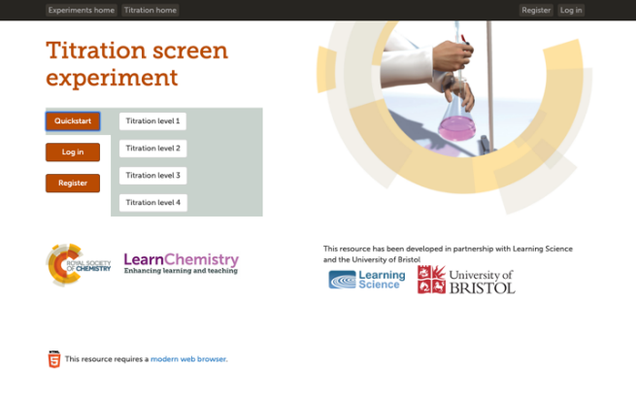

You will proceed through the simulation by answering questions and moving “glassware” and “equipment” to pretend to perform a titration. Each step will require you to press NEXT to move on. I am not concerned with you overall score. I would like you to answer the following questions as you go. If you get stuck, take a pic and send it to me so I can help if possible.

- On the fill in the blank section, some key information included:
  - When an acid and alkali react to form water and salt it is called ______________ reaction.
  - An indicator helps us to see the ____________________ during a titration experiment by causing a color change.
  - A titration experiment can be used to determine the ____________________ of acid using a known concentration of base.
- During the Weighing section, the + signs indicate large to small chunks of sample. What did “tare” mean on the balance?

- During the Standard Solution section, move glassware around and be sure to read the information on the left! Why would we have to rinse the beaker after transferring the solution?

- During the Alkali concentration section, we are performing calculations that are slightly different than we would in class. First we have to know the molar mass of NaOH and how to calculate the moles (see reference table T if you get stuck). But then you see this screen:
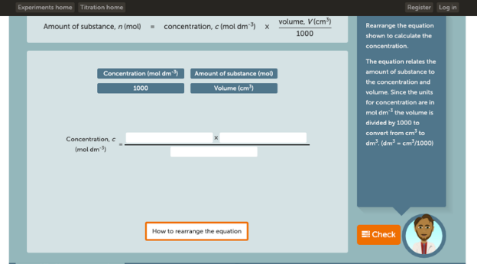
We wouldn’t calculate it this way with dm⁻³ because we use Liters. Try you best to find the appropriate pieces to fill the blanks. Your question is:
If we obtained 10 grams of NaOH (molar mass=40g/mol) and dissolved into 2500mL of water, what is the concentration in M?

- During the Preparing for Titration section, why does the pipette have to be rinsed with NaOH solution?

- During the Burette setup section,
  - in which direction, horizontal or vertical, does the valve need to be in order to stop the flow of solution through the burette?

  - Why should your eye be above the burette when filing the burette, but closer to the middle of the burette when reading the value?

- During the titration experiment section, fill out the data tables in the program and on this worksheet:
Sample site B | Trial | 1st accurate titration | 2nd accurate titration
Final reading (cm³)
Initial reading (cm³)
Volume added (cm³)
Average volume added (cm³)
Sample site C | Trial | 1st accurate titration | 2nd accurate titration
Final reading (cm³)
Initial reading (cm³)
Volume added (cm³)
Average volume added (cm³)

- During the Titration analysis section, you will get the following screens, which again, is not how we will calculate our values. So, do you best to move the numbers around but then answer the following questions:
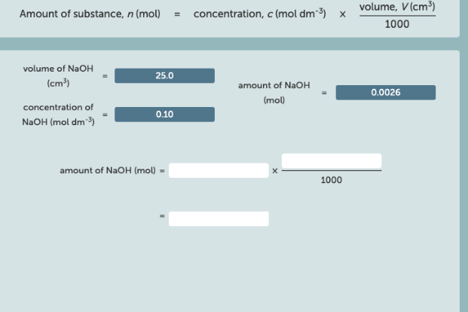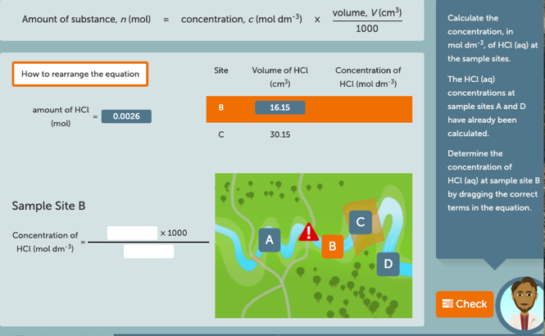
  - The formula we use to determine the Molarity of unknown acid is M_{A}V_{A}=M_{B}V_{B}. Using the average volume of 0.10M NaOH at Site B and the volume of HCl titrated was 10.0cm3 (also known as 10.0mL), calculate the Molarity of HCL at Site B.

  - The formula we use to determine the Molarity of unknown acid is M_{A}V_{A}=M_{B}V_{B}. Using the average volume of 0.10M NaOH at Site C and the volume of HCl titrated was 10.0cm3 (also known as 10.0mL), calculate the Molarity of HCL at Site C.

  - When the following screen appears, the map provides the measured pH values of sites A-D. Provide a brief summary of what happens to the acidity level as you travel down the water stream.
