Unit 2: Time of Death

Meaning of Death: End of life where an “irreversible cessation of circulation of blood” occurs and brain activity stopped.

Manner of Death: Means by which they died
- Natural
- Accidental
- Suicidal
- Homicidal
- Undetermined

Cause of Death: Reason they died
- Ex. Natural
  - Heart attack
  - Stroke
  - Respiratory failure
- Ex. Homicide/Suicide
  - Hanging
  - Drowning
  - Asphyxiation
  - Poison
  - Gunshot wound
    - Stippling (powder burns) indicating gun was a few inches away
    - Starring indicating barrel touching skin
  - Strangulation
    - Petechial hemorrhage as a result of strangulation

Mechanism of death: is the specific change in the body that brought about the end of life
- Cause: Shooting Mechanism: Loss of blood

Time of Death: When they died. Examples:

- Livor Mortis: pooling of blood in tissues after death (lividity)
  - Can determine if body was moved
  - Begins 1-2 hrs. after death
  - 2-8 hrs.: color disappears when skin is pressed
  - >8 hrs.: permanent discoloration
  - Factors affecting Livor Mortis
    - Hot day/area– blood pools faster
    - Cool day/area: slower process

- Rigor Mortis: stiffening of skeletal muscles after death
  - Cause: no oxygen to cells → calcium buildup → muscle fibers remain contracted
  - Starts 1-2 hrs. after death
  - Starts at head, travels to legs
  - 12 hrs: most rigid
  - Stiffness disappears after 24-48 hrs.
  - Factors affecting rigor mortis:
    - Ambient temperature
    - Person’s weight
    - Type of clothing
    - Illness
    - Level of physical activity shortly before death
    - Sun exposure

- Algor Mortis: cooling of body after death
  - Temperature loss in a corpse
  - Thermometer inserted in liver
  - 1 hr. after death: cools 1.4°F per hour
  - After 1st 12 hrs: cools 0.7°F per hour until it reaches surrounding temp.
  - Factors affecting algor mortis:
    - Cooler environment – lose heat faster
    - Windy – fast heat loss
    - Excess body fat – slows heat loss
    - Clothing – slows heat loss
  - Rule of thumb: 1°F per hour

- Stomach and intestinal contents:
  - 0-2 hours after last meal: undigested stomach contents present
  - 4-6 hours after meal: stomach empty, food in S.I.
  - 12+ hours after meal: S.I. empty, wastes in L.I.

- Changes of the eye:
  - Thin film on eye surface:
    - 2-3 hours (eyes open)
    - 24 hours (eyes closed)

- Insects (forensic entomology)
  - Flies and maggots also provide an approximate time of death, very useful for cases where the body has been long dead.
  - Only certain insects will feed and lay eggs on a dead corpse and forensic entomologists study these insects, their larvae cycles and thereafter can determine whether a body has been dead for just one day or up to 3 or 4 weeks.
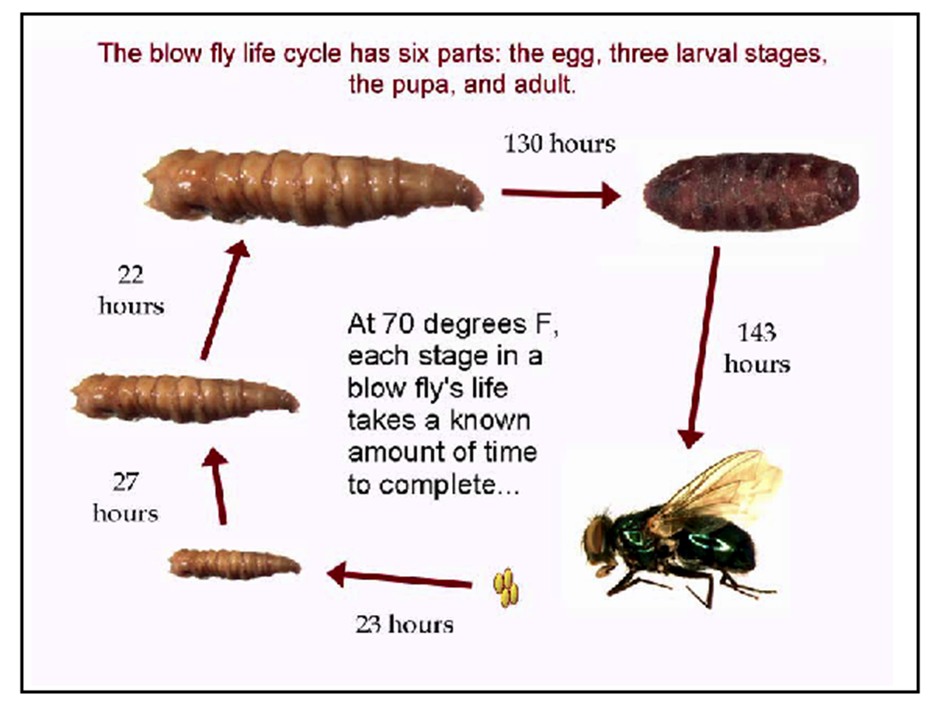
- 0-3 days: Proteins and carbohydrates in the Blowflies: Bluebottle flies, deceased body begin to break down. Syrphidae flies

- 4-7 days: Body is starting to decay and causes the Fly larvae and beetle
abdomen to inflate because of the gases inside.

- 8-18 days: Decay is well and truly setting in; the Ants, cockroaches, beetles and flies
abdomen wall begins to break down.

- 19-30 days: The decaying body enters a stage know Beetles and mites, Acari
as 'post-decay'; in wet, humid conditions, Nematocera, Brachycera
the body is sticky and wet; in hot dry conditions,
the body is dried out.

- 31 and over days: The bones, skin and hair that remain no
longer give off a powerful stench and smell
just like the soil surrounding it.

- Stages of Decomposition
  - 0-2 Days: Green, purplish stains. Skin: marbled appearance. Face discolored. Flies lay eggs on corpse

  - 4 Days: Skin blisters. Abdomen swells (CO₂ gas released by bacteria in intestines). Maggots on corpse

  - 6-10 Days: Corpse bloats with CO₂, chest and abdomen burst and collapse. Fluids leaks from body openings. Eyeballs and other tissues liquefy. Skin sloughs off. More eggs, maggots, flies, beetles

  - 10-20 Days: Bloated body collapses. Flattened body, creamy flesh. Strong smell of decay. Fluids drain and seep

