Name: _____________________________ Sticky Tape Lab

Background: In the electrolysis of water lab, the addition of electrical energy decomposes water into elemental hydrogen and oxygen. The gases were produced at different electrodes represented by the positive and negative terminals of the batteries. Perhaps electrical forces are somehow involved in the way elements are held together in compounds. We can infer the existence of an electrical force within matter from the spark generated when you touch a metal doorknob after walking across a carpet. Further evidence is provided by the observation that a balloon can be made to “stick” to a wall by rubbing it against your hair or a woolen sweater.

Pre-lab Questions:
- What characteristic might be added to our current model to allow it to explain, at the particle level, static electricity?

- What evidence do you have that the behavior of electrical forces varies among metals, nonmetals, and metalloids?

Part 1 – Preparing the Substances and Testing Attractive Forces
- Measure an approximately 15 cm length of transparent tape. Make a handle on one end by folding under the first 1 cm of tape, sticky side to sticky side. Place this tape flat on the lab table, sticky side down. This is the base tape.
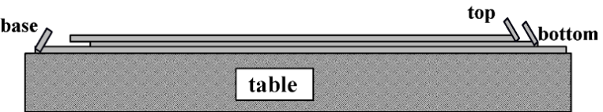
- Measure a second approximately 15 cm length of transparent tape, make a handle as before, and place this tape on top of the base tape, sticky side down, with the handle at the opposite end from the handle on the base tape. Label this tape “B” for bottom tape using a pen or a permanent marker.
- Attach a third similarly prepared strip of tape onto the bottom tape. The handle for the third tape should be at the same end as the bottom (B) tape. Label this tape “T” for top tape.
- Repeat steps 1 through 3 above twice, placing the second set of tapes about 5 cm from the first set.
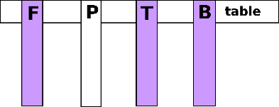
- Obtain 2 pieces of aluminum foil and 2 pieces of printer paper. Hang 1 piece of foil and 1 piece of paper from the edge of the table using tape (see illustration below). Keep other paper and foil to the side, on your table.
- Peel one set of T and B tapes from its base tape, keeping the T and B tapes together. Run your finger down the non-sticky side and then quickly peel the T and B tapes apart.
- Hang the T and B tapes next to the hanging foil and paper on the edge of the table. Repeat with the other set of tapes (peel T and B together from the base tape and then peel T and B apart). Keep this second T tape in one hand and the B tape in another.
- Foil to Foil. Investigate the interactions between these two substances by approaching the hanging piece of foil with the other piece of foil held in one hand. Describe your observations of the interaction between the two identical substances. (Do they attract, repel, or not interact?) Record in the data table below.
- Paper to Paper. repeat the foil process but with paper.
- Foil and Paper. Use this same approach to investigate interactions between the two different substances. Describe your observations of the interaction between the two dissimilar objects. Does the interaction between the foil and paper depend on whether the object is being held or is hanging from the table?
- T tape, B tape, Foil, and Paper: Holding a T tape in one hand and a B tape in the other, investigate all possible interactions between the substances. Describe your observations of the interaction observed as you bring the “T” and “B” tapes in your hand near each of the substances hanging from the table.
- Balloon: Rub a balloon on your shirt or hair provided by your instructor to develop an electrical charge on the balloon. Investigate the interactions between the balloon and the other four objects by approaching the hanging objects with the balloon. Describe your observations of the interaction between these objects. Does the balloon behave like the T tape or the B tape?
Holding Substance | Observed Interaction With Hanging Substance  (Attracted, Repelled, No Change)
 | Foil | Paper | T Tape | B Tape
Foil
Paper
T Tape
B Tape
Balloon

Post Lab Questions:
- We know that opposite charges attract and like repel.
  - How might something become charged?

  - What might neutral mean in terms of charged particles?

- IN PENCIL Draw a model at the particle level of the two pieces of tape as they approach one another.
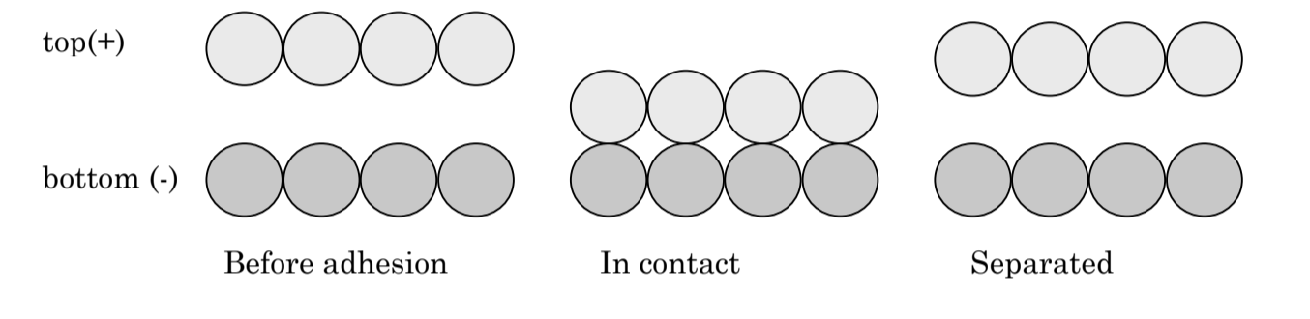
- Did your model account for conservation of mass? If not, fix it, and explain your answer.

- Did your model account for conservation of charge? If not, fix it, and explain your answer.

- Create a narrative to explain your model.

- Student A hypothesized the balloon was positively charged when rubbed on their shirt. Draw how the balloon would interact with each tape by placing the charges in the balloon and tape. Explain the charges you selected.
Top Tape Bottom Tape Explain:

- Student B hypothesized the balloon was negatively charged when rubbed on their shirt. Draw how the balloon would interact with each tape by placing the charges in the balloon and tape. Explain the charges you selected.
Top Tape Bottom Tape Explain:

- With the information you know so far, can you select which student is correct?

- “Charge is arbitrary.” Explain what the statement means based on your answers above.

Watch the video on Thompson’s Model before you move on to Part 2.
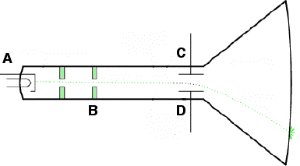
Part 2: Thomson's Model and Sticky Tape Let’s see how we can use Thomson’s model to explain the behavior of the sticky tape when we made our tape stacks. A diagram of the cathode ray tube is represented below. A is the anode. B are the alignment rods to control the path of the subatomic particle that Thompson discovered. C is a negative plate and D is a positive plate.

  - Based on your knowledge of chemistry, label C and D as positive or negative on the diagram. Then label the subatomic particle that is coming from the source, A.

  - Which subatomic particle was identified during the cathode ray tube experiment?

  - What is the charge of that subatomic particle?

  - If the atom is neutral, what additional charge must be in the atom besides the charge of the subatomic particle you identified above?

  - Which charges are able to move in an atom?

  - Based on your answer above, what charge did the balloon accrue as it was rubbed on a shirt?

  - A few atoms from the top tape and the bottom tape are represented in the diagram below. Electrons have been added to the atoms before adhesion. Now add electrons to each atom “in contact” and “separated” to show what happens to the electrons when we make a tape stack out of neutral pieces of tape and then pull them apart. Look back at your notes to make sure you have the charged particles moving in the correct direction.
Top after separation

Bottom after separation

Before adhesion In contact Separated

  - Describe the macroscopic changes in the tapes (what you observed when the tape was separated) and then provide a microscopic explanation based on Thomson’s model of the atom and your drawings (why it happened).

Part 3: Behavior of Foil and Paper with Charged Tapes

We observed that neither foil (metal atoms) nor paper (non-metal atoms) would attract each other. But foil and paper are both attracted to both the charged tapes (top and bottom). How can we use the pudding model of atoms to explain the differences we observed? Several atoms from the paper and foil are drawn below. The ones on the left have no charged object near them. The ones on the right are next to a top tape (+ charge).
- Add force vectors to the non-metal (paper) atoms and the top tape in the first row to show the attraction between the paper and the tape. Then do the same for the foil and the tape in the second row. Be sure the size of the vectors shows the relative strengths of the attractions.
- Now draw the electrons in each atom “bowl” to show their arrangements when no charged object is near present and then when a charged object is brought near.

Non-metal (paper)
Non-metal (paper)

Top Tape

Metal (Al foil)

Metal (Al foil)

Top Tape

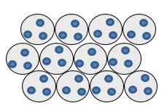

- Explain why these arrangements of electrons would produce the observed attractions.

Several atoms from the paper and foil are drawn below. The ones on the left have no charged object near them. The ones on the right are next to a bottom tape (- charge).
- Add force vectors to the non-metal (paper) atoms and the top tape in the first row to show the attraction between the paper and the tape. Then do the same for the foil and the tape in the second row. Be sure the size of the vectors shows the relative strengths of the attractions.
- Now draw the electrons in each atom “bowl” to show their arrangements when no charged object is near present and then when a charged object is brought near.

Non-metal (paper)
Non-metal (paper)

Bottom Tape

Metal (Al foil)

Metal (Al foil)

Bottom Tape

- Explain why these arrangements of electrons would produce the observed attractions.

- Go to https://phet.colorado.edu/en/simulations/balloons-and-static-electricity and view the simulation. Choose “show all charges’ and one balloon.
  - Rub the balloon on the sweater and describe what happens to the charges.

  - Bring the balloon towards the wall and describe what happens to the charges.

  - Does this simulation support or contradict your lab observations?

