Name: _____________________________________ States of Matter Lab: upload full lab
Guiding Question: How do different states of matter look at the particulate level?

Materials: syringes with caps (3), beaker of water, sand

Pre-Lab Questions:
- Based on your current understanding, draw a particle diagram for a solid, liquid, and gas in the boxes below.
Solid | Liquid | Gas
- How does the arrangement of particles differ between solids, liquids, and gases based on your models above?

- How does the movement of the particles differ between solids, liquids, and gases? (make sure this is clear in your model too)

Procedure A: Solids
- Fill your syringe with sand. Ensure that there are no air pockets in the syringe by pushing the plunger down to the top of the sand, pushing some out, then put the cap on. Record the initial reading.
- Push the plunger down as far as you can. Record the final value and find the difference.
Procedure B: Liquids
- Fill your syringe with water. Ensure that there are no air pockets by inverting the plunger, pushing on the plunger until water comes out. Then, put the cap on securely. Record the initial reading.
- Push the plunger down as far as you can. Record the final value and find the difference.
Procedure C: Gases
- Fill your syringe with air. Then, put the cap on securely. Record the initial reading.
- Push the plunger down as far as you can. Record the final value and find the difference.

Data
Sand initial |  | Water initial |  | Air initial
Sand final |  | Water final |  | Air final
Sand change |  | Water change |  | Air change

Analysis Questions:
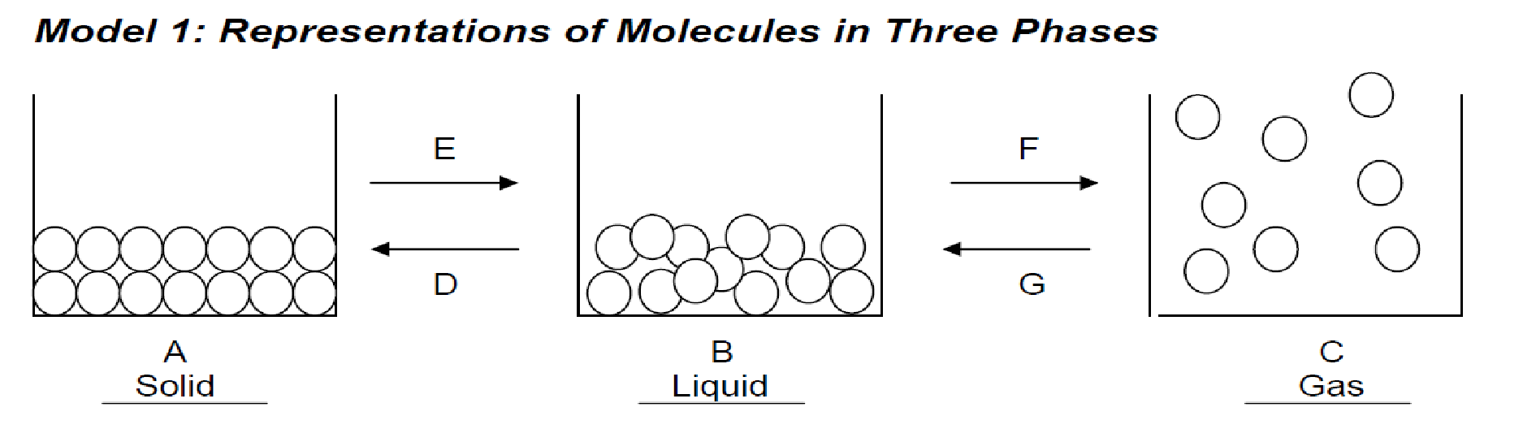
- Claim: Revise your models of solids liquids and gases and draw them in the boxes below.

- Evidence: Are you able to move the plunger for solids, liquids, or gases? Recheck your models for the pre-lab and consider the data you have collected. Which phase(s) should have space between the particles?

- Reasoning: What does this mean about the compressibility of these materials? (If the plunger can move, the material is compressible)

- Label the arrows using the word bank: Melting/fusing, Boiling/vaporization, Freezing, Condensation
- Which arrows represent phase changes that require heat to be added? Highlight them red.
- Which arrows represent phase changes that require heat to be removed? Highlight them blue.
- The word endothermic means energy is needed and is required for the process. Label the direction of endothermic reactions in the diagram.
- The word exothermic means energy is exiting or being released. Label the direction of exothermic reactions in the diagram.
- In the diagram below, write the states of matter in the boxes in order of increasing energy. Then, label the arrows with the correct phase changes: Freezing, Melting, Condensing, Boiling.

Energy

