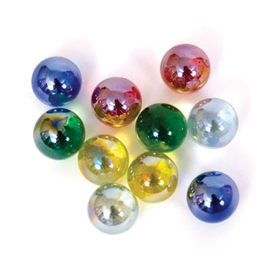
Name: _________________________ Specific Heat

Guiding Question: Which substance is a better conductor of heat: marbles or copper?

Pre-lab Questions:
- Explain what a calorimeter is used for.

- Circle the word(s) that best describe your understanding of heat conductivity. Then write a scientific explanation to defend the prediction you chose.
Prediction: Marbles have a (similar / different) heat conductivity value than copper.
Reasoning: __________________________________________________________________________
____________________________________________________________________________________
- What are the variables of this experiment?

- What should be the constants of this experiment?

Data: My group is testing the specific of ______________________. Record ALL measurements:

Calculations: Calculate the specific heat of your substance.

Compare your specific heat to a group that had a different substance.

Questions:
- The specific heat of glass is actually 0.840J/gC. Calculate the percent error.

- The specific heat of copper is actually 0.385J/gC. Calculate the percent error.

- Explain the transfer of heat between the marbles/copper and the water.

- Construct a claim that supports or contradicts the prediction made in the pre-lab questions.

- Provide evidence that supports your claim. Use your reasoning skills to explain why your evidence is relevant.

- Justify the steps you took to obtain the evidence you obtained.

