Vocabulary
For each word, provide a short but specific definition from YOUR OWN BRAIN! No boring textbook definitions. Write something to help you remember the word. Explain the word as if you were explaining it to an elementary school student. Give an example if you can. Don’t use the words given in your definition!
Solute: ____________________________________________________________________________________
Solvent: ___________________________________________________________________________________
Solution: __________________________________________________________________________________
Heterogeneous Mixture: _____________________________________________________________________
Vapor Pressure: ____________________________________________________________________________
Viscosity: __________________________________________________________________________________
Surface Tension: ____________________________________________________________________________
Solubility: _________________________________________________________________________________
Saturated: _________________________________________________________________________________
Unsaturated: _______________________________________________________________________________
Supersaturated: ____________________________________________________________________________
Concentrated: ______________________________________________________________________________
Dilute: ____________________________________________________________________________________
Molarity: __________________________________________________________________________________
Parts Per Million: ___________________________________________________________________________
Freezing Point Depression: ____________________________________________________________________
Boiling Point Elevation: _______________________________________________________________________
Chromatography: ___________________________________________________________________________
Precipitate: ________________________________________________________________________________

Video 8.1 Vapor Pressure

- When the vapor pressure reaches atmospheric pressure the liquid will undergo what phase change?

- We live at sea level which has a normal pressure of 1 atmosphere, or ___________ kPa. Since we live at normal pressure, our water boils at the normal boiling point for water: _______˚C.

- Find the vapor pressure using Table H:
  - Propanone at 25˚C: ___________, 50˚C: ___________, 75˚C: ___________.
  - Water at 85˚C: ___________, 100˚C: ___________, 110˚C: ___________.
  - Ethanoic acid at 95˚C: ___________, 100˚C: ___________, 120˚C: ___________.

- Give the boiling point using Table H:
  - Propane at 30kPa: ___________, 50kPa: ___________, 75 kPa: ___________.
  - Ethanol at 25kPa: ___________, 65kPa: ___________, 95 kPa: ___________.
  - Water at 15kPa: ___________, 70kPa: ___________, 105 kPa: ___________.

- What is the trend shown in table H for vapor pressure versus boiling point?

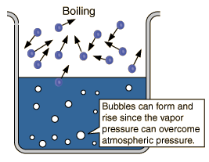
- Explain the trend in terms of particles of the gas and liquid phases.

- Which of the substances on table H has the weakest IMF?

- Which of the substances on table H has the strongest IMF?
Video 8.2 Solubility Rules
- Matter is classified as a pure substance or as a mixture of substances.
- Mixtures are composed of two or more different substances that can be separated by physical means. When different substances are mixed together, a homogeneous or ______________ mixture is formed.
- The proportions of components in a mixture can be varied. Each component in a mixture _____________ its original properties.
- Differences in properties such as density, particle size, molecular polarity, boiling point and freezing point, and solubility permit ______________ separation of the components of the mixture.
- A solution is a ____________________mixture of a solute dissolved in a solvent. The solubility of a solute in a given amount of solvent is dependent on the temperature, the pressure, and the chemical natures of the solute and solvent.
- Why does water have a strong surface tension and high viscosity?

- Give examples of homogeneous and heterogeneous mixtures:

- In sweet tea, what are the solute and solvent?

- Is sweet tea aqueous? How do you know?

- The solubility of sweet tea is 209 grams per 100 g of water at 20C. Explain what this means.

- What could you do to make more sweet tea sugar dissolve in the 100g of water?

- Will pressure affect the solubility of sweet tea? If so, how? If not, name a solution that wil be affected by changes in pressure.

- Using Table F decide if the following are soluble or insoluble:

  - NaNO₃ ______
  - Lithium Chloride ______
  - CaCO₃ ______
  - Magnesium Phosphate ______
  - PbCl₂ ______
  - Strontium sulfate ______
  - Na₂S ______
  - Ammonium hydroxide ______
Video 8.3 Saturation Curves
- When a solution is holding as much solute as it can at that temperature, the solution is called saturated. How can you tell a solution is saturated? Just by looking at it? Or do you have to do more?

- When a solution is unsaturated in can hold more solute at that temperature. How can you tell a solution is unsaturated?

- When a solution is supersaturated it is holding more solute than it should at that temperature. How can you make a supersaturated solution?

- What type/phase of solutes:
  - increase in solubility with an increase in temperature? ___________________
  - decrease in solubility with an increase in temperature? ___________________
  - increase in solubility with an increase in pressure? ___________________

- Using Table G, answer the following:
  - How many grams of KI dissolve at 10C? ___________________
  - How many grams of NaNO₃ dissolve at 10C? ___________________
  - Which salt is more concentrated at 10C, NaNO₃ or KI? ___________________
  - At what temperature will 30g of KCl dissolve? ___________________
  - At what temperature will 60 grams of NH₄Cl dissolve? ___________________
  - How many more grams of KClO₃ will dissolve if the temperature is changed from 20C to 50C?

  - How many grams will precipitate out of KNO₃ if the temperature is changed from 60C to 0C?

  - 40g of NaCl is added to 100 g of water at 100C. What type of solution is this? _______________
  - 20 grams of KClO₃ is added to 100g of water at 40C. What type of solution is this? ___________
  - 10 g of NH₃ is added to 100g of water at 70C. What type of solution is this? ________________

Video 8.4 Concentration
- The concentration of a solution may be expressed as _____________________ (M), percent by volume, percent by mass, or parts per _______________ (ppm).
- Give an example of a solution that could be concentrated but unsaturated.

- Give an example of a solution that is dilute but supersaturated.

- A solution is created with 2 moles of NaCl in 1.5L of solution. Calculate the molarity.

- A solution is created with 3.5 moles of NaCl in 250mL of solution. Calculate the molarity.

- A solution is created with 25.0 grams of NaCl in 1.0L of solution. Calculate the molarity.

- A solution is created with 150 grams of NaCl in 1250mL of solution. Calculate the molarity.

- For questions 4-7 which was the most concentrated solution? _____ The most dilute? _______

Video 8.5 Percent and Parts Per Million
Percent What key words do you have to look for when answering these questions? ______________________

- Calculate the percent by mass of 25.0 grams of NaCl in 150 grams of solution.

- Calculate the percent by mass of 150 grams of NaCl in 1250 grams of water.

Parts Per Million: If you are the only person who wins the Mega millions and 259 million people play, what is your part per million?
- Calculate the parts per million of 2.0 grams of NaCl in 15000 grams of solution.

- Calculate the parts per million of 1.50 grams of NaCl in 8000 grams of water.

Video 8.6 Colligative Properties
- The addition of a nonvolatile solute to a solvent causes the boiling point of the solvent to _____________ and the freezing point of the solvent to ______________. The greater the concentration of particles, the greater the effect.

- What is the freezing point of water at standard pressure in degrees Celsius? ___________

- What is the boiling point of water at standard pressure in degrees Celsius? ___________

- What happens to the freezing point of water when a solute is added? Why?

- What happens to the boiling point of water when a solute is added? Why?

- Give an example of freezing point depression in your life.

- Give an example of boiling point elevation in your life.

- Which solute will raise the temperature of boiling the highest? Circle one. Explain your answer.

NaCl CaCl₂ C₆H₁₂O₆ Ca₃(PO₄)₂

- Which solute will lower the temperature of freezing the least? Circle one. Explain your answer.

NaCl CaCl₂ C₆H₁₂O₆ Ca₃(PO₄)₂

Regents Review Questions

- Hydrogen bonding is a type of
  - strong covalent bond B) weak ionic bond
C) strong intermolecular force D) weak intermolecular force

- The relatively high boiling point of water is due to water having
  - hydrogen bonding B) metallic bonding
C) nonpolar covalent bonding D) strong ionic bonding

- Water has a higher melting point than hydrogen fluoride. What is the main reason for this?
  - Water forms more extensive hydrogen bonds than hydrogen fluoride.
  - The covalent bond between O and H is stronger than that between F and H.
  - Water contains more ions than hydrogen fluoride.
  - Water is more polar than hydrogen fluoride.

- At 298 K, the vapor pressure of H₂O is less than the vapor pressure of CH₃OH because H₂O has
  - larger molecules B) a larger molecular mass
C) stronger ionic bonds D) stronger hydrogen bonds

- At 50.°C and standard pressure, intermolecular forces of attraction are strongest in a sample of
  - ethanoic acid B) ethanol C) propanone D) water

- At which temperature is the vapor pressure of ethanol equal to 80. kPa?
A) 48C B) 73C C) 80C D) 101C

- Which liquid has the lowest vapor pressure at 65°C?
  - ethanoic acid B) ethanol C) propanone D) water

- Which compound has the lowest vapor pressure at 50°C?
  - ethanoic acid B) ethanol C) propanone D) water

- Which liquid has the highest vapor pressure at 75°C?
  - ethanoic acid B) ethanol C) propanone D) water

- According to Reference Table H, what is the vapor pressure of propanone at 45°C?
  - 22 kPa B) 33 kPa C) 70 kPa D) 98 kPa

- As the temperature of a liquid increases, its vapor pressure
  - Decreases B) increases C) remains the same

- The graph below represents the vapor curves of four liquids. (Standard pressure is 760mmHg)
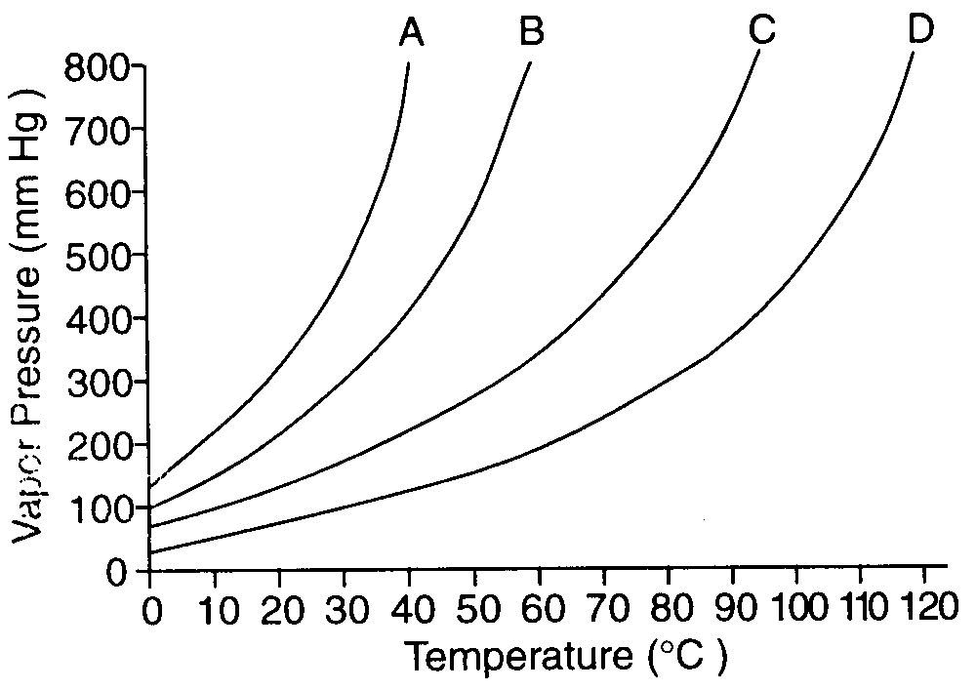
Which liquid has the highest normal boiling point?
  - A B) B C) C D) D

- Which sample of water will have the highest vapor pressure?
  - 10.0 ml at 62°C B) 20.0 ml at 52°C C) 30.0 ml at 42°C D) 40.0 ml at 32°C

- The vapor pressure of ethanol at its normal boiling point is
  - 80 kPa B) 100 kPa C) 101.3 kPa D) 273 kPa

- The graph below represents the relationship between the vapor pressure and temperature of 4 liquids.
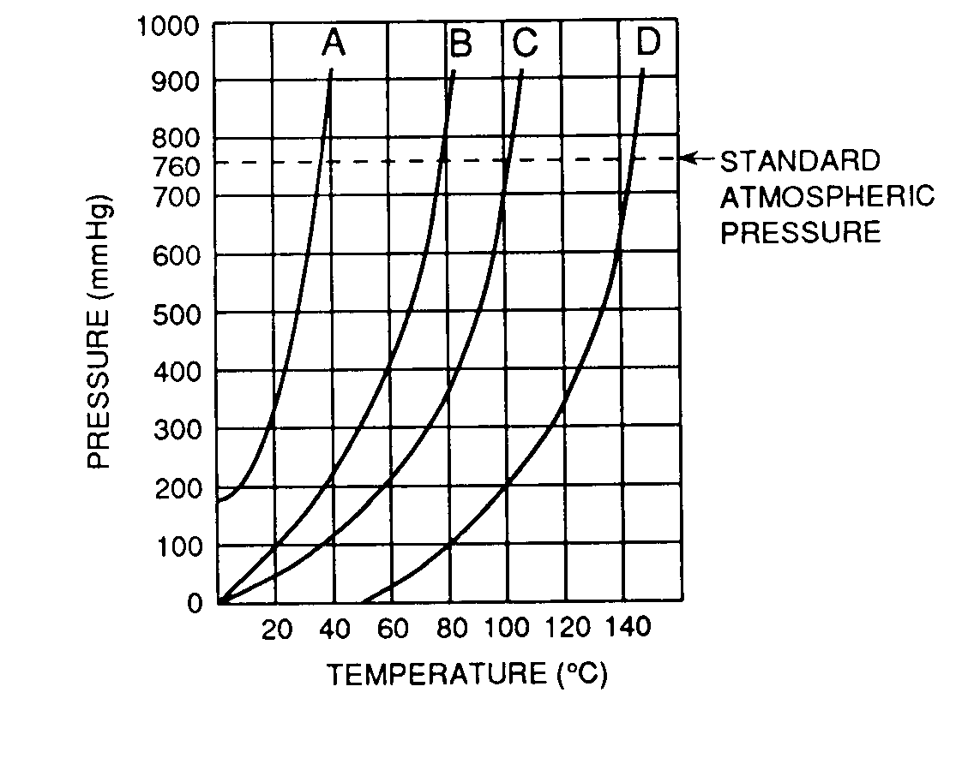
Which liquid has a normal boiling point of 79°C?
  - A B) B C) C D) D

- An aqueous solution of sodium chloride is best classified as a
  - homogeneous compound B) homogeneous mixture
C) heterogeneous compound D) heterogeneous mixture

- Which formula represents a homogeneous mixture?
  - H₂O() B) H₂S(g) C) NaH(s) D) HCl(aq)

- When sample X is passed through a filter paper a white residue, Y, remains on the paper and a clear liquid, Z, passes through. When liquid Z is vaporized, another white residue remains. Sample X is best classified as
  - an element B) a compound
C) a heterogeneous mixture D) a homogeneous mixture

- A mixture of sand and table salt can be separated by filtration because the substances in the mixture differ in
  - boiling point B) density at STP
C) freezing point D) solubility in water

- A bottle of rubbing alcohol contains both 2-propanol and water. These liquids can be separated by the process of distillation because the 2-propanol and water
  - have combined chemically and retain their different boiling points
  - have combined chemically and have the same boiling point
  - have combined physically and retain their different boiling points
  - have combined physically and have the same boiling point

- Given the diagram representing a process being used to separate the colored dyes in food coloring:
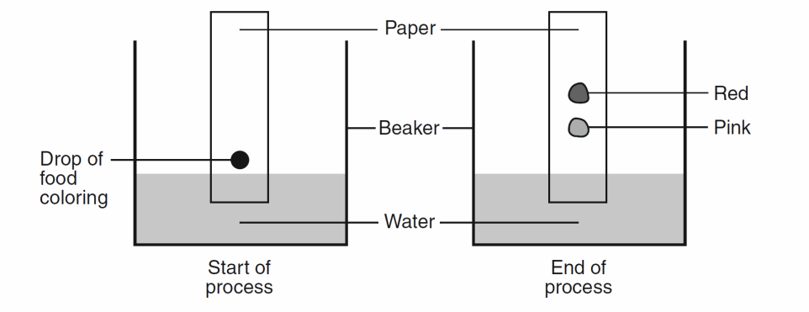
Which process is represented by this diagram?
  - chromatography B) electrolysis C) distillation D) titration

- Which compound is insoluble in water?
  - calcium bromide B) potassium bromide
C) silver bromide D) sodium bromide

- Which compound is insoluble in water?
  - BaSO₄ B) CaCrO₄ C) KClO₃ D) Na₂S

- Which ion, when combined with chloride ions, Cl–, forms an insoluble substance in water?
  - Fe2+ B) Mg2+ C) Pb2+ D) Zn2+

- Based on Reference Table F, which of these saturated solutions has the lowest concentration of dissolved ions?
  - NaCl(aq) B) MgCl₂(aq) C) NiCl₂(aq) D) AgCl(aq)

- According to Reference Table F, which substance is most soluble?
  - AgI B) CaSO₄ C) PbCl₂ D) (NH₄)₂CO₃

- In an aqueous solution of potassium chloride, the solute is
  - Cl B) K C) KCl D) H₂O

- Which compound is most soluble in water?
  - silver acetate B) silver chloride C) silver hydroxide D) none, all are insoluble

- Under which conditions of temperature and pressure is a gas most soluble in water?
  - high temperature and low pressure B) high temperature and high pressure
C) low temperature and low pressure D) low temperature and high pressure

- At which temperature can water contain the most dissolved oxygen at a pressure of 1 atmosphere?
A) 10.ºC B) 20.ºC C) 30.ºC D) 40.ºC

- A change in pressure would have the greatest effect on the solubility of a
  - solid in a liquid B) gas in a liquid
C) liquid in a liquid D) liquid in a solid

- Which change will cause the solubility of KNO₃(s) to increase?
  - decreasing the pressure C) increasing the pressure
  - decreasing the temperature D) increasing the temperature

- At standard pressure, which substance becomes less soluble in water as temperature increases from 10.°C to 80.°C?
  - HCl B) KCl C) NaCl D) NH₄Cl

- An unsaturated aqueous solution of NH3 is at 90°C in 100. grams of water. According to Reference Table
G, how many grams of NH₃ could this unsaturated solution contain?
A) 5 g B) 10. g C) 15 g D) 20. G

- According to your Reference Tables, which substance forms an unsaturated solution when 80 grams of the substance is dissolved in 100 grams of H2O at 10°C?
  - KI B) KNO₃ C) NaNO₃ D) NaCl

- Solubility data for four different salts in water at 60°C are shown in the table below.
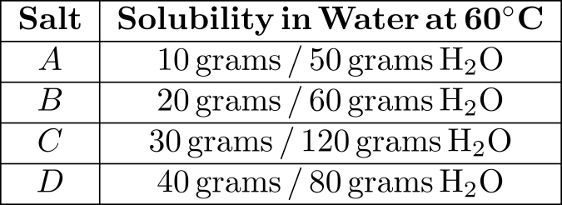
Which salt is most soluble at 60°C?
  - A B) B C) C D) D

- According to Reference Table G, how many grams of KNO₃ would be needed to saturate 200 grams of water at 70ºC?
A) 43 g B) 86 g C) 134 g D) 268 g

- According to Reference Table G, how does a decrease in temperature from 40°C to 20°C affect the solubility of NH₃ and KCl?
  - The solubility of NH3 decreases, and the solubility of KCl decreases.
  - The solubility of NH3 decreases, and the solubility of KCl increases.
  - The solubility of NH3 increases, and the solubility of KCl decreases.
  - The solubility of NH3 increases, and the solubility of KCl increases.

- As the temperature increases from 0ºC to 25ºC the amount of NH₃ that can be dissolved in 100 grams of water
  - decreases by 10 grams B) decreases by 40 grams
C) increases by 10 grams D) increases by 40 grams

- According to Reference Table G, a temperature change from 10°C to 30°C would have the least effect on the solubility of
  - NaCl B) KClO3 C) NH3 D) SO2

- The graph below represents four solubility curves. Which curve best represents the solubility of a gas in water?
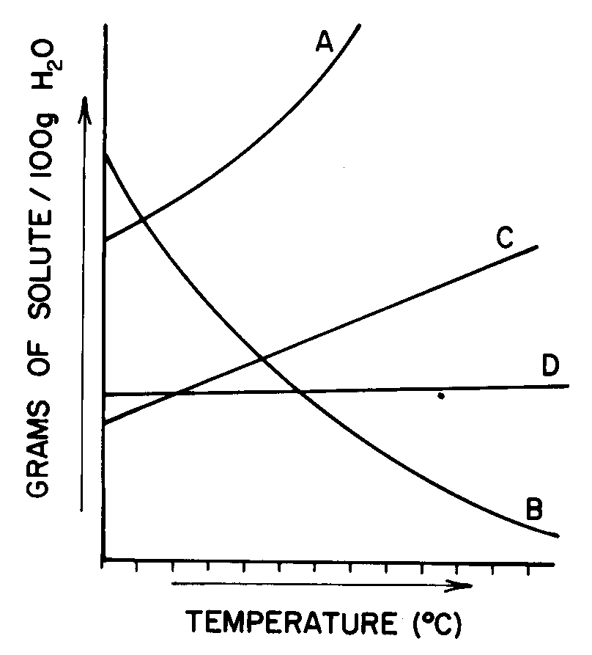
  - A B) B C) C D) D

- When 5 grams of KCl are dissolved in 50. grams of water at 25°C, the resulting mixture can be described as
  - heterogeneous and unsaturated B) heterogeneous and supersaturated
C) homogeneous and unsaturated D) homogeneous and supersaturated

- A solution contains 130 grams of KNO₃ dissolved in 100 grams of water. When 3 more grams of KNO₃ is added, none of it dissolves, nor do any additional crystals appear. The temperature of the solution is closest to
A) 65ºC B) 68ºC C) 70ºC D) 72ºC

- A solution containing 90. grams of KNO₃ per 100. grams of H2O at 50.°C is considered to be
  - dilute and unsaturated B) dilute and supersaturated
C) concentrated and unsaturated D) concentrated and supersaturated

- A solution contains 90 grams of a salt dissolved in 100 grams of water at 40ºC. The solution could be an unsaturated solution of
  - KCl B) KNO₃ C) NaCl D) NaNO₃

- According to Reference Table G, how many grams of NH₄Cl must be dissolved in 100 grams of H2O at 70ºC to reach solution equilibrium?
A) 52 g B) 56 g C) 62 g D) 86 g

- What is the total number of grams of potassium chloride needed to saturate exactly 300 grams of water at 10°C?
A) 60 B) 70 C) 80 D) 90

- A solution containing 55 grams of NH₄Cl in 100. grams of water is saturated at a temperature of
A) 47ºC B) 57ºC C) 67ºC D) 77ºC

- The molarity of an aqueous solution of NaCl is defined as the
  - grams of NaCl per liter of water B) grams of NaCl per liter of solution
C) moles of NaCl per liter of water D) moles of NaCl per liter of solution

- Which unit can be used to express solution concentration?
  - J/mol B) L/mol C) mol/L D) mol/s

- How many moles of solute are contained in 200 milliliters of a 1 M solution?
A) 1 B) 0.2 C) 0.8 D) 200

- Which preparation produces a 2.0 M solution of C₆H₁₂O₆? [molecular mass = 180.0]
  - 90.0 g of C₆H₁₂O₆ dissolved in 500.0 mL of solution
  - 90.0 g of C₆H₁₂O₆ dissolved in 1000. mL of solution
  - 180.0 g of C₆H₁₂O₆ dissolved in 500.0 mL of solution
  - 180.0 g of C₆H₁₂O₆ dissolved in 1000. mL of solution

- What is the total number of moles of solute in 2.0 liters of 3.0 M NaOH?
  - 1.0 mole B) 2.0 moles C) 3.0 moles D) 6.0 moles

- What is the total number of grams of HI in 0.500 liter of 1.00 M HI?
A) 1.00 g B) 0.500 g C) 64.0 g D) 128 g

- What is the total number of grams of NaOH (formula mass = 40.) needed to make 1.0 liter of a 0.20 M solution?
A) 20. g B) 2.0 g C) 80. g D) 8.0 g

- What is the molarity of an H2SO4 solution if 0.25 liter of the solution contains 0.75 mole of H2SO4?
A) 0.33 M B) 0.75 M C) 3.0 M D) 6.0 M

- When 20. milliliters of 1.0 M HCl is diluted to a total volume of 60. milliliters, the concentration of the resulting solution is
A) 1.0 M B) 0.50 M C) 0.33 M D) 0.25 M

- If 100. milliliters of a 1.0-molar NaCl solution is evaporated to 25 milliliters, what will be the concentration of the resulting NaCl solution?
A) 0.25 M B) 2.0 M C) 0.50 M D) 4.0 M

- Which solution contains exactly 0.50 mole of H₂SO₄?
  - 1.0 L of a 1.0 M solution B) 2.0 L of a 1.0 M solution
C) 1.0 L of a 0.50 M solution D) 2.0 L of a 0.50 M solution

- What is the molarity of a solution that contains 30. grams of NaOH in 500. milliliters of solution?
A) 0.75 M B) 1.3 M C) 1.5 M D) 2.6 M

- What is the molarity of a solution of KNO₃ (molecular mass = 101) that contains 404 grams of KNO₃ in
2.00 liters of solution?
A) 1.00 B) 2.00 C) 0.500 D) 4.00

- Which type of concentration is calculated when the grams of solute is divided by the grams of the solution, and the result is multiplied by 1,000,000?
  - molarity B) parts per million
C) percent by mass D) percent by volume

- Which unit can be used to express the concentration of a solution?
  - L/s B) J/g C) ppm D) kPa

- If 0.025 gram of Pb(NO₃)₂ is dissolved in 100. grams of H₂O, what is the concentration of the resulting solution, in parts per million?
A) 2.5 × 10–4 ppm B) 2.5 ppm C) 250 ppm D) 4.0 × 103 ppm

- What is the concentration of a solution, in parts per million, if 0.02 gram of Na₃PO₄ is dissolved in 1000 grams of water?
  - 20 ppm B) 2 ppm C) 0.2 ppm D) 0.02 ppm

- What is the concentration expressed in parts per million of a solution containing 15.0 grams of KNO₃ in
65.0 grams of H2O?
A) 1.88 × 105 ppm B) 2.00 × 105 ppm C) 2.31 × 105 ppm D) 5.33 × 106 ppm

- What is the total mass of solute in 1000. grams of a solution having a concentration of 5 parts per million?
A) 0.005 g B) 0.05g C) 0.5 g D) 5g

- Compared to pure water, an aqueous solution of calcium chloride has a
  - higher boiling point and higher freezing point
  - higher boiling point and lower freezing point
  - lower boiling point and higher freezing point
  - lower boiling point and lower freezing point

- Which concentration of a solution of CH₃OH in water has the lowest freezing point?
A) 0.1 M B) 0.01 M C) 0.001 M D) 0.0001 M

- A 1 kilogram sample of water will have the highest freezing point when it contains
  - 1 × 1017 dissolved particles B) 1 × 1019 dissolved particles
C) 1 × 1021 dissolved particles D) 1 × 1023 dissolved particles

- Which solution will freeze at the lowest temperature?
  - 1 mole of sugar in 500 g of water B) 1 mole of sugar in 1,000 g of water
C) 2 moles of sugar in 500 g of water D) 2 moles of sugar in 1,000 g of water

