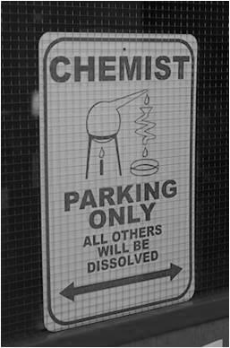



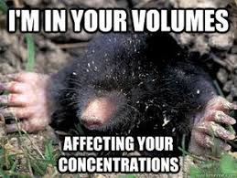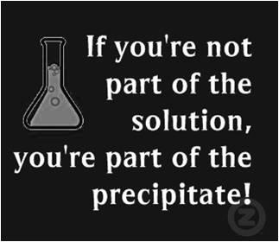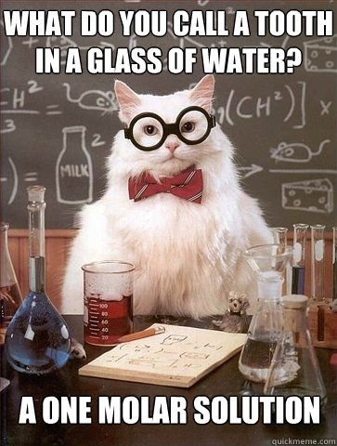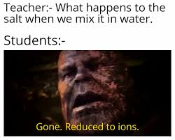

**Vapor Pressure**

Liquids evaporate when they are left in the open air. This is also known as ____________________. Liquids also go through this phase changed in closed containers. The vapor that is produced in either container exerts a pressure on top of the liquid phase. This pressure is known as _________________ ____________________. In order for the vapor to escape its original liquid phase completely its pressure must overcome the regular atmospheric pressure above it. As temperature of the liquid increases, the number of particles evaporating ____________________ and the vapor pressure ____________________. Therefore, temperature and vapor pressure have a direct correlation. Under high atmospheric pressure, the liquid will have a harder time escaping the liquid phase so the temperature at which it boils is higher than normal. Under low atmospheric pressure, the liquid will have an easier time escaping the liquid phase so the temperature at which it boils is_________________ than normal.

**Use Table H to answer these questions:**

1. Which substance has the lowest boiling point? ____________________
2. Which substance has a normal boiling point of 100C? ____________________
3. What is the normal boiling point of propanone? ____________________
4. Which substance has the highest vapor pressure at 40C? ____________________
5. At what pressure will water boil at 90C? ____________________
6. At what pressure will propanone boil at 20C? ____________________
7. What temperature will ethanoic acid boil at 48kPa? ____________________
8. What temperature will water boil at 110kPa? ____________________
9. Which substance has the greatest IMF? ____________________
10. Observe the demonstration of water, ethanol, and propanone provide by your teacher.

|  |  |
| --- | --- |
| **Observations:** | **Diagram:** |
| **Narrative:** | |

**Liquid Demo**

|  |  |
| --- | --- |
| **Before** | **After** |
| Sketch the 3 layers of liquids in the first cylinder before shaking. Label each layer and sketch structures for each of the molecules in the layers. Identify the liquids as polar or non-polar based on your structures. | Sketch the appearance of the contents of the cylinder after shaking. In which layer (hexane or water) did the methanol appear to dissolve? From the class discussion, what generalization was made about polarity and solubility? |
| Sketch the 3 layers of liquids in the second cylinder before shaking. Label each layer and sketch the structures for the 1,1-dichloroethane. Predict whether this liquid would dissolve in the organic or aqueous phase; explain your prediction. | Sketch the appearance of the contents of the cylinder after shaking. In which layer (hexane or water) did the dichlorethane appear to dissolve? Explain what modification should be made to the generalization about solubility. |
| Sketch the 3 layers of liquids in the third cylinder before shaking. Label each layer and sketch the structures for the acetone. Predict whether this liquid would dissolve in the organic or aqueous phase; explain your prediction. | Sketch the appearance of the contents of the cylinder after shaking. In which layer(s) - hexane or water - did the acetone appear to dissolve? Explain what is problematic about the generalization "like dissolves like". |

**Structures of Molecules and IMF**

Use your knowledge of intermolecular forces (IMFs)to determine whether each molecule is **polar or non-polar**. For polar molecules, determine if they are capable of forming **hydrogen bonds** with another molecule like it. Circle the atoms in the molecule that give it that capability.

H2O CH3CH2CH2CH2CH3 CH3OH

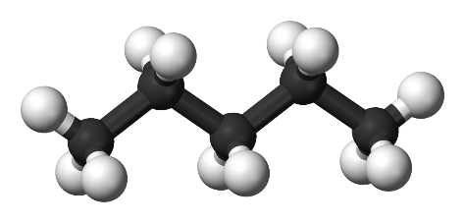

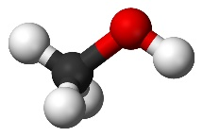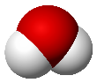

Water Pentane Methanol

CHCl2CH3 CH3COCH3

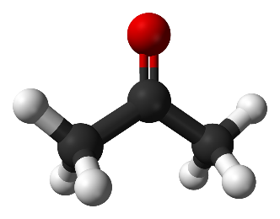

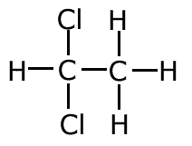

1,1-dichloroethane Acetone

Alcohol Solubility (WB Activity)

Examine the solubility information for methanol and pentanol below. Explain the difference in the solubility of each alcohol. Draw particle diagrams of the interactions between each alcohol and water molecules to support your explanation.

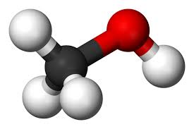

Methanol   CH3OH        miscible

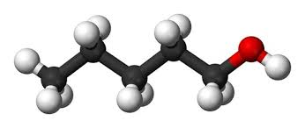

Pentanol   C5H11OH   2.7g/100g solubility

**Solubility Table F**

Use Table F to determine if the following compounds are soluble or insoluble.

|  |  |  |
| --- | --- | --- |
| a. NaCl | e. K3PO4 | i. calcium hydroxide |
| b. PbBr2 | f. MgCO3 | j. copper (II) hydroxide |
| c. CaSO4 | g. NH4NO3 | k. lead(II) sulfate |
| d. K2CrO4 | h. sodium hydrogen  carbonate | l. ammonium sulfide |

|  |  |  |  |  |  |  |  |  |  |  |  |  |  |  |
| --- | --- | --- | --- | --- | --- | --- | --- | --- | --- | --- | --- | --- | --- | --- |
| ***Key:***  ***I – Insoluble***  ***S – Soluble*** | **Acetate** | **Bromide** | **Carbonate** | **Chlorate** | **Chloride** | **Chromate** | **Hydroxide** | **Hydrogen Carbonate** | **Iodide** | **Nitrate** | **Perchlorate** | **Phosphate** | **Sulfate** | **Sulfide** |
| **Aluminum** |  |  |  |  |  |  |  |  |  |  |  |  |  |  |
| **Ammonium** |  |  |  |  |  |  |  |  |  |  |  |  |  |  |
| **Barium** |  |  |  |  |  |  |  |  |  |  |  |  |  |  |
| **Calcium** |  |  |  |  |  |  |  |  |  |  |  |  |  |  |
| **Dimercury** |  |  |  |  |  |  |  |  |  |  |  |  |  |  |
| **Copper II** |  |  |  |  |  |  |  |  |  |  |  |  |  |  |
| **Iron II** |  |  |  |  |  |  |  |  |  |  |  |  |  |  |
| **Iron III** |  |  |  |  |  |  |  |  |  |  |  |  |  |  |
| **Lithium** |  |  |  |  |  |  |  |  |  |  |  |  |  |  |
| **Lead** |  |  |  |  |  |  |  |  |  |  |  |  |  |  |
| **Magnesium** |  |  |  |  |  |  |  |  |  |  |  |  |  |  |
| **Potassium** |  |  |  |  |  |  |  |  |  |  |  |  |  |  |
| **Silver** |  |  |  |  |  |  |  |  |  |  |  |  |  |  |
| **Sodium** |  |  |  |  |  |  |  |  |  |  |  |  |  |  |
| **Strontium** |  |  |  |  |  |  |  |  |  |  |  |  |  |  |
| **Zinc** |  |  |  |  |  |  |  |  |  |  |  |  |  |  |

Net Ionic Equations Activity

1. Observe the reaction between aqueous cobalt (II) nitrate and aqueous sodium carbonate. Imagine how they look at the molecular level.
2. Write the molecular equation for this reaction:
3. Write the balanced net ionic equation for this reaction:
4. What is/are the spectators in this reaction?
5. What is the precipitate’s name?
6. Draw the reactants before the reaction.

 

Key

1. Draw the products after the reaction. (Be aware of how many of each ion you started with.)



1. Observe the reaction between aqueous Barium chloride and sodium sulfate. Imagine how they look at the molecular level.
   1. Write the molecular equation for this reaction:
   2. Write the balanced net ionic equation for this reaction:
   3. What is/are the spectators in this reaction?
   4. What is the precipitate’s name?
   5. Draw the reactants before the reaction.

 

Key

* 1. Draw the products after the reaction. (Be aware of how many of each ion you started with.)



1. Observe the reaction between aqueous copper (II) chloride and sodium carbonate. Imagine how they look at the molecular level.
   1. Write the molecular equation for this reaction:
   2. Write the balanced net ionic equation for this reaction:
   3. What is/are the spectators in this reaction?
   4. What is the precipitate’s name?
   5. Draw the reactants before the reaction.

 

Key

* 1. Draw the products after the reaction. (Be aware of how many of each ion you started with.)



1. Observe the reaction between aqueous lead (II) nitrate and sodium iodide. Imagine how they look at the molecular level.
2. Write the molecular equation for this reaction:
3. Write the balanced net ionic equation for this reaction:
4. What is/are the spectators in this reaction?
5. What is the precipitate’s name?
6. Draw the reactants before the reaction and the products after.

  

Key

5. Double replacement reactions require the cations to switch with the anions. Identify which of the following DR reactions are written correctly. Correct the mistakes in the wrong reactions:

a. (NH4)3PO4(aq) + AlCl3(aq) 🡪 Al(PO4)3(s) + NH4Cl3(aq) ____________________________________

b. NaCl(aq) + AgNO3(aq) 🡪 AgCl(S) + NaNO3(aq) ____________________________________

c. NaBr(aq) + PbI2(aq) 🡪 NaI(aq) ____________________________________________________

d. K2SO4(aq) + BaI2(aq) 🡪 BaSO4(s) + 2KI(aq) ____________________________________

e. CaCl2(aq) + Li2CO3(aq) 🡪 2LiCl(s) + CaCO3(aq) ____________________________________

**Solubility Table G**

1. Check the conditions under which each of the following solutes will be most soluble.

|  |  |  |  |  |  |  |  |  |
| --- | --- | --- | --- | --- | --- | --- | --- | --- |
| **Solute Name** | **Solute Formula** | **Temperature** | | **Pressure** | | | **Best Solvent** | |
| **Low** | **High** | **Low** | **High** | **No Effect** | **H2O** | **CCl4** |
| potassium nitrate | KNO3(s) |  |  |  |  |  |  |  |
| hydrogen chloride | HCl(g) |  |  |  |  |  |  |  |
| nitrogen trihydride | NH3(g) |  |  |  |  |  |  |  |
| ammonium chloride | NH4Cl(s) |  |  |  |  |  |  |  |
| carbon dioxide | CO2(g) |  |  |  |  |  |  |  |
| potassium iodide | KI(s) |  |  |  |  |  |  |  |
| potassium chlorate | KClO3(s) |  |  |  |  |  |  |  |

1. Observe the demonstration of unsaturated, saturated, and supersaturated solutions.

|  |  |
| --- | --- |
| **Observations:** | **Diagram:** |
| **Graphical:** | **Narrative:** |

1. State whether each of the following solutions is *saturated, unsaturated, or supersaturated*.

(a) 80 g NaNO3 in 100 g H2O at 10ºC ___________________________

(b) 75 g NaNO3 in 100 g H2O at 10ºC ___________________________

(c) 90 g NaNO3 in 100 g H2O at 10ºC ___________________________

(d) 90 g KNO3 in 100 g H2O at 50ºC ___________________________

(e) 90 g KI in 100 g H2O at 50ºC ___________________________

(f) 5 g KClO3 in 100 g H2O at 5ºC ___________________________

(g) 40 g KCl in 50 g H2O at 60ºC ___________________________

(h) 35 g NaNO3 in 50 g H2O at 10ºC ___________________________

(i) 5 g KClO3 in 50 g H2O at 5ºC ___________________________

(j) 5 g KClO3 in 200 g H2O at 5ºC ___________________________

(k) 30 g NH4Cl in 200 g H2O at 10ºC ___________________________

(l) 40 g SO2 in 200 g H2O at 5ºC ___________________________

1. Tell how many MORE grams of each solute must be added to 100 g of water to form a saturated solution at that temperature.

|  |  |  |  |  |  |  |  |
| --- | --- | --- | --- | --- | --- | --- | --- |
| **Grams Solute per**  **100 g H2O** | **Solute Added to make Saturated** |  | **Grams Solute per**  **100 g H2O** | **Solute Added to make Saturated** |  | **Grams Solute per**  **100 g H2O** | **Solute Added to make Saturated** |
| a. 35 g KNO3 at 40ºC |  |  | d. 35 g NaCl at 90ºC |  |  | g. 25 g NH3 at 5ºC |  |
| b. 50 g NH3 at 10ºC |  |  | e. 5 g NH3 at 90ºC |  |  | h. 30 g NaNO3 at 50ºC |  |
| c. 15 g KCl at 75ºC |  |  | f. 10 g KClO3 at 40ºC |  |  | i. 15 g KClO3 at 75ºC |  |

1. Tell how many grams of each solute will crystallize/precipitate/settle. Assume all solutions are saturated and in 100 grams of H2O.

|  |  |  |  |  |
| --- | --- | --- | --- | --- |
| **Amount cooled** | **Amount Precipitated** |  | **Amount cooled** | **Amount Precipitated** |
| a. KNO3 (aq) is cooled  from 70ºC to 40ºC |  |  | d. NaCl (aq) is cooled  from 100ºC to 40ºC |  |
| b. NH4Cl (aq) is cooled  from 90ºC to 20ºC |  |  | e. KNO3 (aq) is cooled  from 65ºC to 25ºC |  |
| c. KCl (aq) is cooled  from 55ºC to 30ºC |  |  | f. KClO3 (aq) is cooled  from 100ºC to 40ºC |  |

1. Rank the following solids in order from least to most soluble in 100 g H2O at 50ºC :

NH4Cl, NaNO3, KClO3, KNO3

**Molarity**

**Molarity** is one way to calculate concentration, or the amount of “small stuff” in your “total stuff.”

Define molarity in scientific terms:

1. Calculate the molarity of each of the following solutions:
   1. 2.50 mol of NaOH in 0.500 L of solution c. 1.80L of solution containing 3.30mol KNO3
   2. 7.50 mol of NaOH in 500.mL of solution d. 0.00800 mol of K2SO4 in 1500.mL of solution
2. Calculate the total moles of solute in each of the following solutions:
   1. 1.70L of 0.350M NaOH c. 0.0500 L of 3.30-molar KNO3
   2. 500.mL of 1.25 M NaOH d. 116 mL of 1.50 M K2SO4
3. Find the Molarity of the following solutions:
   1. 80.0 grams of NaOH in 1.50 liter of solution.
   2. 101 grams of KNO3 in 50.0L of solution.
   3. 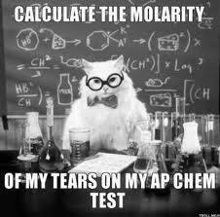202.5 grams of CuCl2 dissolved in 2000.mL of water.
   4. 74 grams of Ca(OH)2 in 500. mL of water.
4. Find the mass needed for each solution:
   1. A solution of 1.00L of 2.00M NaCl
   2. A solution of 0.500L of 3.00M NaOH
   3. A solution of 600.0mL of 0.50M CaCl2
   4. A solution of 4.00mL of 0.25M CuSO4.5H2O
5. A saline drip is required to hydrate a patient in a hospital. 9.00g of NaCl is added to 1000mL of water in the IV bag. Calculate the molarity of the saline.
6. Two solutions are made, 80.0g of NaOH in 2.00L and 58.5g of NaCl in 1.00L solution. Compare their concentrations.
7. A solution of 2.00L of 5.00M HCl is found in the lab storage room. The Molarity is too strong for the lab. Calculate the amount of water needed to add to the solution in order to obtain 2.50M solution.
8. A solution of 125mL of 10.0M NaOH is available. An additional 200mL of water is added to dilute the NaOH. What is the new Molarity?

**Dilutions**

1. Calculate the volume of 3.00 M nitric acid that must be diluted with water to produce 1.50 L of 0.750 M nitric acid.

2. Calculate the volume of 6.00 M hydrochloric acid that must be diluted with water to produce 2.00 L of 1.75 M hydrochloric acid.

3. Calculate the volume of 5.00 M KOH that must be diluted with water to produce 355 mL of 0.250 M KOH.

4. Calculate the final volume of 3.00 M sulfuric acid when 1.50L of 6.00M sulfuric acid is diluted.

5. A student is given 2.00L of 5.00M NaOH and must dilute to create a 1.25M solution of NaOH. Calculate the amount of water that must be added to the original solution.

6. Outline the correct laboratory procedure for diluting a stock solution of 18.4 M sulfuric acid to produce 1.0 L of 1.84 M sulfuric acid. Take care to include any calculations; safety procedures and how you would use appropriate glassware in your answer.

**Percent By Mass**

**Percent by mass** is an additional way to calculate the “small stuff” in your “total stuff.” Explain percent by mass in chemical terms:

Calculate the percent by mass of the following solutions:

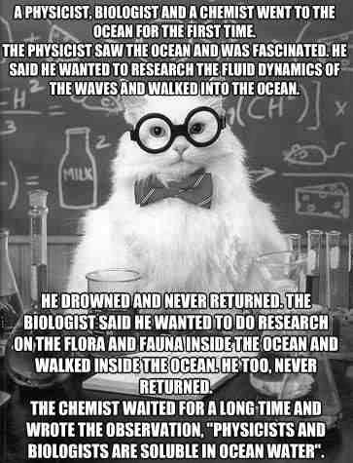

1. 50.0 grams of solute in 200.0 grams of solution
2. 25.0 grams of solute in 150.0 grams of solution
3. 15.0 grams of NaCl in 250.0 grams of solution
4. 10.0 grams of KI in 1000.0 grams of solution
5. 2.0 grams of solute in 2000.0 grams of water
6. 0.500 grams of solute in 150.0 grams of water
7. 0.250 grams of NaBr in 125.0 grams of water
8. 0.0125 grams of O2 in 25,000,000.0 grams of water
9. What could be a better unit to express your answer to number 8?

**Parts Per Million**

**Parts per million** is another concentration. Compare and contrast ppm with percent by mass.

1. Calculate the concentration of chlorine in ppm in a swimming pool if there is 0.02 g of chlorine in 10,000 g of pool water.
2. Exposure to lead has been linked to delays in physical and mental development and attention deficit disorders in children as well as kidney problems in adults. One source of this toxic heavy metal is drinking water in older homes whose plumbing contains lead. Water with a lead concentration of below 0.015ppm is considered safe to drink. A 100 g water sample taken from a home contains 1.2 x 10-6 grams of lead. Is this water considered safe to drink?
3. The health of fish depends on the amount of oxygen dissolved in the water. A dissolved oxygen (DO) concentration between 6 parts per million and 8 parts per million is best for fish health. A DO concentration greater than 1 part per million is necessary for fish survival. Fish health is also affected by water temperature and concentrations of dissolved ammonia, hydrogen sulfide, chloride compounds, and nitrate compounds. A student’s fish tank contains fish, green plants, and 3800 grams of fish-tank water with 2.7 x 10-2 gram of dissolved oxygen.
4. State how an increase in the temperature of the fish-tank water affects the solubility of oxygen in the water.
5. Determine if the DO concentration in the fish tank is healthy for fish. Your response must include:

• a correct numerical setup to calculate the DO concentration in the water in parts per million

• the calculated result

• a statement using your calculated result that tells why the DO concentration in the water is or is not healthy for fish

1. Explain, in terms of molecular polarity, why oxygen gas has low solubility in water. Your response must include *both* oxygen and water.
2. Under what kind of conditions of temperature and pressure would oxygen gas be most soluble in water?
3. An aqueous solution has a concentration of 7 ppm of oxygen dissolved in 1000. grams of water. Calculate the amount of oxygen in the solution in grams. Your response must include *both* a correct numerical setup and the calculated result.

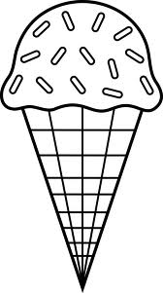**Colligative Properties**

1. Which solution has the highest boiling point?

(1) 0.5 M NaCl

(2) 0.5 M CaCl2

(3) 1.0 M (NH­4)3PO4

(4) 2.0 M CH3OH

2. Compared to pure water, an aqueous solution of calcium chloride has a

(1) higher boiling point and higher freezing point

(2) higher boiling point and lower freezing point

(3) lower boiling point and higher freezing point

(4) lower boiling point and lower freezing point

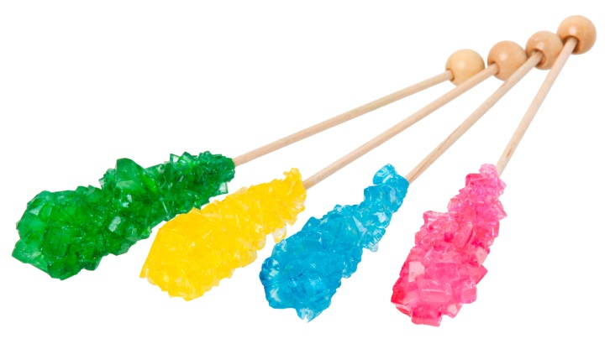3. Which solution has the highestboiling point?

(1) 1.0 M KNO3 (3) 1.0 M Ca(NO3)2

(2) 2.0 M KNO3 (4) 2.0 M Ca(NO3)2

4. Which solution has the *lowest* freezing point?

1. 10. g of KI dissolved in 100. g of water
2. 30. g of KI dissolved in 100. g of water
3. 20. g of KI dissolved in 200. g of water
4. 40. g of KI dissolved in 200. g of water

5. As water is added to a 0.10 M NaCl aqueous solution, the conductivity of the resulting solution  
 (1) decreases because the concentration of ions decreases  
 (2) decreases, but the concentration of ions remains the same  
 (3) increases because the concentration of ions decreases  
 (4) increases, but the concentration of ions remains the same

6. Which aqueous solution of KI freezes at the lowest temperature?  
 (1) 1 mol of KI in 500. g of water (3) 1 mol of KI in 1000. g of water  
 (2) 2 mol of KI in 500. g of water (4) 2 mol of KI in 1000. g of water

7. Compared to a 2.0 M aqueous solution of NaCl at 1 atmosphere, a 3.0 M aqueous solution of NaCl at

1 atmosphere has a  
 (1) lower boiling point and a higher freezing point  
 (2) lower boiling point and a lower freezing point  
 (3) higher boiling point and a higher freezing point  
 (4) higher boiling point and a lower freezing point

8. Based on Reference Table F, which of these saturated solutions has the lowest concentration of dissolved ions?  
(1) NaCl(aq)      (2) MgCl2(aq)      (3) NiCl2(aq) (4) AgCl(aq)

**Solutions Review**

|  |  |  |  |
| --- | --- | --- | --- |
|  | **Key Idea Question** | **Justify your answer**  **with an explanation or calculation.** | **Confidence Level**  **None Moderate Fully**  http://www.mentisology.org/wp-content/uploads/2015/07/scale-1-10.jpg |
| 1 | Which changes will make a real gas deviate from ideal gas behavior?   1. High temp, low pressure 2. High pressure, low temp 3. High pressure and temp |  | Pre-discussion:  Post discussion: |
| 2 | What is the normal boiling point of propanone?   1. 55C c. 101.3kPa 2. 60C d. 55kPa |  | Pre-discussion:  Post discussion: |
| 3 | Which of the following substances have an inverse relationship between solubility and temperature?   1. HCl c. KI 2. KNO3 d. NaCl |  | Pre-discussion:  Post discussion: |
| 4 | When added to water, which of the following substances will raise the boiling point of the water the most?   1. KI b. CH4 c. MgCl2 |  | Pre-discussion:  Post discussion: |
| 5 | Which of the following could be a precipitate in a double replacement reaction?   1. KNO3 c. PbI2 2. NH4Cl d. Ca(OH)2 |  | Pre-discussion:  Post discussion: |
| 6 | Sketch graphs to show the relationships between pressure and volume, volume and temperature, & pressure and temperature. |  | Pre-discussion:  Post discussion: |
| 7 | A solution of KClO3 is saturated at 30C.How many more grams can be dissolved when the solution is heated to 70C? |  | Pre-discussion:  Post discussion: |
| 8 | Calculate the percent by mass of a solution containing 34g of KF dissolved in 250g of water. |  | Pre-discussion:  Post discussion: |
| 9 | A solution of salt (NaCl) is created using 78g of solute dissolved in 300mL of solution. Calculate the molarity. |  | Pre-discussion:  Post discussion: |
| 10 | Calculate the ppm of a solution created with 0.0020 g of solute dissolved in 300.0 g of solution. |  | Pre-discussion:  Post discussion: |

Common Sense Chemistry Review

*Chemistry Matters*

1. Imagine what would happen if a substance were to bubble out of one's blood like carbon dioxide bubbling out of a soda can. This is exactly what can happen to an undersea diver who returns to the surface too quickly: nitrogen rises up within the body, producing decompression sickness—known as "the bends." This condition may manifest as itching and other skin problems, joint pain, choking, blindness, seizures, unconsciousness, permanent neurological defects such as paraplegia, and possibly even death. If a scuba diver descending to a depth of 45.72 m or more were to use ordinary air in his or her tanks, the results would be disastrous. The high pressure exerted by the water at such depths creates a high pressure on the air in the tank, meaning a high partial pressure on the nitrogen component in the air. The result would be a high concentration of nitrogen in the blood, and hence the bends. Instead, divers use a mixture of helium and oxygen. Helium gas does not dissolve well in blood, and thus it is safer for a diver to inhale this oxygen-helium mixture. At the same time, the oxygen exerts the same pressure that it would normally—in other words, it operates in accordance with Dalton's observations concerning partial pressure. If the scuba tank reads a pressure of 3000psi (pounds per square inch) and Helium makes up 2100psi, how much pressure does the oxygen exert?
2. Water normal boils at 100C. But at higher altitudes the water boils at lower temperatures and food is harder to cook. Many people choose to use pressure cookers to heat their food. How will the pressure cooker work to cook the food?
3. Many houses are supplied with “hard” water, water containing calcium ions that when mixed with carbonate ions create “lime buildup” in your showers, sinks, and cooking appliances. What phase is the calcium carbonate? Why doesn’t it just wash down with the water when you shower?
4. Soda cans are considered to be supersaturated solutions of carbon dioxide in sugar water. How will more CO2 dissolve than the water solution can hold?
5. A student wants to brine this holiday turkey with poultry salt, potassium chloride. If the student is using 400mL of water and boiling the water at atmospheric pressure, how much potassium chloride should initially saturate the solution? (Side question: Why “initially”? What happens to the solubility of the salt and the boiling point of the water as the salt is added?)

1. Farts can be deadly. Farts contain hydrogen sulfide gas, which as concentrations of 15ppm or greater, can be toxic. What volume of hydrogen sulfide gas must be present in the fart if the total fart has a volume of 90mL?
2. Certain water based solutions do not freeze in the freezer at waters normal freezing point such as alcohols and sodas. Anti-freeze is a water based solution added to cars to keep the motor running smoothly in the winter. How do these solution resist freezing?
3. Like many developing countries, Vietnam is plagued by poor water quality — millions of the country's inhabitants still lack access to clean drinking water, largely because local companies can't afford expensive filtration systems to treat wastewater. A team of scientists has found that pouring metal and acid-laden water over a bed of crushed clam or mussel shells provides an easy fix. The shells are made of aragonite, a form of calcium carbonate (CaCO3) that readily swaps out its calcium atoms in favor of heavy metals, locking them into a solid form. Explain how the carbonate and heavy metals in the water such as Mercury, react and can be eliminated from the drinking water.
4. A safe level of fluoride ions is added to many public drinking water supplies. Fluoride ions have been found to help prevent tooth decay. Another common source of fluoride ions is toothpaste. One of the fluoride compounds used in toothpaste is tin(II) fluoride. A town located downstream from a chemical plant was concerned about fluoride ions from the plant leaking into its drinking water. According to the Environmental Protection Agency, the fluoride ion concentration in drinking water cannot exceed 4 ppm. The town hired a chemist to analyze its water. The chemist determined that a 175-gram sample of the town’s water contains 0.000 250 gram of fluoride ions.
5. How many parts per million of fluoride ions are present in the analyzed sample?
6. Is the town’s drinking water safe to drink? Support your decision using information in the passage and your calculated fluoride level in question c.