Skeletal Evidence Lab Reference Sheet
Skull
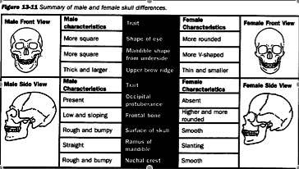
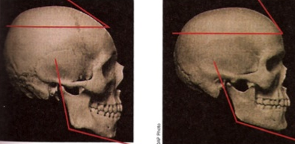
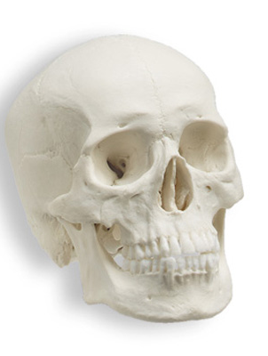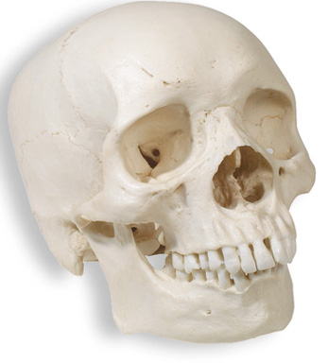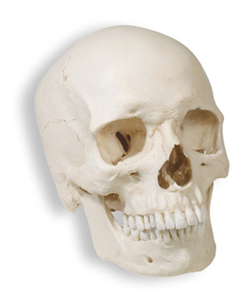
Projected nose spine
Bregmatic depression
Lower nose overgrowth
Asian African European
- rounded eye sockets - square eye sockets - angular eye sockets
- eye closer together - eyes further apart - eyes medium distance apart
- thin nasal opening - wide nasal opening - low nasal opening
- parabole jaw - rectangular jaw - triangular jaw
Pelvis
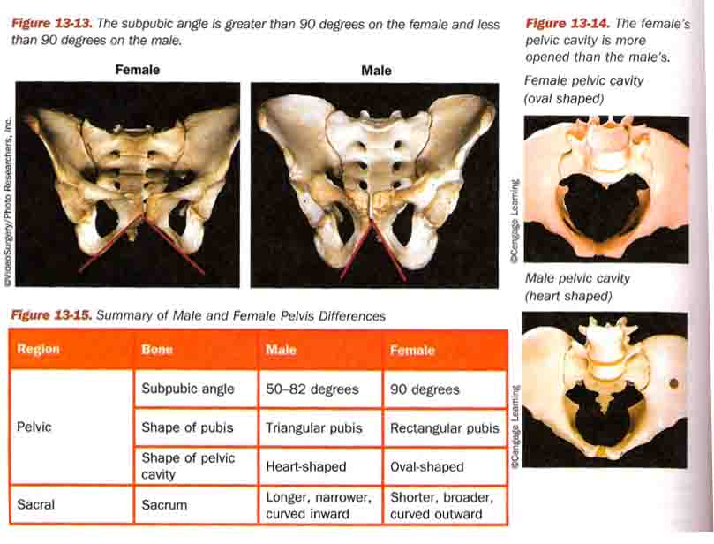
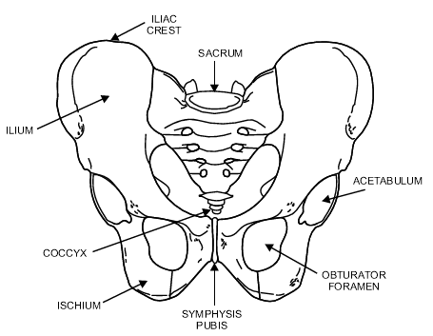
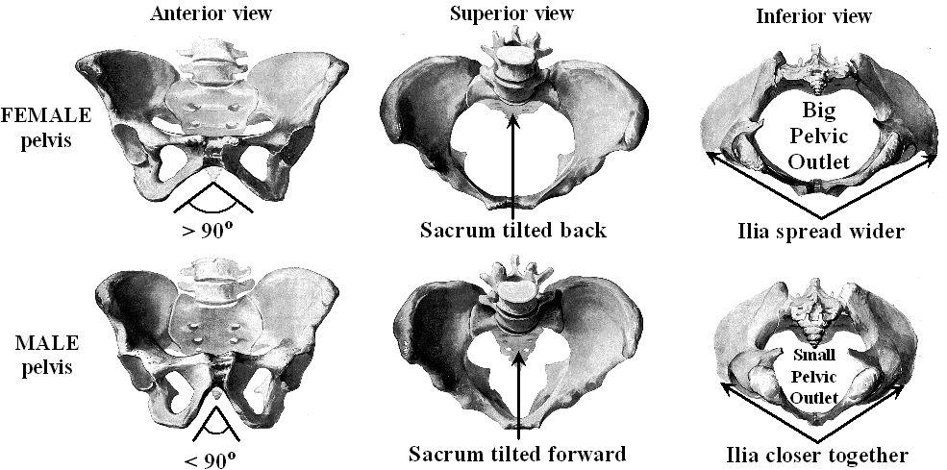
Other Bones
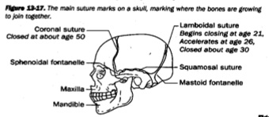
The sagittal suture is at the top of the skull, dividing the left from the right side, completely closing at 32 years of age (26+ in males, 29+ in females). So if you can see through the suture, the person must be under 32 years old. The coronal suture runs from your temples across your skull and closes around 50 years of age. The lambodial suture is at the back of the skull and closes around 21-30 years of age.

Region | Bone | Age
Arm | Humerus head bones fused | 4-6
 | Humerus head fused to shaft | 18-20
Leg | Femur: greater trochanter appears | 4
 | Less trochanter appears | 13-14
 | Femur head fused to shaft | 16-18
 | Condyles join shaft | 20
Shoulder | Clavicle and sternum close | 18-24
Pelvis | Pubis, ishium united | 7-8
 | Ileum, ischium, pubic are united | 20-25
 | All sacrum united | 25-30
Skull | Lambodial suture closed | 21-30
 | Sagittal suture closed | 32
 | Coromal suture closed | 50

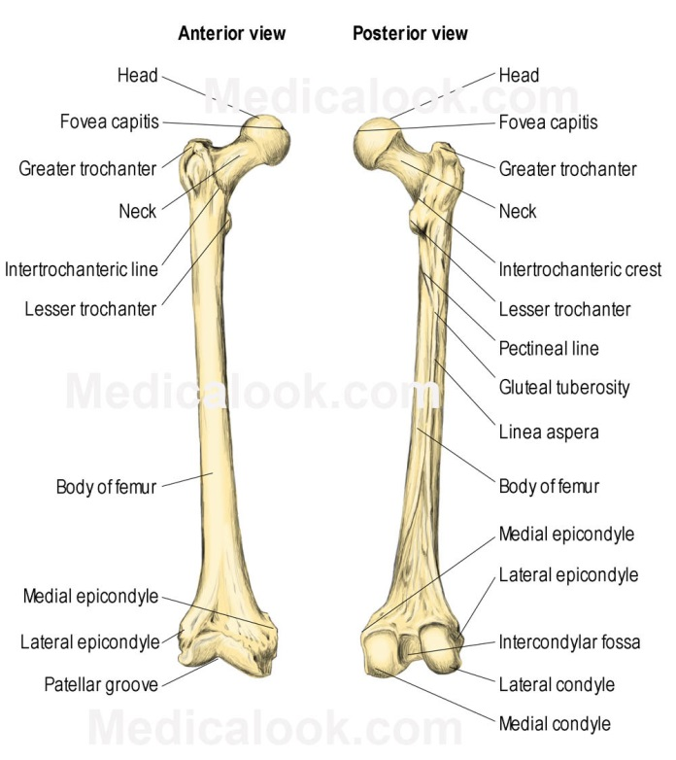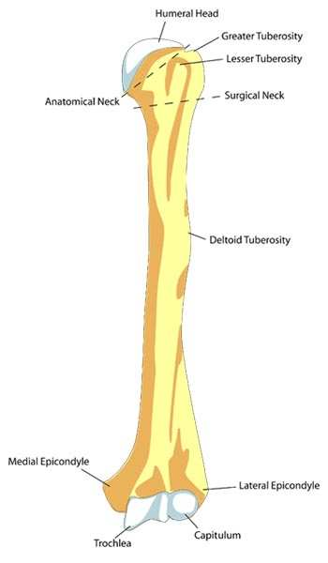
Name: ____________________________________ Skeleton Lab Sheet
We have two unknown skeletons in our closet! Let’s identify their age, gender, and race.
Procedure: Observe both skeletons using you reference sheet to determine the gender, age, and race of the skeletons. Write observations in the blanks provided.
- Determine the gender of the skeletons and give 3 piece of evidence for each skeleton:
Skeleton 1: _______________________ Skeleton 2: ___________________________
Skull: _______________________ Skull: ___________________________
Eye: _______________________ Eye: ___________________________
Pelvis: _______________________ Pelvis: ___________________________
- Determine the race of the skeletons and give 3 piece of evidence for each skeleton:
Skeleton 1: _______________________ Skeleton 2: ___________________________
Eye: _______________________ Eye: ___________________________
Nose: _______________________ Nose: ___________________________
Jaw: _______________________ Jaw: ___________________________
- Determine the age of the skeletons and give 3 piece of evidence for each skeleton:
Skeleton 1: _______________________ Skeleton 2: ___________________________
_______________________ ___________________________
_______________________ ___________________________
_______________________ ___________________________
- For each skeleton give your final conclusions of age, gender and race.
Skeleton 1: ________________________________________________________________
Skeleton 2: ________________________________________________________________
- What were some bones that gave you trouble deciding the age? Explain.
- What were some bones that gave you trouble deciding the race? Explain.
- What were some bones that gave you trouble deciding the gender? Explain.

