Name: ________________________ Separating a Mixture Lab

Task: You will be given a mixture of sand and salt. Your task is to design a method of separating the sand and salt to determine the percent of sand and the percent of salt in the mixture.

Materials: Sand and salt mixture, beaker, flask, graduated cylinder, funnel, filter paper, hot plate, electronic balance, magnet, ruler.

Procedure: As a team, write a step-by-step procedure that you will use to separate the mixture. Consider the fact that you just need the sand separated from the salt but they can be mixed with other substances. Have your teacher approve your procedure before you perform your experiment.

Data: Record relevant observations and measurement (be sure to include the mass of the original mixture and the mass of the sand and salt separately.)

Analysis:
- How well did your procedure work for separating the sand from salt? Explain.

- Would you change anything about your procedure or how you carried it out that could improve your results?

- What test(s) could you do to ensure the separated materials are purely sand and purely salt?

- Calculate the percent of sand and salt in the mixture.
  - Sand: b. Salt:

- Explain why the salt did not have to be purified (completely alone) in order to solve for the mass and mass percentages of the sand and salt.

Modeling:
- The left side of the diagram below shows the setup that one student used to separate the sand from the salt. The right side of the diagram shows a magnified view of the filter paper and the space just above and just below it. You can see the small holes (pores) in the filter paper that allows for fluid and small particles to pass through. In their procedure, the student added water to the sand and salt mixture. Then they poured mixture into the funnel with the filter paper. Complete the particle model in the magnified view of the sample using the key provided.
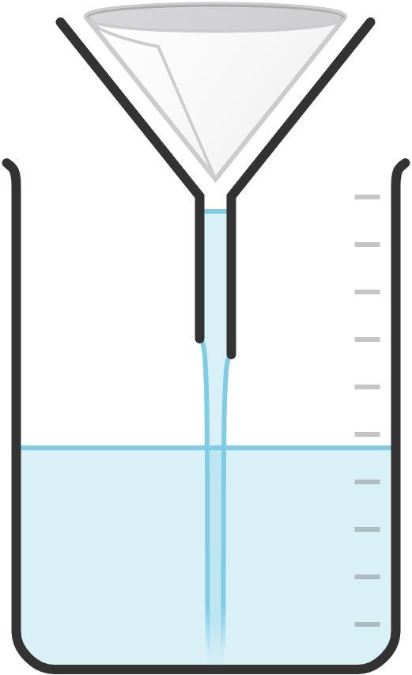

Magnified view of sample
Sample before passing through filter paper
}
}
Sample passing through filter paper
}
Sample after passing through filter paper
Paper particles
Pores in paper
Key:

Blue: water particle
Red: salt particle
Brown: paper particle
Green: sand particle

- The left side of the diagram below shows the process that one student group used to purify the salt. As the diagram shows, the students heated a beaker of salt and water on a hot plate. The right side of the diagram is incomplete. It is designed to show a magnified view of the boundary between the liquid and vapor phases of the water. Fill in the right side of the diagram to represent water and salt particles just above and below the boundary
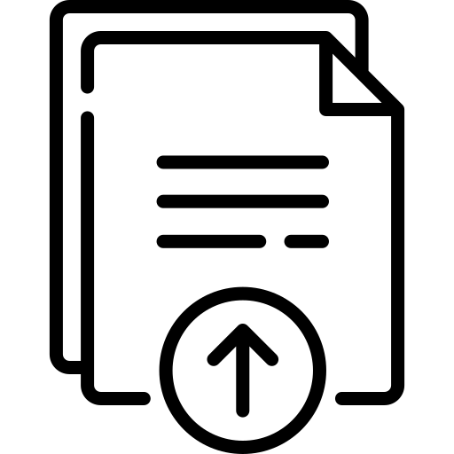
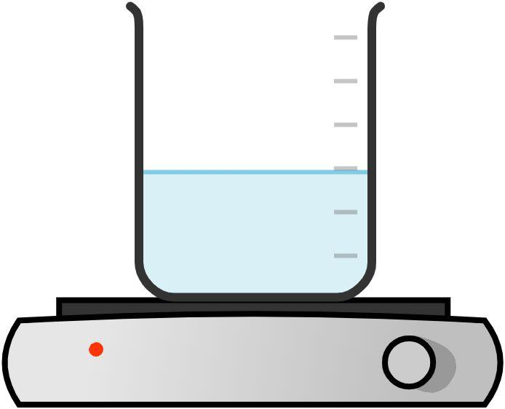

Magnified View
}
}
vapor
liquid

