Name: ______________________________________ Solving a Problem with Scientific Method

Background: A method by which a scientist solves a problem is called a scientific method. This method usually includes observation, hypothesis formation, experimentation, and interpretation. Scientific methods are often compared to the procedures a detective uses in solving a crime or mystery. The following investigation creates a scientific problem for you and asks you to solve it. You will use a scientific method in attempting to solve the problem.

Objective:
You will use a scientific method to solve whether flasks A and B contain similar liquids.
You will make careful observations.
You will record accurate experimental results.
You will use your data as a basis for deciding if the two liquids are similar or different.

Materials
2 Erlenmeyer flasks containing liquids
2 stoppers (to fit flasks)
beaker
clock or watch with second hand

Safety: Do not dispose of these materials in the sink or trash can. Do not taste, eat, or drink any materials used in the lab. Inform your teacher if you come in contact with any chemicals. Wear goggles and an apron.

Part A—Observation
1. Examine the two flasks. DO NOT remove the stoppers and DO NOT shake the contents.
2. Notice that the flasks have been labeled A and B.
3. Record in Table 1 two or three similarities and differences between the two flasks.
a. Do you think both flasks contain the same liquid? Explain.

b. Is your hypothesis to question a based on experimentation or observation?

c. Would scientists form a hypothesis about answers to questions, or would they experiment first?

d. Do both flasks contain exactly the same amount of liquid?

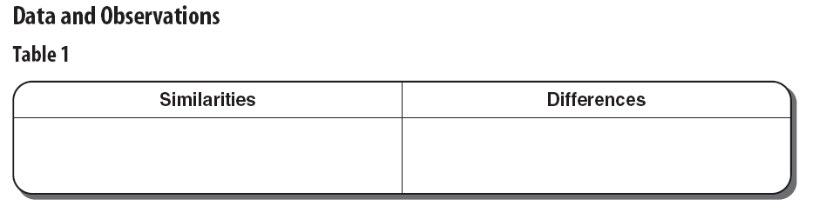
Part B—Experimentation

Experiment 1: What happens if you shake the liquids?
1. Give each flask one hard shake using an up-and-down motion of your hand. Make sure your thumb covers the stopper as you shake.
2. Observe each flask carefully.

3. Record your observations in Table 2. Again, look for similarities and differences.
a. After shaking the flasks, do you think they contain different liquids?

b. What was present in flask A that might have been responsible for the change in the liquid?

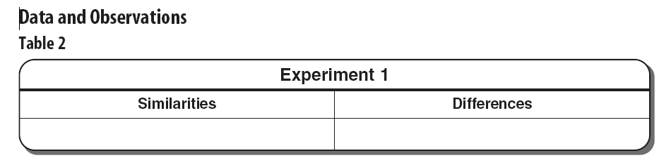

Experiment 2: What happens if you remove some of the liquid in flask B?

Procedure
1. Remove the stopper from flask B and pour out half of the contents into a beaker or other
suitable container. See Figure 1. Make sure the amount of liquid remaining in flask B is equal to the amount of liquid in flask A.
2. Replace the stopper. Give both flasks one hard shake using an up-and-down motion of your hand. Hold the stopper in place while shaking.
3. Observe each flask carefully.
4. Record any similarities or differences observed in Table 3.
a. Do both flasks now appear to contain the same liquid?

b. What may have been added to flask B that was not present before?

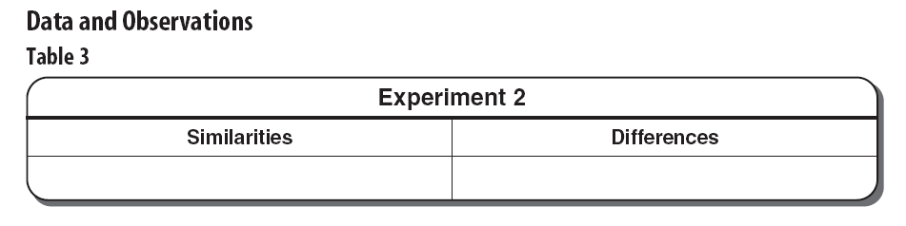
Experiment 3: What happens if you shake the flasks more than once?

Procedure
1. Give both flasks one hard shake using an up-and-down motion.
2. Note the exact time in seconds after shaking that it takes for each liquid to return to its original condition. Record the time in Table 4 under 1 shake, Trial 1.
3. Give both flasks two hard shakes using an up-and-down motion.
4. Again record in Table 4 the time it takes for the liquids to return to their original conditions. Record these times under 2 shakes, Trial 1.
5. Give both flasks three hard shakes using an up-and-down hand motion.
6. Record in Table 4 under 3 shakes, Trial 1, the time it takes for them to return to their original conditions.
a. After one shake, are the two liquids generally behaving in a similar way? That is, is the time needed for flasks A and B to return to their original conditions about the same?

b. After two and three shakes, are flasks A and B generally behaving in a way similar to each other?

7. Look at your data in Table 4.
a. As the number of shakes increases from one to three, does flask A show an increase or decrease in time needed to return to its original condition?

b. Does flask B show a similar change?

8. Run two more trials for each part of Experiment 3. Be sure to keep track of the amount of
time needed for the liquids to return to their original conditions. Record the results of these
trials as Trials 2 and 3 in Table 4.
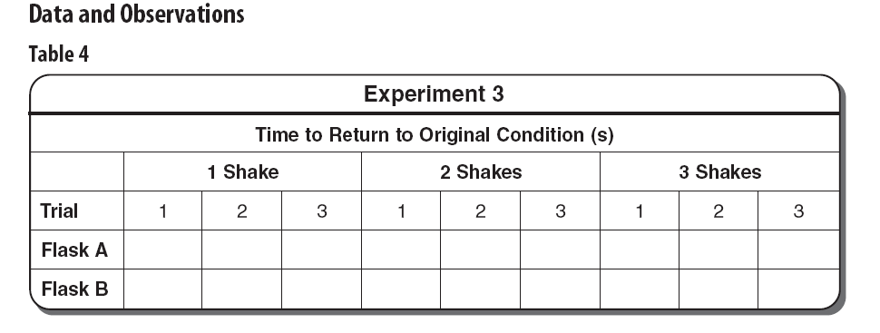
9. Do three trials give better evidence than one trial in helping you to determine
a. the contents of flasks A and B?

b. the effects of shaking on flasks A and B?

Questions and Conclusions
Questions 1 through 4 should help you to interpret what you have observed. Interpretations are
reasoning based on observations and experiments. They are usually the next step in a scientific method.

- On the basis of your first observations in Part A, could you decide if both flasks contained the same liquid?

- After performing Experiment 1, could you decide if both flasks contained the same liquid?

- Which experiment or experiments may have helped you to decide that the liquids in flasks A and B were similar or different? Explain.

- Besides the liquid itself, what else seems to be needed in order for the liquid to change color?

Questions 5 through 7 should help you to form a hypothesis. In a hypothesis, all facts are joined in an attempt to explain what has been observed.

- Explain why flask B did not change color when shaken in Experiment 1.’

- Why must the liquids in the half-filled flasks be shaken in order to produce a color change?

- Did more shaking increase the amount of time needed for the liquids in flasks A and B to change back to their original color? Why or why not?

- Why is experimenting a better method of problem solving than guessing?

- What is meant by the phrase “solving a problem by using scientific methods”?

Strategy Check
- Can you use a scientific method to solve whether or not flasks A and B contain similar liquids?
- Can you make careful observations?
- Can you record accurate experimental results?
- Can you use your data as a basis for deciding if the two liquids are similar or different?

