Vocabulary
For each word, provide a short but specific definition from YOUR OWN BRAIN! No boring textbook definitions. Write something to help you remember the word. Explain the word as if you were explaining it to an elementary school student. Give an example if you can. Don’t use the words given in your definition!
Reduction: _________________________________________________________________________________
Oxidation: _________________________________________________________________________________
Spectator Ion: ______________________________________________________________________________
Half Reaction: ______________________________________________________________________________
Redox Reaction: ____________________________________________________________________________
Electrochemical Cell (Voltaic): _________________________________________________________________
Anode: ____________________________________________________________________________________
Cathode: __________________________________________________________________________________
Salt Bridge: ________________________________________________________________________________
Electrolytic Cell: ____________________________________________________________________________

Video 12.1 Oxidation Numbers
Oxidation Number Rules:
- All pure non-bonded elements have an oxidation number of ______. Elements are not charged.
- All ions have the _________ charge and oxidation number.
- All compounds must have a sum of oxidation numbers equal to ______. Compounds are not charged.
- All group 1 elements have a ______ oxidation number as seen on the periodic table (except H). Similarly, group two must have ______. Aluminum is ______.
- If a halogen (F, Cl, Br, I) is at the end of the molecule it is ______. Otherwise you have options for oxidation numbers if it is in the middle of the compound.
- If Oxygen is the anion, it will have a charge of ______UNLESS it is with F or an alkali metal in a 1:1 (or 2:2) ratio.
- H is ______ in the front and ______ in the back.
- The sum of oxidation numbers for an ion must equal the ion’s charge.

Questions: Find the oxidation number of all elements below:

C₂F₂
H₂O
Br₂
HI
CaH₂
MnCl₂
Li₂O₂
MgO
H₂S
NaH
Cr₂O₃
N₂O₅
OF₂
CaSO₄
NaClO
KClO
KClO₂
KClO₃
KClO₄
SO₂
SO₃
Na₂S
Na₂SO₄
Mg
AgNO₃
Na₂SO₄
Ca(NO₃)₂

(Hint for the last one: distribute the two through the nitrate ion so you have the standard 3 elements to work with.)

Video 12.2 RedOx reactions, spectators, and agents
Key Ideas: Circle the best fit in the parenthesis or fill in the blanks.
- Elements oxidize because they (lose/gain) electrons and their charges (increase /decrease).
- Elements reduce because they (lose/gain) electrons and their charges (increase /decrease).
- Elements that do not change charges are known as ____________________________.
- Redox reactions occur as long as reduction and oxidation both occur.
- Table ______ shows a list of the most active metals and nonmetals. Active metals tend to ___ electrons and therefore (oxidize/reduce). Metals at the top of this table (oxide/reduce) the best.
- Active nonmetals tend to _______ electrons and therefore (oxidize/reduce). Nonmetals at the top of this table (oxide/reduce) the best.

Questions:
- For the following reactions, identify the redox reactions. For the redox reactions ONLY: identify the elements as reducing, oxidizing, or spectators.

  - Cl₂ + 2KBr 2KCl + Br₂ Is it redox? _____ Spectator: _____
Reducing: _____ Oxidizing: _____

  - Cu + AgNO₃ CuNO₃ + Ag Is it redox? _____ Spectator: _____
Reducing: _____ Oxidizing: _____

  - Zn + 2HCl H₂ + ZnCl₂ Is it redox? _____ Spectator: _____
Reducing: _____ Oxidizing: _____

  - CaCO₃ + HCl H₂O + CO₂ + CaCl₂ Is it redox? _____ Spectator: _____
Reducing: _____ Oxidizing: _____

- Identify redox reactions. For redox reactions ONLY: Use table J to determine if the reaction is spontaneous.
  - Cu + 2HCl CuCl₂ + H₂ Which element oxidizes? _____
Which element reduces? _____
Should it according to table J? _____

  - Mg + 2HCl MgCl₂ + H₂ Which element oxidizes? _____
Which element reduces? _____
Should it according to table J? _____
Video 12.3 Electrochemical/Voltaic Cells
Key Ideas:
- In a RedOx reaction, ___________ are transferred from the oxidizing elements which loses to the reducing element which gains.
- LEO stands for __________________________ and GER stands for ____________________________.
- In a voltaic cell, or battery, _______________ occurs at the anode, which is _________ charged.
- In a voltaic cell, or battery, _______________ occurs at the cathode, which is _________ charged.
- Electrons flow from the _________________ to the ______________ of the battery.
- The __________ __________ permits the flow of ions in the voltaic cell in order to maintain the charges of the anode and cathode.

Questions:
- Why does it make sense that electrons flow from the anode to the cathode in terms of charge? Discuss the charges of electrons, the anode, and the cathode in your answer.
- Using the diagram below, answer the following questions:
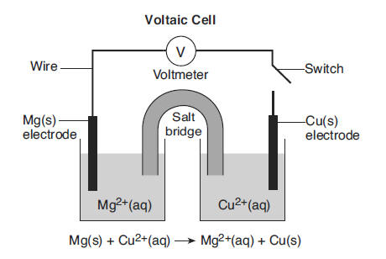

  - Which element is present at the anode? _____
  - Which element is present at the cathode? _____
  - Draw an arrow to show the direction of electron flow in the battery, through the wire.
  - Where are spectator ions such as Cl⁻ and Na⁺ located (They are not on the diagram labeled-you have to think about it)? What do they do?
  - How many total electrons between one atom of each metal? _____
  - Write the half reaction for magnesium including the electrons.

  - Write the half reaction for copper including the electrons.
Video 12.4 Electrolytic Cells
Key Ideas:
- Electrolytic cells are not spontaneous so you must apply power.
- Electrolytic cells are different from voltaic cells (or batteries) because the electrodes charges are reversed (however, electrons still travel from ____________ to ______________.
Questions:
- What is the charge of a voltaic cell’s anode? ______
- What is the charge of an electrolytic cell’s anode? ______
- What is the charge of a voltaic cell’s cathode? ______
- What is the charge of an electrolytic cell’s cathode? ______
- Regardless of the cell, electrons always travel from which electrode? __________
- Regardless of the cell, oxidation always occurs at the ______________.
- Regardless of the cell, reduction always occurs at the ______________.
- Use the diagram below to answer the following questions:
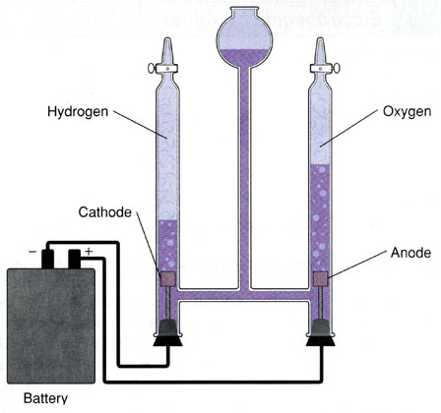

The picture to the left show what happens when water is exposed to an electric current. The water is literally ZAPPED with electric and decomposes into H₂ and O₂.
2H₂O 2H₂ + O₂

- The cathode has hydrogen gas generating from the water. Write the half reaction that shows the hydrogen atom’s oxidation number in water changing to normal H₂ gas. Is this reaction oxidation or reduction?
- The anode has oxygen gas generating from the water. Write the half reaction that shows the oxygen atom’s oxidation number in water changing to normal O₂ gas. Is this reaction oxidation or reduction?
- Why is a battery put in this picture? Does water simply become gaseous H₂ and O₂ spontaneously?

