VOCABULARY

For each word, provide a short but specific definition from YOUR OWN BRAIN! No boring textbook definitions. Write something to help you remember the word. Explain the word as if you were explaining it to an elementary school student. Give an example if you can. Don’t use the words given in your definition!

Periodic Law: _______________________________________________________________________________
Period: ____________________________________________________________________________________
Group: ____________________________________________________________________________________
Metal:_____________________________________________________________________________________
Nonmetal: _________________________________________________________________________________
Metalloid/semimetal: ________________________________________________________________________
Alkali metal: _______________________________________________________________________________
Alkaline earth metal: ________________________________________________________________________
Transition metal: ____________________________________________________________________________
Halogen: __________________________________________________________________________________
Noble gas: _________________________________________________________________________________
Octet: ____________________________________________________________________________________
Atomic radius: ______________________________________________________________________________
Ionic radius: _______________________________________________________________________________
Ionization energy: ___________________________________________________________________________
Electronegativity: ___________________________________________________________________________

Video 4.1 Introduction to the Periodic Table

- The placement or location of elements on the Periodic Table gives an indication of physical and chemical properties of that element. The elements on the Periodic Table are arranged in order of increasing _______________________.
- Elements can be differentiated by chemical properties. Chemical properties describe how an element behaves during a chemical reaction.
- Some elements exist in two or more forms in the same phase. These forms differ in their molecular or crystal structure, and hence in their properties.
- For Groups 1, 2, and 13-18 on the Periodic Table, elements within the same __________________ have the same number of ___________________________ (helium is an exception) and therefore similar chemical properties.

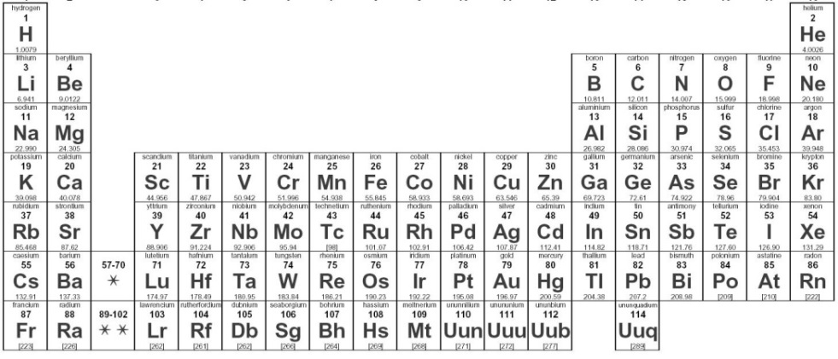

- On the table color the alkali metals red and write their 4 major properties:

___________________________ __________________________

__________________________ __________________________

- On the table color the alkaline earth metals orange and write their 3 major properties:

__________________________ __________________________ ________________________

- On the table color the transition metals yellow and write their major properties:

_________________________________________________________________

- On the table color the halogens green and write their 4 major properties:

___________________________ __________________________

__________________________ __________________________

- On the table color the noble gases blue and write their 4 major properties:

___________________________ __________________________

__________________________ __________________________

- How many periods are there? ____

- How many groups are there? ____

- What is the periodic law? _______________________________________________________________

Video 4.2 Metals, Nonmetals, and Metalloids

- Elements can be classified by their properties and located on the Periodic Table as metals, nonmetals, _____________________ (B, Si, Ge, As, Sb, Te), and noble gases.
- Elements can be differentiated by their physical properties. Physical properties of substances, such as density, conductivity, malleability, solubility, and hardness, differ among elements.

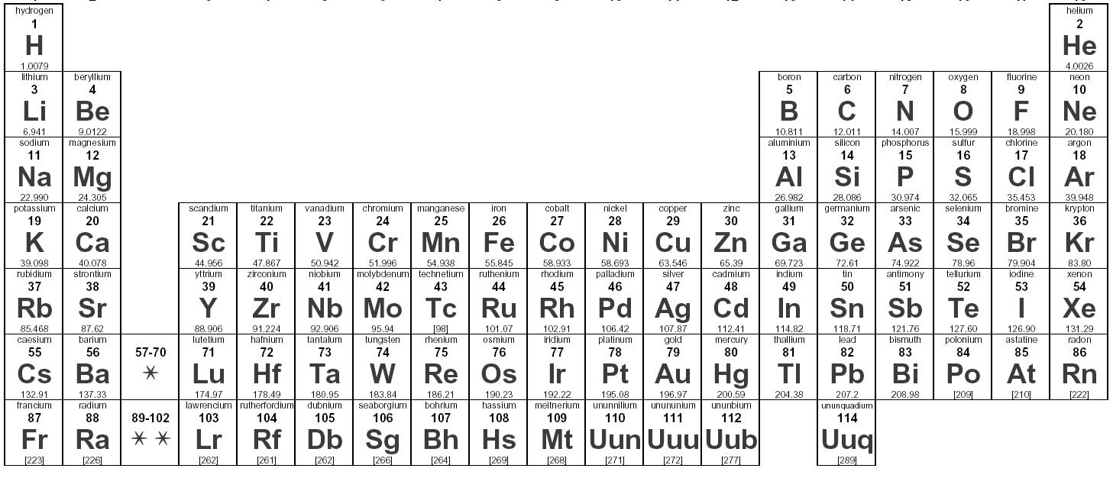
- On the table draw the line that separates the metals from the nonmetals in black.
- On the table color all metalloids green.
- On the table color all metals yellow.
- On the table color all nonmetals blue.
- Circle the properties that pertain to metals:

shiny dull malleable brittle ductile

lose e- gaine e- conductor nonconductor solid gas

- What does ductile mean? _______________________________________________________________

- What does malleable mean? _____________________________________________________________

- What are the only two liquid elements at room temperature? __________________ and _____________
(nonmetal) (metal)

- What is the most metallic element? ______________ The most nonmetallic? _____________________

- Why is the most nonmetallic element NOT the most reactive nonmetallic element? )________________
____________________________________________________________________________________
- Metals tend to _______ electrons because they have ___-___ valence electrons.

- Nonmetals tend to _______ electrons because they have ___-___ valence electrons.

Video 4.3 Atomic Radius
- The succession of elements within the same group demonstrates characteristic trends: differences in atomic radius, ionic radius, electronegativity, first ionization energy, metallic/nonmetallic properties.
- The succession of elements across the same period demonstrates characteristic trends: differences in atomic radius, ionic radius, electronegativity, first ionization energy, metallic/nonmetallic properties.

1. Draw the Bohr diagrams for Lithium and Neon.

a. Look up their atomic radius on Table S. Li: ___________ Ne: ______________
b. Why are they not the same size (think about protons). ______________________________________
c. When elements are in order across a period their atomic radius ___________________.
2. Draw the Bohr diagrams for Fluorine and Chlorine.

a. Look up their atomic radius on Table S. F: ___________ Cl: ______________
b. Why are they not the same size? Be specific. _____________________________________________
c. When elements are in order down a group their atomic radius ___________________.
3. Which element has the largest radius? ________________ The smallest? ___________________
4. Metals tend to __________ electrons because they have ____-____ valence electrons so their cations are
_____________ than the atom.
5. Nonmetals tend to __________ electrons because they have ____-____ valence electrons so their anions are
_____________ than the atom.

Video 4.4 Ionization Energy
1. What does ionization energy mean? __________________________________________________________
2. Draw the Bohr diagrams for sodium and sulfur.

a. Look up their ionization energy (IE) on Table S. Na: ___________ S: ______________
b. Why don’t they both lose electrons with the same amount of energy? (Think about their protons)
_________________________________________________________________________________
c. When elements are in order across a period their ionization energy ___________________.
3. Draw the Bohr diagrams for beryllium and magnesium.

a. Look up their ionization energy (IE) on Table S. Be: ___________ Mg: ______________
b. Why don’t they both lose electrons with the same amount of energy? (Think about the energy levels)
_________________________________________________________________________________
c. When elements are in order down a group their ionization energy ___________________.
4. Which element has the highest IE? _______________ The lowest? ____________________
5. Why are Noble gases IE particularly high? (Think about their valence!)
________________________________________________________________________________________

Video 4.5 Electronegativity
1. What does electronegativity mean? __________________________________________________________
2. Draw the Bohr diagrams for potassium and bromine.

a. Look up their electronegativity on Table S. K: ___________ Br: ______________
b. Why don’t they both attract electrons in the same way? (think about their size and protons)
_________________________________________________________________________________
c. When elements are in order across a period their electronegativity ___________________.
3. Draw the Bohr diagrams for nitrogen and phosphorous.

a. Look up their electronegativity on Table S. N: ___________ P: ______________
b. Why don’t they both attract electrons in the same way? (Think about their size and protons)
_________________________________________________________________________________
c. When elements are in order down a group their electronegativity ___________________.
4. Which element has the highest electronegativity? _______________ The lowest? ____________________
5. Why don’t noble gases have electronegativity values? ____________________________________________

