Name: ________________________ Pop Your Top

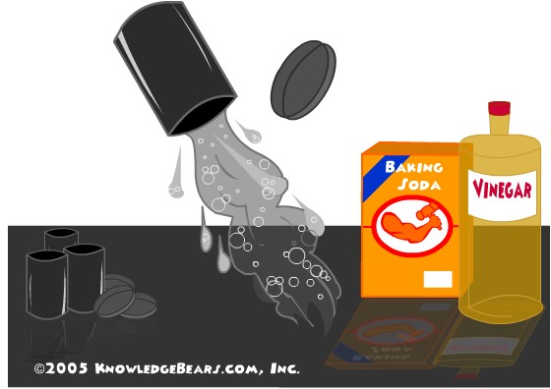
Background Information: When Alka-Seltzer is placed in the same container as water it bubbles and reacts. The container you will be given is an old film canister. When the two react with the top on, the bubbles will build up pressure and force the top to pop off.

Guiding Question: What factors will increase the rate of reaction?

Pre-Lab:
- Define the following:

Rate of reaction- ______________________________________________________________________

Collision theory- ______________________________________________________________________

Concentration- _______________________________________________________________________

- Brainstorm: What factors may change the rate of reaction?

- If a reaction takes longer to complete, does that mean the rate increased or decreased?

- A student says, “The top will pop off fastest if the water used is hot, the tablet is crushed and the concentration is high.” Write a claim to either support or disprove the student’s statement and defend your prediction.

Prediction: __________________________________________________________________________

Reasoning: __________________________________________________________________________

____________________________________________________________________________________

Procedure: You need to time the reaction and then create trials to discover and prove how factors can affect the rate of reaction.

Our classes’ control trial:

Our teams’ variable:

Our team’s procedure:

Materials Needed:

Our Team’s Data: (clearly label)

Class Data:

Variable | Constants  (check all that apply) |  |  |  | Results
High temp | Volume | Tablet size | temperature | solvent
Low temp

Increased surface area
High concentration

Low concentration (change water)

Low concentration (change tablet)

vinegar

Questions:
- Explain how a change in temperature will affect the kinetic energy of the particles in a reaction.

- Using collision theory, explain how changes in temperature affect the rate of reaction.

- Using collision theory, explain how changes in concentration affect the rate of reaction.

- Construct a claim that supports or contradicts the prediction made in the pre-lab questions.

- Provide evidence that supports your claim. Use your reasoning skills to explain why your evidence is relevant.

- Justify the steps you took to obtain the evidence you obtained.

