Name: ________________________ Pop Your Top
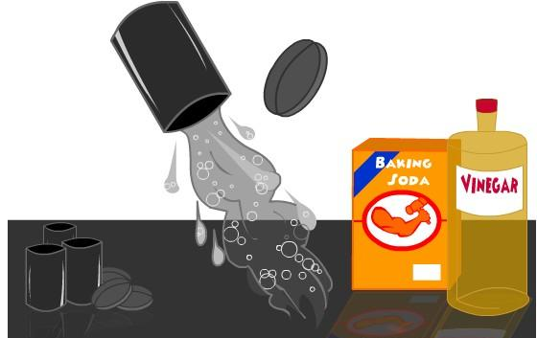
Background Information: When Alka-Seltzer is placed in the same container as water it bubbles and reacts. The container is an old film canister. When the two react with the top on, the bubbles will build up pressure and force the top to pop off.

Guiding Question: What factors will increase the rate of reaction?

Procedure: You need to time the reaction and then create trials to discover and prove how factors can affect the rate of reaction.
Variable | Measurements |  |  |  | Timing and observations | Faster or slower than control?
 | Water Volume | Tablet  Size | Solvent  Temperature | Solvent
Control
Trial
High Temperature
Low Temperature
Increased Surface Area
High Concentration
Low Concentration
Dilute
Solution
Vinegar as Solvent

Analysis: Key: Water Alka-seltzer

- In the boxes below, use particle models to diagram how an increase in temperature affects the rate of this reaction.
High T
Low T
  - Explain how an increase in temperature will affect the kinetic energy of the particles in a reaction.

  - Using collision theory, explain how an increase in temperature affects the rate of reaction.
- Use particle models to diagram how increasing surface area affects the rate of this reaction.
High SA
Low SA

  - Explain how an increase in surface area will affect the number of particles in solution.

  - Using collision theory, explain how an increase in surface area will affect the rate of reaction.

- Use particle models to diagram how an increase in concentration affects the rate of this reaction.

High C
Low C

  - Explain how an increase in concentration will affect the number of particles in a reaction.

  - Using collision theory, explain and increase in concentration affect the rate of reaction.

- Vinegar is ionic and water is covalently bonded.
  - Compare the rate of the reaction with water to the rate of reaction with vinegar.

  - Using collision theory, explain why the rates of reaction with water and vinegar were not equal.

- “The top will pop off fastest if the water used is hot and a whole crushed tablet is used.”
  - Write a claim to either support or disprove the student’s statement.

  - Defend your claim with evidence from this lab.

  - Justify your evidence using collision theory.

