Photoelectron Spectroscopy
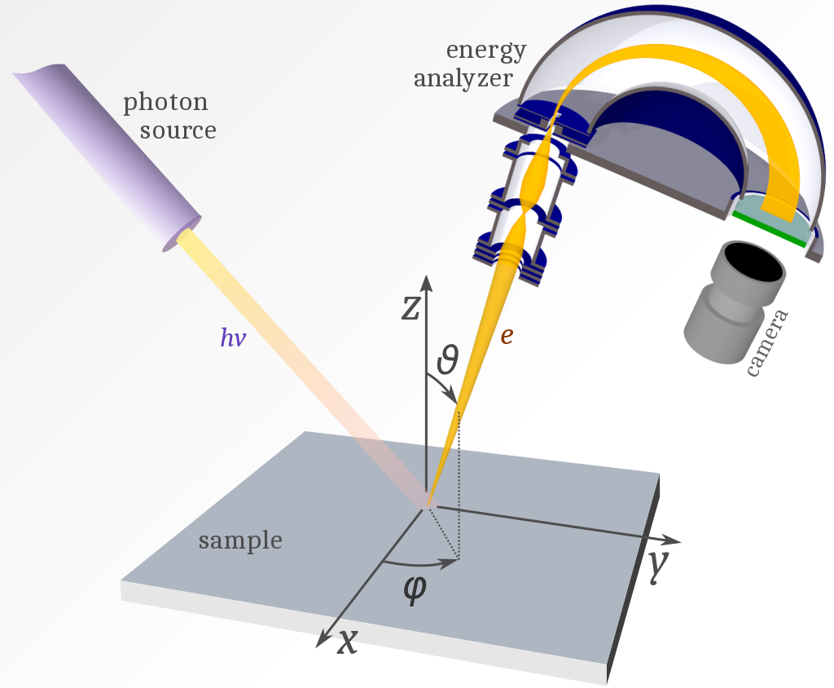
Photoelectron Spectroscopy (PES) measures the energy of electrons emitted from the atom when the sample is exposed to ultraviolet light. The high energy light waves remove electrons from the atom, collects them in a vacuum, and counts the electrons.

Binding Energy refers to the minimum energy to remove particle(s) from a system. The binding energy shown in graphs below specifically measures the energy to remove electrons from the atom. This atomic binding energy is the sum of individual ionization energies of each electron in the same energy level or sublevel.

Model 1: PES of Hydrogen and Helium
Hydrogen
Helium
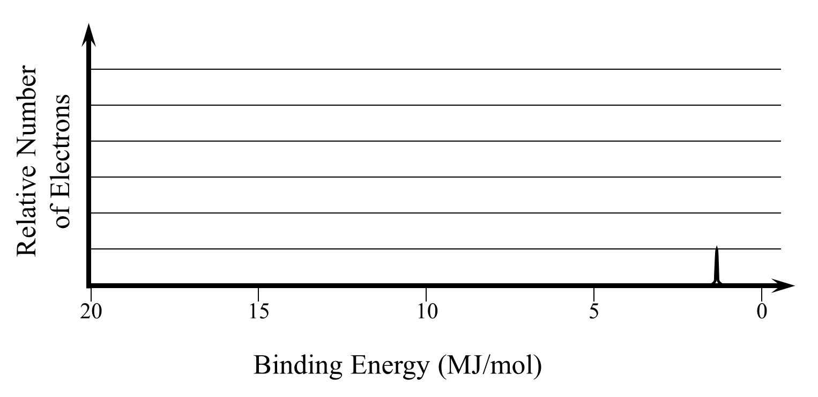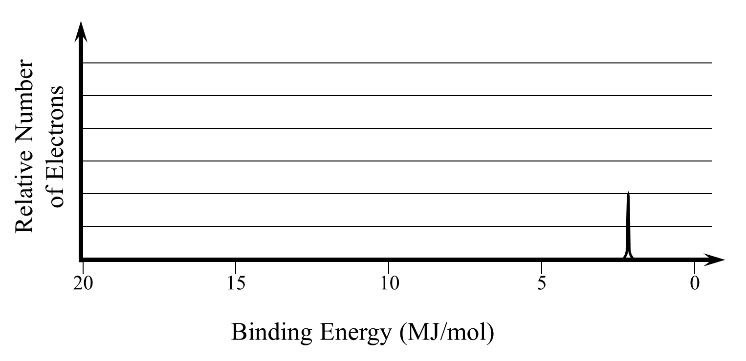
- Which element, H or He, requires more energy to remove its electrons?

- Based on the definition of binding energy above, and your knowledge of ionization energy, why would the element you selected above require more energy to remove the electrons?

- Why is the peak on the PES of helium twice as high as the peak on the PES of hydrogen?

Model 2: PES of Lithium and Beryllium
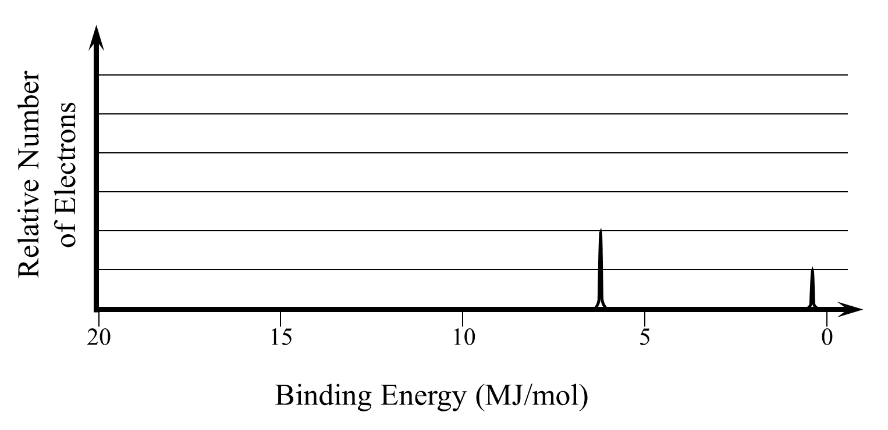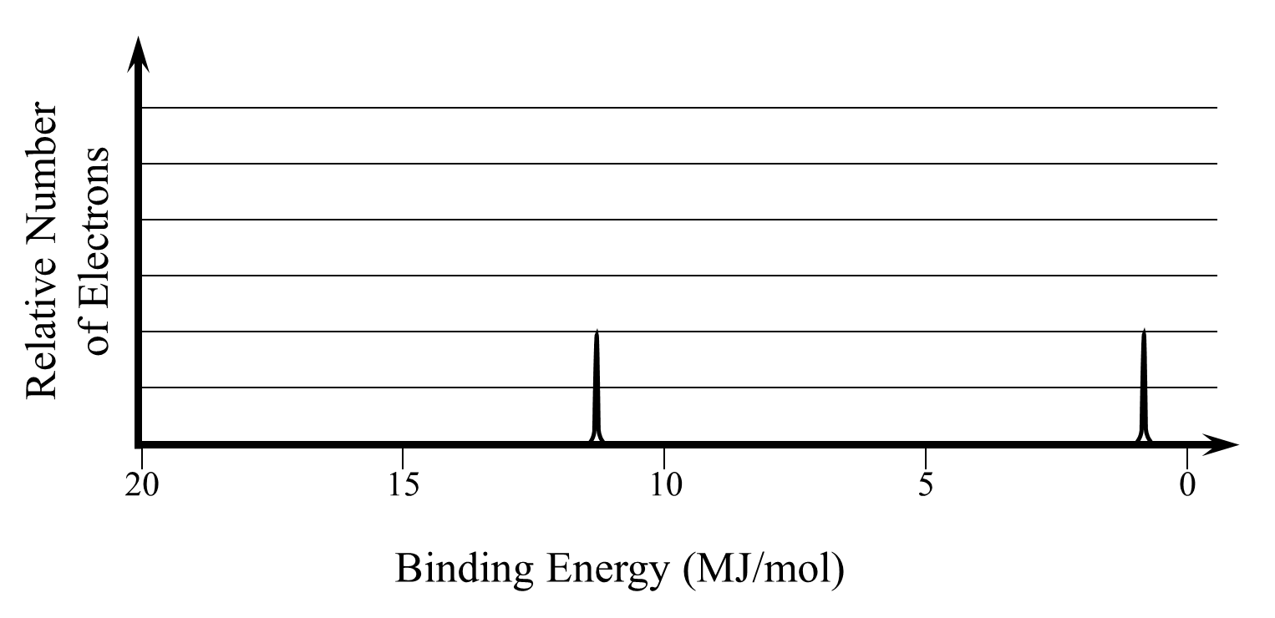
- Using Model 2
  - Draw the Bohr diagrams of Lithium and Beryllium.

  - Based on your diagrams, propose a reason for the two separate peaks shown in the PES. (What in the Bohr diagram is equivalent to two?)

  - Approximately how much energy was required to remove the electrons from the valence of Lithium?

  - Approximately how much energy was required to remove the electrons from the inner energy level of lithium?

  - Why was more energy required to remove electrons from the inner energy level than the valence?

  - Draw the Bohr diagram for Boron.

  - Draw your hypothesis for how the PES of boron will look based on the PES given above. Be sure to consider the number and height of your peaks as well as what energy they will require.
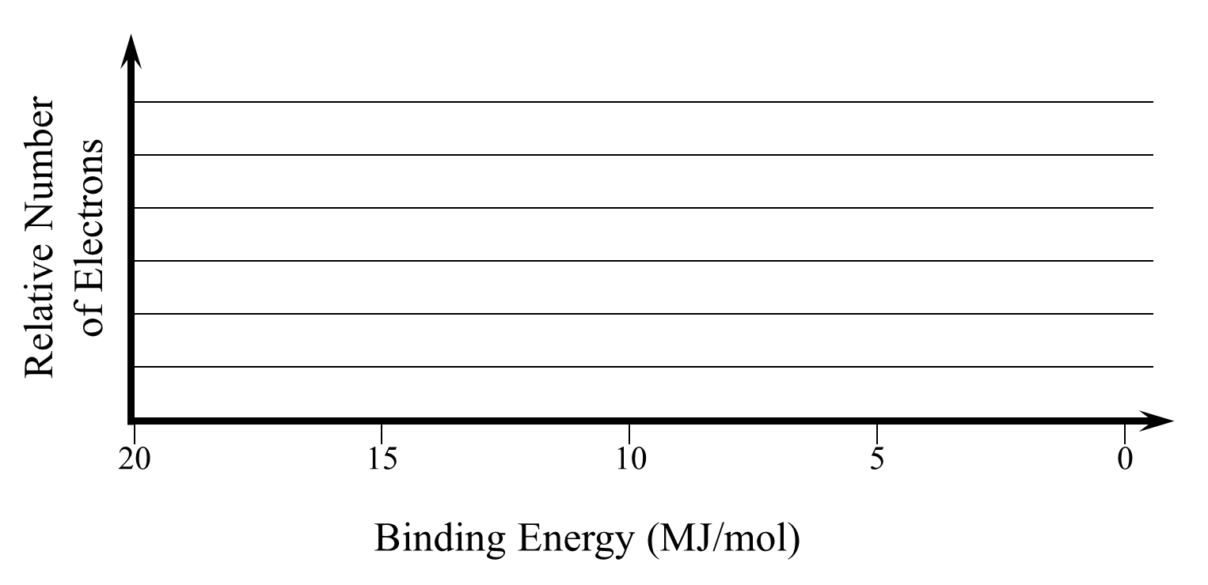
Model 3: PES of Period 2 Elements
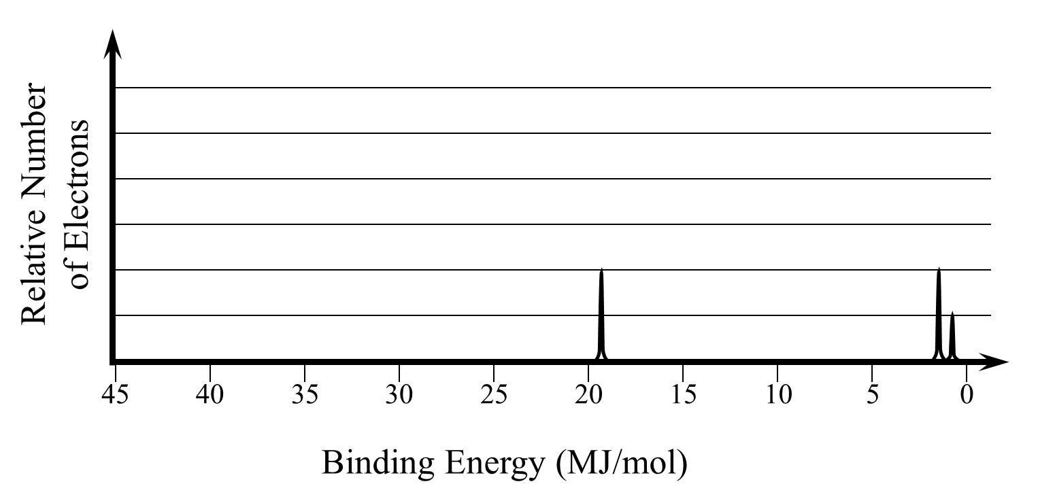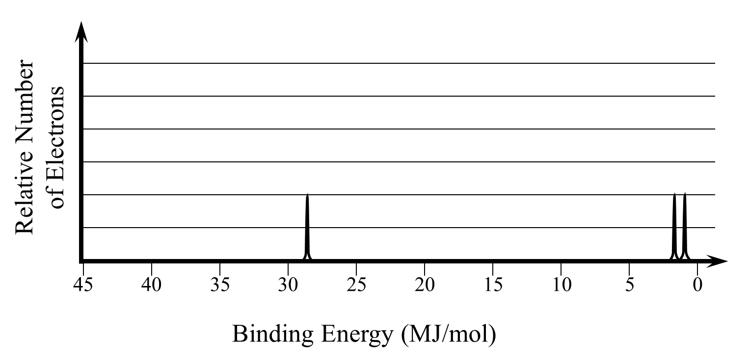
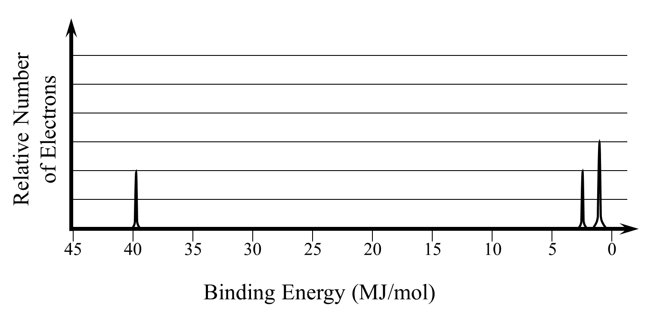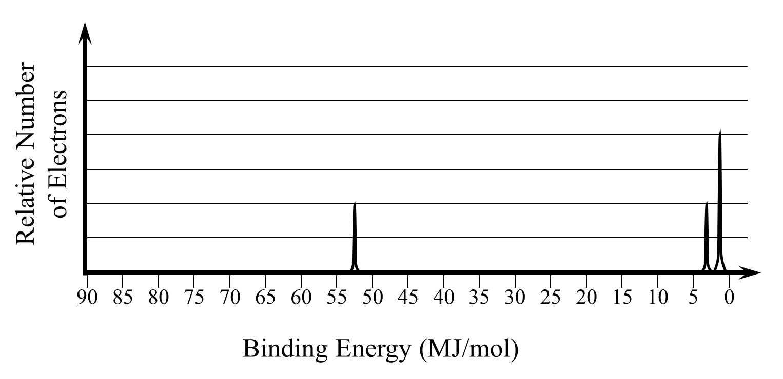
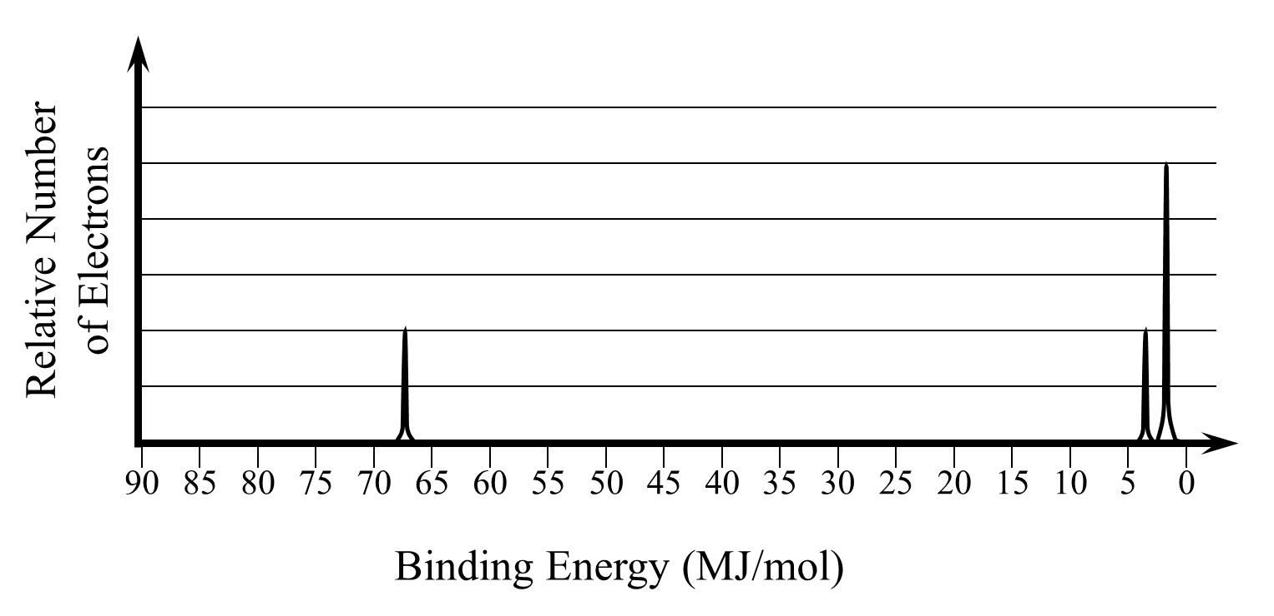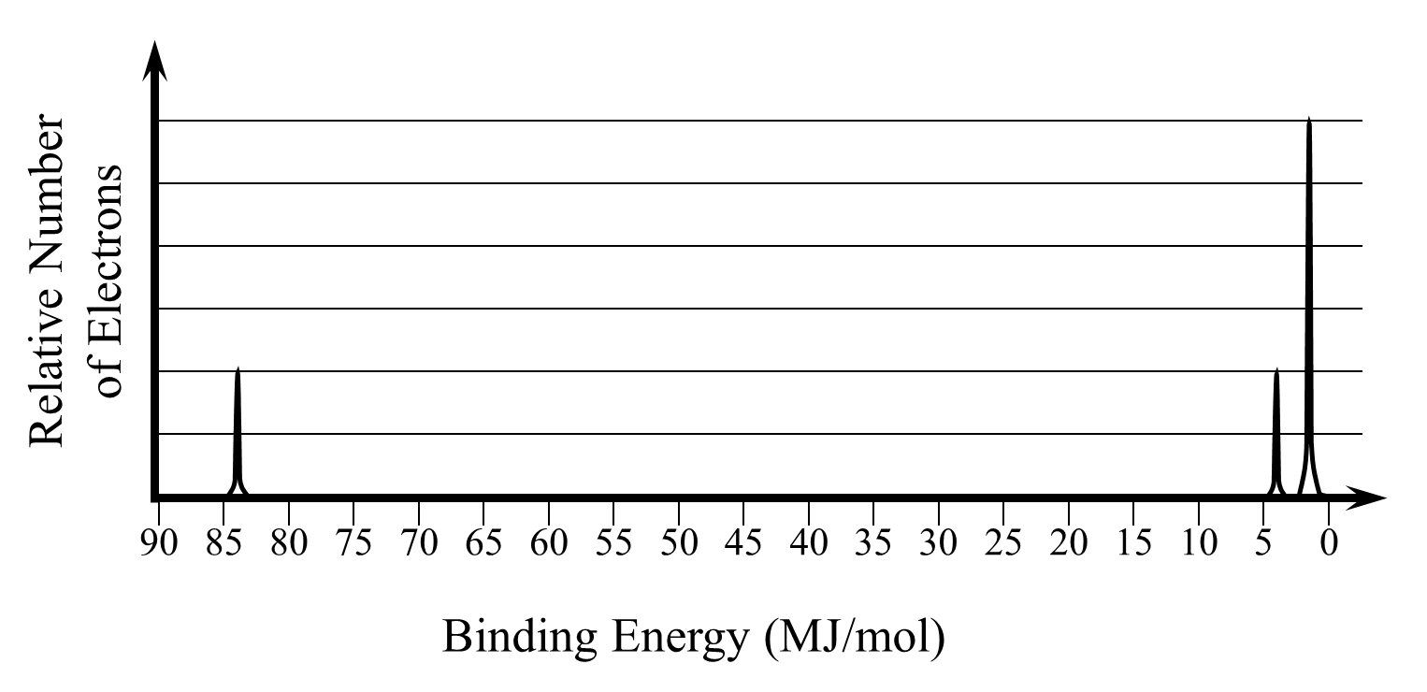

- Based on the number of electrons present in each PES, label the diagrams with which element they represent.

- Observe the PES of boron:
  - Compare and contrast it to the answer you hypothesized in question 4g.

  - Does the binding energies and peaks of the PES of Boron align with your Bohr diagram in question 4f? Explain your answer.

The additional peaks in the PES of period 2 elements correspond to a sublevel contained in the second energy level. The second energy level is split into two sublevels known as “s” and “p.” The s sublevel is filled first and then the p sublevel.

- Observe all PES in Model 3.
  - Label each peak with the energy level and sublevel the electrons are found in. For example, label Boron’s peaks would be labeled 1s, 2s, and 2p from left to right.

  - How many electrons fit in the first sublevel, s, of the second energy level?

  - How many electrons could fill the p sublevel?

  - How many electrons fill the second energy level when s and p are combined?

  - Does your previous answer align with your knowledge of Bohr diagrams? Explain your answer.

  - If more energy is needed to remove electrons from s sublevels than p sublevels, are s sublevels closer or further from the nucleus than p sublevels? Explain your answer.

Model 4: PES of Period 3 Elements
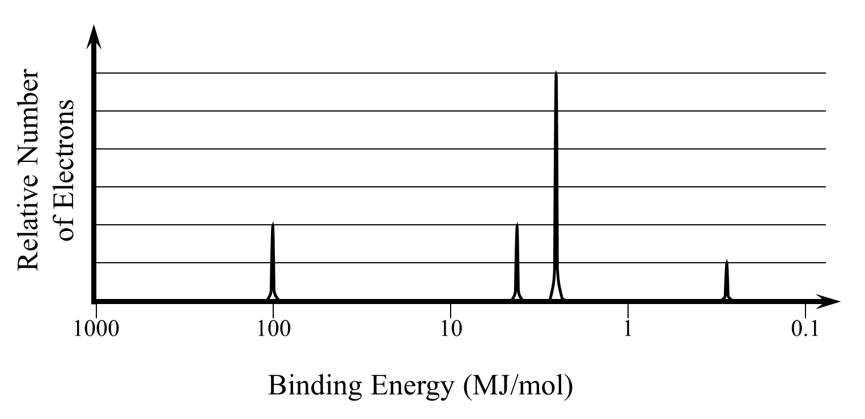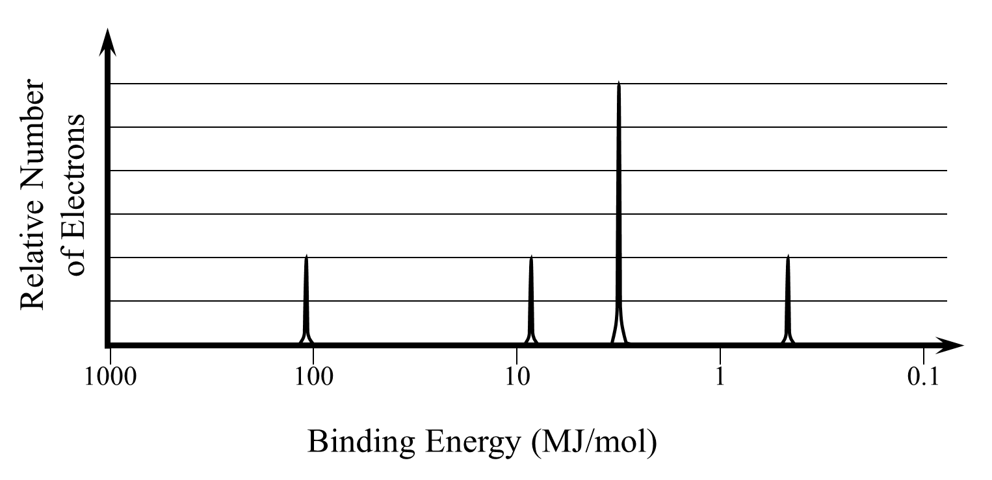
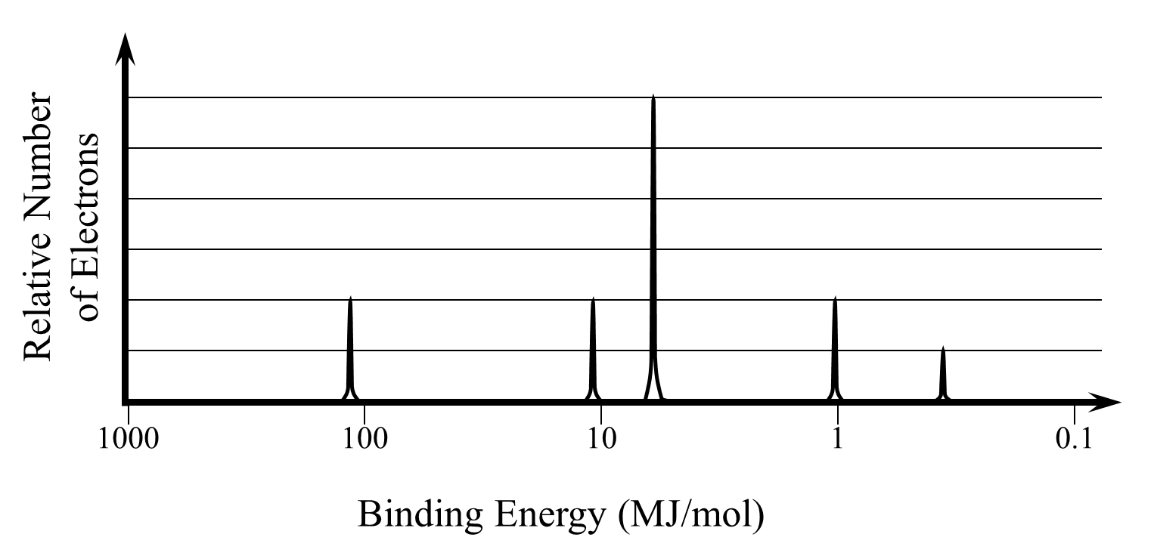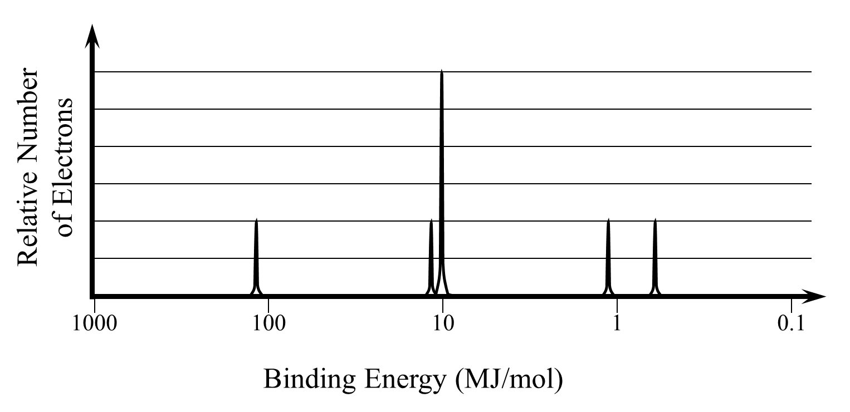
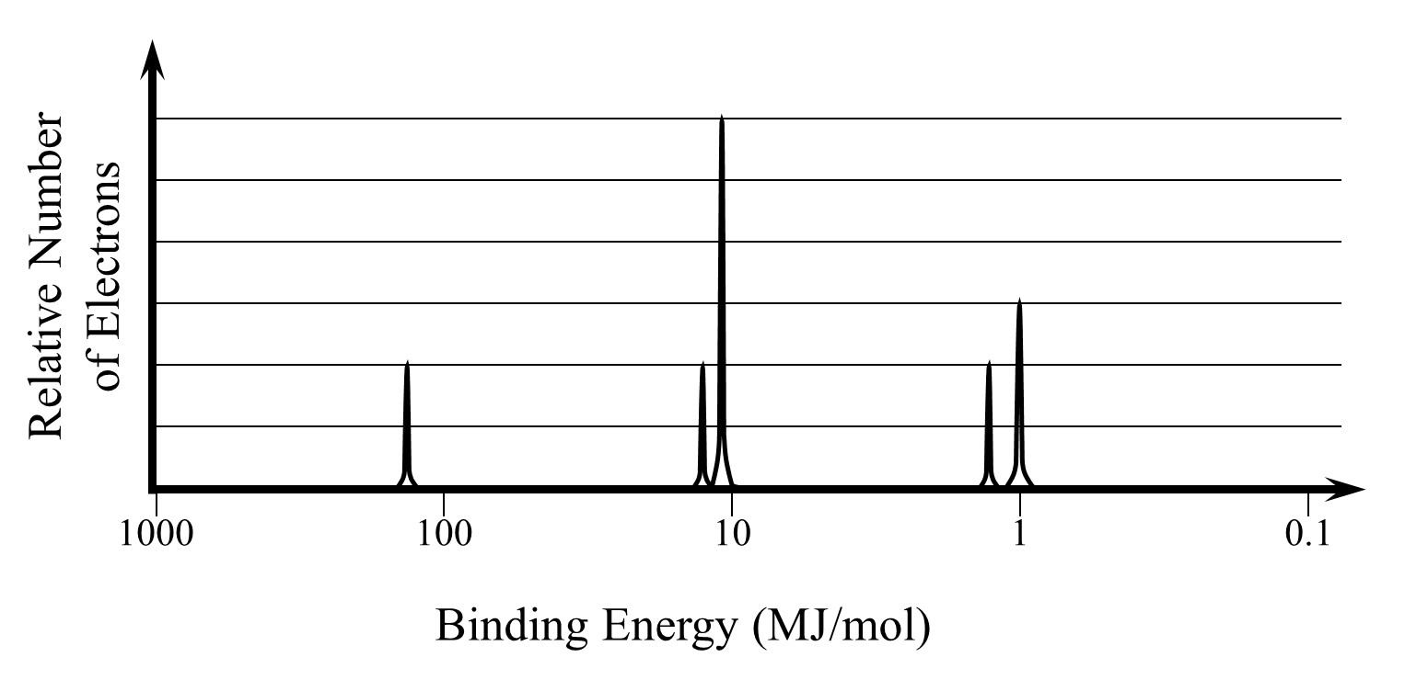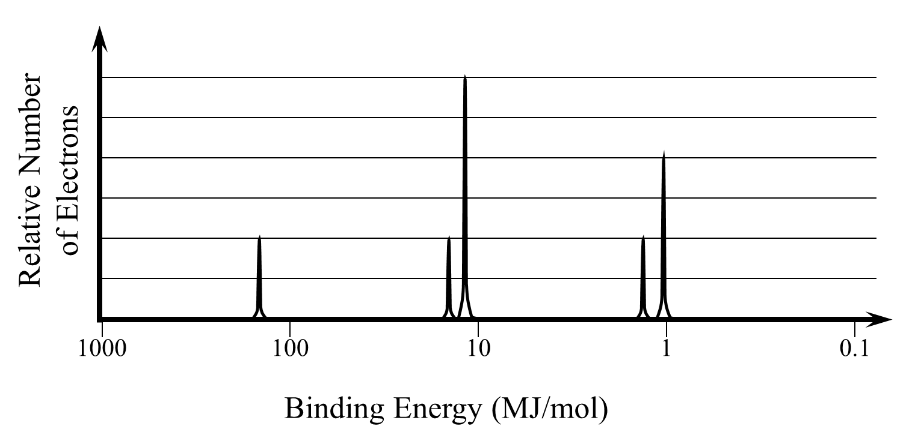
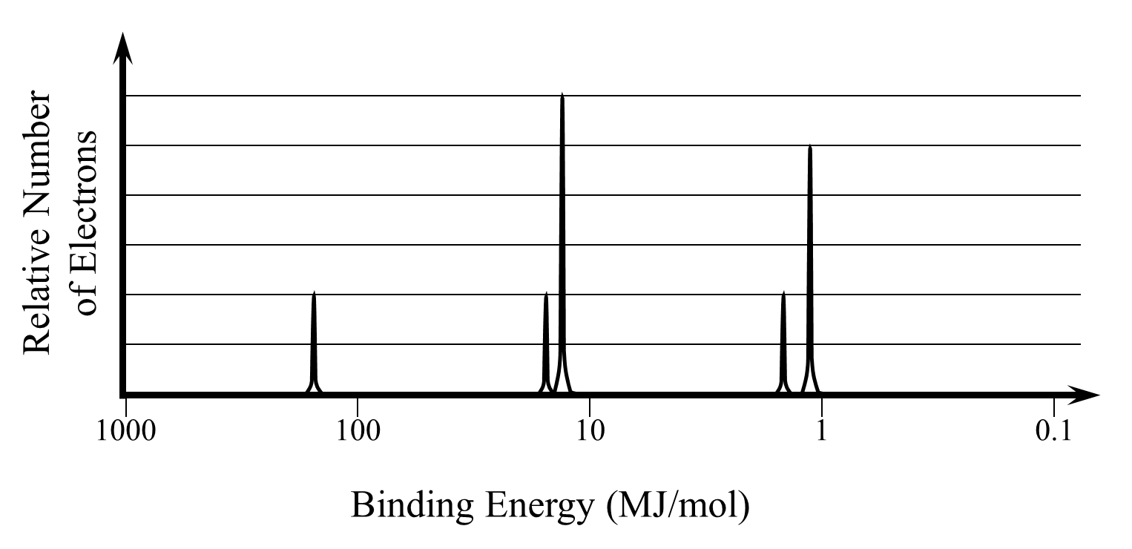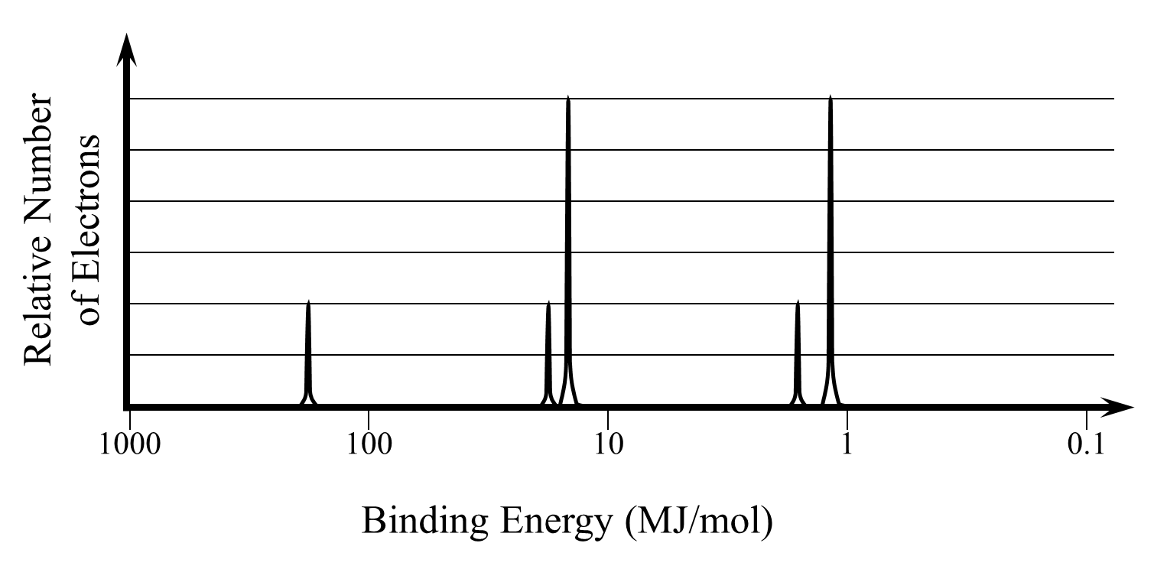
- Based on the number of electrons present in each PES, label the diagrams with which element they represent.
- Label each peak with the energy level and sublevel the electrons are found in. For example, Sodium’s peaks would be labeled 1s, 2s, 2p. 3s, and 3p from left to right.
  - How many electrons fill the 2s sublevel?

  - How many electrons fill the 3p sublevel?
- Consider the electron configuration of potassium.
  - Draw the Bohr diagram for potassium.

  - The PES of potassium is shown below. Label each peak with its corresponding energy level and sublevel.
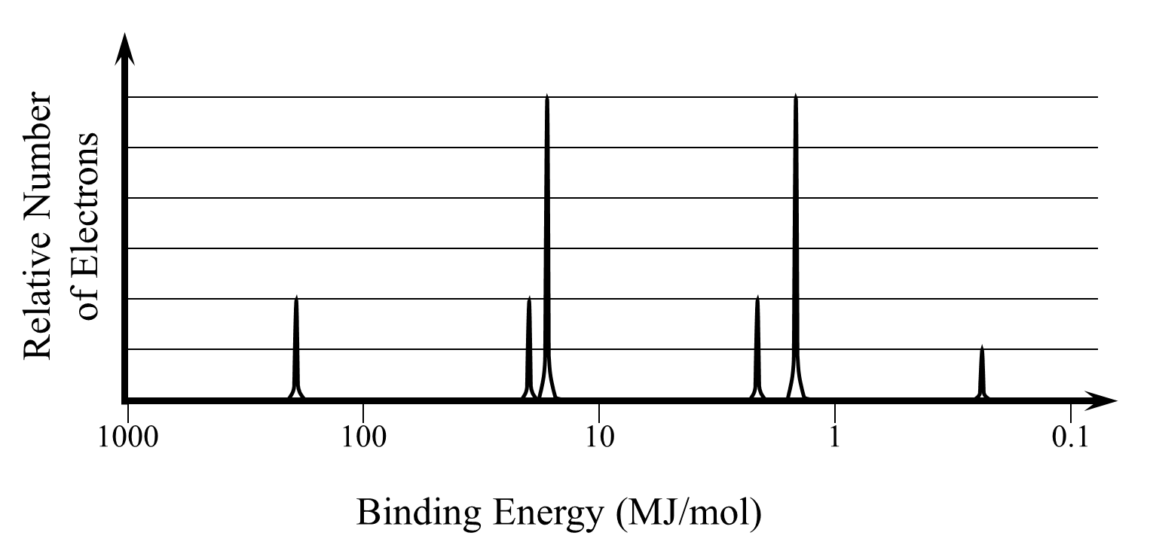
  - Which peak represents the valence electrons of potassium? Explain your answer in terms of peak height and binding energy.

  - Potassium has one less electron and one less proton than calcium. Sketch the peak that could represent the valence electrons of calcium on the PES above. Be sure to consider the height and energy of the peak.

