Name: _________________________ Phase Change Lab

Procedure: Watch the video of the ice being heated. Keep a close eye on the x axis of time and pause the video if needed. Record missing observations and measurements in the data table below.

Time (s) | Observations | Temperature (°C)
0 | Solid phase | -1.0
300 | Solid and liquid phases
500
700
800
1200
1300

Analysis Questions:
- Graph the data from above on the chart below. The x axis should be labeled time and the y axis should be labeled temperature (°C). Title your graph. Re-watch the video to ensure you have a similar graph.

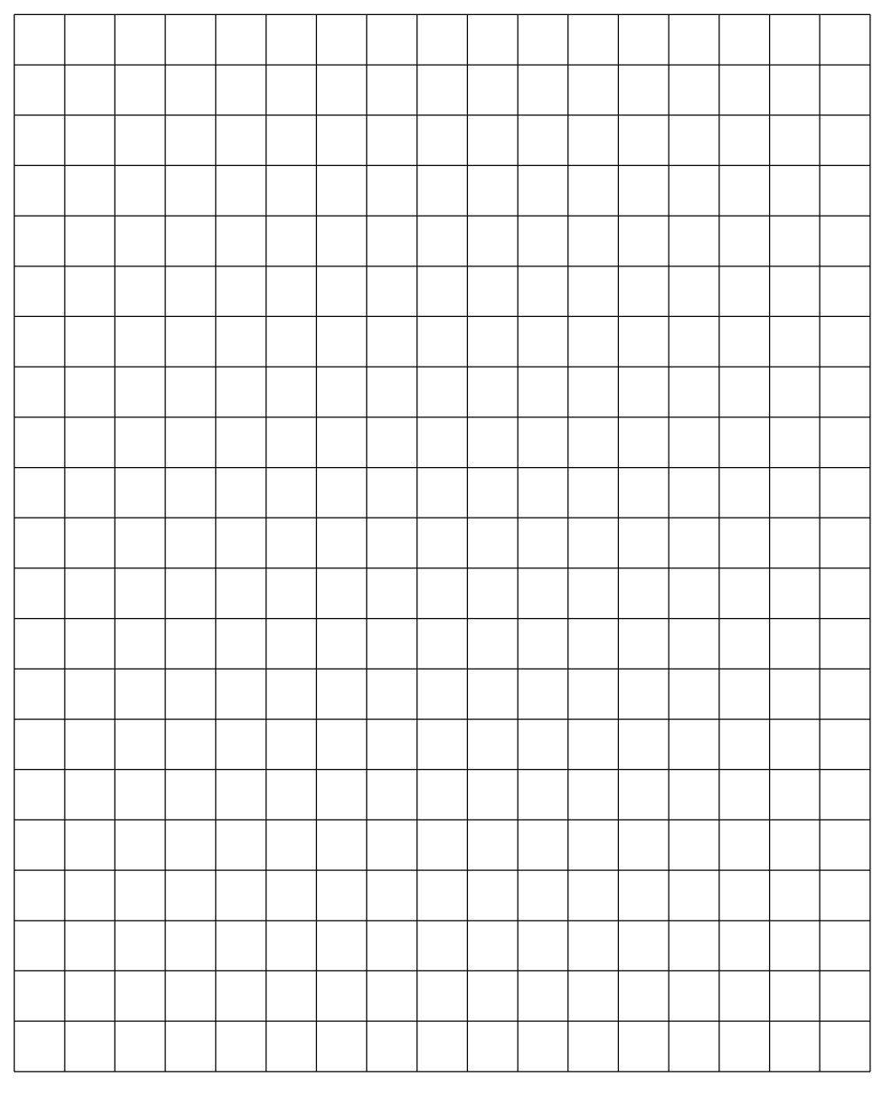

- Divide your heating curve into three regions; label each region:
  - a low temperature plateau
  - a region of temperature change
  - a high temperature plateau

- For each region on your graph:
  - Label each region with what phases were present
  - Draw a model at the particle level that shows how the water particles were behaving at the regions a, b, and c from question 2.
b
c

a

- Did the system absorb or release energy? Explain.

- How would increasing the rate of heating by using a hot plate at a higher heat setting affect the shape of the curve?

- If the water was continued to be heated, predict what may occur to the particles:
  - Phase

  - Space between particles

  - Temperature

