Periodic Table Review
Vocabulary
- Electronegativity-The ability of an atom to attract electrons.
- Ionization Energy-The energy needed to remove an electron from the valence shell of a gaseous atom or ion in the ground state
- Atomic Radius-The size of the atom in the ground state
- Ionic Radius- The radius of an atom’s ion
- Electron Affinity- The change in energy of a neutral atom
- Shielding- A barrier made of inner shell electrons and it decreases the nucleus’ pull on the outer electrons

Key Information
- Atomic radius increases down a group due to more energy levels, electron-electron repulsions, and shielding of the kernel electrons.
- Atomic radius decreases down a period due to a higher nuclear charge (more protons) pulling the electrons in tighter.
- Ionic radius increases down a group due to increase in energy levels, electron-electron repulsions and shielding.
- Across a period the ionic radius depends on its charge and configuration.
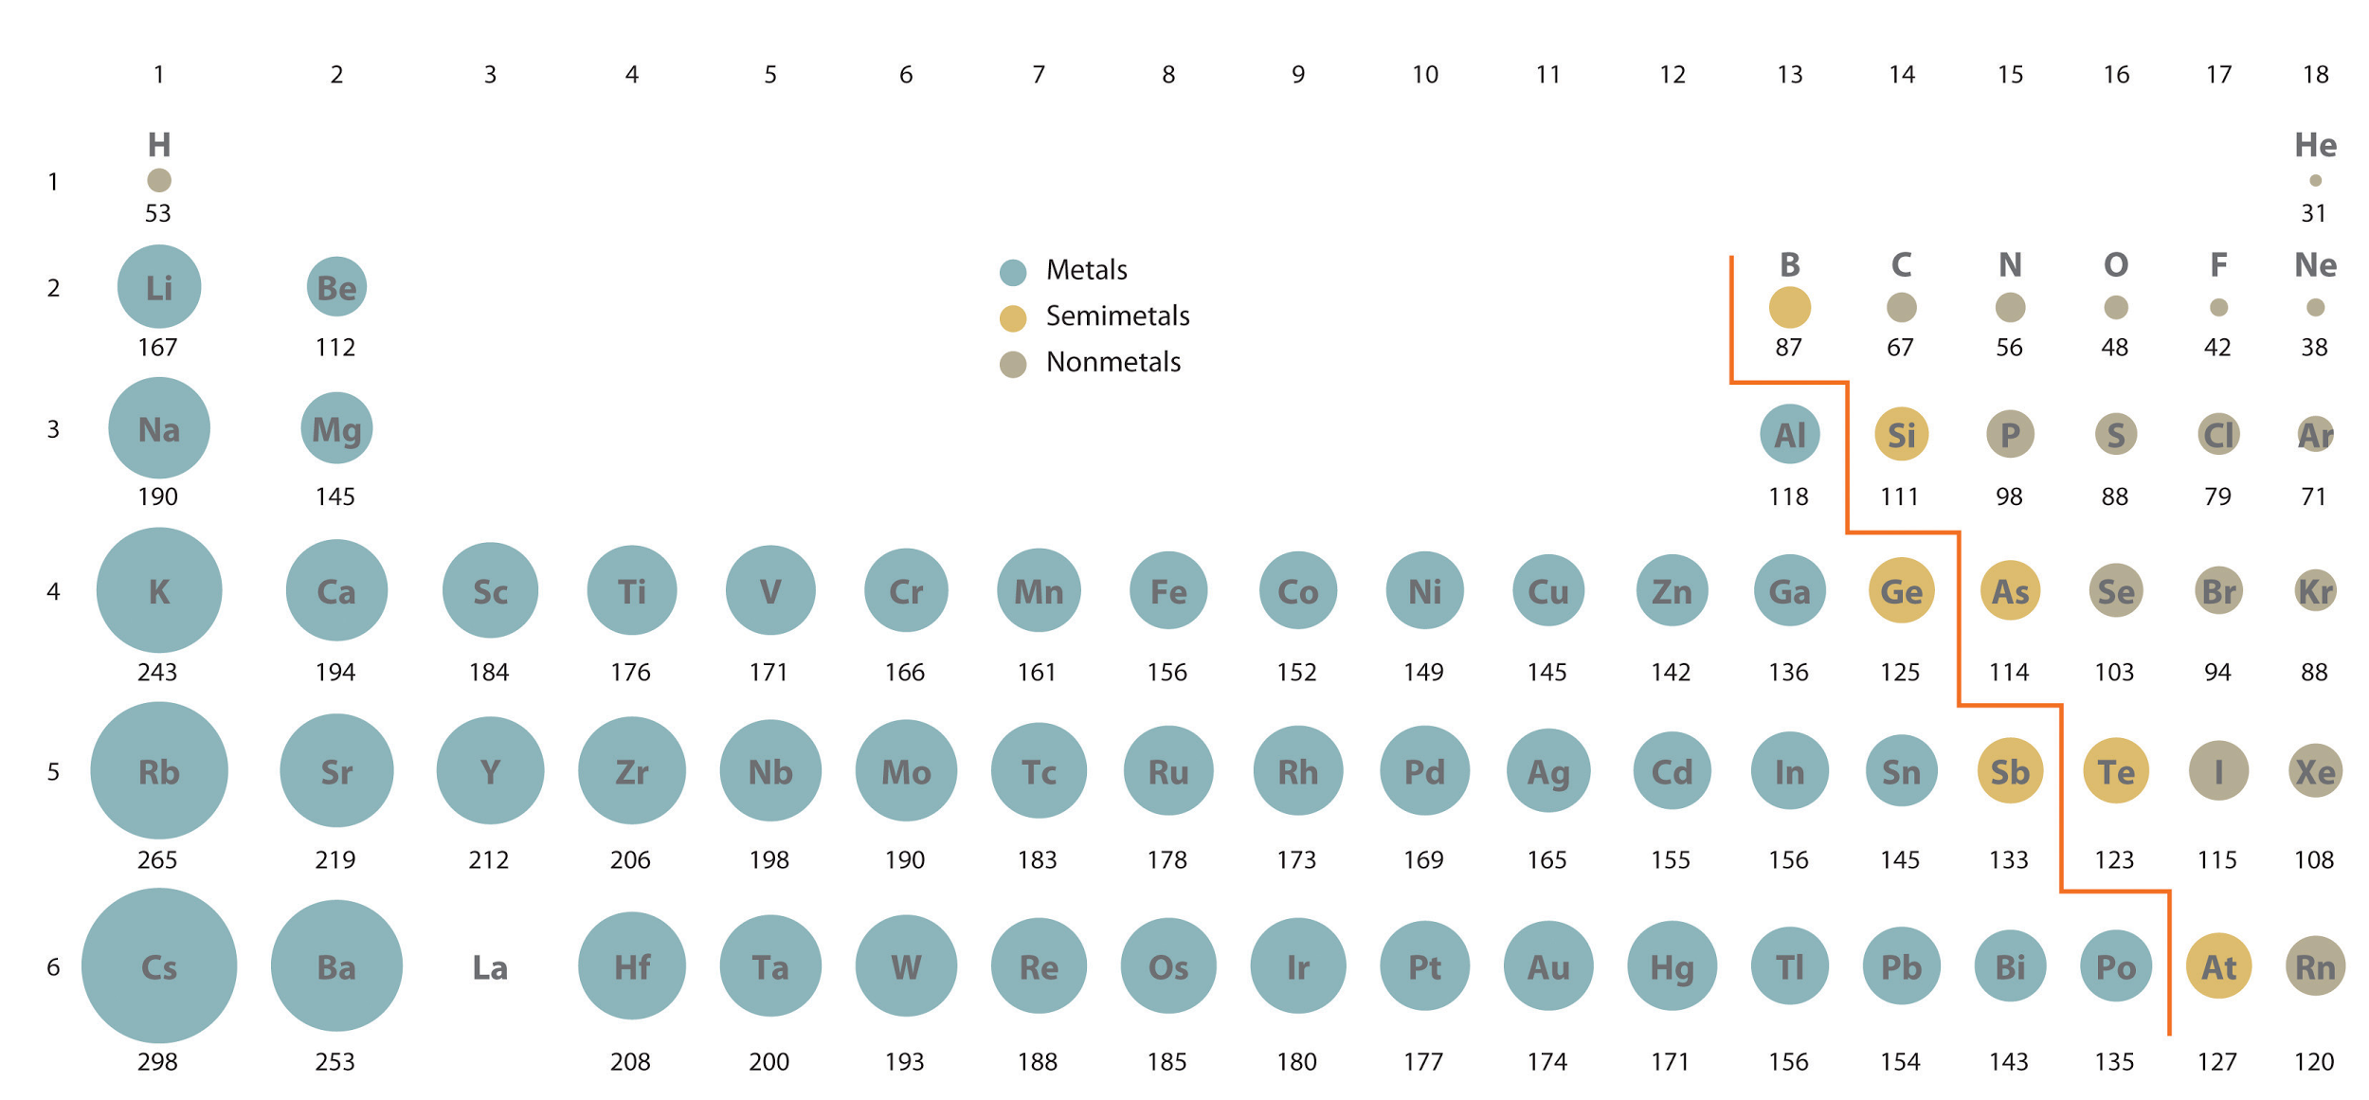
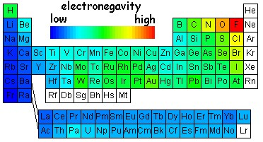
- Electronegativity decreases down a group due to higher shielding from the nucleus by inner electrons.
- Electronegativity increases across a period due to stronger nuclear charge and needing to fill the octet.
- Ionization energy decreases down a group because electrons are less bound to the nucleus due to higher shielding from the nucleus by more inner electrons.
- Ionization energy increases across a period because electrons are more tightly bound to a stronger nuclear charge, therefore they are harder to remove.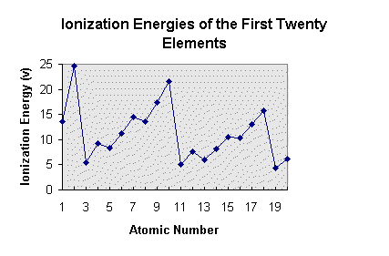
- Fluorine has the highest electronegativity and one of the highest ionization energies.
- A compound is polar if it’s electronegativity difference (END) is greater than .4
- A compound is nonpolar if it’s electronegativity difference (END) is less than .4

Octet Rule
Atoms bond with other atoms by sharing or transferring electrons in order to achieve a stable octet (8 valence electrons).
- When bonds are formed, energy is released.
- When bonds are broken, energy is absorbed.

Metallic Bonds
- Sea of electrons
- Metals only
- High melting and boiling points
- Insoluble
- Always conduct
- All other metallic properties

Covalent Bonds
- Share electrons
- Nonmetals only
- Low melting and boiling points
- Insoluble unless polar
- Never conduct
- Creates molecules
- If two atoms or more form a bond with the same electronegativity, the bonds are nonpolar and they share electrons equally.
- If there is an electronegativity difference between bonded atoms, the bonds are polar and electrons are pulled toward the more electronegative atom.

Lattice Energy
- Lattice energy is the change in energy that takes place when separate gaseous ions are packed together ions are packed together to form an ionic solid.
- Lattice energy is generally exothermic and has a major affect on whether a compound can be made.
- Coulomb’s Law can be used to calculate and compare the lattice energy of compounds.
  - LE = k(Q1Q2/r)
  - K = constant
  - Q = charge of ion
  - r = distance between ions

Heat of Formation
- The following steps must be taken to find heat of formation:
  - Sublimation
  - Ionization
  - Dissociation
  - Electron Affinity
  - Lattice Energy

Geometry
- Linear- The molecule is on one plane (flat).
- Bent- The molecule is bent at an angle due to unshared electrons and two bonding pairs on the central atom.
- Pyramidal- The molecule has a triangular shape due to a lone pair and three bonding pairs on the central atom.
- Tetrahedral- The molecule has four bonding pairs and no lone pairs on the central atom.
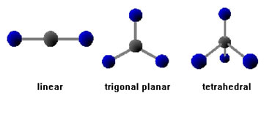

Dipolar Molecules
- If a molecule is polar, it will have a slightly negative and slightly positive side, called a dipolar molecule.
- Dipolar bonds can create polar or nonpolar molecules.
- A polar molecule will have polar bonds and be asymmetrical.
- A nonpolar molecule will either have nonpolar bonds or polar bonds with a symmetrical shape.

Bond Energy
- Forming bonds is exothermic and need to be negated.
- Breaking bonds is endothermic and are positive.
- Heat of Formation = (Bonds broken) - (Bonds formed)

Metals v. Nonmetals vs. Semimetals
- Metals are ductile and malleable while nonmetals are brittle
- Metals are good conductors of heat and electricity while nonmetals are poor conductors and semimetals only partially conduct electricity
- Metals tend to lose electrons while nonmetals tend to gain them

How to Draw a Lewis Dot Diagram
- Find the number of electrons that are in the compound
- Arrange the electrons so that each atom contributes one electron to a single bond between each atom
- If each atom has an octet then it is complete but if not then you need to rearrange the electrons so that each atom as a stable octet

Special Periodic Groups
- Alkali Metals: group one metals that have low melting and boiling points that are very reactive, soft, can be cut with a knife, and have low densities
- Alkaline Earth Metals: group two metals that are shiny, somewhat reactive, and have low densities, boiling points and melting points
- Halogens: group 17 nonmetals that are highly electronegative and reactive
- Noble Gases: group 18 gases that are odorless, colorless, monatomic and non reactive due to their already stable octet

Practice Problems
- Which of the following has the highest electron affinity?
- Rb b. Br- c. Br d. Rb+
- Answer: C) Br

- Which of the following has the smallest atomic radius?
- Li b. Rb c. Cs d. Na
- Answer: A) Li

- Which of the following molecules is the most polar?
- CH4 b. NH4 c. CCL4 d. H2O
- Answer: D) H2O

- How much energy is absorbed or released (identify which) when the following reaction takes place?
The relevant bond energies are:
C—H 414 kJ/mol CH4 (g) + 2 O2 (g) --> CO2 (g) + 2 H2O (g)
O==O 502 kJ/mol
C==O 730 kJ/mol
O—H 464 kJ/mol
H—H 435 kJ/mol
- Answer: 656 kJ released

- Predict the trend in radius for Be, Mg, Ca, and Sr.
- Answer: Be, Mg, Ca, and Sr increase due to an increased number of principal energy levels.

- What happens to electronegativity as you go across a period?
- Answer: Electronegativity increases as you go across a period due to stronger nuclear charge.

- What happens to atomic radius as you go down a group?
- Answer: As you go down a group atomic radius increases due to more energy levels.

- What would happen to the lattice energy if the radii was tripled?
- Answer: If the radii triples, the LE decreases.

