A functional group in an organic molecule is an atom or a group of atoms that replaces a hydrogen atom in a hydrocarbon. These replacement groups are much more reactive than the hydrogen atom that was replaced. They give the molecule its functionality, or its reactivity.

Reference Table R is very helpful to name and draw structure of organic molecules that contain a functional group. The table lists the class of compound, the functional group, the general formula and an example to help in the naming. The R and R’ in the general formula stands for the hydrocarbon that makes up the rest of the molecule.

Directions: For each Model below, determine how the name is derived from the structural formula. Using table R in your reference table and the models, circle the functional group and name the compound.

MODEL 1: Halide or Halocarbon (group 17)
Halides have a halogen (group 17 element) in place of a hydrogen atom. The name is derived by changing the ending of the halogen name to –o and adding it to the hydrocarbon name. A number is used to identify the carbon in the chain to which the halogen is attached.

Name | General Formula | Structural formula | Condensed formula
2-chloropropane | 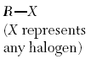 | 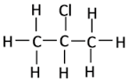 | CH₃CHClCH₃
1,2 dibromoethane |  | 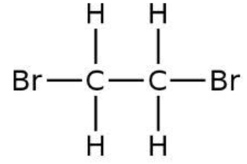 | CHBrCHBr

Using Reference Table R and the model above, circle the functional group(s) then name the organic molecule.
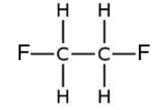

Name:

MODEL 2: Alcohols (-OH group) = -ol ending
Alcohols have a hydroxyl group (-OH). The hydroxyl group is NOT the same as a hydroxide ion…it has no charge. (Alcohols are NOT bases!) Alcohols are named just like alkanes, but the -e at the end is replaced with an -ol ending. You also need to put a number in front of the name, separated with a dash, to indicate which carbon atom the -OH group is attached. As always, use the smallest possible number.
Name | General Formula | Structural formula | Condensed formula
1-propanol | 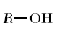 | 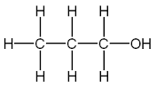 | CH₃CH₂CH₂OH
2-pentanol |  | 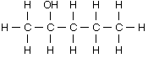 | OH  |  CH₃CHCH₂CH₂CH₂CH₃
3-pentanol |  | 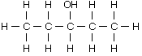 | OH  |  CH₃CH₂CHCH₂CH₂CH₃

Circle the functional group then name the organic molecule.
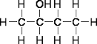

Name:

MODEL 3: Ethers (-O-)
Ethers have an oxygen bonded between two hydrocarbon chains. In an ether, the carbon chain on each side of the –o– is named separately with a –yl ending then the word ether. The hydrocarbon chains should be named in alphabetical order (except for the ** below.)

Name | General Formula | Structural formula | Condensed formula
***methyl ethyl ether | 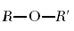 | 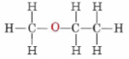 | CH₃OCH₂CH₃
dimethyl ether |  | 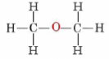 | CH₃OCH₃
diethyl ether |  | 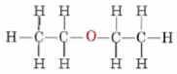 | CH₃CH₂OCH₂CH₃

****The R and R’ in the general formula stands for the hydrocarbon that makes up the rest of the molecule. Notice that there are hydrocarbons on both sides of the oxygen atom.

Circle the functional group then name the organic molecule.
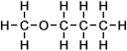

Name:

O
||
MODEL 4: Aldehydes (–C–H group or –CHO group) = -al ending
An aldehyde is an organic molecule that has an oxygen atom doubly bonded to the end carbon of the backbone carbon chain. The C=O group is referred to as a carbonyl group. An aldehyde is named like an alkane except with an -al ending. Since the CHO must be on the terminal #1 carbon atom, the position of the CHO is not specified in the name. (No number is needed).

Name | General Formula | Structural formula | Condensed formula
propanal | 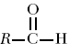 | 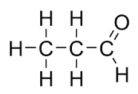 | O  ||  CH₃CH₂C-H
ethanal |  | 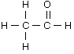 | O  ||  CH₃C-H
pentanal |  | 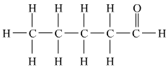 | O  ||  CH₃CH₂CH₂CH₂C-H

****The R in the general formula stands for the hydrocarbon that makes up the rest of the molecule. Notice that the functional group is on the end of the compound (carbon 1)

Circle the functional group then name the organic molecule.
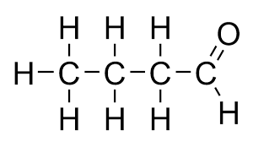

Name:

O
||
MODEL 5: Ketones (–C– group) = -one ending
Ketones are very similar to aldehydes. Aldehydes and ketones with the same number of carbons are isomers. The only difference is that the C=O in a ketone is in the middle of a chain and not on the end carbon. To name a ketone, use the -one ending and specify the position of the C=O with a number at the beginning of the name.

Name | General Formula | Structural formula | Condensed formula
2-pentanone | 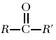 | 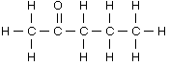 | O  ||  CH₃CCH₂CH₂CH₃
propanone |  | 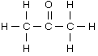 | O  ||  CH₃CCH₃
butanone |  | 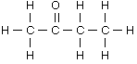 | O  ||  CH₃CCH₂CH₃

****The R and R’ in the general formula stands for the hydrocarbon that makes up the rest of the molecule. Notice that there are hydrocarbons on both sides of the functional group (C=O).

What is the difference between an aldehyde and a keytone?

Why is it not necessary to number propanone and butanone?

Circle the functional group then name the organic molecule.
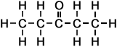

Name:

O
||
MODEL 6: Organic Acids (–C–OH or –COOH group)
Organic acids have a carboxyl group at the end of the carbon chain. The acidic H is attached to the oxygen in the carboxyl group. To name an acid, change the end of the hydrocarbon to –oic acid. No number is needed because the functional group is at the end of the carbon chain.

Name | General Formula | Structural formula | Condensed formula
propanoic acid | 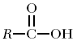 | 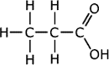 | O  ||  CH₃CH₂C-OH  (or CH₃CH₂COOH)
ethanoic acid |  | 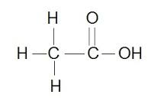 | O  ||  CH₃C-OH  (or CH₃COOH)
butanoic acid |  | 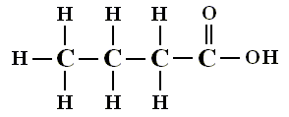 | O  ||  CH₃CH₂CH₂C-OH  (or CH₃CH₂CH₂COOH)

****The R in the general formula stands for the hydrocarbon that makes up the rest of the molecule. Notice that the functional group is on the end of the compound (carbon 1)

Circle the functional group then name the organic molecule.
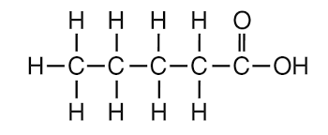

Name:

O
||
MODEL 7: Esters (–C–O– or –COO– group)
Esters are named by the right side first (side bonded to oxygen) with a –yl ending. The second part of the name come from the left side (side bonded to C=O) with the ending –oate.

Name | General Formula | Structural formula | Condensed formula
methyl propanoate | 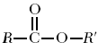 | 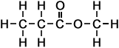 | O  ||  CH₃CH₂COCH₃
ethyl propanoate |  | 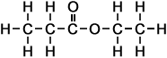 | O  ||  CH₃CH₂COCH₂CH₃

****The R and R’ in the general formula stands for the hydrocarbon that makes up the rest of the molecule. Notice that there are hydrocarbons on both sides of the functional group.

What is the difference between and ester and an organic acid?

Circle the functional group then name the organic molecule.

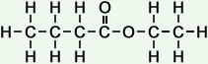
Name:

MODEL 8: Amines (-N- group)
To name an amine, drop the end –e in the hydrocarbon name and replace it with -amine. Be sure to number the carbon in the chain to which the -NH₂ group is attached.

Name | General Formula | Structural formula | Condensed formula
1-propanamine | 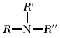 | 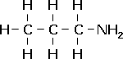 | CH₃CH₂CH₂NH₂
ethanamine |  | 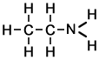 | CH₃CH₂NH₂

Circle the functional group then name the organic molecule.
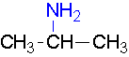
Name:

O
||
MODEL 9: Amides (–C–OH group)
To name amides, replace the –e in the name of the hydrocarbon with –amide. No number is needed as the functional group is at the end of the hydrocarbon chain.

Name | General Formula | Structural formula | Condensed formula
propanamide | 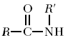 | 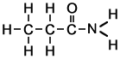 | O  ||  CH₃CH₂C-NH₂
ethanamide |  | 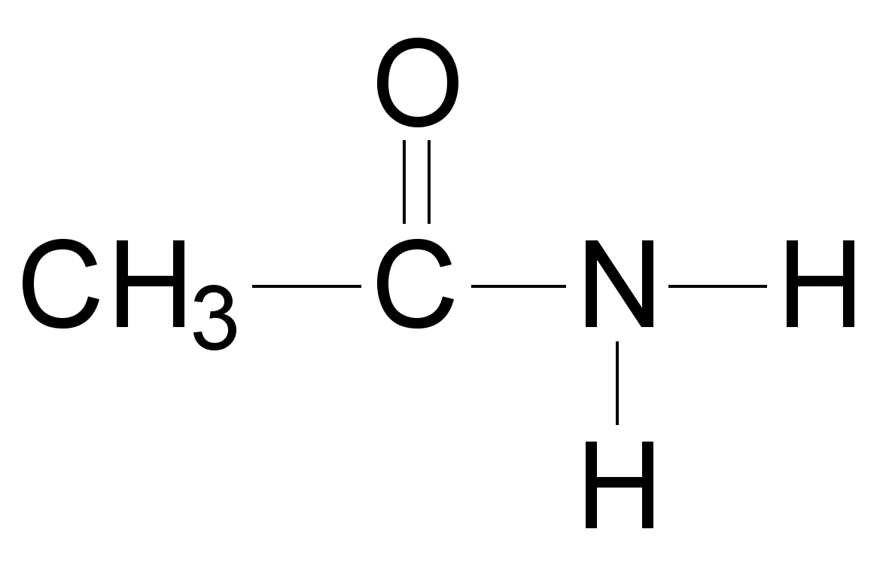 | O  ||  CH₃C-NH₂
Circle the functional group then name the organic molecule.

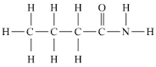 Name:

Practice:
Identify the class of organic compounds to which each of the following belongs. Name the compound using the IUPAC name. It may be helpful to draw structural formulas first!

CH₃COOH CH₃CH₂COOCH₃

CH₃COCH₃ CH₃CH₂COOH

CH₃CH₂OH CH₃OCH₃

CH₃CH₂OCH₃ CH₃CH₂COCH₃

CH₃CH₂CHO CH₃CH₂CH₂CONH₂

Draw the structural formula for each of the following:

butanoic acid methyl methanoate

methanal 3-pentanol

