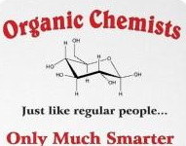
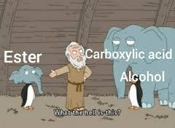
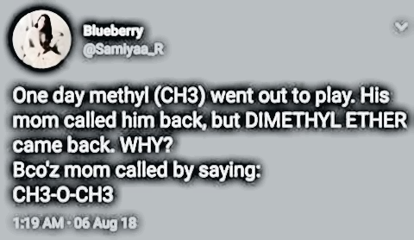
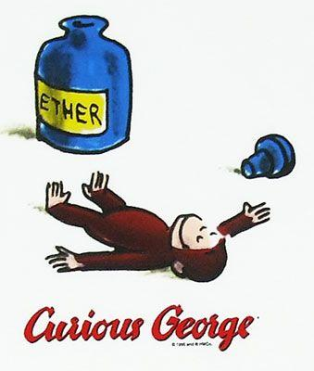
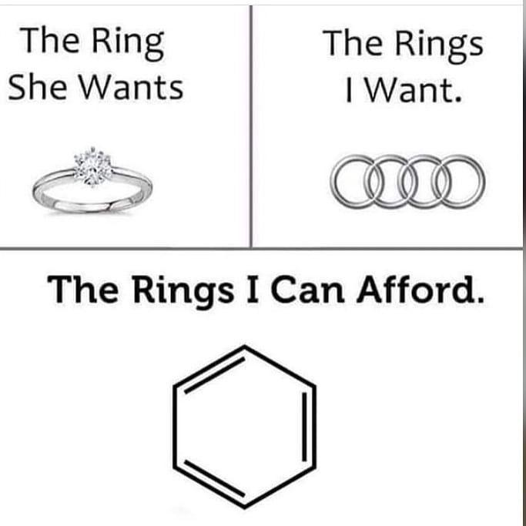
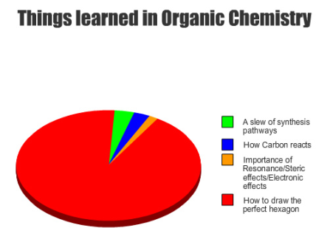
Organic Compounds and Hydrocarbons Think Tank Questions
The Stock System and IUPAC nomenclature has been used to name Inorganic compounds, which by definition compounds that do not contain primarily Carbon and Hydrogen (example: NaCl). Organic compounds contain Carbon as a primary element in the composition of the molecule. The carbon atoms are connected to each other to form the backbone of a molecule. The term “organic” finds its roots in the fact that these compounds were first identified as those that make up the components of living organisms (tissues, enzymes, etc.). Many organic compounds are referred to as hydrocarbons, due to their containing carbon and hydrogen only. (This term is especially applicable to the petroleum industry, where most of the compounds are of this type). However, other types of organic compounds also include elements such as oxygen, sulfur, and nitrogen, which have a wide range of effects on their properties. This activity is designed to address only simple hydrocarbons.

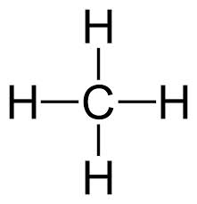
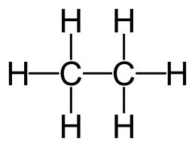
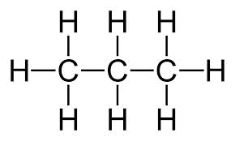
Model 1

methane ethane propane
- Using model 1, how many bonds does Carbon always make in an organic compound?

- The molecules above are called hydrocarbons. What are the only elements that hydrocarbons possess?

- Using model 1, draw a compound containing 4 carbon atoms.

Organic compounds that only have single bonds are called saturated hydrocarbons. This is because they contain the maximum number of hydrogen atoms bonded to the carbon chain. Organic compounds that contain a double or triple bond are referred to as unsaturated. Look at Table Q of your reference tables.
- What is the name of the series of saturated hydrocarbons that possess only single bonds?

- What is the name of the series of unsaturated hydrocarbons that possess 1 double bond?

- What is the name of the series of unsaturated hydrocarbons that possess 1 triple bond?

- Using the general formula how many hydrogen atoms would a compound contain if it had 5 Carbon atoms and only single bonds?

- Using the general formula how many hydrogen atoms would a compound contain if it had 5 Carbon atoms and a double bond?

- Using the general formula how many hydrogen atoms would a compound contain if it had 5 Carbon atoms and a triple bond?

Look at Table P of your reference tables.
NAMING ALKANES (saturated hydrocarbons)
- For all alkanes, what is similar about their names (look at Model 1)? What is different?

- What does the eth- in ethane tell you?
12. Determine the name of the following compounds:
a. C₄H₁₀ b. C₅H₁₂ c. C₆H₁₄ d. C₇H₁₆

13. How many C atoms and H atoms do the following compounds contain?
a. octane b. nonane

NAMING ALKENES (unsaturated hydrocarbons)
- What is different about the name of compounds containing a double bond versus a single bond?

- Name the following alkenes:
a. C₄H₈ b. C₅H₁₀ c. C₆H₁₂ d. C₇H₁₄

- If you are given the following molecular formulas: C₅H₁₂ and C₅H₁₀ how can you distinguish which is an alkane and which is an alkene?

- Name the two compounds in question 16.

NAMING ALKYNES (unsaturated hydrocarbons)
- What is different about the name of compounds containing a triple bond versus a single or double bond?

- Name the following alkynes:
a. C₄H₆ b. C₅H₈ c. C₆H₁₀ d. C₇H₁₂

20. Which compound is an alkyne? C₉H₁₈ or C₉H₁₆
Structural formulas show the arrangement of the atoms within the molecules as far as which atoms are bonded to which and whether single, double or triple bonds are used.

MODEL 2: Structural formulas for alkanes

methane ethane propane
- Using model 2 above, draw the structural formula for the following alkanes.
- C₄H₁₀ b. C₅H₁₂ c. C₆H₁₄

- Name the compounds in question 21.

MODEL 3: Structural Formulas for Alkenes
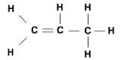
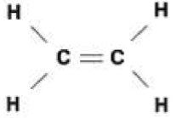
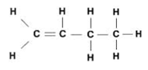

ethene
propene
butene

- Based upon model 3 and your knowledge of alkenes, why does the compound methene not exist?

- Why do the carbon atoms with the double bond contain 2 less Hydrogen atoms than carbon atoms that contain a single bond?

- Using model 3 above, draw the structural formula for the following alkenes. (Refer to table P and Q in your reference table). Then name the compounds you drew.
a. C₅H₁₀ b. C₆H₁₂ c. C₇H₁₄

When naming alkenes you must give the location of the double bond in the name when there are more than 3 carbon atoms in the compound. You do this by numbering the carbon atoms and stating which number carbon the double bond is on. You can number the carbon atoms from left to right or right to left whichever gives the double bond the lowest possible numbered location. This is because compounds are not stationary in the “real world” and are therefore constantly moving. See Model 4.
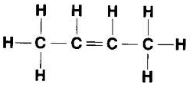
MODEL 4:
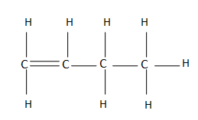
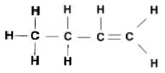

1-butene 2-butene 1-butene
- Why is the third compound in model 4 not called 3-butene?

- Referring to the models, name following compounds:
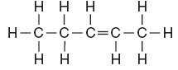
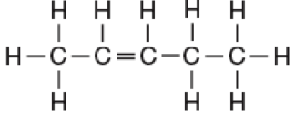
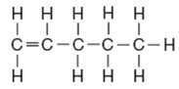

Drawing structural formulas for alkynes is exactly the same as alkenes except they contain a triple bond instead of a double bond.

MODEL 5: Structural Formulas for alkynes
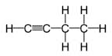
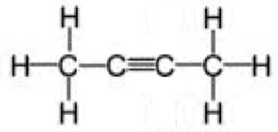
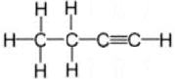

1-butyne 2-butyne 1-butyne
- Why do the carbons with the triple bond contain no bonded hydrogen atoms?

- Using model 5 above, draw the structural formula for the following alkynes. Then name the compounds you drew.
a. C₅H₈ b. C₆H₁₀ c. C₇H₁₂

- Name the following compounds:
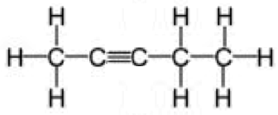
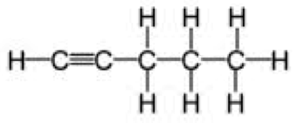

31. Draw the structural formula for the following compounds:
a. C₈H₁₆ b. C₄H₆

c. 2-hexene d. 2-heptyne

e. 3-hexene f. 1-heptyne

32. Which of the above hydrocarbons are parts of the same homologous series (family)?

Isomers are two compounds with the same molecular formula (C_{n}H_{n}) but a different structural formula (how it is drawn). Therefore, isomers have different properties and names.

33. Which of the above hydrocarbons are isomers?

Hydrocarbons Check Your Understanding
- How many carbon atoms are in each compound?
  - Methane ____
  - Ethane ____
  - Ethene ____
  - Pentane ____
  - Propene ____
  - Hexane ____
  - Ethyne ____
  - Propane ____
  - Heptane ____
  - Octane ____
  - Decane ____
  - Butyne ____
  - Butane ____
  - Propyne ____
  - Butene ____

- For each compound fill in each blank:
Number of Carbon atoms Series Formula
  - Methane ________ ___________ _______________
  - Butane ________ ___________ _______________
  - Propyne ________ ___________ _______________
  - Pentane ________ ___________ _______________
  - Octane ________ ___________ _______________
  - Heptene ________ ___________ _______________
  - Propene ________ ___________ _______________
  - Butyne ________ ___________ _______________
  - Decane ________ ___________ _______________
  - Nonane ________ ___________ _______________
  - Heptane ________ ___________ _______________
  - Ethyne ________ ___________ _______________
  - Hexyne ________ ___________ _______________
  - Ethane ________ ___________ _______________
  - Propane ________ ___________ _______________
  - Decene ________ ___________ _______________
  - Octyne ________ ___________ _______________

- How many times does carbon bond and why?

- For each of the following, draw the structural formula and then name the compound.
  - C₂H₆ ________________
  - C₅H₁₀ ________________
  - C₆H₁₂ ________________
  - C₇H₁₂ ________________
  - C₉H₂₀ ________________
  - C₂H₂ ________________
  - C₈H₁₆ ________________
  - C₄H₈ ________________
  - C₁₀H₁₈ ________________
  - C₅H₈ ________________
  - C₆H₁₄ ________________
  - C₉H₁₆ ________________
- For each of the following use tables P and Q to determine the name.
  - CH₄ ________________
  - C₁₀H₂₀ ________________
  - C₃H₄ ________________
  - C₈H₁₈ ________________
  - C₅H₁₂ ________________
  - C₉H₁₈ ________________
  - C₂H₆ ________________
  - C₄H₆ ________________
  - C₇H₁₆ ________________
  - C₆H₁₂ ________________

- Create a rule to determine an easy way to find the homologous series to which a compound belongs.

Branched and Cyclic Hydrocarbons Think Tank Problems

- What element bonds four times, often to atoms of itself, in branches and rings? _____________
- The prefix “cyclo” means cyclic or in a circle. If a hydrocarbon has this prefix, the carbon atoms are arranged in a circle rather than one chain. Attempt to draw the following cyclic hydrocarbons:
  - Cyclobutane c. Cyclohexene

  - Cyclopentane d. Cyclobutene

- Smaller chains of hydrocarbons can branch off from larger chains as shown below. Notice the name identifies the smaller chain first and then the larger chain.
2-methyl hexane 3-methyl hexane
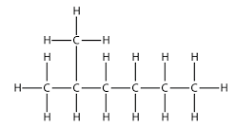
  - What do the numbers before the name represent?

  - What would 1-methyl hexane look like? Draw it.

  - What really is the name of 1-methylhexane?

  - What would 4-methyl hexane look like? Draw it.

  - Once the teacher shows you the models of each of these examples, which two structures are the same?

  - What are the rules for naming branched hydrocarbons?

Branched and Cyclic Hydrocarbons Check your Understanding
- Draw the following cyclic compounds:
Cyclopentene 1, 3 Cyclohexadiene 1, 4 Cyclooctadiene

1, 3 Cycloheptadiene 1, 3, 5 Cyclohexatriene Benzene

- Draw the following branched hydrocarbons:
2-methyl butane 3-ethyl hexane

2, 3-dimethyl pentane 4-methyl, 3-ethyl 1-octyne

- Name the following compounds:
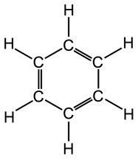
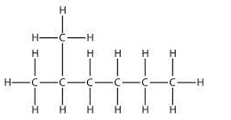
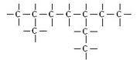
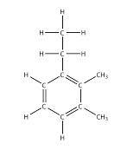
Isomers Think Tank Problems
- Record the Structural formula, molecular formula, and condensed formula for the following:
Name | Structural: Draw the molecule | Molecular: Count the total C&H | Condensed: Don’t draw the H just count them on each C
2, 3-dimethyl butane
2, 2-dimethyl butane
2-heptyne
3-hexene
2-methyl
1-pentene
- Which of the above have the same molecular formula? These are known as isomers because they have the same number of each of the elements but a different structure which gives them different names and properties.

- Draw 2-heptyne.

- Draw an isomer of 2-heptyne.

- Give the name of your isomer.

- Name the following and identify the isomers.
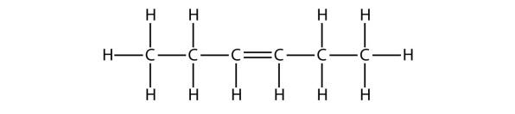
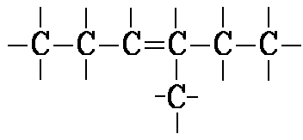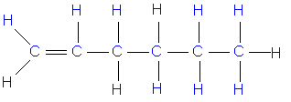
Hydrocarbons Check your Understanding
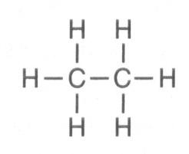
- Which formula represents an unsaturated hydrocarbon?
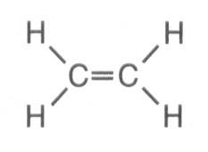
  - C)

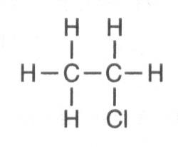
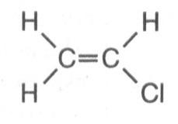
  - D)

- Which organic compound is a saturated hydrocarbon?
  - ethyne C) ethene
  - ethanol D) ethane

- Which formula represents a hydrocarbon?
  - CH₃CH₂CH₂CHO C) CH₃CH₂CH₂COOH
  - CH₃CH₂CH₂CH₃ D) CH₃CH₂COOCH₃

- Which structural formula correctly represents a hydrocarbon molecule?
A) 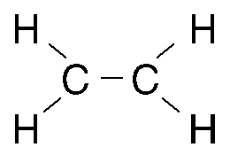 B) 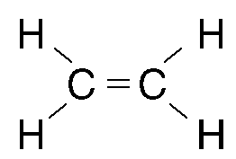
C) 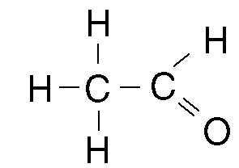 D) 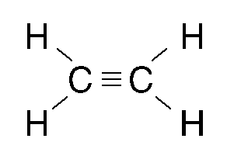

- In saturated hydrocarbons, carbon atoms are bonded to each other by
  - single covalent bonds, only
  - double covalent bonds, only
  - alternating single and double covalent bonds
  - alternating double and triple covalent bonds

- What is the general formula for the members of the alkane series?
  - CnH2n C) CnH2n+2
  - CnH2n–2 D) CnH2n–6
- In which group could the hydrocarbons all belong to the same alkene series?
A) C₂H₂, C₂H₄, C₂H₆ C) C₂H₄, C₂H₆, C₃H₆
B) C₂H₂, C₂H₄, C₄H₈ D) C₂H₄, C₃H₆, C₄H₈

- A molecule of butane and a molecule of 2-butene both have the same total number of
  - carbon atoms C) hydrogen atoms
  - single bonds D) double bonds

- A double carbon-carbon bond is found in a molecule of
  - pentane C) pentene
  - pentyne D) pentanol

- The multiple covalent bond in a molecule of 1-butene is a
  - double covalent bond that has 6 shared electrons
  - double covalent bond that has 4 shared electrons
  - triple covalent bond that has 6 shared electrons
  - triple covalent bond that has 4 shared electrons

- Given the formula:
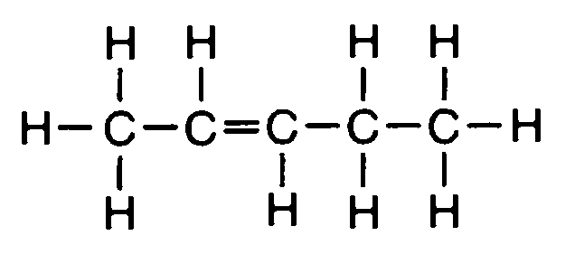
What is the IUPAC name of this compound?
- 2-pentene C) 2-pentyne
- 2-butene D) 2-butyne

- Given the structural formula:
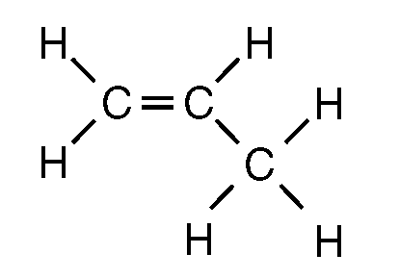
What is the IUPAC name of this compound?
  - propane C) propene
  - propanone D) propanal
- What is the correct formula for butene?
  - C₄H₄ C) C₄H₆
  - C₄H₈ D) C₄H₁₀

- Which general formula represents the homologous series of hydrocarbons that includes the compound l-heptyne?
  - CnH2n-6 C) CnH2n-2
  - CnH2n D) CnH2n+2

- Which compound is an unsaturated hydrocarbon?
  - hexanal C) hexane
  - hexanoic acid D) hexyne

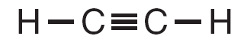
- Given the structural formula:
What is the total number of electrons shared in the bond between the two C?
A) 6 B)2 C) 3 D) 4

- Which formula represents propyne?
  - C₃H₄ C) C₃H₆
  - C₅H₈ D) C₅H₁₀

- What is the name of a compound that has the molecular formula C₆H₆?
  - butane C) butene
  - benzene D) butyne

- Two substances have different physical and chemical properties. Both substances have molecules that contain two carbon atoms, one oxygen atom, and six hydrogen atoms. These two substances must be
  - isomers of each other
  - isotopes of each other
C) the same compound
D) the same hydrocarbon

- The three isomers of pentane have different
  - formula masses
  - molecular formulas
  - empirical formulas
  - structural formulas

- Molecules of 1-bromopropane and 2-bromopropane differ in
  - molecular formula
  - structural formula
  - number of carbon atoms per molecule
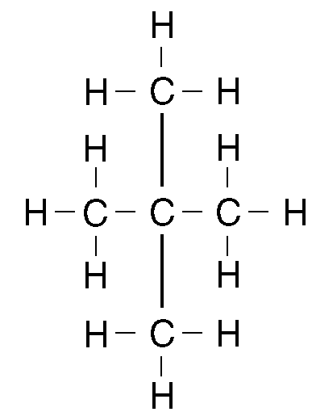
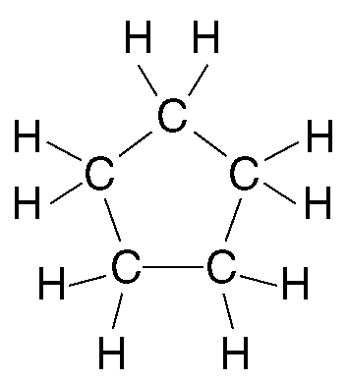
  - number of bromine atoms per molecule

- Which compound is an isomer of pentane?
  - butane C) propane
  - methyl butane D) methyl propane

- What is the maximum number of covalent bonds that can be formed by one carbon atom?
A) 1 B) 2 C) 3 D) 4

- Atoms of which element can bond with each other to form ring and chain structures in compounds?
  - C B) Ca C) H D) Na

- Which element must be present in an organic compound?
  - H B) C C) O D) N

- Organic compounds that are non-polar and exhibit weak intermolecular forces have
  - low vapor pressure
  - low melting points
  - high boiling points
  - high electrical conductivity in solution

- A characteristic of most organic compounds is that they
  - have low melting points
  - have high melting points
  - are soluble in water
  - conduct electricity when aqueous

- In general, which property do organic compounds share?
  - high melting point
  - high electrical conductivity
C) readily soluble in water
D) slow reaction

Functional Groups Think Tank Questions

A functional group in an organic molecule is an atom or a group of atoms that replaces a hydrogen atom in a hydrocarbon. These replacement groups are much more reactive than the hydrogen atom that was replaced. They give the molecule its functionality, or its reactivity. Reference Table R is very helpful to name and draw the structure of organic molecules that contain a functional group. The table lists the class of compound, the functional group, the general formula and an example to help in the naming. The R and R’ in the general formula stands for the hydrocarbon that makes up the rest of the molecule.

Directions: For each Model below, determine how the name is derived from the structural formula. Using table R in your reference table and the models, circle the functional group and name the compound.

MODEL 1: Halide or Halocarbon (group 17)
Halides have a halogen (group 17 element) in place of a hydrogen atom. The name is derived by changing the ending of the halogen name to –o and adding it to the hydrocarbon name. A number is used to identify the carbon in the chain to which the halogen is attached.

Name | General Formula | Structural formula | Condensed formula
2-chloropropane | 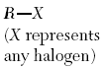 | 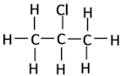 | CH₃CHClCH₃
1,2 dibromoethane |  | 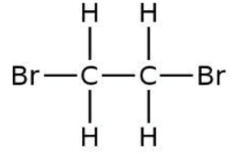 | CH₂BrCH₂Br

Using Reference Table R and the model above, circle the functional group(s) then name the organic molecule.
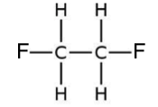

Name:

MODEL 2: Alcohols (-OH group) = -ol ending
Alcohols have a hydroxyl group (-OH). Alcohols are named just like alkanes, but the -e at the end is replaced with an -ol ending. You also need to put a number in front of the name, separated with a dash, to indicate which carbon atom the -OH group is attached. As always, use the smallest possible number.
Name | General Formula | Structural formula | Condensed formula
1-propanol | 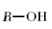 | 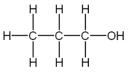 | CH₃CH₂CH₂OH
2-pentanol |  | 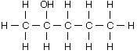 | CH₃CHOHCH₂CH₂CH₂CH₃
3-pentanol |  | 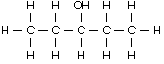 | CH₃CH₂CHOHCH₂CH₂CH₃
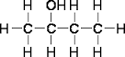

Name: ________________________________________

MODEL 3: Ethers (-O-)
Ethers have an oxygen bonded between two hydrocarbon chains. In an ether, the carbon chain on each side of the –o– is named separately with a –yl ending then the word ether. The hydrocarbon chains should be named in alphabetical order (except for the ** below.)

Name | General Formula | Structural formula | Condensed formula
***methyl ethyl ether | 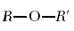 | 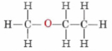 | CH₃OCH₂CH₃
dimethyl ether |  | 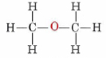 | CH₃OCH₃
diethyl ether |  | 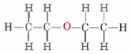 | CH₃CH₂OCH₂CH₃
****The R and R’ in the general formula stands for the hydrocarbon that makes up the rest of the molecule. Notice that there are hydrocarbons on both sides of the oxygen atom.
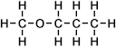
Name: ________________________________________
MODEL 4: Aldehydes (–CHO group) = -al ending
An aldehyde is an organic molecule that has an oxygen atom double bonded to the end carbon of the carbon chain. An aldehyde is named like an alkane except with an -al ending. Since the CHO must be on the terminal #1 carbon atom, the position of the CHO is not specified in the name (no number).
Name | General Formula | Structural formula | Condensed formula
propanal | 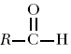 | 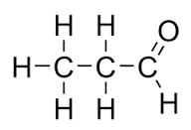 | CH₃CH₂CHO
ethanal |  | 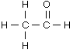 | CH₃CHO
pentanal |  | 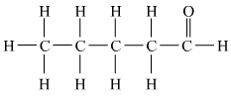 | CH₃CH₂CH₂CH₂CHO
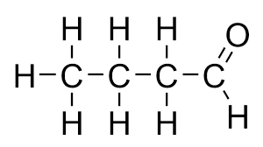
Name: _________________________________________

MODEL 5: Ketones = -one ending
Ketones are very similar to aldehydes. Aldehydes and ketones with the same number of carbons are isomers. The only difference is that the C=O in a ketone is in the middle of a chain and not on the end carbon. To name a ketone, use the -one ending and specify the position of the C=O with a number at the beginning of the name.
Name | General Formula | Structural formula | Condensed formula
2-pentanone | 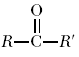 | 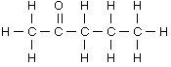 | CH₃COCH₂CH₂CH₃
propanone |  | 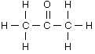 | CH₃COCH₃
butanone |  | 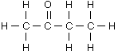 | CH₃COCH₂CH₃
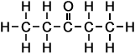
Name: _________________________________________
MODEL 6: Organic Acids ( –COOH group)
Organic acids have a carboxyl group at the end of the carbon chain. The acidic H is attached to the oxygen in the carboxyl group. To name an acid, change the end of the hydrocarbon to –oic acid. No number is needed because the functional group is at the end of the carbon chain.
Name | General Formula | Structural formula | Condensed formula
propanoic acid | 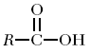 | 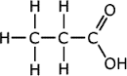 | O  ||  CH₃CH₂C-OH  (or CH₃CH₂COOH)
ethanoic acid |  | 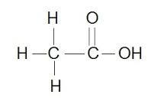 | O  ||  CH₃C-OH  (or CH₃COOH)
butanoic acid |  | 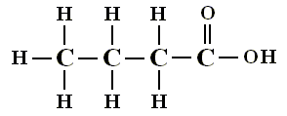 | O  ||  CH₃CH₂CH₂C-OH  (or CH₃CH₂CH₂COOH)
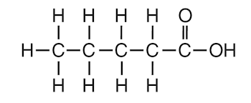
Name: _________________________________________

MODEL 7: Esters (–COO– group)
Esters are named first with the side bonded to oxygen with a –yl ending. The second part of the name comes from the side bonded to C=O with the ending –oate.
Name | General Formula | Structural formula | Condensed formula
methyl propanoate | 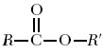 | 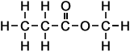 | O  ||  CH₃CH₂COCH₃
ethyl propanoate |  | 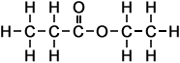 | O  ||  CH₃CH₂COCH₂CH₃
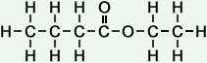 Name: _________________________________________
MODEL 8: Amines (-N- group)
To name an amine, drop the end –e in the hydrocarbon name and replace it with -amine. Be sure to number the carbon in the chain to which the -NH₂ group is attached.

Name | General Formula | Structural formula | Condensed formula
1-propanamine | 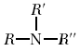 | 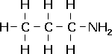 | CH₃CH₂CH₂NH₂
ethanamine |  | 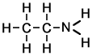 | CH₃CH₂NH₂

Circle the functional group then name the organic molecule.
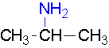
Name: _________________________________________

O
||
MODEL 9: Amides (–C–NH₂ group)
To name amides, replace the –e in the name of the hydrocarbon with –amide. No number is needed as the functional group is at the end of the hydrocarbon chain.

Name | General Formula | Structural formula | Condensed formula
propanamide | 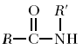 | 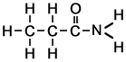 | O  ||  CH₃CH₂C-NH₂
ethanamide |  | 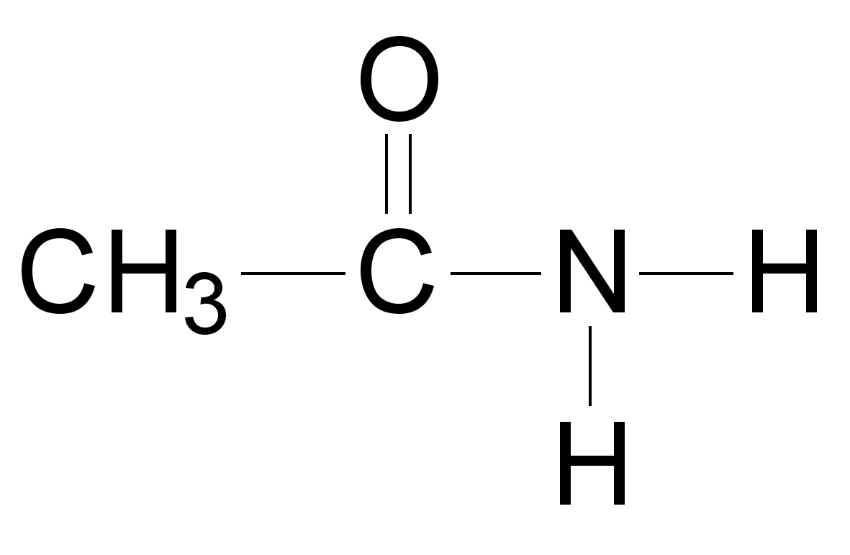 | O  ||  CH₃C-NH₂
Circle the functional group then name the organic molecule.

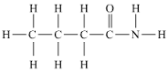 Name: _________________________________________

Functional Groups Naming Check you Understanding
For each of the following identify the functional group and then name the compound using table R.
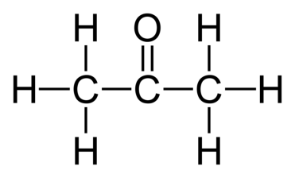  Functional Group: _____________  Name : ______________________ | 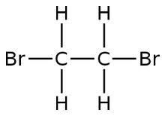  Functional Group: _____________  Name : ______________________ | 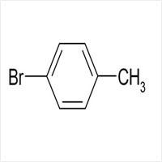  Functional Group: _____________  Name : ______________________
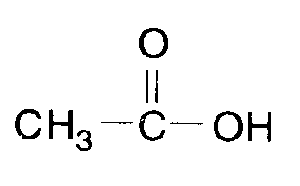  Functional Group: _____________  Name : ______________________ | 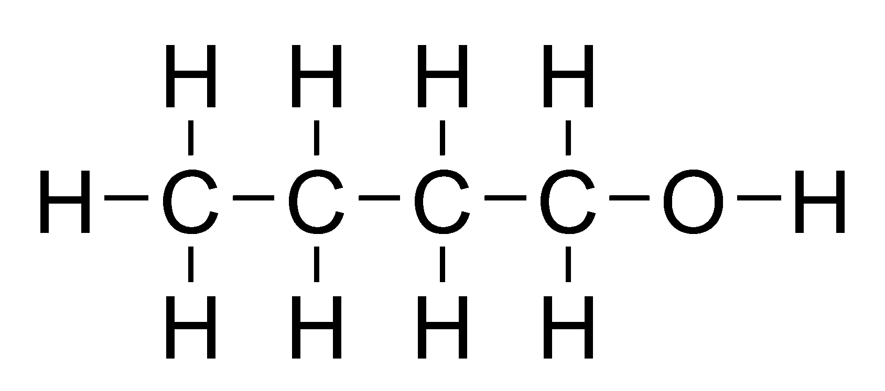  Functional Group: _____________  Name : ______________________ | 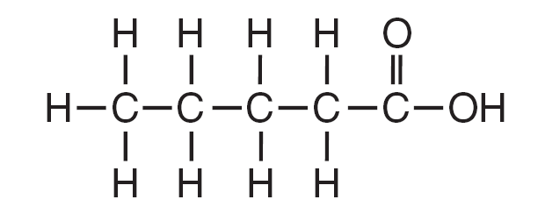  Functional Group: _____________  Name : ______________________
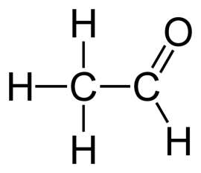  Functional Group: _____________  Name : ______________________ | 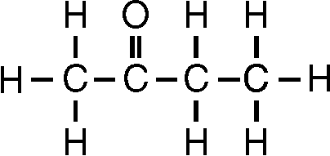  Functional Group: _____________  Name : ______________________ | 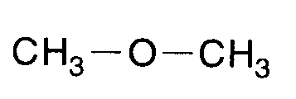  Functional Group: _____________  Name : ______________________
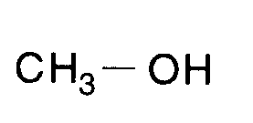  Functional Group: _____________  Name : ______________________ | 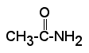  Functional Group: _____________  Name : ______________________ | 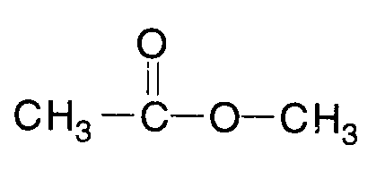  Functional Group: _____________  Name : ______________________

Functional Groups Structure Check your Understanding

Directions: Identify the class of organic compounds to which each of the following belongs. Draw and name the compound using the IUPAC system (Table R).

CH₃COOH CH₃CH₂COOCH₃

CH₃COCH₃ CH₃CH₂COOH

CH₃CH₂OH CH₃OCH₃

CH₃CH₂OCH₃ CH₃CH₂COCH₃

CH₃CH₂CHO CH₃CH₂CH₂CONH₂

Directions: Draw the structural formula and provide the condensed- formula for each of the following.

butanoic acid methyl methanoate

methanal 3-pentanol

Functional Groups Formulas Check Your Understanding

For the following compounds, determine the family and draw the compound:
Name | Functional Group | Structural Formula | Condensed Formula | Empirical Formula
Butanoic acid

Methanal

Butanamide

3-iodo octane

Methyl pentanoate

Ethanol

2-heptanone

Diethyl ether

2-pentanol

Ethanoic acid

2-propanamine

Hexanal

Ethyl methanoate

Organic Reactions Think Tank Questions

Organic reactions have their own set of classifications that have some overlap from the initial reaction types known as synthesis, decomposition, single and double replacement. Match the reaction below to the description provided.
- C₁₃H₂₈ 🡪 C₈H₁₈ + C₂H₄ + C₃H₆
- C₃H₈ + 5O₂ 🡪 3CO₂ + 4H₂O
- C₃H₆ + I₂ 🡪 C₃H₆I₂
- C₆H₁₂O₆🡪 C₂H₅OH +CO₂
- n(CH₂CH₂) 🡪 (CH₂CH₂)_{n}
- C₂H₆ + Cl₂ 🡪 C₂H₅Cl + HCl
- g. C₃H₆COOH + C₂H₅OH 🡪 C₃H₆COOC₂H₅ + H₂
- (C₁₇H₃₅COO)₃C₃H₅ + 3 NaOH 🡪 C₃H₅(OH)₃ + 3C₁₇H₃₅COONa

_____ 1. Addition: Similar to synthesis, an alkene or alkyne breaks bonds to add in H or halogen.

_____ 2. Substitution: Similar to single replacement, an alkane removes H atom to replace with halogen.

_____ 3. Cracking: Similar to decomposition, a hydrocarbon breaks into small fragments.

_____ 4. Combustion: A hydrocarbon is burned in oxygen to produce carbon dioxide and water.

_____ 5. Fermentation: Sugar is decomposed (in the presence of a catalyst) to form alcohol.

_____ 6. Esterification: Acids and alcohols react to form esters that smell great.

_____ 7. Polymerization: Small carbon chains link together to form long carbon chains where n may
represent 100+ molecules.

_____ 8. Saponification: Large fat molecules react with bases like sodium hydroxide to form soap. The
soap is an ionic compound containing a metal cation and a large nonpolar anion.

- Explain the difference(s) between addition and substitution reactions.

- Explain how cracking is similar to decomposition reactions.

- Humans are “combustion engines.” Explain this in terms of combustion reactions' reactants and products.

- Examples of polymers include rubber, nylon (fabric), teflon (pans), kevlar (bullet proof vests), and other synthetic materials. What does the prefix “poly” mean and how does the amount of electrons in a polymer influence its intermolecular forces of attraction?

- In the movie Fight Club, they steal fat from a liposuction factory to create their own soaps.
  - What process would be used to do this?
  - What other organic compound could be added to the soap to make it fragrant?

Organic Reactions Check Your Understanding
Name the reaction:
- A saturated alkane reacts with fluorine _____________________________
- Small alkene chains connect to form larger alkane chains _____________________________
- Sugar is decomposed to form an alcohol _____________________________
- Large hydrocarbons are heated and break into smaller fragments _____________________________
- An unsaturated hydrocarbon reacts with bromine _____________________________
- An alcohol and an organic acid are reacted _____________________________
- A base is added to a fat molecule to form a soap _____________________________
- Hydrocarbons are burned in the presence of oxygen _____________________________
- Another name for hydrogenation* _____________________________
- Another name for halogenation* _____________________________

Draw all organic reactants and products. Then name and give the formula for the missing substance in the reaction. Give the reaction type.
- C₂H₄ + F₂ 🡪 ________________ Rxn: __________________________

- C₃H₆ + H₂ 🡪 ________________ Rxn: __________________________

- C₂H₆ + Cl₂ 🡪 ________________ + HCl Rxn: __________________________

- C₄H₁₀ + Br₂ 🡪 ________________ + HBr Rxn: __________________________

- CH₄ + O₂ 🡪 ______ + H₂O Rxn: __________________________

- C₃H₈ + O₂ 🡪 CO₂ + ______ Rxn: __________________________

- C₆H₁₂O₆ 🡪 2CO₂ + 2________________ Rxn: __________________________

- C₈H₁₈ 🡪 C₆H₁₂ + ________________ Rxn: __________________________

- C₂H₅OH + C₃H₇COOH 🡪 H₂O + ________________ Rxn: __________________________

- C₃H₇OH + C₂H₅COOH 🡪 H₂O + ________________ Rxn: __________________________

- C₅H₁₀ + F₂ 🡪 ________________ Rxn: __________________________

- C₅H₁₂ + F₂ 🡪 ________________ Rxn: __________________________

- (C₁₇H₃₅COO)₃C₃H₅ + 3_________ 🡪 C₃H₅(OH)₃ + 3C₁₇H₃₅COONa Rxn: __________________________

Organic Check Your Understanding
- Given the structural formulas for two organic compounds:
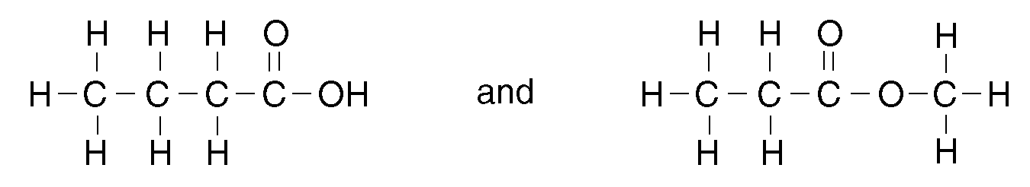
The differences in their physical and chemical properties are primarily due to their different
  - number of hydrogen atoms
  - number of carbon atoms
C) molecular masses
D) functional groups

- Organic compounds that are essentially non-polar and exhibit weak intermolecular forces have
  - low vapor pressure
  - high electrical conductivity in solution
C) low melting points
D) high boiling points

- Given the structural formulas:
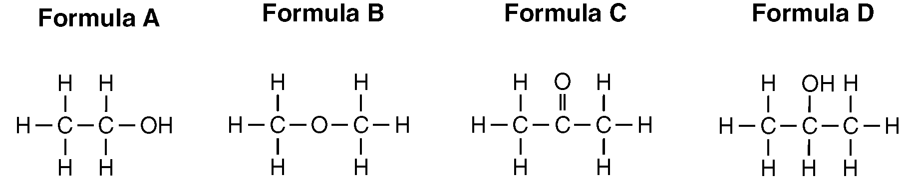
Which two formulas represent compounds that are isomers of each other?
  - B and D C) A and B
  - A and C D) C and D

- Which compound is an isomer of CH₃CH₂OH?
  - CH₃COOH C) CH₃CH₂CH₃
  - CH₃COCH₃ D) CH₃OCH₃
- What is the total number of carbon atoms in a molecule of ethanoic acid?
A) 1 B) 2 C) 3 D) 4
- Given the structural formula:
What is the IUPAC name of this compound?
  - methyl pentanoate C) pentanol
B) pentanal D) pentanoic acid
- Given the three organic structural formulas shown below:
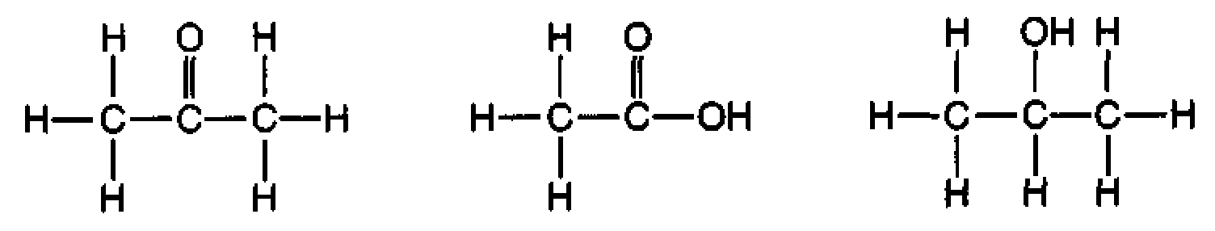
Which organic compound classes are represented by these structural formulas, as shown from left to right?
  - ketone, aldehyde, alcohol
  - ester, organic acid, ketone
C) ketone, organic acid, alcohol
D) ester, aldehyde, organic acid

- Which of these compounds has chemical properties most similar to the chemical properties of ethanoic acid?
  - C₃H₇COOH C) C₂H₅COOC₂H₅
  - C₂H₅OH D) C₂H5OC₂H₅

- Which compound is an alcohol?
  - methanol C) butane
  - ethyne D) propanal

- Given the formulas of four organic compounds:
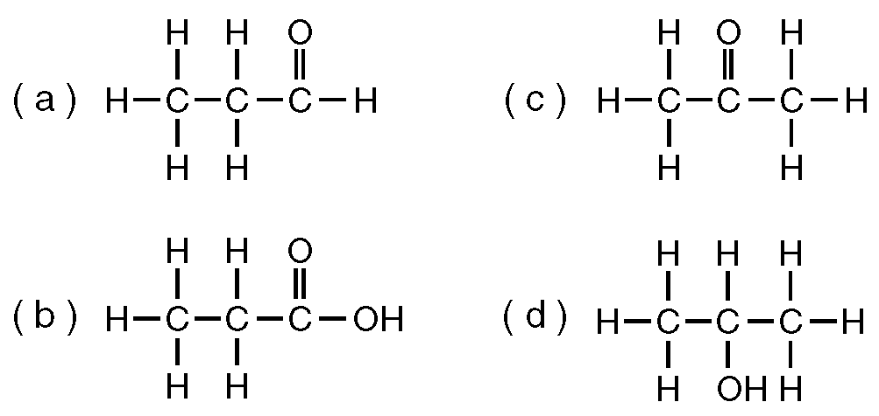
Which pair below contains an alcohol and an acid?
  - a and b C) c and d
  - a and c D) b and d

- What is the IUPAC name for the compound that has the condensed structural formula CH₃CH₂CH₂CHO?
  - propanol C) butanal
  - propanal D) butanol

- The organic compound represented by the condensed structural formula CH₃CH₂CH₂CHO is classified as an
  - ether C) alcohol
  - ester D) aldehyde

- What is the IUPAC name of the compound with the following structural formula?
  - propanone C) butanone
  - butanal D) propanal

- Which Lewis electron-dot diagram represents chloroethene?
A) 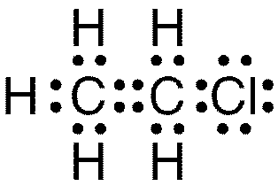 C) 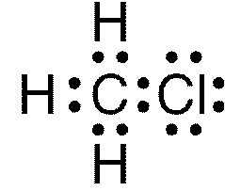
B) 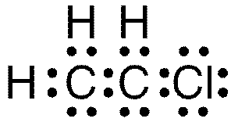 D) 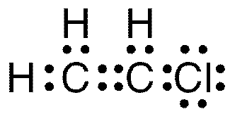

- Given the structural formula:
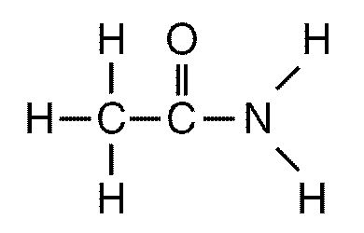
This compound is classified as an
  - aldehyde C) alcohol
  - amide D) amine

- Given the structural formula:
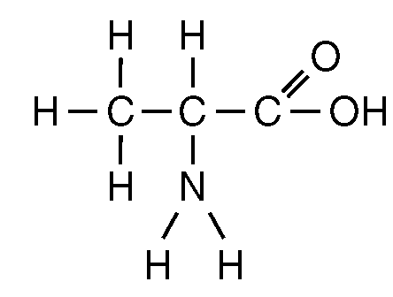
This structural formula represents a molecule of
- a ketone C) an aldehyde
- an ester D) an amino acid

- Which formula represents an ether?
A) C)
B) D)
- Given the balanced equation for an organic reaction:
C₂H₂ + 2Cl₂ 🡪 C₂H₂Cl₄

This reaction is best classified as
  - fermentation C) esterification
  - substitution D) addition

- Given the incomplete equation representing an organic addition reaction:
X(g) + Cl₂(g) 🡪 XCl₂(g)
Which compound could be represented by X?
  - C₃H₈ C) C₄H₁₀
  - CH₄ D) C₂H₄

- Given the equation:
CH₄ + Br₂ 🡪 CH₃Br + HBr
Which type of reaction does this equation represent?
  - substitution C) polymerization
  - addition D) hydrogenation

- Which organic reaction produces rubber and plastics?
  - polymerization C) fermentation
  - esterification D) saponification

- Which type of reaction is represented by the equation below?
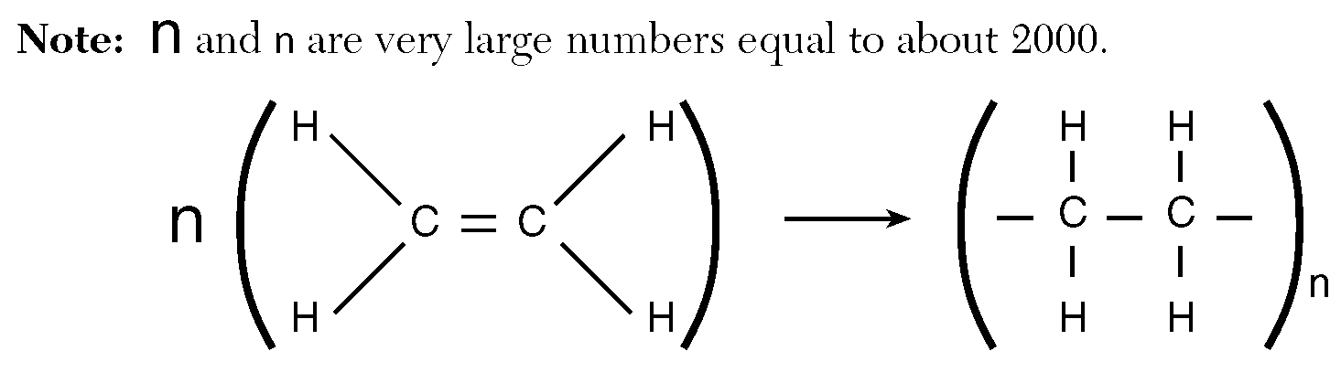
  - saponification C) esterification
  - fermentation D) polymerization
- Given the reaction:
This reaction is an example of
  - hydrogenation C) fermentation
  - saponification D) esterification

- When butane burns in an excess of oxygen, the principal products are
  - CO and H₂O C) CO₂ and H₂O
  - CO₂ and H₂ D) CO and H₂

- In which reaction is soap a product?
  - saponification C) polymerization
  - addition D) substitution

- What are the two main products of a fermentation reaction?
  - ethanol and water
  - ethanol and carbon dioxide
  - sugar and water
  - sugar and carbon dioxide

- Base your answer to the following question on the information below.
The incomplete equation below represents an esterification reaction. The alcohol reactant is represented by X.
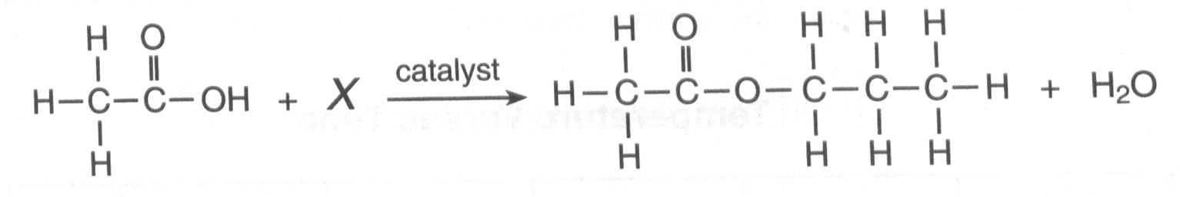
Draw the structural formula for the alcohol represented by X.

- A gasoline engine burns gasoline in the presence of excess oxygen to form carbon dioxide and water. The main components of gasoline are isomers of octane. A structural formula of octane is shown below.
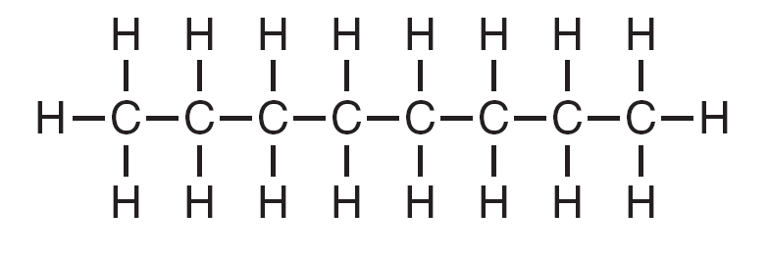

Draw a structural formula for 2,2,4-trimethylpentane.

Base your answers to questions 29 and 30 on the information below.

Many esters have distinctive odors, which lead to their widespread use as artificial flavorings and fragrances. For example, methyl butanoate has an odor like pineapple and ethyl methanoate has an odor like raspberry.

- What is a chemical name for the alcohol that reacts with methanoic acid to produce the ester that has an odor like raspberry?

- Draw a structural formula for the ester that has an odor like pineapple.
Base your answers to questions 31 through 33 on the equation below, which represents an organic compound reacting with bromine.

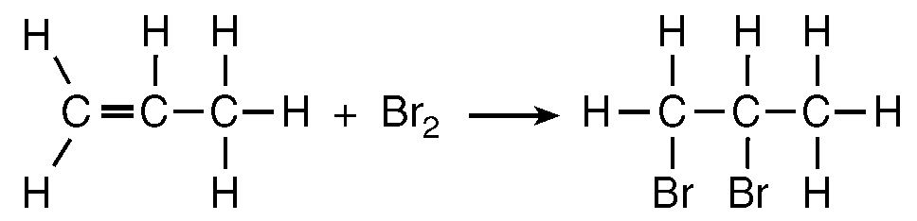
- What is the gram-formula mass of the product in this reaction?

- What type of organic reaction is represented by this equation?

- What is the IUPAC name for the organic compound that reacts with Br2?

Base your answers to questions 34 through 37 on the information and diagram below and on your knowledge of chemistry.
Crude oil is a mixture of many hydrocarbons that have different numbers of carbon atoms. The use of a fractionating tower allows the separation of this mixture based on the boiling points of the hydrocarbons. To begin the separation process, the crude oil is heated to about 400°C in a furnace, causing many of the hydrocarbons of the crude oil to vaporize. The vaporized mixture is pumped into a fractionating tower that is usually more than 30 meters tall. The temperature of the tower is highest at the bottom. As vaporized samples of hydrocarbons travel up the tower, they cool and condense. The liquid hydrocarbons are collected on trays and removed from the tower. The diagram below illustrates the fractional distillation of the crude oil and the temperature ranges in which the different hydrocarbons condense.
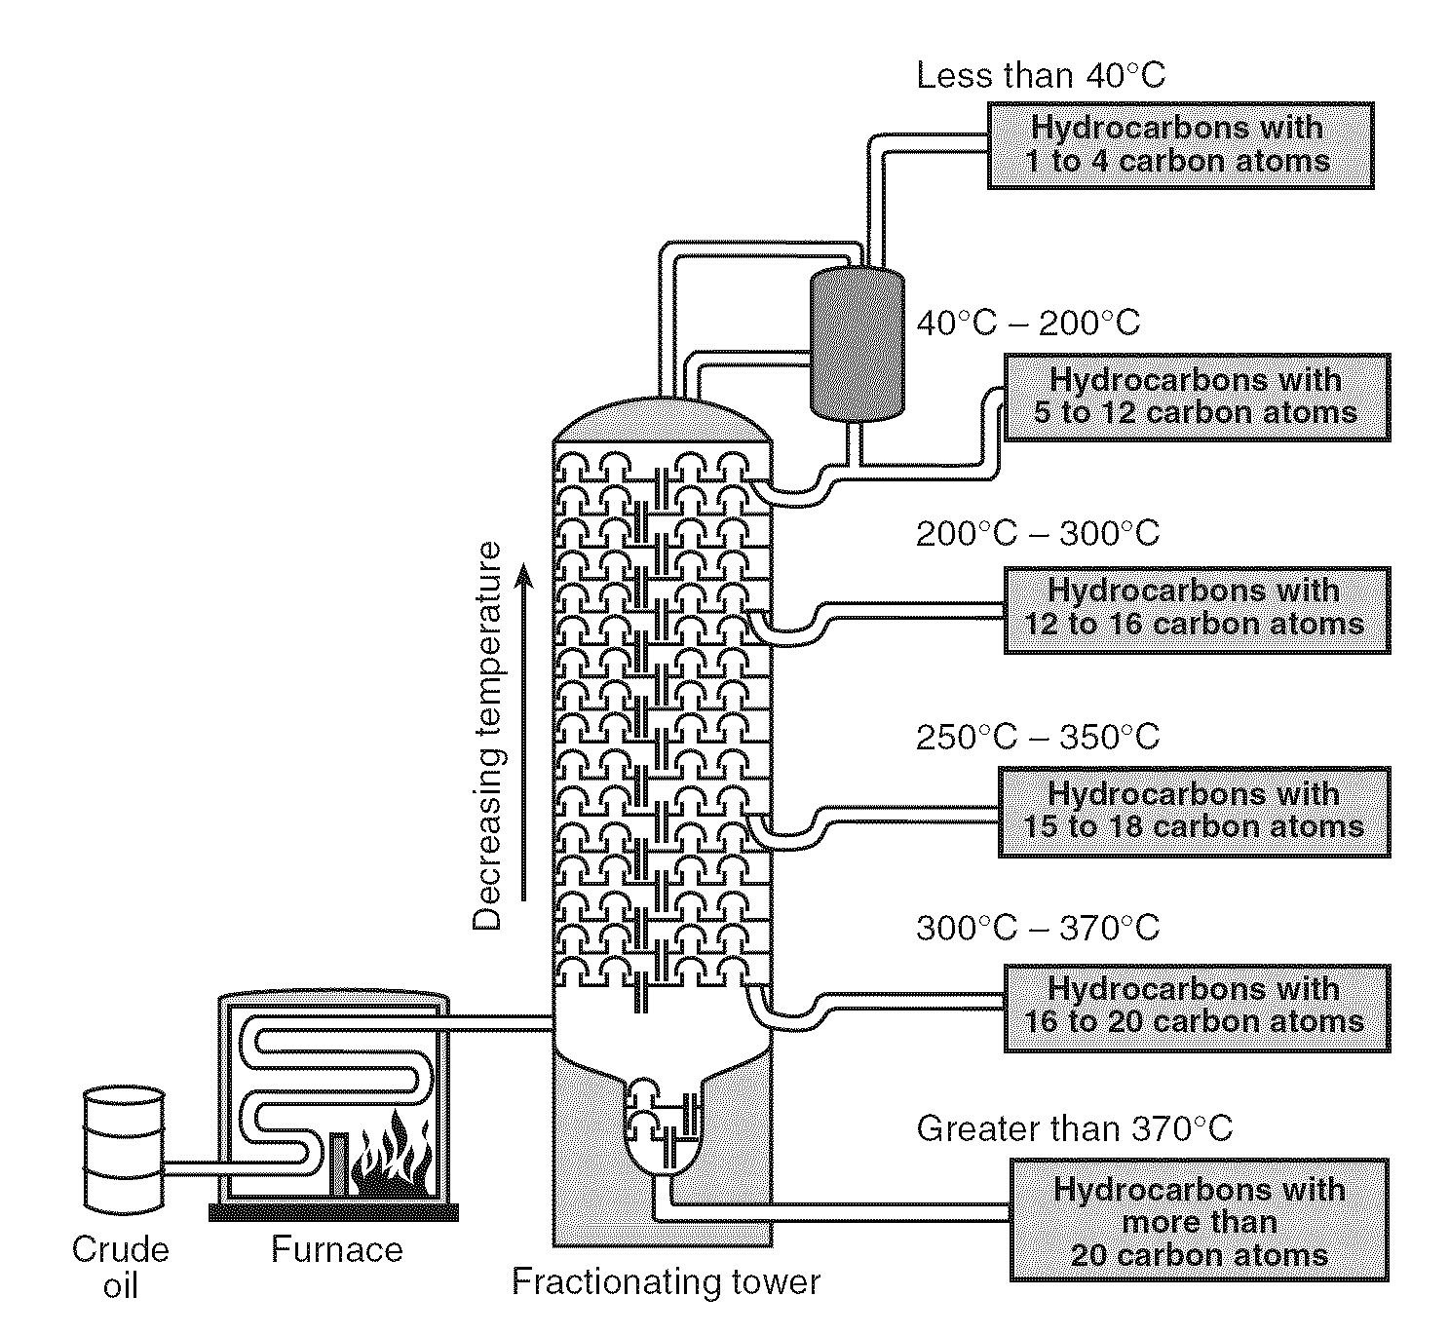
- How many hydrogen atoms are present in one molecule of octane?

- Write an IUPAC name of one saturated hydrocarbon that leaves the fractionating tower at less than 40°C.
- Describe the relationship between the strength of the intermolecular forces and the number of carbon atoms in the different hydrocarbon molecules.

- State the trend between the boiling point of the hydrocarbons contained in the crude oil and the number of carbon atoms in these molecules.

Base your answers to questions 38 and 39 on the information below. Given the reaction between 1-butene and chlorine gas:
C₄H₈ + Cl₂ 🡪 C₄H₈Cl₂

- Draw the structural formula of the product 1,2-dichlorobutane

- Which type of chemical reaction is represented by this equation?

Base your answers to questions 40 and 41 on the information below.
Diethyl ether is widely used as a solvent.

- In the space provided draw the structural formula for diethyl ether.

- Draw the structural formula for an alcohol that is an isomer of diethyl ether.

- How is the bonding between carbon atoms different in unsaturated hydrocarbons and saturated hydrocarbons?

Organic Review
 | Key Idea Question | Justify your answer  with an explanation or calculation. | Confidence Level
1 | Which of the following is a general formula for alkanes?  - CnH2n-2 c. CnH2n+2  - CnH2n |  | Pre-discussion:  Post discussion:
2 | Which is true about isomers?  - Same formula & properties.  - Different formula & properties.  - Same formula, different properties.  - Different formula, same properties. |  | Pre-discussion:  Post discussion:
3 | Which of the following is a saturated hydrocarbon?  - C₃H₈ c. C₄H₈O  - C₂H₄ d. C₅H₁₁OH |  | Pre-discussion:  Post discussion:
4 | Which can undergo substitution?  - CH₄ c. C₃H₆  - C₂H₄ d. C₄H₆ |  | Pre-discussion:  Post discussion:
5 | Which is a product of fermentation?  - C₂H₅OH c. C₂H₅O  - CH₃COOH d. CH₃COOCH₃ |  | Pre-discussion:  Post discussion:
6 | Draw an isomer of ethanol. |  | Pre-discussion:  Post discussion:
7 | Draw the Lewis dot diagram of Ethanoic Acid. |  | Pre-discussion:  Post discussion:
8 | Explain in terms of forces of attraction, why alcohols have higher boiling points than alkanes. |  | Pre-discussion:  Post discussion:
9 | Determine the homologous series to which octane belongs. |  | Pre-discussion:  Post discussion:
10 | What are the products of the combustion of propane in oxygen gas? |  | Pre-discussion:  Post discussion:
Common Sense Chemistry Review
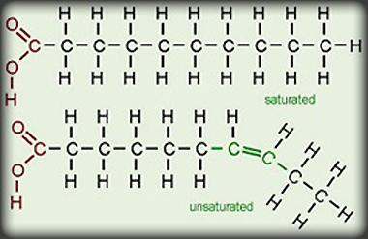
- Examples of foods containing a high proportion of saturated fat include animal fat products such as cream, cheese, butter, other whole milk dairy products and fatty meats which also contain dietary cholesterol. Certain vegetable products have high saturated fat content, such as coconut oil and palm kernel oil. Many prepared foods are high in saturated fat content, such as pizza, dairy desserts, and sausage. Saturated fats tend to have higher melting points than their corresponding unsaturated fats, leading to the popular understanding that saturated fats tend to be solids at room temperatures, while unsaturated fats tend to be liquid at room temperature with varying degrees of viscosity (meaning both saturated and unsaturated fats are found to be liquid at body temperature). In cellular metabolism, unsaturated fat molecules contain somewhat less energy (i.e., fewer calories) than an equivalent amount of saturated fat.
  - What is the major chemical difference between saturated and unsaturated fats or molecules?

  - What is a polyunsaturated fat?

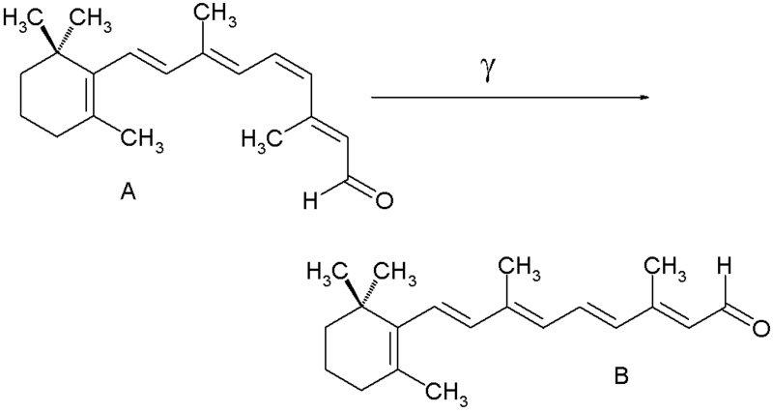
- Pharmaceutical chemists have found that very small changes in certain drugs have been found to be more effective in treating diseases. Some structures transform their own bonds to create isomers of themselves. Explain why these two structures are isomers, and not the same exact molecule.

- Polyethylene is used in plastic bags and boxes. What is its IUPAC name and what type of reaction can it under go: addition or substitution?
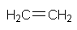

- For each, circle the functional group and label. For the non-benzene structures, give the chemical name. Any isomers?
  - Found in wines, liquors, and beer.
  - Used in soaps and fragrances.
  - Used as a local anesthetic.
  - Makes up proteins.
  - Found naturally in spices.
  - Vinegar’s primary component.
  - Used to preserve specimens.
  - Nail polish remover.
  - Used in bug sprays to keep bugs away.

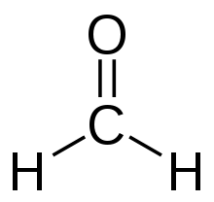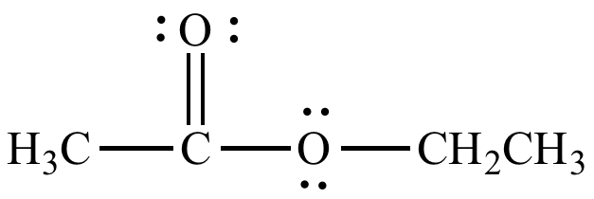

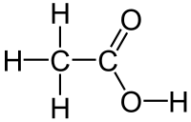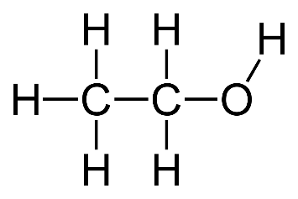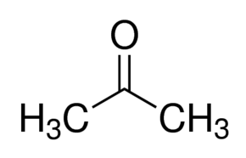

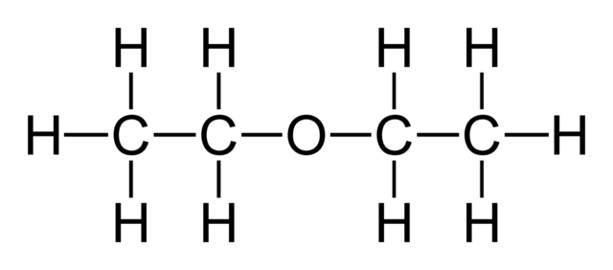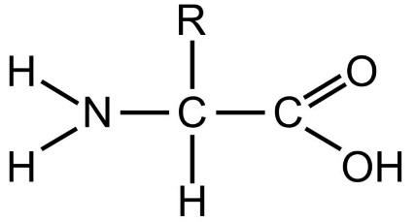
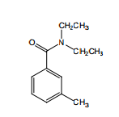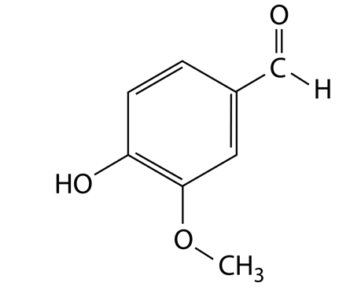
- Name that reaction!
  - In fight club, Norton’s character created soap on his hand using the fatty part of his hand and a strong basic solution.
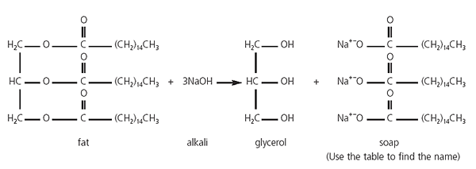

  - Wineries out east use cold moldy grapes to create wine.
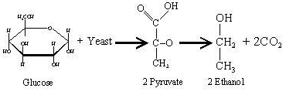

  - Polystyrene is used in Styrofoam cups at Dunkin Donuts.

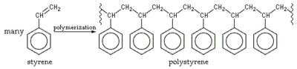

  - Petroleum oils are drilled from the earth and separated into smaller compounds we use in our daily lives such as methane, propane, butane, and octane.

