Combustion | Substitution
CH_{4(g)} + 2O_{2 (g)} → CO_{2 (g)} + 2H₂O_{(l)} | C₃H₈ + Br₂ 🡪 C₃H₇Br + HBr
C₃H_{8(g)} + 5O_{2(g)} → 3CO_{2(g)} + 4H₂O_{(l)} | 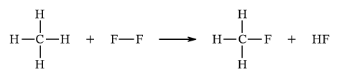
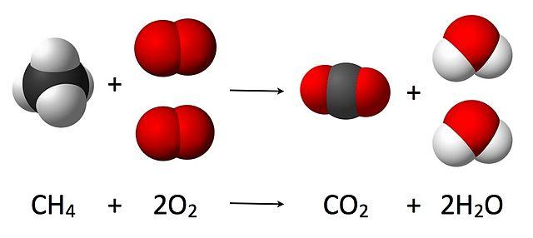 | 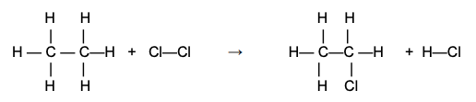
A halogen reacts with a saturated hydrocarbon | Similar to single replacement reactions
Esterification | Addition
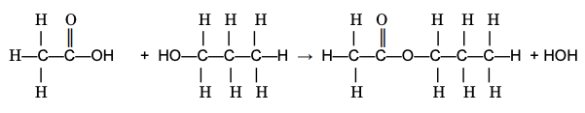 | 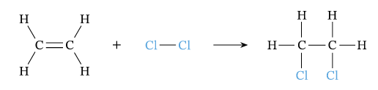
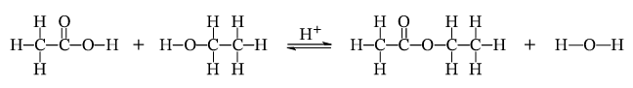 | 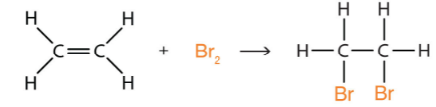
C₂H₅OH + CH₃COOH 🡪 CH₃COOC₂H₅ + H₂O | C₃H₆ + F₂ 🡪 C₂H₆F₂
Alcohol + Acid 🡪 Ester + Water | Similar to synthesis reactions
Creates a great smelling organic compound | A halogen reacts with an unsaturated hydrocarbon
Polymerization | Fermentation
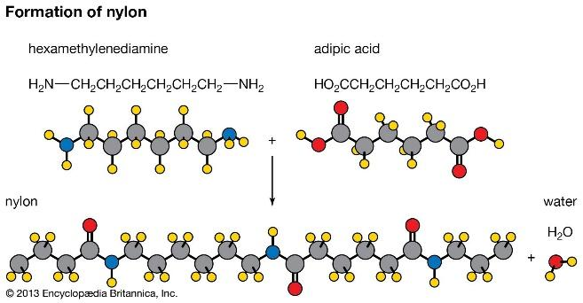 | 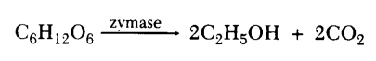
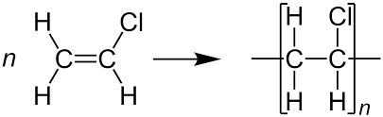 | 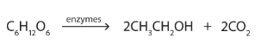
Creates plastics, nylon, rubber, Kevlar, teflon, and other materials
Small unsaturated hydrocarbon chains form long saturated hydrocarbon chains | Sugar breaks down into alcohol and carbon dioxide
Saponification | Cracking
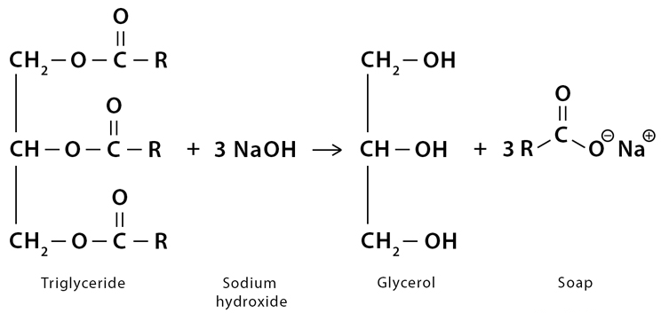 | 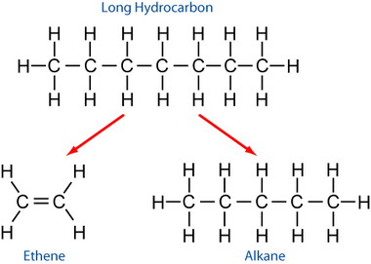
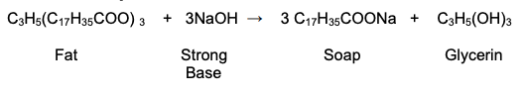 | 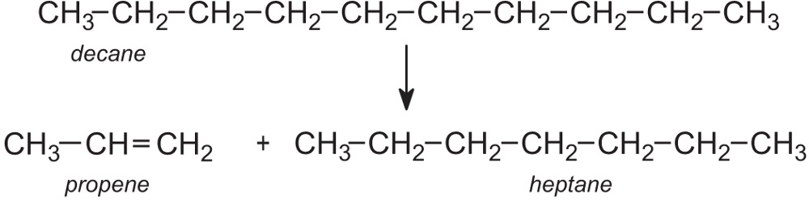
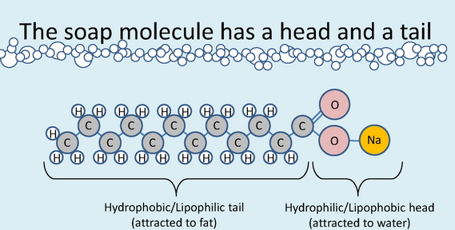 | Long hydrocarbons break down into smaller hydrocarbon chains
Creates a soap that has both nonpolar chains (to clean nonpolar solutes) and ionic portion (to clean ionic and polar solutes) | Similar to decomposition reactions

