Organic Chemistry Inquiry: Structural Formulas

Background: Structural formulas show the arrangement of the atoms within the molecules as far as which atoms are bonded to which and whether single, double or triple bonds are used.

MODEL 1:
Structural formulas for alkanes
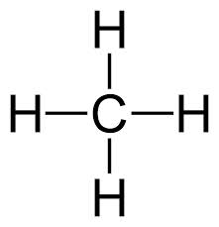
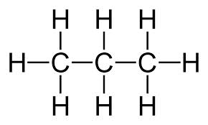
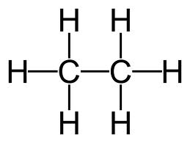

methane ethane propane

- Using model 1 above, draw the structural formula for the following alkanes. (Refer to table P and Q in your reference table)

- C₄H₁₀ b. C₅H₁₂ c. C₆H₁₄

- Name the compounds in question 1.

MODEL 2:
Structural Formulas for Alkenes

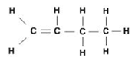
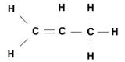
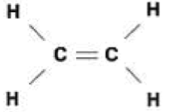

butene
propene
ethene

- Based upon model 2 and your knowledge of alkenes, why does the compound methene not exist?

- Why do the carbon atoms with the double bond contain 1 less Hydrogen atoms then carbon atoms that contains a single bond?

- Using model 2 above, draw the structural formula for the following alkenes. (Refer to table P and Q in your reference table). Then name the compounds you drew.

a. C₅H₁₀ b. C₆H₁₂ c. C₇H₁₄

READ THIS!!!! When naming alkenes you must give the location of the double bond in the name when there are more than 3 carbon atoms in the compound. You do this by numbering the carbon atoms and stating which number carbon the double bond is on. You can number the carbon atoms from left to right or right to left which ever gives the double bond the lowest possible numbered location. This is because compounds are not stationary in the “real world” and are therefore constantly moving. See Model 3 below.
MODEL 3:
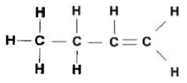
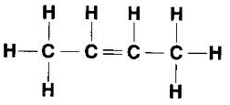
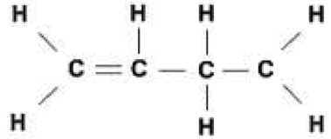

1-butene 2-butene 1-butene

- Why is the third compound in model 3 not called 3-butene?

- Using model 3 and reference tables P & Q name the following compounds:
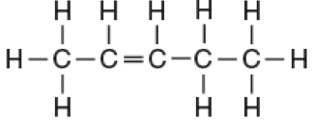
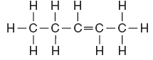

_______________________________________ _______________________________________
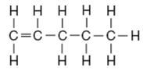

_______________________________________
READ THIS!!! Drawing structural formulas for alkynes is exactly the same as alkenes except they contain a triple bond instead of a double bond.
MODEL 4:
Structural Formulas for alkynes
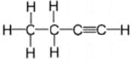
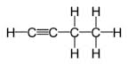
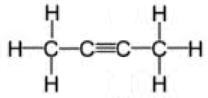

1-butyne 2-butyne 1-butyne

- Why do the carbons with the triple bond contain no bonded hydrogen atoms?

- Using model 2 above, draw the structural formula for the following alkynes. (Refer to table P and Q in your reference table) Then name the compounds you drew.
a. C₅H₈ b. C₆H₁₀ c. C₇H₁₂

- Name the following compounds:
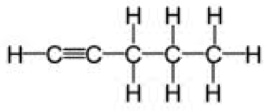
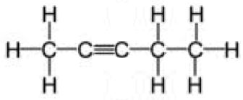

_____________________________________ ______________________________________
EXTENSION:
Draw the structural formula for the following compounds:
a. C₈H₁₆ b. C₄H₆

c. 2-hexene d. 2-heptyne

e. 3-hexene f. 1-heptyne

Which of the above hydrocarbons are parts of the same homologous series (family)?

READ THIS! Isomers are two compounds with the same molecular formula (C_{n}H_{n}) but a different structural formula (how it is drawn). Therefore isomers have different properties and names.

Which of the above hydrocarbons are isomers?

