The Stock System and IUPAC nomenclature has been used to name Inorganic compounds, or compounds, or by definition compounds that do not contain primarily Carbon and Hydrogen (example: NaCl). Organic compounds contain Carbon as a primary element in the composition of the molecule. The carbon atoms are connected to each other to form the backbone of a molecule. The term “organic” finds its roots in the fact that these compounds were first identified as those that make up the components of living organisms (tissues, enzymes, etc.). Many organic compounds are referred to as hydrocarbons, due to their containing carbon and hydrogen only. (This term is especially applicable to the petroleum industry, where most of the compounds are of this type). However, other types of organic compounds also include elements such as oxygen, sulfur, and nitrogen, which have a wide range of effects on their properties. This activity is designed to address only simple hydrocarbons.

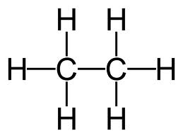
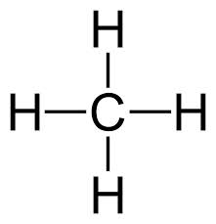
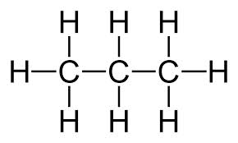
Model 1

methane ethane propane

- Using model 1, how many bonds does Carbon always make in an organic compound?

- The molecules above are called hydrocarbons. What are the only elements that hydrocarbons possess?

- Using model 1, draw a compound containing 4 carbon atoms.

Organic compounds that only have single bonds are called saturated hydrocarbons. This is because they contain the maximum number of hydrogen atoms bonded to the carbon chain. Organic compounds that contain a double or triple bond are referred to as unsaturated.
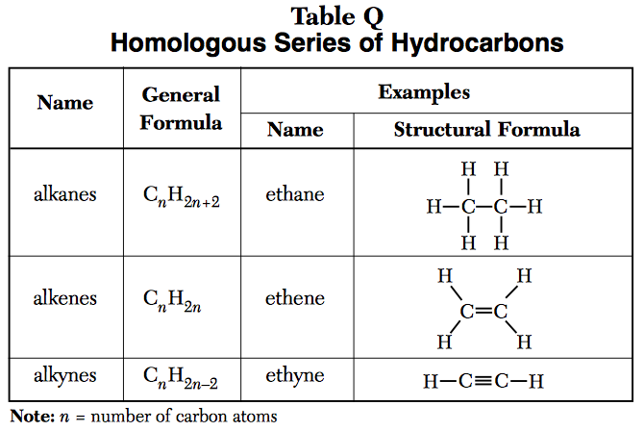
Model 2

- What is the name of the series of saturated hydrocarbons that possess only single bonds?

- What is the name of the series of unsaturated hydrocarbons that possess 1 double bond?

- What is the name of the series of unsaturated hydrocarbons that possess 1 triple bond?

- Using the general formula how many hydrogen atoms would a compound contain if it had 5 Carbon atoms and only single bonds?

- Using the general formula how many hydrogen atoms would a compound contain if it had 5 Carbon atoms and a double bond?

- Using the general formula how many hydrogen atoms would a compound contain if it had 5 Carbon atoms and a triple bond?

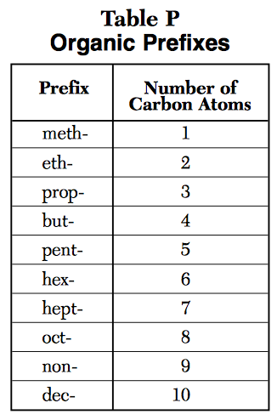
Model 3

NAMING ALKANES (saturated hydrocarbons)
- Referring to model 1, which are all alkanes, what is similar about their names? What is different?

- Referring to models 2 and 3, what does the eth- in ethane tell you?

12. Referring to models 2 and 3, determine the name of the following compounds:
a. C₄H₁₀ b. C₅H₁₂ c. C₆H₁₄ d. C₇H₁₆

13. How many C atoms and H atoms do the following compounds contain:
a. octane b. butane

NAMING ALKENES (unsaturated hydrocarbons)
- Referring to models 2 and 3, what is different about the name of compounds containing a double bond versus a single bond?

- Name the following alkenes:
a. C₄H₈ b. C₅H₁₀ c. C₆H₁₂ d. C₇H₁₄

- If you are given the following molecular formulas: C₅H₁₂ and C₅H₁₀ how can you distinguish which is an alkane and which is an alkene?

- Name the two compounds in question 16.

NAMING ALKYNES (unsaturated hydrocarbons)
- Referring to models 2 and 3, what is different about the name of compounds containing a triple bond versus a single or double bond?

- Name the following alkynes:
a. C₄H₆ b. C₅H₈ c. C₆H₁₀ d. C₇H₁₂

20. Which compound is an alkyne? C₉H₁₈ or C₉H₁₆

Structural formulas show the arrangement of the atoms within the molecules as far as which atoms are bonded to which and whether single, double or triple bonds are used.

MODEL 4: Structural formulas for alkanes

methane ethane propane

- Using model 4 above, draw the structural formula for the following alkanes.
- C₄H₁₀ b. C₅H₁₂ c. C₆H₁₄

- Name the compounds in question 21.

MODEL 5: Structural Formulas for Alkenes
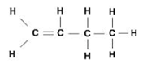
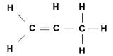
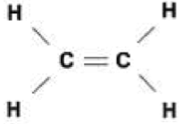

butene
propene
ethene

- Based upon model 5 and your knowledge of alkenes, why does the compound methene not exist?

- Why do the carbon atoms with the double bond contain 1 less Hydrogen atoms then carbon atoms that contains a single bond?

- Using model 5 above, draw the structural formula for the following alkenes. (Refer to table P and Q in your reference table). Then name the compounds you drew.
a. C₅H₁₀ b. C₆H₁₂ c. C₇H₁₄

When naming alkenes you must give the location of the double bond in the name when there are more than 3 carbon atoms in the compound. You do this by numbering the carbon atoms and stating which number carbon the double bond is on. You can number the carbon atoms from left to right or right to left which ever gives the double bond the lowest possible numbered location. This is because compounds are not stationary in the “real world” and are therefore constantly moving. See Model 6 below.
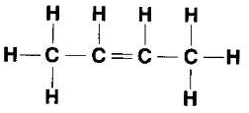
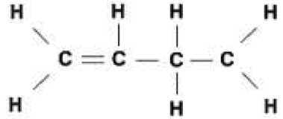
MODEL 6:
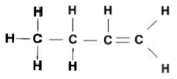

1-butene 2-butene 1-butene

- Why is the third compound in model 6 not called 3-butene?

- Referring to the models, following compounds:
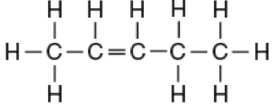
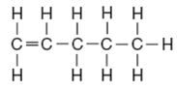
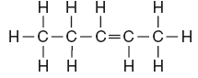

Drawing structural formulas for alkynes is exactly the same as alkenes except they contain a triple bond instead of a double bond.
MODEL 7: Structural Formulas for alkynes
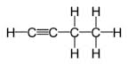
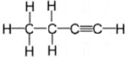
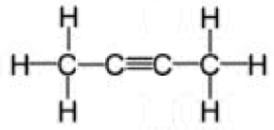

1-butyne 2-butyne 1-butyne

- Why do the carbons with the triple bond contain no bonded hydrogen atoms?

- Using model 2 above, draw the structural formula for the following alkynes. Then name the compounds you drew.
a. C₅H₈ b. C₆H₁₀ c. C₇H₁₂

- Name the following compounds:
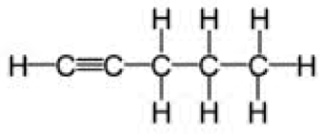
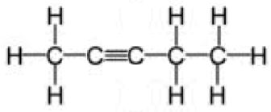

EXTENSION:
1. Draw the structural formula for the following compounds:
a. C₈H₁₆ b. C₄H₆

c. 2-hexene d. 2-heptyne

e. 3-hexene f. 1-heptyne

2. Which of the above hydrocarbons are parts of the same homologous series (family)?

Isomers are two compounds with the same molecular formula (C_{n}H_{n}) but a different structural formula (how it is drawn). Therefore, isomers have different properties and names.

3. Which of the above hydrocarbons are isomers?

