Memorize These From Last Year:

F | Fluoro
Cl | Chloro
Br | Bromo
I | Iodo
NH₃ | Amino
NO₂ | Nitro
2 | Di
3 | Tri
4 | Tetra
5 | Penta
6 | Hexa
7 | Hepta
8 | Octa
9 | Nona
10 | Deca

Video 10.1 Hydrocarbons
- How many carbon atoms are in each compound?

  - Methane ____
  - Ethane ____
  - Ethene ____
  - Pentane ____
  - Propene ____
  - Hexane ____
  - Ethyne ____
  - Propane ____
  - Heptane ____
  - Octane ____
  - Decane ____
  - Butyne ____
  - Butane ____
  - Propyne ____
  - Butene ____

- How many times does carbon bond and why?

- For each of the following, draw the structural formula and then name the compound.

  - C₂H₆ ________________
  - C₅H₁₀ ________________
  - C₆H₁₂ ________________
  - C₇H₁₂ ________________
  - C₉H₂₀ ________________
  - C₂H₂ ________________
  - C₈H₁₆ ________________
  - C₄H₈ ________________
  - C₁₀H₁₈ ________________
  - C₅H₈ ________________
  - C₆H₁₄ ________________
  - C₉H₁₆ ________________

- For each of the following determine the name.

  - CH₄ ________________
  - C₁₀H₂₀ ________________
  - C₃H₄ ________________
  - C₈H₁₈ ________________
  - C₅H₁₂ ________________
  - C₉H₁₈ ________________
  - C₂H₆ ________________
  - C₄H₆ ________________
  - C₇H₁₆ ________________
  - C₆H₁₂ ________________

- Create a rule to determine an easy way to find the homologous series to which a compound belongs.

Video 10.2 Branched and Cyclic Hydrocarbons
- What element bonds four times, often to atoms of itself, in branches and rings? _____________
- Draw the following cyclic compounds:
Cyclobutane Cyclopentane Cyclohexane

Cyclobutene 1, 3 Cyclohexadiene 1, 4 Cyclooctyne

1, 3 Cycloheptadiene 1, 3, 5 Cyclohexatriene Benzene

- What prefix do most cyclic hydrocarbons have in common? ___________________
- What is another name for benzene? ______________________

- Draw the following branched hydrocarbons:
2-methyl butane 3-ethyl hexane

2, 3-dimethyl pentane 4-methyl, 3-ethyl 1-octyne

2, 5 dimethyl 3 nonyne 8, 8, 9-trimethyl 2, 4, 6-decatriene

- What do the numbers before the last name represent? _______________________________________
- Why can’t any names start with a 1? (Hint: draw 1-methyl butane) _____________________________
____________________________________________________________________________________
- Name the following compounds:
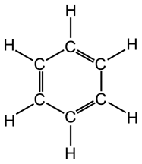

______________________ ______________________ ______________________

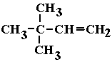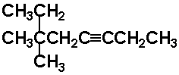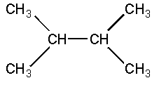

______________________ ______________________ ______________________
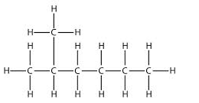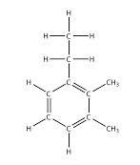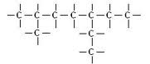

______________________ ______________________ ______________________

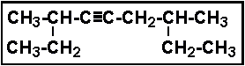 _____________________________ 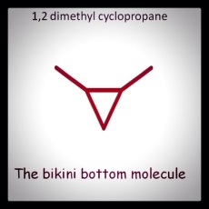
Video 10.3 Isomers
- Record the Structural formula, molecular formula, and condensed formula for the following:
Name | Structural | Molecular | Condensed
2, 3-dimethyl butane
2, 2-dimethyl butane
2-heptyne
3-hexene
2-methyl
1-pentene
- Where any of the above isomers? Explain your answer. _______________________________________
____________________________________________________________________________________
- Draw an isomer of 2-heptyne below. Give the name of your isomer: ____________________________

- Name the following and identify the isomers.
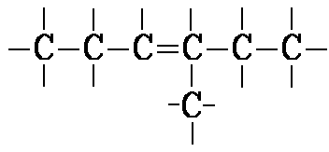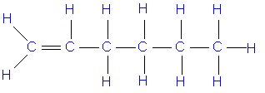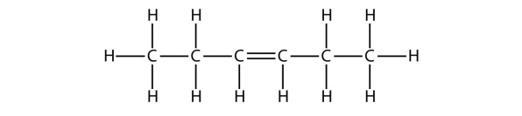

______________________ ______________________ ______________________
- Which of the hydrocarbons in the table above were saturated?

Video 10.4 Functional Groups (Memorize)
Name | Functional Group | How to name | Draw the example on the reference table | Properties
Alcohol |  |  |  | Soluble, flammable
Ether |  |  |  | Soluble, anesthetic (puts you to sleep)
Aldehyde |  |  |  | Soluble, reactive, formaldehyde (methanal) is used to preserve specimens.
Keytone |  |  |  | Somewhat soluble, needs at least 3 C, acetone (propanone) is nail polish remover
Acid |  |  |  | Weak acids, aka carboxylic acids.
Ester |  |  |  | Smell great, used in perfumes and found in fruits.
Amine |  |  |  | Used in dyes, found in DNA
Polymer |  |  |  | Used in plastics
Amide  ` |  |  |  | Used in dyes

For each of the following identify the functional group and then name the compound.
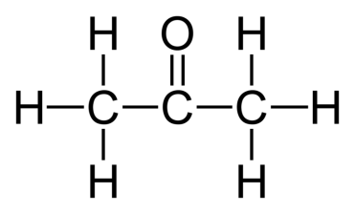  Functional Group: _____________  Name : ______________________ | 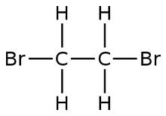  Functional Group: _____________  Name : ______________________ | 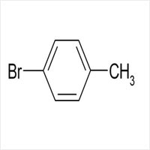  Functional Group: _____________  Name : ______________________
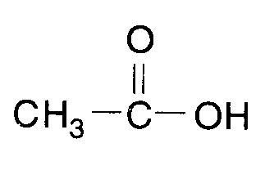  Functional Group: _____________  Name : ______________________ | 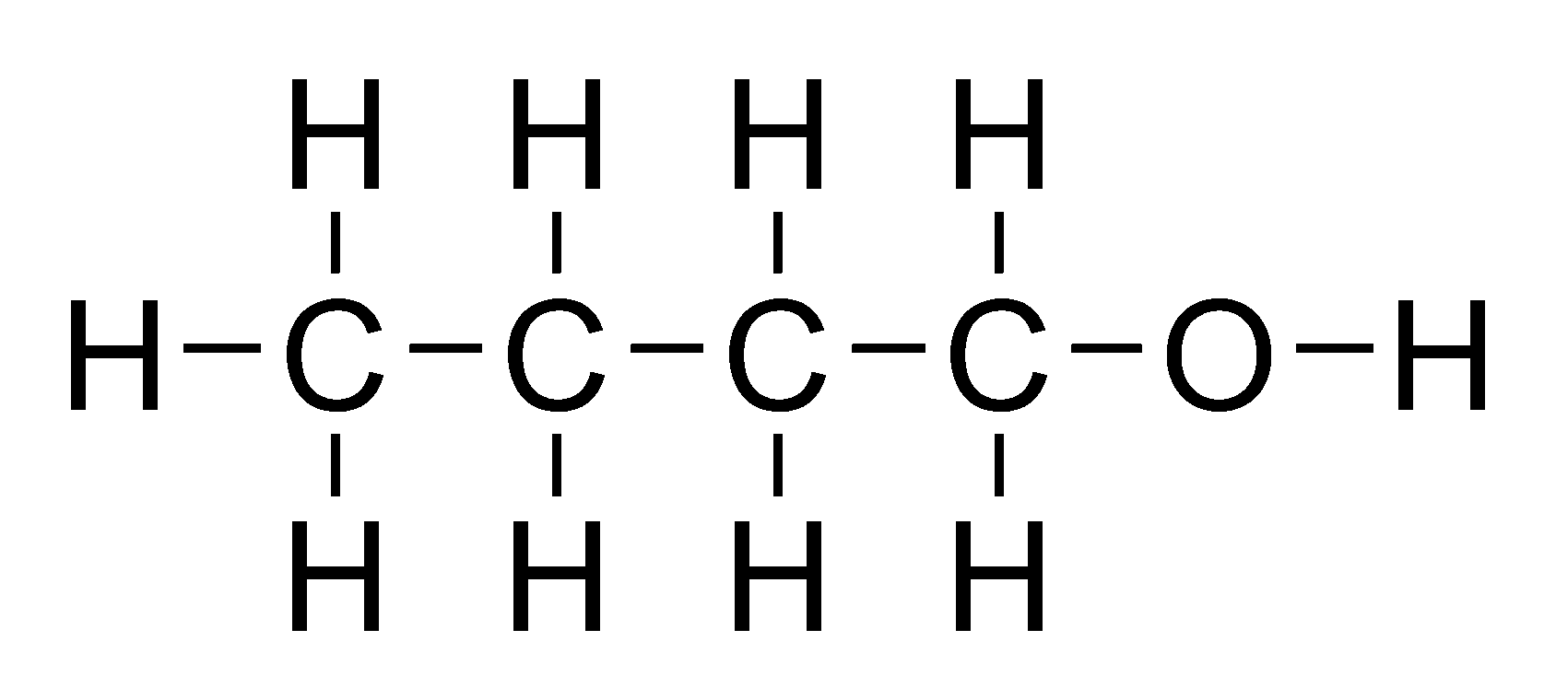  Functional Group: _____________  Name : ______________________ | 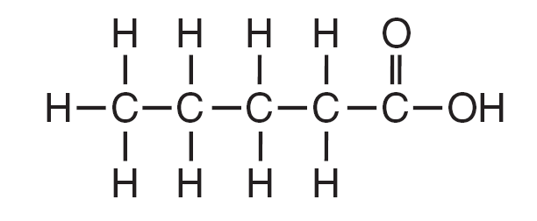  Functional Group: _____________  Name : ______________________
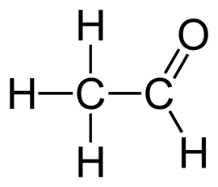  Functional Group: _____________  Name : ______________________ | 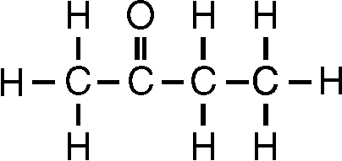  Functional Group: _____________  Name : ______________________ | 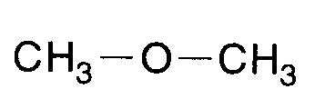  Functional Group: _____________  Name : ______________________
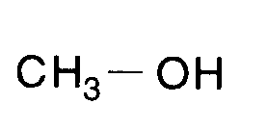  Functional Group: _____________  Name : ______________________ | 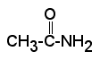  Functional Group: _____________  Name : ______________________ | 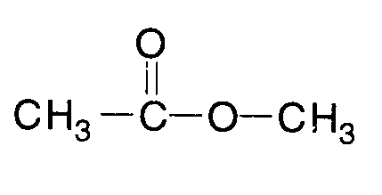  Functional Group: _____________  Name : ______________________
For the following compounds, determine the family and draw the compound:
Name | Family | Structural Formula | Condensed Formula
Butanoic acid

Methanal

Butanamide

3-iodo octane

Methyl pentanoate

Ethanol

2-heptanone

Diethyl ether

2-pentanol

Ethanoic acid

2-propanamine

Hexanal

Ethyl methanoate

Video 10.5 Organic Reactions (Memorize)
 | Notes (in red on ppt) | Example
Addition  (like synthesis) |  | C₂H₄ + Br₂ C₂H₄Br₂
Substitution  (like SR) |  | CH₄ + Br₂ CH₃Br + HBr
Combustion |  | CH₄ + 2O₂ CO₂ + 2H₂0
Esterification |  | C₃H₆COOH + C₂H₅OH C₃H₆COOC₂H₅ + H₂O
Fermentation |  | C₆H₁₂O₆ C₂H₅OH +CO₂
Saponification |  | 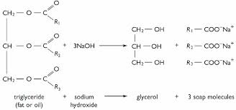
Polymerization |  | 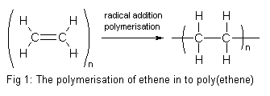
Cracking |  | 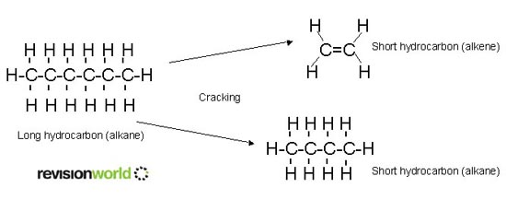

Match the reaction to its name:
___ 1. Addition a. C₁₃H₂₈ C₈H₁₈ + C₂H₄ + C₃H₆
___ 2. Substitution b. C₃H₈ + 5O₂ 3CO₂ + 4H₂0
___ 3. Combustion c. (C₁₇H₃₅COO)₃C₃H₅ + 3 NaOH C₃H₅(OH)₃ + 3C₁₇H₃₅COONa
___ 4. Cracking d. C₆H₁₂O₆ C₂H₅OH +CO₂
___ 5. Polymerization e. n(CH₂CH₂) (CH₂CH₂)_{n}
___ 6. Fermentation f. C₂H₆ + Cl₂ C₂H₅Cl + HCl
___ 7. Esterification g. C₃H₆COOH + C₂H₅OH C₃H₆COOC₂H₅ + H₂O
___ 8. Saponification h. C₃H₆ + I₂ C₃H₆I₂

Name the reaction:
- A saturated alkane reacts with fluorine _____________________________
- Small alkene chains connect to form larger alkane chains _____________________________
- Sugar is decomposed to form an alcohol _____________________________
- Large hydrocarbons are heated and break into smaller fragments _____________________________
- An unsaturated hydrocarbon reacts with bromine _____________________________
- An alcohol and an organic acid are reacted _____________________________
- A base is added to a fat molecule to form a soap _____________________________
- Hydrocarbons are burned in the presence of oxygen _____________________________
- Another name for hydrogenation* _____________________________
- Another name for halogenation* _____________________________

Draw all organic reactants and products. Then name and give the formula for the missing substance in the reaction. Give the reaction type.
- C₂H₄ + F₂ ________________ Rxn: __________________________

- C₃H₆ + H₂ ________________ Rxn: __________________________

- C₂H₆ + Cl₂ ________________ + HCl Rxn: __________________________

- C₄H₁₀ + Br₂ ________________ + HBr Rxn: __________________________

- CH₄ + O₂ ______ + H₂O Rxn: __________________________

- C₃H₈ + O₂ CO₂ + ______ Rxn: __________________________

- C₆H₁₂O₆ 2CO₂ + 2________________ Rxn: __________________________

- C₈H₁₈ C₆H₁₂ + ________________ Rxn: __________________________

- C₂H₅OH + C₃H₇COOH H₂O + ________________ Rxn: __________________________

- C₅H₁₀ + F₂ ________________ Rxn: __________________________

Video 10.6 AP Extension

- Draw the following:

o-methyl benzene | p-nitro benzene | m-ethyl benzene
p-fluorobenzene | m-aminobenzene | Cis-2-butene
Cis-3-hexene | Trans-4-octene | Trans-2-butene
Acetone | Acetic acid | acetaldehyde
Formaldehyde | Formic acid | 2,3 propantriol

- Label the following as dihydroxy or trihydroxy alcohols:
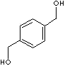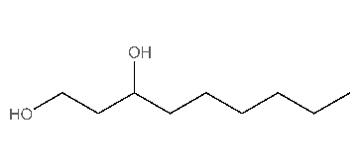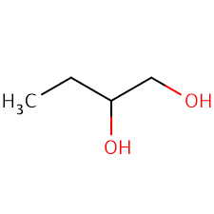
_____________________ _____________________ _____________________

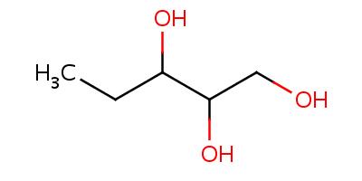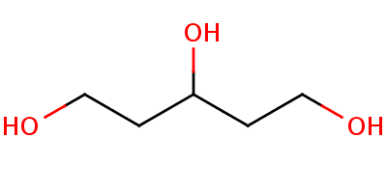
_____________________ _____________________

- Explain the difference between primary, secondary, and tertiary alcohols:
