Name: ________________________________ Mass and Volume Lab

Guiding Question: What is the relationship (if any) between mass and volume?
Materials: Metal samples, ruler, graduated cylinder, balance.
Pre-lab Questions:
- Explain Archimedes principle (volume displacement).

- Why is it important to measure the mass of the sample before the volume?

- Circle the word(s) that best describe your understanding of mass and volume. Then write a scientific explanation to defend the prediction you chose.
Prediction: The mass of a substance is (directly / indirectly / not) proportional to the volume
of the same substance.

Reasoning: ________________________________________________________________

________________________________________________________________

Procedure: Find the mass & volume of the samples. Record every measurement taken with labels, units, and observations that can lead to errors in the lab. Then answer the following questions about your substances.
Metal | Description of the substance and errors | Mass(es)  Balance Precision: ________ | Volume(s)  Cylinder Precision: ________  Ruler Precision: ________
A

B

C

D

E

Analysis Questions:
- Graph your data below. Label the x axis “volume” and y axis “mass” with units and values. Be sure to use constant intervals.
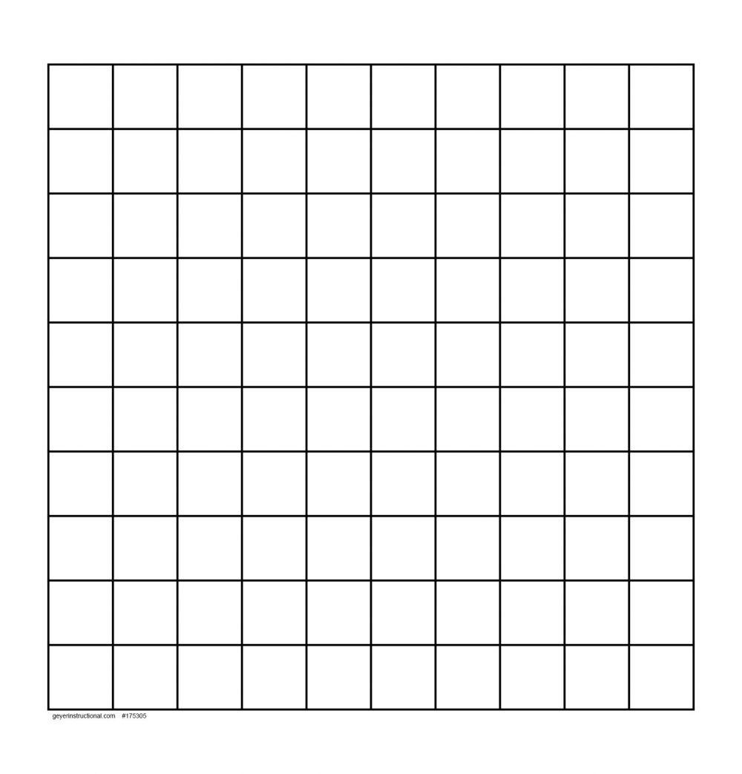

- Label each point on your graph as A-E of the metal it represents.
- Find two separate lines of best fit between samples of the same substance: Use a RULER!
  - Connect points A, B, and C
  - Connect points D and E.
  - Explain why points A, B, and C should not connect to D and E.

- Slope is determined by the formula m = ∆y/∆x.
  - Calculate the slope of the line you drew for A/B/C.

  - Calculate the slope of the line you drew for D/E.

- Using your data and graph, answer the guiding question: “What is the relationship (if any) between mass and volume?”

- What scientific term does the slope of a line created by graphing mass versus volume represent?
- This graph should have a y intercept of zero because if the mass is zero, the volume should also be zero, and the samples don't exist. What errors may have occurred during the lab that would account for any non-zero y-intercepts on your graph?
Material | Density (g/cm³)
Lead
Copper
Brass | 8.60
Iron
Zinc
Aluminum
Glass | 2.25
Glycerol | 1.25
Wood | 0.93
Oil | 0.92
Ethanol | 0.79
- Fill in the rest of the table on the right using Table S.
- Calculate the density of each object using just your data. Show work.
- Using the table to the right, identify each object you tested.

Metal | Calculated Density | Material
A

B

C

D

E

- Calculate the percent error of your densities.

A | B | C
D | E | Explanations:

- Draw particle diagrams that represent the metal samples.

A | B | C
D | E

- Provide evidence (information from your data and calculations) and reasoning (explaining how the evidence is important) that supports your drawings above.

