Liquids Before and After Mixing
- Place 10mL of liquid A in cylinder A.
- Place 10mL of solution B in cylinder B.
- Place both cylinders on the balance and record the total mass on your “Initial Mass” section.
- Pour liquid B into liquid A and swirl to combine.
- Place both cylinders on the balance and record the total mass on your “Final Mass” section.
- Rinse both cylinders and reset the lab station.
- Move to the next lab station, in numerical order, at the direction of your teacher.

Before After
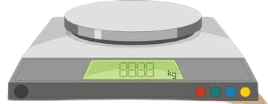
B
B
A
A
Sugar and Water Before and After Mixing
- Place 10mL of water the beaker A.
- Place 1 scoop of sugar to beaker B.
- Place both the beaker of water and the beaker of sugar on the balance and record the total mass on your “Initial Mass” section.
- Pour beaker B in to beaker A and swirl to combine.
- Place both beakers on the balance record the total mass on your “Final Mass” section.
- Rinse the beakers and reset the lab station.
- Move to the next lab station, in numerical order, at the direction of your teacher.

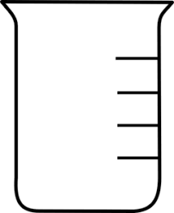
B
B
A
A

Before After
Alka Seltzer and Water Before and After Mixing
- Place 10mL of water the beaker.
- Place both the beaker of water and one Alka-Seltzer tablet on the balance and record the total mass on your “Initial Mass” section.
- While still on the balance, place the Alka-seltzer tablet into the beaker of water and allow it to react completely.
- Record the total mass on your “Final Mass” section.
- Rinse the beaker and reset the lab station.
- Move to the next lab station, in numerical order, at the direction of your teacher.
Before After

B
A
B
A

