Name: _________________________________________ K_{sp} Investigation of Potassium Hydrogen Tartrate (KHT)

Background Information: Potassium Hydrogen Tartrate (KHT) is a monoprotic acidic salt that ionizes as shown in the first equation below. A saturated solution of potassium hydrogen tartrate can be titrated with standardized NaOH to determine its concentration in the second equation below.. From concentration, the salt solubility product constant, K_{sp}, can be calculated.
KHC₄H₄O₆(s) ↔ K⁺(aq) + HC₄H₄O₆⁻(aq)
HC₄H₄O₆⁻ (aq) + NaOH → H₂O(l) + NaC₄H₄O₆(aq)

Purpose: To determine the K_{sp} of Potassium Hydrogen Tartrate (KHT).

Materials: Phenolphthalein, graduated pipette, weight boat, Erlenmeyer flask, 2 beakers, burette, graduated cylinder, potassium hydrogen tartrate saturated solution, ring stand, burette clamps, funnel, standardized sodium hydroxide.

Procedure A: Preparation of saturated KHT solution (the day before the experiment is run)
- Measure approximately 2.0 grams of finely powdered KHT into a weight boat.
- Measure 150 mL of water with a graduated cylinder. Transfer it to a clean 250 mL beaker.
- Pour and the massed KHT into the beaker of water.
- Add the magnetic stirrer AND place the beaker on the magnetic stir plate. Stir the mixture with a moderate vortex for 20 minutes.
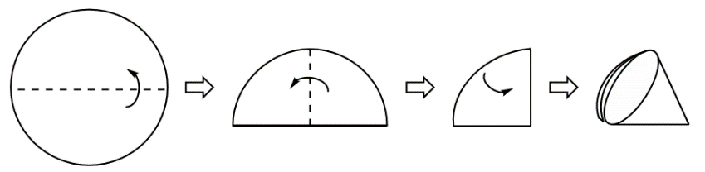
- Allow the solution to sit overnight, giving some time for the excess KHT to collect at the bottom of the container.

Procedure B: Filtration & Titration.
- Place folded filter paper in the funnel and the funnel into the mouth of a 250 mL Erlenmeyer flask.
- Hold the filter paper down into the funnel and completely filter the saturated KHT solution.
- Record the molarity of the standardized NaOH solution from a past lab.
- Prepare your burette: Set up the ring stand with a burette. Using a funnel, rinse the buret with water and then ~5 mL NaOH and fill with the standardized NaOH. Release NaOH buret into the waste beaker to fill the tip. Make sure there are no air bubbles in the tip.
- Record the initial burette reading.
- Using the graduated pipet, measure 25.00 mL of the filtered, saturated KHT solution and dispense it into a clean 150mL Erlenmeyer flask. Record the exact volume of KHT delivered.
- Add 1 drop of Phenolphthalein to the acid solution.
- Titrate until a very pale pink color persists for about 60 seconds. Make sure to rinse the sides with deionized water and swirl the flask periodically throughout the titration to ensure all of the KHT is reacting.
- Record the final burette reading.

Data:
Molarity of standardized NaOH:
Initial volume of standardized NaOH:
Initial volume of KHT:
Final volume of standardized NaOH:
Calculations and Questions: All work must be shown with proper significant figures and units.
- Calculate the moles of base, NaOH, titrated.

- Calculate the moles of acid, KHT, titrated.

- Calculate the molarity of HC₄H₄O₆⁻(aq).

- Determine the molarity of K⁺ that must have been formed in the titration.

- Write the K_{sp} expression for KHT.

- Determine the K_{sp} of KHT

- Calculate the % error for the K_{sp} determined in the experiment (accepted: K_{sp} =1.01x10⁻³).

- What was physical evidence that the initial KHT solution was saturated? Explain.

- If the water used to create the solutions was at a higher temperature, how would that affect the values of the molarities of K⁺ and HC₄H₄O₆⁻ and the K_{sp}?

