Unit 6; Matter and Kinetics

Pre-Lesson; Kinetics Review-

- In order for a reaction to occur, the particles must collide with proper energy and orientation.
- Potential energy -energy stored due to an object's position or arrangement.
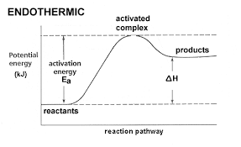
- Activation energy -amount of energy that reactants must absorb before a chemical reaction will start .
- When a catalyst is used, the activation energy decreases.
- Ideal gas behavior- PLIGHT

Lesson One; Rate Expressions-

REACTION RATE:
- The change in concentration of a reactant and a product with time (m/s).
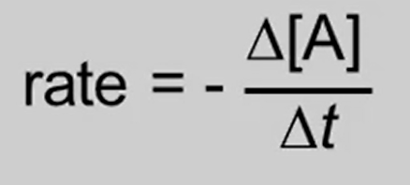
- Calculate this by using a rate expression(A→B)
  - Always balance reaction before
  - Reactants are negative
  - Products are positive
  - △t is time
  - [A] is the change in concentration
- As time increases, rate decreases

AP KINETICS EXPERIMENT (LAB):
In this lab, we determined how rate is affected by changes in concentrations and in the pre-lab we were asked to create rate expressions. Factors that must be held constant to affect the rate of reaction are temperature, pressure, surface area, volume and adding a catalyst. To create a rate expression, first we had to balance the equation and then we created a rate law for the overall reaction.

Lesson Two; Rate Laws-

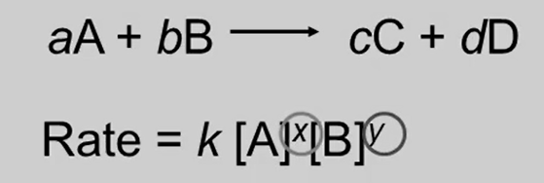
RATE LAWS:
- The relationship between the concentration of the reactants and the rate of reaction.
- Rate laws are always determined experimentally.
- The slow reaction determines the rate law.

ORDERS:
- The order of reactant is not related to the coefficient of the reactant.
- Reaction order is the sum of all individual orders.
- First order
  - Concentration and rate change the same way (ratio 1:1).
- Second order
  - Rate squares what concentration does.
- Zero order
  - Concentration changes but rate doesn’t.
- Negative order
  - Rate changes the same as concentration, but in the opposite direction.
- Examples

Run # | Initial A | Initial B | Initial Rate
1 | 1.00 M | 1.00 M | 1.25 x 10^-2 M/s
2 | 1.00 M | 2.00 M | 2.5 x 10 ^-2 M/s
3 | 2.00 M | 2.00 M | 2.5 x 10^-2 M/s

- A’s order is 0 (concentration changed but the rate didn’t)
- B’s order is 1 (rate and concentration changes are the same)
- Overall order is 1 (0 plus 1 equals 1)

RATE CONSTANT:
- Rate Constant is equal to K.
- Units vary depending on order of reaction.

Lesson Three; Rate Equations-
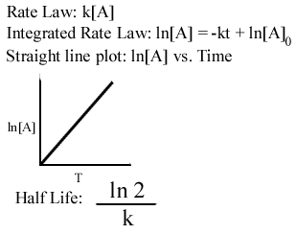
FIRST ORDER REACTIONS:
- Rate depends on the concentration to the first power.
- [A]t is the concentration of a at anytime,t.
- [A]o is the initial concentration of A.
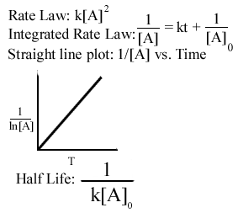
- Half Life: the time required for the reaction to decrease to half of its initial concentration
- Units: /s

SECOND ORDER REACTIONS:
- Units: /ms
- Slope = K

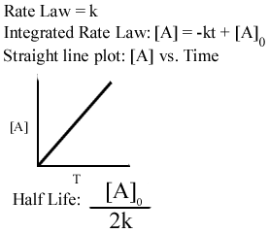
ZERO ORDER REACTIONS:
- Not dependant on concentration
- Units: m/s

THE KINETICS OF WATER FLOW THROUGH A BURETTE (LAB):
In this lab, we were able to determine the reaction order for the process of flowing water flowing through a burette.
We found 3 different slopes and from these we were able to find out which is zero, first, and second. Zero order is time vs. volume so the slope was negative. First order is time vs. ln(volume) so the slope was also negative. Second order was the different one, time vs. 1/ln(volume) the slope was positive.

Lesson Four; Reaction Mechanisms-
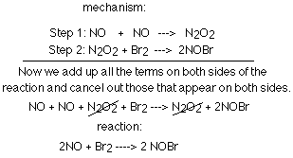
REACTION MECHANISM
- Overall progress of a chemical reaction can be represented at the molecular level by a series of elementary steps.
- The sequence of elementary steps that leads to product formation is the reaction mechanism.
- Intermediates: species that appear in a reaction mechanism but not in the overall balanced equation
- CATALYST
- Speed up reaction
- Found in reactants of first elementary step, products of last step
- Function by lowering the activation energy of an elementary step

RATE DETERMINING STEP:
- Slow step determines rate law
- Will have similar rate law as the overall reactions rate law

AP Multiple Choice; Kinetics-

- Relatively slow rates of chemical reaction are associated with which of the following?
- The presence of a catalyst (B) High Temperature
(C) High concentration of reactants (D) Strong bonds in a reactant molecules
(E) Low activation energy

2. Which of the following is a correct statement about reaction order?
- Reaction order can only be a whole number
- Reaction order can be determined only from the coefficients of the balanced equation for the reaction
- Reaction order can be determined only by experiment
- Reaction order increases with increasing temperature
- A second-order reaction must involve at least two different compounds as reactants

3. Which of the following must be true for a reaction for which the activation energy is the same for both the forward and reverse reactions?
- A catalyst is present
- The reaction order can be obtained directly from the balanced equation
- The reaction order is zero
- ΔH° for the reaction is zero

