Name: _____________________________________ Date: _________ Period: ____
Do Now:
Should criminal suspects be able to choose who will give them a polygraph test? Why or why not? ________________________________________________________________________________________________________________________________________________________________________________________________________________________________________________
The use of polygraph testing generated much controversy
in the 1996 murder investigation of a six-year-old beauty
queen, named JonBenet Ramsey.
Who is JonBenet?
https://www.youtube.com/watch?v=SEBgn0HtK8E
The Murder & Subsequent Investigation
Early on the morning of December 26, 1996, Boulder
Colorado resident Patsy Ramsey called 911 to report her
young daughter JonBenet missing.

Listen to the call:
https://www.cnn.com/videos/entertainment/2017/03/01/hirh-jonbenet-911-call.cnn
1. What is your reaction to this phone call? How does Patsy appear to feel? Do you believe her? ____________________________________________________________________________________________________________________________________________________________________________________

Mrs. Ramsey then said that they had found a handwritten random note demanding $118,000. Police arrived at 5:55 AM and found no signs of forced entry. Hours after Boulder police arrived and secured the house, John Ramsey found his daughter’s lifeless body in the basement of their large mansion. JonBenet had suffered blunt force trauma to the head and had been strangled.
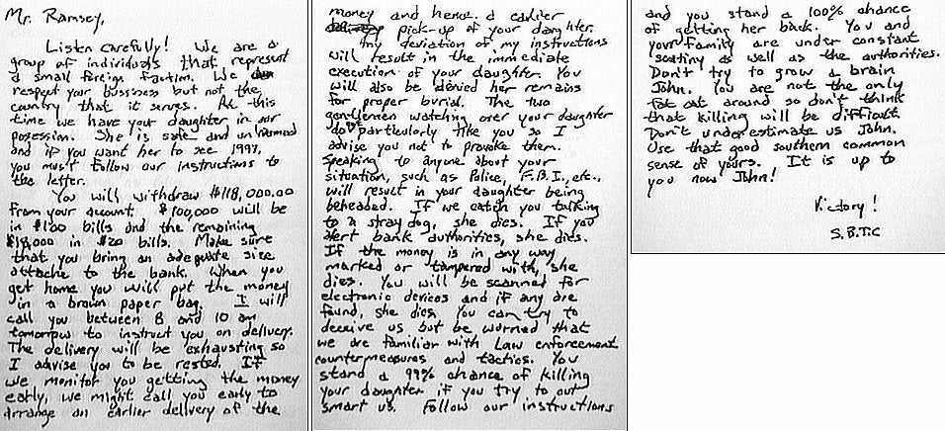

2. What are some peculiar things you notice about the ransom note? ____________________________________________________________________________________________________________________________________________________________________________________
3. Do you think this ransom note is legitimate? Why or why not? ____________________________________________________________________________________________________________________________________________________________________________________
4. What is a question you want to ask if you were investigating this crime? ____________________________________________________________
________________________________________________________________________________________________________________________
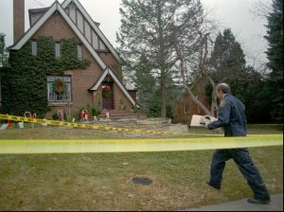
Before JonBenét’s body was even found, there were many investigative mistakes made. Only JonBenét’s room was cornered off, so friends and family roamed the rest of the house, picking up things and potentially destroying evidence. The Boulder Police Department also shared evidence they found with the Ramseys and delayed conducting their informal interviews with the parents. At 1:00 PM the detectives instructed Mr. Ramsey and a family friend to go around the house to see if anything was amiss. The first place they looked was the basement, where they found JonBenét’s body. John Ramsey immediately picked up his daughter’s body and brought her upstairs, which unfortunately destroyed potential evidence by disturbing the crime scene.
A lengthy investigation into JonBenet Ramsey’s murder failed to produce any credible suspects. Boulder Police officials said her parents were under suspicion. In April and June, both Patsy and John Ramsey were questioned by police. Even JonBenet’s 9-year-old brother, Burke was interviewed for 6 hours. Police insisted they could not rule out Patsy as the writer of the ransom note.
5. At this point in the investigation, who do police officials feel is under suspicion? _______________________________________________________

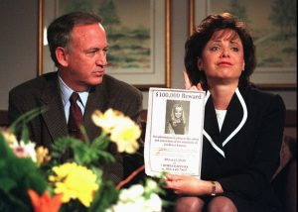
Controversy Surrounding Polygraph Testing
In order to pardon themselves, John and Patsy Ramsey offered to take polygraph tests to prove they had nothing to do with their daughter’s death. The Boulder Police Department (BPD) agreed as long as it was conducted by the FBI (a normal procedure done in all serious criminal cases). The Ramsey’s refused to take FBI polygraph test saying that the FBI was involved with the case and as a result would be biased. The Ramseys then submitted a list of polygraphists to the Boulder Police Department that they wanted to conduct their polygraph tests. The Boulder Police rejected all the proposed polygraphists.
The determined and wealthy John and Patsy Ramsey then proposed that Edward Gleib, a polygraphist with 30 years of experience and past president of the American Polygraph Association, could conduct their polygraph tests, but the Boulder Police continued to insist upon the FBI.
6. Why do you think the FBI was insisting that they conduct the polygraph tests? ______________________________________________________________________________________________________________
Then the American Polygraph Association (APA) became involved announcing that they were willing to provide a polygraphist to administer polygraph tests similar to the FBI’s to the Ramseys. JonBenet’s parents agreed, but Boulder police rejected the offer. The Ramseys then decided to reject the APA’s offer, preferring to pay Edward Gleib to administer their tests.
The Boulder Police Department’s continuous refusal this request was based on a convincing argument. They stated that only a law enforcement agency like the FBI could complete a reliable and valid polygraph examination because they had access to the thousands of pieces of undisclosed and sensitive evidence related to the case.
7. Why did the Boulder Police Department refuse to allow the APA to provide a polygraph test to the Ramseys? ______________________________________________________________________________________________________________
The unwavering Ramseys hired Edward Gleib to conduct a polygraph examination with both of them. Gleib’s findings cleared them both of any involvement in their daughter’s death. The Boulder Police rejected these results saying that they were only willing to accept valid polygraph findings from the FBI. The Ramseys offered to allow the police to question Edward Gleib about his polygraph testing procedures, but the Boulder police Department refused.
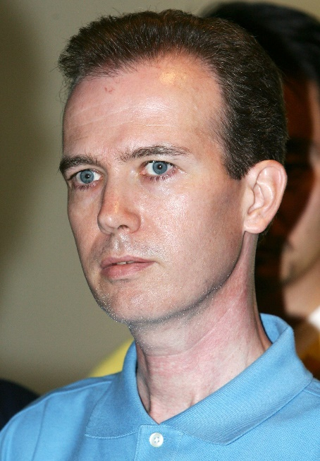
As of December 2005, it has been nine years since little JonBenet Ramsey was brutally murdered and found dead in her home. The Ramseys still refuse to take FBI polygraph tests, while the Boulder Police Department still refuse to accept polygraph results from any other source.
Much of the recent investigation in the case revolves around the DNA profiles developed from the sample found in her underwear and the touch DNA later developed from her long johns. One of the most famous suspects was John Karr. He was arrested in 2006 when he confessed to killing JonBenét by accident, after he had drugged and sexually assaulted her. Karr was eventually dismissed as a suspect after it was revealed that no drugs had been found in JonBenét’s system, police could not confirm he was in Boulder at the time, and his DNA did not match the profile generated from the samples found.

8. Why do you think John Karr confessed to the murder of JonBenet even though he was innocent (DNA analysis ruled him out)? _____________________________________________________________________________________________________________________________________________________________________
In 2006, Boulder District Attorney Mary Lacy took over the case. She agreed with the federal prosecutor that the intruder theory was more plausible than the Ramseys killing their daughter. Under Lacy’s lead, investigators developed a DNA profile from touch DNA (DNA left behind by skin cells) on her long johns.
9. Which theory do you believe is more plausible – the intruder theory or the Ramseys killing their own daughter theory? ______________________________________________________

The case remains unsolved and is considered to be a ‘cold case’ since no new credible suspects or witnesses have surfaced.
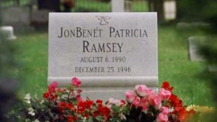
Closure:
Revisit the same question from the beginning of class:
Should criminal suspects be able to choose who will give them a polygraph test? Why or why not? – Now that you have studied the case of JonBenet Ramsey, did your opinion change or remain the same? Explain. ____________________________________________________________________________________________________________________________________________________________________________________________________________________________________________________________________________________________________________

