Name: _______________________________________ IMF Lab: upload full lab

Guiding Question: How do intermolecular forces affect properties of matter?

Materials: Petri dishes, food dye, mineral oil, toothpicks, pepper, detergent, balloon, pennies, droppers, mineral oil, acetone, Styrofoam pieces, NH₄Cl, NaOH, 2 beakers.

Pre-lab questions:
- Explain polarity in terms of charges and attraction.

- Explain the rule of “like dissolves like” In terms of polar and nonpolar substances.

- Define endothermic and exothermic reactions with an example of each.

Procedure/Data: You must write down observations, data, and models from each lab station and complete that station’s questions. Clean up each lab station before going to the next station.
- In a petri dish, pour enough water to fill the left half of the dish. Fill the other side with mineral oil. Place one drop of food dye to the oil side. Then move that small bubble over to the water side.
- Models and description: Before After

- In terms of polarity, why doesn’t the water and oil mix well?

- In terms of polarity, why does the food dye dissolve in one solvent and not the other?

- In a petri dish, add water until it is half full. Sprinkle pepper on the top of the water. Notice and write down if the pepper is sinking or floating. Add a few drops of liquid detergent.
  - Observations:

  - Surface tension of liquids results when forces of attraction in a liquid are high enough to resist external forces. In terms of forces and surface tension, explain why water can hold up the pepper, although pepper is denser than water.

  - In terms of forces and surface tension, explain what happened when the detergent was added.

- Run the water in the faucet on a very low setting. Rub a balloon on someone in your group’s clothing (preferably something soft). Bring the balloon near the stream of water without getting the balloon wet.
  - Models and description: Before After
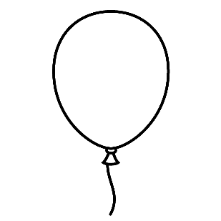
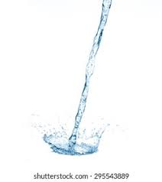

  - In terms of charges, what happened when you were rubbing the balloon on your clothes?

  - In terms of polarity and charges, why was the water attracted to the balloon?

- Using a dropper, count and record how many drops of water fit on the head of a penny without spilling over. Repeat using mineral oil instead of water.
  - Observations:

  - Surface tension of liquids results when forces of attraction in a liquid are high enough to resist external forces. In terms of forces and surface tension, explain why more drops of one liquid stayed on the head of the penny than the other liquid.

  - A penny could hold more drops of soapy water than oil. But the penny would hold less drops of soapy water than pure water. Explain why soapy water places second in this experiment in terms of forces.

- In a petri dish, add acetone until about 1/3 of the dish is full. Then place in a piece of Styrofoam.
  - Observations:

  - In terms of polarity, why doesn’t Styrofoam dissolve in water?

  - In terms of polarity, explain your observations of styrofoam in the acetone.

- Fill both beakers with approximately 25mL of water. In beaker 1 add one scoop of NH₄Cl and feel the outside of the beaker. In beaker 2 add one scoop of NaOH and feel the outside of the beaker.
  - Observations:

  - In terms of heat, explain what type of reaction occurred when NH₄Cl dissolved in water.

  - Were more forces broken or formed when NH₄Cl dissolved in water?

  - In terms of heat, explain what type of reaction occurred when NaOH dissolved in water.

  - Were more forces broken or formed when NaOH dissolved in water?

Post-Lab Questions: Fill in the blanks with: endothermic or exothermic, and polar or nonpolar.
- Breaking forces will be characterized as ___________________ reactions. Draw a model to explain your claim:

- Forming forces will be characterized as ___________________ reactions.Draw a model to explain your claim:

- Like dissolves like. This means that ______________ solvents dissolve polar solutes. Additionally, nonpolar solvents dissolve _____________ solutes.

