Name: _______________________________ How to Lab: Safety and Measurement
Upload full lab
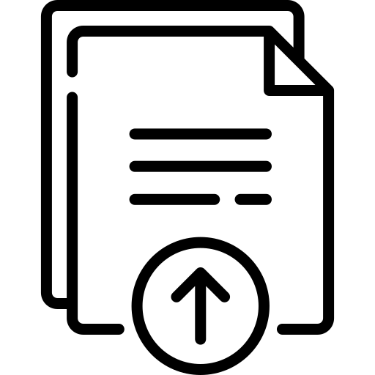
Guiding Questions: How long must you flush clothes and skin with water after coming into contact with acid or base? How can we get the most precise and accurate measurements?

Station 1: Effect of acids and bases on clothing
The potential hazard of a given acid or base depends on a number of factors, including the strength of the acid/base and the amount of the reactant in the water. The 6M represents amounts of the acid or base added to water, where 6M has 6 times more acid or base than 1M. Pieces of fabric were stretched over a beaker and fastened with a rubber band. Then two drops of each liquid were added to the fabrics and allowed to sit out this morning. Make observations about each fabric and liquid below.

 | 6M Hydrochloric acid, HCl | 6M Sodium Hydroxide base, NaOH
Nylon/Rayon
Cotton

- Make a claim about the hazards of using chemicals in the classroom with evidence from your observations above.

- What safety procedures should we follow to ensure we are careful?

- Earlier, this morning, this station was run in exactly the same way, but after dropping the reagents on the fabrics, the fabrics were rinsed in running water. Compare your results from above with what you observe on the (now dry) fabrics that were quickly rinsed under running water. Did rinsing the fabrics make a difference?

Station 2: Effects of acids and bases on Biological Materials
Egg White is made up of protein and will serve as a model of your skin. These were prepared for you this morning. Make observations about the effects on the samples in the table below.

Acid/Base | Egg White
6M Sodium hydroxide base, NaOH
6M Hydrochloric acid, HCl

- Make a claim about the hazards of using chemicals in the classroom with evidence from your observations above.

- What safety procedures should we follow to ensure we are careful?

Station 3: Measuring length using rulers
There is a selection of labeled rulers and a length of string. First make observations about the number of marks each ruler has. You can record this in words or a drawing. Then, measure the length of the string to the best of your ability. Remember you can only estimate one place beyond what you can read.

Rulers | Observations | Length Reading
Ruler 1
Ruler 2
Ruler 3

- Make a claim that states which ruler seems the most precise using evidence you collected above.

- Make a claim that states which ruler seems the least precise using evidence you collected above.

Station 4: Measuring mass using balances
There is a standard mass sitting next to three labeled balances. Measure it on each balance and record below. Be sure to record all digits in the mass.
Balances | Mass reading
Digital balance 1
Digital balance 2
Triple beam balance

- Make a claim that states which balance seems the most precise using evidence you collected.

- Make a claim that states which balance seems the least precise using evidence you collected.

- Make a claim that states which balance seems the most accurate using evidence you collected.

- Make a claim that states which balance seems the least accurate using evidence you collected.

Station 5: Measuring the volume using glassware
Compare how the following pieces of glassware do in terms of both precision and accuracy in measuring volumes of water. For each of the following glassware pieces, perform the following procedure:
- Measure out 50 mL of water as precisely as you can. You may use a dropper to help you get as close to 50 mL as possible. Read the labels closely and estimate a place beyond.
- Put a plastic cup on the balance and use the “tare” button so that the mass reads 0 while the cup is on it.
- Pour the water into the cup. Record the mass of the water below. (1 gram of water = 1 mL)
Glassware | Volume reading | Mass reading
50 mL beaker
50 mL graduated cylinder
50 mL Erlenmeyer flask
25 mL Volumetric flask
- Make a claim that states which glassware seems the most precise using evidence you collected.

- Make a claim that states which glassware seems the least precise using evidence you collected.

- Make a claim that states which glassware seems the most accurate using evidence you collected.

- Make a claim that states which glassware seems the least accurate using evidence you collected.

Stations 6 and 7: Measuring volumes with different glassware
For each piece of glassware, draw a sketch of the glassware for your future forgetful self and then record the volume it is holding (remember to estimate one place beyond!)
Glassware | Sketch | Volume reading
Beaker
Erlenmeyer flask
Graduated Cylinder
Graduated Pipette
Volumetric flask
Buret

- Generally glassware is more expensive when it is more accurate. Try to match the prices below with the glassware above.
  - $3.80
  - $4.50
  - $6.50
  - $21.77
  - $30.00
  - $64.34

- Did you notice one of these glassware has markings reversed from the others? Think about why this could be based on the design of the glassware.

