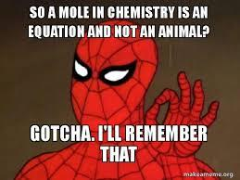
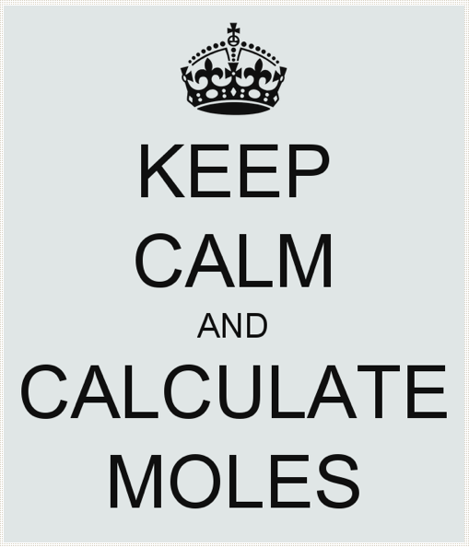

Moles Think Tank
You know the common joke, “Which weighs more: a pound of feathers or a pound of lead?” People often pick lead because they might know that lead is denser than a feather but what they are really comparing is particles. Lead is heavier than feathers when you compare the same number of particles. But upon reflection of the initial question you realize the question asked about equal weights. Now change that to, “What weighs more: a gram of hydrogen or a gram of lead?” and we are talking CHEMISTRY! Obviously the same result, they weigh the same; but can we compare them particle to particle as some do with feathers and lead? That would require us to define a specific amount of particles to compare, which is no easy feat, since these particles are pico-scopic. We need millions and billions and trillions of particles all together in order to just see the sample and weigh it on a balance. So what’s the number chosen? It’s not a pair, dozen, million, billion, or trillion. It’s a mole and it is defined at 6x10²³ particles of any substance. That is 600,000,000,000,000,000,000,000 particles. If we gather up that amount of even the lightest element, we can weigh it on a balance.

Most hydrogen atoms have a mass number of 1 because the most common isotope of hydrogen is H-1 with 1 proton with 1 atomic mass unit and 1 electron with relatively no mass (no neutrons in H-1). This isotope of hydrogen is so common that its average atomic mass is rounded to 1 u as well (1.00794 to be exact). And carbon is similar in that it has a very common isotope C-12 (6 protons, 6 neutrons, and 6 massless electrons) which constitutes so much of the average that the average atomic mass of carbon also rounds to 12 u (12.011amu to be exact). Therefore, as long as we compare the same number of particles of hydrogen and carbon, carbon will always weigh 12 times more than hydrogen.
For example: 1H = 1 u and 1C = 12 u
100H = 100 u and 100C = 1200 u
Recall that the u, or atomic mass unit, is a count of the number of nucleons (protons & neutrons) in the atom and not a mass determined by a balance. But when extrapolated to the mole 6x10²³ particles it actually can be massed on a balance. When a mole of hydrogen is massed on a balance it equals 1.00794g! And carbon is about 12 times that mass at 12.011g. These masses are the same as the average atomic masses and are reported on the periodic table. When 6x10²³ atoms of an element are massed on a balance it is called the molar mass or gram formula mass of the element.

The number 6x10²³ is known as Avogadro’s number because he was a scientist who first determined that equal volumes of different gases at the same temperature and pressure contained the same number of particles. Avogadro and other scientists calculated this number by various methods including using electron’s charges and x-ray technology. Presently Avogadro’s number has many more decimal places (6.02214076x10²³) with much more significant figures. The number was created so the atomic mass would equal the molar mass of an element.

Find the molar mass of the following elements:
- Lead | - Iron
- Potassium | - Gold
When elements combine to form compounds their masses can be summed together. The sum of the mass of a compound is also known as the molar mass or gram formula mass.
Find the molar mass of the following:
- CO | - CO₂
- H₂O | - NaCl
Will we always work with just one mole of a substance? We can mass any quantity of an element or compound on a balance and it is not necessarily one mole worth of the substance. If carbon weighs 12g for every mole, if you mass 24g that means you will have twice the molar mass of carbon and therefore 2 moles of carbon. Remember that the mole represents 6x10²³ particles of a substance. So 24g would be equivalent to 12x10²³ atoms of carbon.
 | Find the moles of the following measurements: | Find the number of particles in the following measurements:
- 46g Na
- 96g S
- 160g Ar
- 36g H₂O
- 132g CO₂
- 140g CO
Additionally, we will not always mass a full mole of massive substances on a balance. For example, if you massed 6g of carbon on a balance, that is half the molar mass and therefore half of a mole or 3x10²³ particles.
 | Find the mass of the following measurements: | Find the number of particles in the following measurements:
- 0.5 moles Be
- 0.5 moles Si
- 0.5 moles H₂O
- 0.25 moles CO
- 10 moles of CO₂
- 100 moles Cr

In reality, we can measure any quantity of a substance on a balance and it probably will not be a whole number of moles. For example if I randomly mass out 8.45g of carbon, that's not a full mole, 2 moles or a half of a mole. Let’s think about this:
- Explain the mathematical calculation you are doing to convert from moles to mass.

- Explain the mathematical calculation you are doing to convert from mass to moles.

- Which equation could be used to calculate the moles for any number? “Grams given” is the mass provided by a balance.
  - moles = grams given * gram formula mass
  - moles = gram formula mass / grams given
  - moles = grams given / gram formula mass
  - moles = gram formula mass * grams given

When reactions are written for reacting chemicals the substances on the left are known as reactants and the substances after the arrow are the products. The reactions can be interpreted on the atomic scale. For example:
Ca(s) + S(s) → CaS(s)

“One atom of calcium is reacting with one atom of sulfur to create one molecule of calcium sulfide.” But these can also react in any proportional ratio. So 2 Ca atoms react with 2 S atoms to form 2 CaS molecules and 100 Ca atoms can react with 100 sulfur atoms to form 100 molecules of CaS. Therefore 6x10²³ atoms of Ca can react with 6x10²³ atoms of S to form 6x10²³ molecules of CaS. It is much easier to write that as 1 mole of Ca reacts with 1 mole of S to form 1 mole of CaS.

- For each reaction provided below, explain how the chemicals are reacting in terms of atoms and moles. The first one is done for you.
  - 2Na + Cl₂ → 2NaCl
Two atoms of sodium react with 1 molecule of chlorine to form 2 molecules of sodium chloride.
Two moles of sodium react with 1 mole of chlorine to form two moles of sodium chloride.
  - Al + P → AlP

  - 2H₂ + O₂ → 2H₂O

  - N₂ + 3H₂ → 2NH₃

- Can the reaction Ca(s) + S(s) → CaS(s) be read as “1 gram of calcium reacts with 1 gram of sulfur to form 1 gram of calcium sulfide?” Explain your answer using the law of conservation of mass.
Moles and Molar Mass Check your Understanding

Find the gram formula mass of the following: (Show all work)

- CO₂
- FeS
- NaCl
- Al₂(CO₃)₃
- SiO₂
- H₂SO₄
- Al₂(SO₃)₃
- C₁₂H₂₂O₄
- Fe₂O₃
- ZnCl₂
- Ca(OH)₂
- CH₄
- NH₃
- H₂O₂
- NaHCO₃
- C₆H₁₂O₆
- MgO
- SrSO₄.3H₂O
Find the number of moles in the following measurements: (Show your work)
- 900. grams C₆H₁₂O₆
- 24.5 grams H₂SO₄
- 192 grams SiO₂
- 450. grams of ZnCl₂
- 22 grams of CO₂
- 20. grams of Fe₂O₃
- 3.40 grams of H₂O₂
- 840. grams of NaHCO₃
Now solve for the mass given the moles. (Show your work)

- 2.00 moles of C₆H₁₂O₆
- 5.00 moles of SrSO₄.3H₂O
- 0.250 moles of CH₄
- 0.100 moles of NH₃
- 12.0 moles of SiO₂
- 0.330 moles of FeS
- 1.50 moles of MgO
- 0.500 moles of ZnCl₂
Molar Mass and Moles Regents Questions

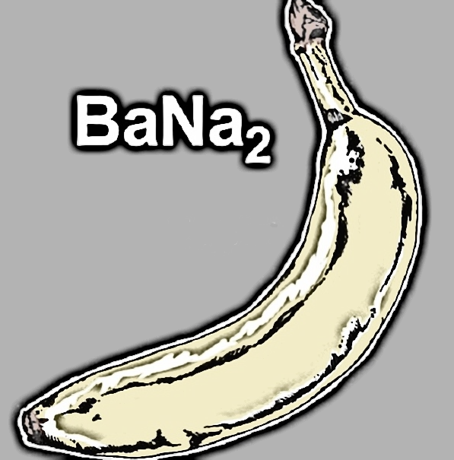
Honors Moles and Avogadro’s Number Think Tank Problems

- Define Avogadro's number and identify the value.

- Calculate the number of molecules contained in the following:
  - 1.00 mole sample of sulfur hexafluoride gas

  - 2.00 mole sample of oxygen gas

- Calculate the number of moles contained in the following:
  - a 6.02x10²³ molecule sample of nitrogen gas

  - a 1.20x 10²⁴ molecule sample of chlorine gas

- Calculate the mass contained in the following:
  - a sample of 6.02x10²³ molecules of nitrogen gas

  - a sample of 1.20x 10²⁴ molecules of chlorine gas

- Calculate the number of molecules in the following:
  - a sample of 56g of iron

  - a sample of 36g of water

Honors Moles and Avogadro’s Number Check Your Understanding

- Calculate the mass of 3.01 x 10²³ molecules of carbon dioxide gas, CO₂.

- Calculate the mass of 1.80 x 10²⁴ molecules of oxygen gas, O₂.

- Calculate the mass of 1.20 x 10²⁴ particles of sodium chloride, NaCl.

- Calculate the mass of 1.00x10²³ atoms of gold, Au.

- Calculate the particles contained in 2.50 moles of lithium nitride. Li₃N.

- Calculate the molecules contained in 2.50 moles of nitrogen, N₂.

- Calculate the atoms contained in 0.75 moles of helium, He.

- Summarize the steps you take to solve these mathematical problems.

Mole Ratios and Reactions Think Tank Questions

- During respiration carbon atoms combine with oxygen to form carbon dioxide:
C + O₂ 🡪 CO₂
  - Draw particle diagrams to show how the atoms react to form the compound.

  - Does this reaction conserve mass? Provide evidence of your answer.

  - Multiple CO₂ molecules can form per minute. The reaction provided can be read in terms of atoms and molecules or in multiples. Draw particle diagrams to show what would happen if 2 atoms of carbon reacted with 2 molecules of oxygen.

  - Additionally, 100 C can react with 100 O₂ to form 100 molecules of CO₂ or 6.02x10²³ atoms can react in a ratio which equals 1 mole of particles. Therefore, 1 mole of C reacts with 1 mole of O₂ to form 1 mole of CO₂.
    - If 2 moles of carbon atoms react with excess oxygen, how many moles of carbon dioxide form?

    - If 3 moles of oxygen molecules react with excess carbon, how many moles of carbon dioxide can be created?

    - If 0.50 moles of carbon dioxide were produced, how many moles of carbon were used in the reaction?

- The engine of your car combines nitrogen gas (most abundant in the air) and oxygen gas to form nitrogen (II) oxide:
N₂ + O₂ 🡪 NO
  - Draw particle diagrams to show how the atoms react to form the compound.

  - Does this reaction conserve mass? Provide evidence of your answer.
  - How should the reaction be modified to obey the law of conservation of mass? Rewrite the “balanced” reaction:

  - Using the better, balance reaction,
    - If 2 moles of N₂ react, how many moles of NO can be produced?

    - If 5 moles of oxygen fully react, how many moles of NO can be formed?

    - If a car emits 20 moles of NO, how many moles of N₂ were reacted?

- When fossil fuels such as propane in gas grills burn, they react with oxygen to form carbon dioxide and water.
C₃H₈ + 5O₂ 🡪 3CO₂ + 4H₂O
  - Draw particle diagrams to show how the atoms react to form the compound.

  - If 2 moles of C₃H₈ react, how many moles of carbon dioxide are emitted?

  - If 0.300 moles of C₃H₈ react, how many moles of carbon dioxide are emitted?

  - If 2.89 moles of oxygen are consumed, how many moles of carbon dioxide are emitted?

  - In 2019, approximately 3.9x10¹⁶g of CO₂ are produced from fossil fuel burning globally.
    - Calculate the amount of moles of CO₂ are produced in 2019.

    - If the only fossil fuel burned was propane, how many moles of propane were burned in 2019.

    - Calculate the moles of propane burned in the previous question.
- When plants photosynthesize they take in carbon dioxide and water to form glucose and oxygen:
6CO₂ + 6H₂O 🡪 C₆H₁₂O₆ + 6O₂
  - Identify the total number of carbon, oxygen, and hydrogen atoms:
    - In the reactants:

    - In the products:

  - Is this reaction “balanced”? Explain your answer.

  - If a plant absorbs 12 moles of carbon dioxide, how many moles of glucose can it produce?

  - If a plant takes in 3 moles of water, how many moles of oxygen does it form?

  - If the plant is watered with 4 moles, how much glucose can it produce?

  - If a plant needs to produce 1.25 moles of glucose, how many moles of CO₂ will it require?
Reactions Check your Understanding

Balancing Reactions Check your Understanding

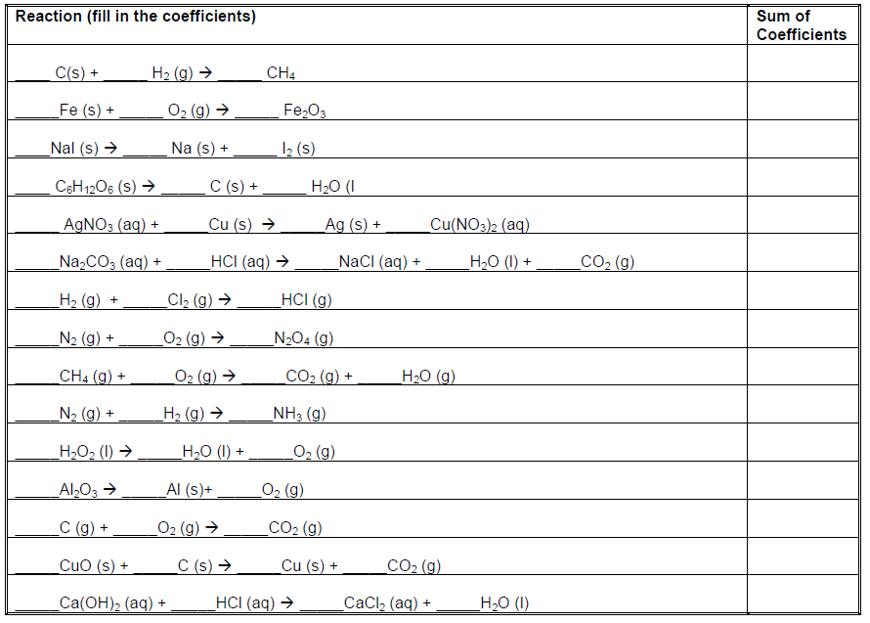

Balance the reactions: Give the type of reaction:

- NO + O₂ 🡪 NO₂ _____________________________________________________
- Ag + S 🡪 Ag₂S ____________________________________________________
- Cu(OH)₂ 🡪 CuO + H₂O ____________________________________________________
- KClO₃ 🡪 KCl + O₂ ____________________________________________________
- Al + O₂ 🡪 Al₂O₃ ____________________________________________________
- CO + O₂ 🡪 CO₂ ____________________________________________________

Balancing Regents Questions Check your Understanding

Net Ionic Equations Activity

- Observe the reaction between aqueous cobalt (II) nitrate and aqueous sodium carbonate. Imagine how they look at the molecular level.
- Write the molecular equation for this reaction:

- Write the balanced net ionic equation for this reaction:

- What is/are the spectators in this reaction?

- What is the precipitate name?

- Draw the reactants before and after the reaction. (Be aware of how many of each ion you started with.)

+-->

- Observe the reaction between aqueous Barium chloride and sodium sulfate. Imagine how they look at the molecular level.
  - Write the molecular equation for this reaction:

  - Write the balanced net ionic equation for this reaction:

  - What is/are the spectators in this reaction?

  - What is the precipitate name?
  - Draw the reactants before and after the reaction.

+ -->

- Observe the reaction between aqueous copper (II) chloride and sodium carbonate. Imagine how they look at the molecular level.
  - Write the molecular equation for this reaction:

  - Write the balanced net ionic equation for this reaction:

  - What is/are the spectators in this reaction?

  - What is the precipitate name?

  - Draw the reactants before and after the reaction.

+ -->

- Observe the reaction between aqueous lead (II) nitrate and sodium iodide. Imagine how they look at the molecular level.
- Write the molecular equation for this reaction:

- Write the balanced net ionic equation for this reaction:

- What is/are the spectators in this reaction?

- What is the precipitate name?

- Draw the reactants before and after the reaction.

+ -->

5. Double replacement reactions require the cations to switch with the anions. Identify which of the following DR reactions are written correctly. Correct the mistakes in the wrong reactions:

a. (NH₄)₃PO_{4(aq)} + AlCl_{3(aq)} 🡪 Al(PO₄)_{3(s)} + NH₄Cl_{3(aq)} ____________________________________

b. NaCl_{(aq)} + AgNO_{3(aq)} 🡪 AgCl_{(S)} + NaNO_{3(aq)} ____________________________________

c. NaBr_{(aq)} + PbI_{2(aq)} 🡪 NaI_{(aq)} ____________________________________________________

d. K₂SO_{4(aq)} + BaI_{2(aq)} 🡪 BaSO_{4(s)} + 2KI_{(aq)} ____________________________________

e. CaCl_{2(aq)} + Li₂CO_{3(aq)} 🡪 2LiCl_{(s)} + CaCO_{3(aq)} ____________________________________

Honors Multi-Step Dimensional Analysis

N₂ + 3H₂ 🡪 2NH₃

1. Convert 28.0grams of nitrogen to grams of ammonia gas at STP.

2. How many grams of hydrogen are formed from 17.0g of ammonia gas at STP?

3. How many molecules of hydrogen will react with 1.20x10²⁴ molecules of nitrogen?

2H₂O 🡪 2H₂ + O₂

4. How many grams of oxygen can be formed from 9.00 grams of water?

5. If 3.01x10²³ molecules of water are used, how many grams of hydrogen gas form at STP?

6. If 36.0g of gaseous water are used, how many grams of hydrogen gas are formed at STP?

7. There is a shortcut for conversions of molecules to molecules under the same conditions. Can you see it in question 3? Why isn’t there a similar shortcut for mass to mass?
Honors Limiting Reactants Think Tank Questions

Reactants are not always present in the exact amounts required by the balanced chemical equation. In planning any cost effective production process, it is necessary to produce and use only what is needed, not have too much of any reactant left over, and to recognize which component limits the amount of material that can be produced.
Model: A cake recipe calls for: 2 cups of water 4 cups of sugar
4 cups of flour 8 oz of butter
8 squares of chocolate 4 eggs
Ingredients you have: unlimited water 4 cups of sugar
5 cups of flour 16 oz of butter
12 square of chocolate 6 eggs

- According to the model, how much of each ingredient will you have left over after baking the cake?
Flour | Chocolate | Sugar | Butter | Eggs
- Which ingredients were in excess?

- Which ingredient was completely consumed?

- What would be a good definition for the term limiting reactant?

- Provide a good method for determining the limiting reactant and the final amount of the product before execution of the procedure.

- If only 3 cups of sugar were available, could cake still be produced?

- How many cakes could be created if you had unlimited water, 8 cups of flour, 32 squares of chocolate, 8 cups of sugar, 24 oz of butter, and a dozen eggs?

- You have 100 bolts, 150 nuts and 150 washers. You assemble a nut/bolt/washer set using the following equation: 2 washers + 1 bolt + 1 nut = 1 shell.
  - How many shells can you assemble from your supply?

  - What is the limiting component?

- You react H₂ with O₂ moles to produce water.
  - Write the balance reaction for the synthesis of water.

  - How many water moles can be produced when 100 molecule of Hydrogen react with 100 molecules of oxygen?

  - If you had 3.00 moles of hydrogen and 3.00 moles of Oxygen, which is the limiter? How many moles of water can be produced?

  - If you had 1.00g of hydrogen and 16.00 g of oxygen, what is the limiting reactant and how many moles of water can be synthesized?

Honors Limiting Reactants with Diagrams Check your Understanding

For each word equation
- Write a balanced chemical equation
- Draw particulate representations of the reaction (make sure you include a key), make sure you include the correct number of each particle based on the information provided.
- Determine which reactant is limiting and which is in excess
- Oxygen molecules react with hydrogen molecules to produce water molecules.
  - Balanced Chemical equation:
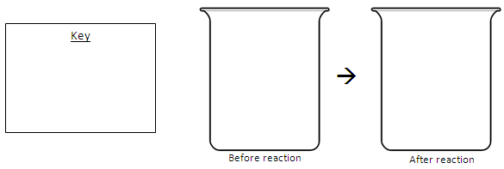
  - Draw particulate representations using three molecules of oxygen and four molecules of hydrogen.

  - Which reactant was limiting? _________ Excess? __________

- Sodium atoms react with water molecules to produce sodium hydroxide and hydrogen gas.
  - Balanced Chemical equation:
  - Draw particulate representations using two sodium atoms and three water molecules.

  - Which reactant was limiting? _________ Excess? __________
- Aluminum atoms combine with chlorine molecules to produce aluminum chloride.
  - Balanced Chemical equation:
  - Draw particulate representations of four aluminum atoms and three chlorine molecules.

  - Which reactant was limiting? _________ Excess? __________
- Potassium chloride reacts with silver oxide to produce potassium oxide and silver chloride.
  - Balanced Chemical equation:
  - Draw particulate representations of two molecules of potassium chloride reacting with two molecules of silver oxide.

Percent Composition Think Tank Problems

- The ingredients list for pretzels identifies 295mg of sodium is present in the serving size. But sodium is coming from sodium chloride, not pure sodium metal. Calculate the mass of chloride ions that must also be present in the serving of pretzels by completing each step below:
  - Calculate the percent of sodium in sodium chloride, NaCl, using molar masses from the periodic table.

  - Identify the mass of sodium, in grams, in the serving size.

  - Calculate the total mass of NaCl that must be present in the serving size.

  - Calculate the mass of chloride ions present in the serving size.

Percent Composition Check your Understanding

Determine the % composition of all elements in these compounds. Show all work!
1) sodium sulfide
Formula _______ %Na _________

Molar mass _______ %S _________

2) aluminum phosphide
Formula _______ %Al _________

Molar mass _______ %P _________

3) lithium bromide
Formula _______ %Li _________

Molar mass _______ %Br _________

4) calcium nitride
Formula _______ %Ca _________

Molar mass _______ %N _________
Empirical and Molecular Formulas Think Tank Questions

- Find the Molar mass and percent by mass of C, H and O in the following compounds:

 | Molar Mass | Percent C | Percent H | Percent O
Glucose C₆H₁₂O₆
Formaldehyde CH₂O
Sucrose C₁₂H₂₂O₁₁

- Glucose is a common sugar found in foods and beverages whereas formaldehyde is a preservative that can be carcinogenic in higher quantities. Sucrose is another sugar commonly found in plants, fruits and vegetables. Identify similarities and differences between the three compounds.

- Glucose has a ratio of 6C : 12H : 6O. Can this ratio be reduced? If so, what would the new reduced formula of glucose be?

- Formaldehyde has a ratio of 1C : 2H : 1O. Can this ratio be reduced? If so, what would the new reduced formula of glucose be?

- Identify the reduced formula of sucrose. These reduced formulas are known as their empirical formulas.

- Compare the empirical formulas of these three compounds.

- Dextrose is an artificial sweetener that has an empirical formula of CH₂O. Which compound is most alike?

Empirical and Molecular Formulas Check your Understanding
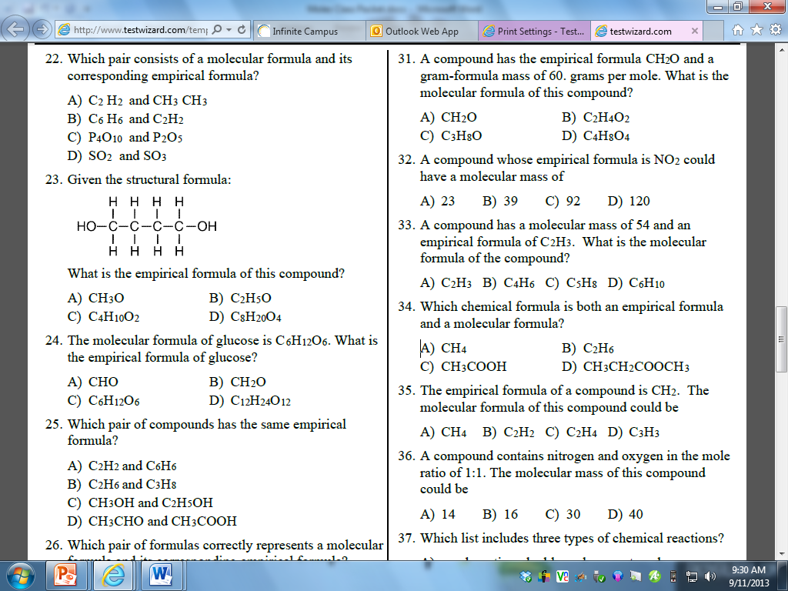
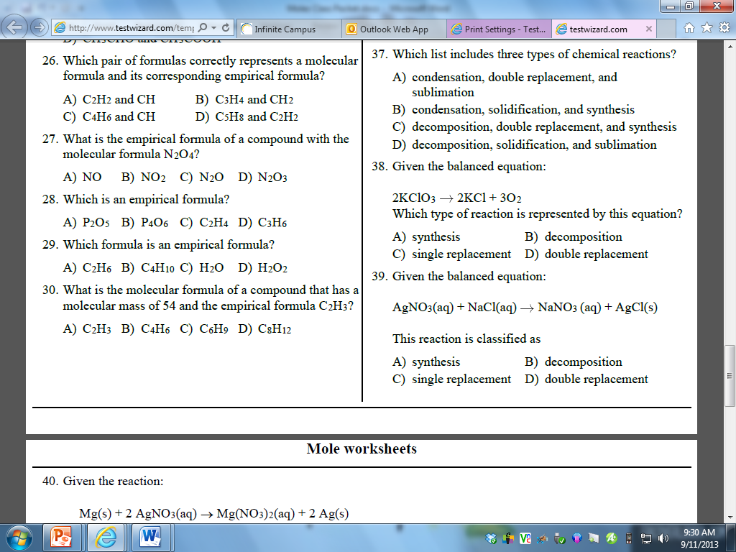
Honors Empirical Formulas Check your Understanding

- What are the empirical formulas for these compounds, that both contain five carbon atoms?
C₅H₁₀ C₅H₁₂

- A common oxide of nitrogen contains 25.93% N. Deduce the empirical formula of the oxide.

- A compound that is usually used as a fertilizer can also be used as a powerful explosive. The compound has the composition 35.00% nitrogen, 59.96% oxygen and the remainder being hydrogen. What is its empirical formula?

- A substance has an empirical formula of CH₂Br and a molar mass of 188 g mol⁻¹. What is the molecular formula of the compound?

- The common pain medicine, Advil, contains the active ingredient Ibuprofen that has a molar mass of 206 g mol-1. Ibuprofen contains 75.73% C, 8.74% H, the remainder being oxygen. What are the empirical and molecular formulas for Ibuprofen?

- The molar mass of the common antibiotic oxytetracycline is found to be 460 g mol-1 and a 2.000 g sample contains 1.1478 g of carbon, 0.10435 g of H, 0.62609 g of oxygen and the remainder being nitrogen. What is the molecular formula of the oxytetracycline?

Honors Ideal Gas Law Think Tank Problems

- Review the relationships below for an ideal gas:
  - Temperature and volume:

  - Temperature and internal pressure:

  - Volume and internal pressure:

- Identify the combined gas law from table T and record it:

- If more molecules of a gas are added to a flexible container, what is the relationship between moles and volume of a gas?

- If more molecules of a gas are added to a rigid container, what is the relationship between moles and internal pressure of a gas?

- Using the relationships you determine above, where will n (moles) be placed in the combined gas law?

- If 1.00 mole of a gas is placed in a 1.00 L container at STP, what is the reduced value of one side of the combined gas law?

- Using the value as the R (relationship between all gas variables) calculated above, determine the volume of 3.00moles of a gas at 2.00atm and 400C.
Honors Ideal Gas Law Check Your Understanding

- A 7.8g piece of solid carbon dioxide (dry ice) is placed in a 2.0L balloon at 27 degrees Celsius. What is the pressure in atmospheres in the container after all the carbon dioxide vaporizes? Is it sufficient to blow up the balloon (above standard pressure)?

- Using the Haber process to produce ammonia gas, an important fertilizer, you can obtain the greatest yield of ammonia at high temperatures and pressures, but it is dangerous, so lower T and P is used. Typically, the Haber process is performed at 500.°C and 250. atmospheres. Assuming the reaction goes to completion, what volume would ammonia occupy if 21.0g of ammonia is formed from hydrogen and nitrogen? N₂ + 3H₂ 🡪 2NH₃

- The Hindenburg exploded in 1937. It held 2.0x10⁵ m³ of hydrogen gas at 23C and standard pressure.
  - How many moles of hydrogen were present?

  - How many grams?

  - How many molecules?

  - How many atoms?

- A scuba diver's tank contains 0.29kg of oxygen compressed into a volume of 2.3L. What is the pressure in the tank at 9.0°C?

Moles for Gas Laws Review
Graham’s Law of Diffusion Check your Understanding
- At STP, which gas diffuses at the faster rate?
A) H2 B) N2 C) CO2 D) NH3
- Under the same conditions of temperature and pressure, which gas will diffuse at the slowest rate?
- He B) Ne C) Ar D) Rn
- Which gas would diffuse most rapidly under the same conditions of temperature and pressure?
A) gas A, molecular mass = 4 C) gas B, molecular mass = 16
B) gas C, molecular mass = 36 D) gas D, molecular mass = 49
- Arrange the following gas in order of increasing average molecular speed at 25C: He, O₂, CO₂, H₂O.

Avogadro’s Law Check your Understanding
- A sample of oxygen gas is sealed in container X. A sample of hydrogen gas is sealed in container Z. Both samples have the same volume, temperature, and pressure. Which statement is true?
  - Container X contains more gas molecules than container Z.
  - Container X contains fewer gas molecules than container Z.
  - Containers X and Z both contain the same number of gas molecules.
  - Containers X and Z both contain the same mass of gas.
- At the same temperature and pressure, 1.0 liter of CO(g) and 1.0 liter of CO2(g) have
  - equal masses and the same number of molecules
  - different masses and a different number of molecules
  - equal volumes and the same number of molecules
  - different volumes and a different number of molecules
- Each stoppered flask contains 2 liters of a gas at STP. Each gas sample has the same

  - Density B) mass C) number of molecules D) number of atoms

Dalton’s Law of Partial Pressures Check your Understanding
- What is the pressure of a mixture of CO2, SO2, and H2O, if each gas has a partial pressure of 25 kPa?
  - 25 kPa B) 50 kPa C) 75 kPa D) 101 kPa
- A flask contains a mixture of N2(g) and O2(g) at STP. If the partial pressure exerted by the N2(g) is 40.0 kPa, the partial pressure of the O2(g) is
  - 21.3 kPa B) 37.3 kPa C) 61.3 kPa D) 720 kPa
- The partial pressures of gases A, B, and C in a mixture are 0.750 atmosphere, 0.250 atmosphere, and 1.25 atmospheres, respectively. What is the total pressure of the gas mixture in kPa?
  - 2.25 kPa B) 202 kPa C) 228 kPa D) 301 kPa
- A mixture of oxygen, nitrogen, and hydrogen gases exerts a total pressure of 74 kPa at 0ºC. The partial pressure of the oxygen is 20 kPa and the partial pressure of the nitrogen is 40 kPa. What is the partial pressure of the hydrogen gas in this mixture?
  - 14 kPa B) 20 kPa C) 40 kPa D) 74 kPa
- A mixture of gases contains 0.75mol nitrogen, 0.30mol oxygen, and 0.15 mol of carbon dioxide. If the total pressure is 2.3atm, what are the partial pressures?
Molarity Think Tank Questions

- Molarity is one way to calculate concentration, or the amount of “small stuff” in your “total stuff.” Define molarity in scientific terms using reference table T:

- How is a 1.00M solution of salt water, NaCl(aq), created?

- How is a 2.00M solution of salt water different from a 1.00M solution of salt water?

- The diagram below represents a 1.00M solution of NaCl, where water is in the background and not drawn for clarity. Draw a new model that represents a 2.00M solution of NaCl in the same volume. Then draw 1.00M and 2.00M MgCl₂ solutions.
1M NaCl | 2M NaCl | 1M MgCl₂ | 2M MgCl₂

- Describe what is happening to the number of particles of salt and water in the solutions as the molarity is increasing.

- I made a 1.8M solution of kool aid and it was too weak, not sugary enough for me! How can you increase the concentration, or Molarity, of a solution?

- A student made a 3.00M solution of lemonade and it was too strong, way too sour! How can you increase the concentration, or Molarity, of a solution?

Molarity Check your Understanding

- Calculate the molarity of each of the following solutions:
  - 2.50 mol of NaOH in 0.500 L of solution c. 1.80L containing 3.30mol KNO₃

  - 7.50 mol of NaOH in 500.mL of solution d. 0.00800 mol of K₂SO₄ in 1500.mL

- Calculate the total moles of solute in each of the following solutions:
  - 1.70L of 0.350M NaOH c. 0.0500 L of 3.30-molar KNO₃

  - 500.mL of 1.25 M NaOH d. 116 mL of 1.50 M K₂SO₄

- Find the Molarity of the following solutions:
  - 80.0 grams of NaOH in 1.50 liters of solution.

  - 101 grams of KNO₃ in 50.0L of solution.

- Find the mass needed for each solution:
  - A solution of 1.00L of 2.00M NaCl

  - A solution of 0.500L of 3.00M NaOH

- A saline drip is required to hydrate a patient in a hospital. 9.00g of NaCl is added to 1000mL of water in the IV bag. Calculate the molarity of the saline.

- Two solutions are made, 80.0g of NaOH in 2.00L and 58.5g of NaCl in 1.00L solution. Compare their concentrations.

Dilutions Think Tank Problems

- Draw a models that represent:
  - a 1.00M solution of KI in 1.00L of water.
  - the KI solution above when 1.00L of water is added for a final volume of 2.00L

- What is the new molarity of the KI solution?

- A solution of 2.00L of 5.00M HCl is found in the lab storage room. The Molarity is too strong for the lab. Calculate the amount of water needed to add to the solution in order to obtain a 2.50M solution.

- A solution of 125mL of 10.0M NaOH is available. An additional 200mL of water is added to dilute the NaOH. What is the new Molarity?

Dilutions Check your Understanding
- Calculate the volume of 3.00 M nitric acid that must be diluted with water to produce 1.50 L of 0.750 M

- Calculate the volume of 6.00 M hydrochloric acid that must be diluted with water to produce 2.00 L of 1.75 M hydrochloric acid.

- Calculate the volume of 5.00 M KOH that must be diluted with water to produce 355 mL of 0.250 M

- Calculate the final volume of 3.00 M sulfuric acid when 1.50L of 6.00M sulfuric acid is diluted.

- A student is given 2.00L of 5.00M NaOH and must dilute to create a 1.25M solution of NaOH. Calculate the amount of water that must be added to the original solution.

Percent By Mass in Solutions Check your Understanding

- Percent by mass is an additional way to calculate the “small stuff” in your “total stuff.” Explain percent by mass in chemical terms using Table T:

- Calculate the percent by mass of the following solutions:
- 50.0 grams of solute in 200.0 grams of solution
- 25.0 grams of solute in 150.0 grams of solution
- 15.0 grams of NaCl in 250.0 grams of solution
- 10.0 grams of KI in 1000.0 grams of solution
- 2.0 grams of solute in 2000.0 grams of water
- 0.500 grams of solute in 150.0 grams of water
- 0.250 grams of NaBr in 125.0 grams of water
- 0.0125 grams of O₂ in 25,000,000.0 grams of water
- What could be a better unit to express your previous answer?

Parts PerMillion Think Tank Problems
- Parts per million is another concentration unit. Compare and contrast ppm with percent by mass using Table T.

- Explain what per-“cent” means as a ratio of solute and solution.

- Explain what parts per-“million” means as a ratio of solute and solution.

- Describe the image below as if explaining what it means to a friend.
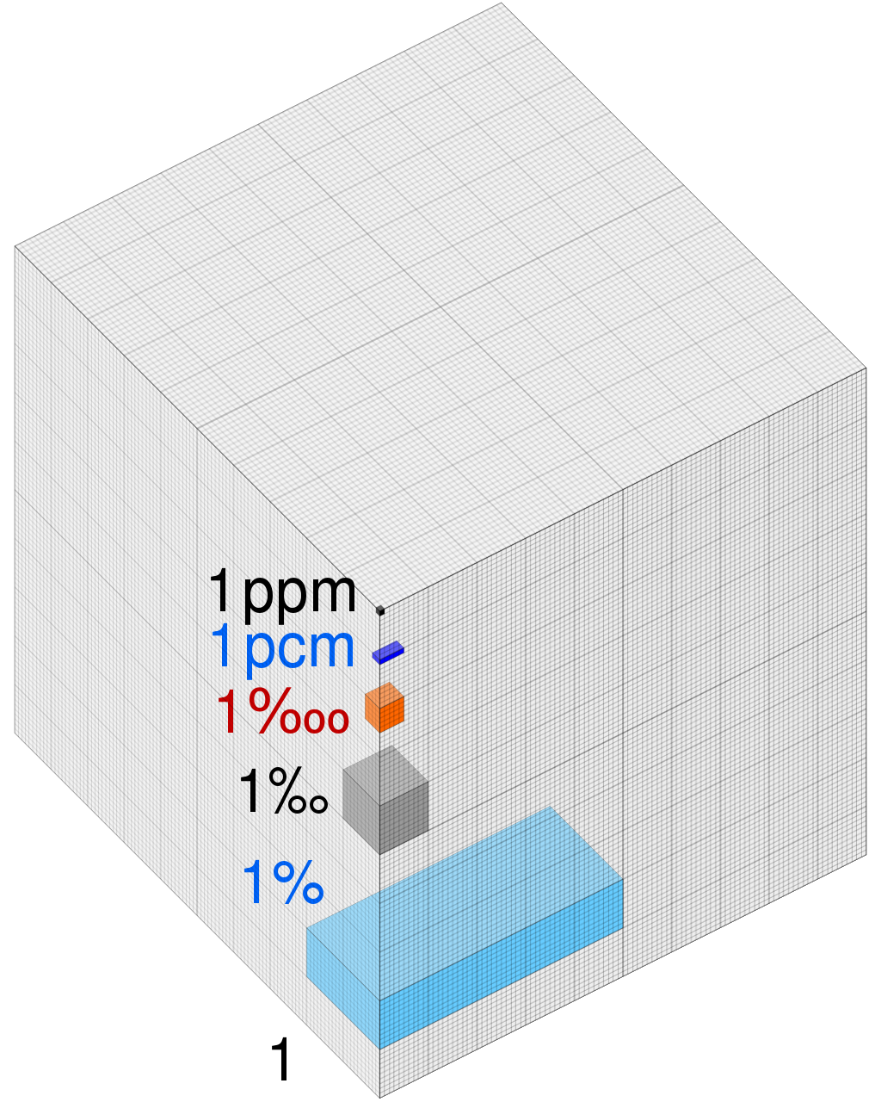

- How many more boxes would you need to fill in to create a 3 ppm image above?

- How many more boxes would you need to fill in to create a 3% image above?

- Two solutions are created: 10% salt solution by mass and 10 ppm salt solution.
  - Which has more total mass?

  - Compare the amount of salt dissolved in each solution.

  - Which is more concentrated?

Parts Per Million Check your Understanding

- Exposure to lead has been linked to delays in physical and mental development and attention deficit disorders in children as well as kidney problems in adults. One source of this toxic heavy metal is drinking water in older homes whose plumbing contains lead. Water with a lead concentration of below 0.015ppm is considered safe to drink. A 100 g water sample taken from a home contains 1.2 x 10⁻⁶ grams of lead. Is this water considered safe to drink? You must include a correct numerical setup, the calculated result, and a statement.

- The health of fish depends on the amount of oxygen dissolved in the water. A dissolved oxygen (DO) concentration between 6 parts per million and 8 parts per million is best for fish health. A DO concentration greater than 1 part per million is necessary for fish survival. Fish health is also affected by water temperature and concentrations of dissolved ammonia, hydrogen sulfide, chloride compounds, and nitrate compounds. A student’s fish tank contains fish, green plants, and 3800 grams of fish-tank water with 2.7 x 10⁻² g of dissolved oxygen.
  - State how an increase in the temperature of the fish-tank water affects the solubility of oxygen in the water.

  - Determine if the DO concentration in the fish tank is healthy for fish. You must include a correct numerical setup, the calculated result, and a statement.

  - Explain, in terms of molecular polarity, why oxygen gas has low solubility in water. Your response must include both oxygen and water.

  - Under what kind of conditions of temperature and pressure would oxygen gas be most soluble in water?

  - An aqueous solution has a concentration of 7 ppm of oxygen dissolved in 1000. grams of water. Calculate the amount of oxygen in the solution in grams. Your response must include both a correct numerical setup and the calculated result.

Colligative Properties Think Tank Problems

- When it snows, the town puts down salt to make the snow melt.
  - Explain the relationship between the amount of salt used and the rate at which the snow melts.

  - Sugar cannot be used to melt the snow as effectively. Compare the bonds in table salt and sugar.

  - Draw a model to show what happens when salt dissolves in water.
  - Draw a second model to show what happens when sugar dissolves in water.
salt | sugar
  - Try to determine why salt is better at melting the snow than sugar.

  - What is the maximum temperature it can be outside to still have snow on the ground not melting?

  - What must the salt be doing to the melting point of the snow as it dissolves?

- To make rock candy you must dissolve a lot of sugar in water and create a supersaturated solution.
  - What happens to the solubility of most solids as the temperature of a solution increases? Use Table G to review your answer.

  - What is the boiling point of pure water?

  - As the temperature reaches the boiling point, the sugar increases the boiling point average. Will more or less sugar be able to dissolve at the higher temperature?

Colligative Properties Check your Understanding

- Draw particle models for the following solutions. Circle the solution that creates the most particles.

2M KCl (aq) 2M NaNO₃ (aq) 1M CO₂ (aq) 1M CaCl₂ (aq)

- Which solution has the highest boiling point?
  - 2M KCl b. 2M NaNO₃ c. 1M CO₂ d. 1M CaCl

- Compared to pure water, an aqueous solution of calcium chloride has a
  - higher BP and higher FP c. lower BP and higher FP
  - higher BP and lower FP d. lower BP and lower FP

- Which solution has the highest boiling point?
  - 1.0 M KNO₃ b. 1.0 M Ca(NO₃)₂ c. 2.0 M KNO₃ d. 2.0 M Ca(NO₃)₂

- Which solution has the lowest freezing point?
- 10. g of KI dissolved in 100. g of water c. 20. g of KI dissolved in 200. g of water
- 30. g of KI dissolved in 100. g of water d. 40. g of KI dissolved in 200. g of water

- As water is added to a 0.10 M NaCl aqueous solution, the conductivity of the resulting solution
  - decreases because the concentration of ions decrease
  - decreases, but the concentration of ions remains the same
  - increases because the concentration of ions decreases
  - increases, but the concentration of ions remains the same

- Which aqueous solution of KI freezes at the lowest temperature?
  - 1 mol of KI in 500. g of water c. 1 mol of KI in 1000. g of water
  - 2 mol of KI in 500. g of water d. 2 mol of KI in 1000. g of water

- Compared to a 2.0 M aqueous solution of NaCl, a 3.0 M aqueous solution of NaCl has a
- lower BP and a higher FP c. higher BP and a higher FP
- lower BP and a lower FP d. higher BP and a lower FP

8. Using Reference Table F, which of these saturated solutions has the lowest concentration of dissolved ions?
- NaCl(aq) b. MgCl₂(aq) c. NiCl₂(aq) d. AgCl(aq)
Review

 | Key Idea Question | Justify your answer  with an explanation or calculation. | Confidence Level  None Moderate Fully  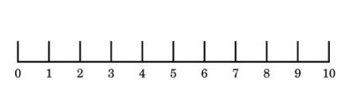
1 | What is the gram formula mass of Ca₃(PO₄)₂?  a. 279 g/mol c. 310 g/mol  b. 87 g/mol d. 168 g/mol |  | Pre-discussion:  Post discussion:
2 | What is the empirical formula of N₂O₄?  a. NO c. NO₂  b. N₂O₄ d. NO₃ |  | Pre-discussion:  Post discussion:
3 | What is a possible mass of a compound with the empirical formula CH₄?  a. 12 g/mol c. 24 g/mol  b. 48 g/mol d. 20 g/mol |  | Pre-discussion:  Post discussion:
4 | According to the reaction, what is the ratio of hydrogen to oxygen?  2H₂ + O₂ 🡪 2H₂O  - 2 mol:1 mol c. 2g : 1g  - 1mol:2mol d. 1g: 2g |  | Pre-discussion:  Post discussion:
5 | What is the percent by mass of nitrogen in N₂H₄?  - 44% c. 13%  - 88% d. 78% |  | Pre-discussion:  Post discussion:
6 | Calculate the number of moles equal to 128.2 grams of P₂O₅. |  | Pre-discussion:  Post discussion:
7 | Identify the types of reactions:  N₂ + O₂ 🡪 2NO  CuO₂ 🡪 Cu + O₂  Ca(NO₃)₂ + 2Li 🡪 2LiNO₃ + Ca  2NaCl + Pb(NO₃)₂ 🡪 NaNO₃ + PbCl₂ |  | Pre-discussion:  Post discussion:
8 | 78 grams of K reacts with 60 grams of MgF₂ and forms 58 grams of potassium fluoride. How many grams of magnesium are formed? |  | Pre-discussion:  Post discussion:
9 | 2.5 grams of a hydrate is heated to form 1.75 grams of the anhydrate. Calculate the mass of water in the original hydrate. |  | Pre-discussion:  Post discussion:
10 | Balance the reaction:  ___ N₂ + ___ H₂ 🡪 ___NH₃ |  | Pre-discussion:  Post discussion:
11 | When added to water, which of the following substances will raise the boiling point of the water the most?  - KI b. CH₄ c. MgCl₂ |  | Pre-discussion:  Post discussion:
12 | Which of the following could be a precipitate in a double replacement reaction?  - KNO₃ c. PbI₂  - NH₄Cl d. Ca(OH)₂ |  | Pre-discussion:  Post discussion:
13 | Describe how polarity can be used to determine solubility in water. |  | Pre-discussion:  Post discussion:
14 | Calculate the percent by mass of a solution containing 34g of KF dissolved in 250g of water. |  | Pre-discussion:  Post discussion:
15 | A solution of salt (NaCl) is created using 78g of solute dissolved in 300mL of solution. Calculate the molarity. |  | Pre-discussion:  Post discussion:

Common Sense Chemistry Review

- A platinum ore site in Canada was discovered and everyone heads out to make some money. You obtain 8.25kg of platinum arsenide. Assuming you know how to extract the platinum and sell it, how much money can you make? PtAs₂ 🡪 Pt + 2As
  - What type of reaction will you carry out to extract the platinum?

  - Calculate the moles of PtAs₂ recovered.

  - Calculate the moles of Pt formed.

  - Calculate the grams of Pt formed.

  - You get a buyer that will pay $32 per gram. How much money will you make?

- Your brother left his bike out in the back yard all winter and it has a red coating on it. What is the empirical formula and IUPAC name of the compound formed on the bike? Fe + O₂ 🡪 _________________
- What type of reaction occurred in question 3?

- You are asked to create acetaminophen, the main component for Tylenol, C₈H₉NO₂. You follow procedures dutifully and weigh your final product. It weighs 453 g/mol. What is the molecular formula of the compound you’ve made? Is the product you formed safe to use in Tylenol?

- The following are common names for compounds. Give the IUPAC name:
  - Baking soda NaHCO₃
  - Bleach NaClO
  - Chalk CaCO₃
  - Lime CaO
  - Water H₂O
- A student wants to brine this holiday turkey with poultry salt, potassium chloride. If the student is using 400mL of water and boiling the water at atmospheric pressure, how much potassium chloride should initially saturate the solution? (Side question: Why “initially”? What happens to the solubility of the salt and the boiling point of the water as the salt is added?)

- Farts can be deadly. Farts contain hydrogen sulfide gas, which as concentrations of 15 ppm or greater, can be toxic. What volume of hydrogen sulfide gas must be present in the fart if the total fart has a volume of 90mL?

- Certain water based solutions do not freeze in the freezer at water's normal freezing point such as alcohols and sodas. How do these solutions resist freezing?

- Like many developing countries, Vietnam is plagued by poor water quality. Millions of the country's inhabitants still lack access to clean drinking water, largely because local companies can't afford expensive filtration systems to treat wastewater. A team of scientists has found that pouring metal and acid-laden water over a bed of crushed clam or mussel shells provides an easy fix. The shells are made of aragonite, a form of calcium carbonate (CaCO₃).Explain how the carbonate and heavy metals in the water such as Mercury, react and can be eliminated from the drinking water.

- A safe level of fluoride ions is added to many public drinking water supplies. Fluoride ions have been found to help prevent tooth decay. Another common source of fluoride ions is toothpaste. One of the fluoride compounds used in toothpaste is tin (II) fluoride. A town located downstream from a chemical plant was concerned about fluoride ions from the plant leaking into its drinking water. According to the Environmental Protection Agency, the fluoride ion concentration in drinking water cannot exceed 4 ppm. The town hired a chemist to analyze its water. The chemist determined that a 175-gram sample of the town’s water contains 0.000 250 gram of fluoride ions. How many parts per million of fluoride ions are present in the analyzed sample? Is it safe?

