Key Ideas
- Compounds can be differentiated by their chemical and physical properties. (3.1dd)
- Two major categories of compounds are ionic and molecular (covalent) compounds. (5.2g)
- Chemical bonds are formed when valence electrons are transferred from one atom to another (ionic), shared between atoms (covalent), mobile within a metal (metallic). (5.2a)
- In a multiple covalent bond, more than one pair of electrons are shared between two atoms. (5.2e)
- Molecular polarity can be determined by the shape of the molecule and the distribution of charge. Symmetrical (nonpolar) molecules include CO₂, CH₄, and diatomic elements. Asymmetrical (polar) molecules include HCl, NH₃, and H₂O. (5.2l)
- When an atom gains one or more electrons, it becomes a negative ion and its radius increases. When an atom loses one or more electrons, it becomes a positive ion and its radius decreases. (5.2c)
- When a bond is broken, energy is absorbed. When a bond is formed, energy is released. (5.2i)
- Atoms attain a stable valence electron configuration by bonding with other atoms. Noble gases have stable valence configurations and tend not to bond. (5.2b)
- Physical properties of substances can be explained in terms of chemical bonds and intermolecular forces. These properties include conductivity, malleability, solubility, hardness, melting point, and boiling point. (5.2n)
- Electron-dot diagrams (Lewis structures) can represent the valence electron arrangement in elements, compounds, and ions. (5.2d)
- Electronegativity indicates how strongly an atom of an element attracts electrons in a chemical bond. Electronegativity values are assigned according to arbitrary scales. (5.2j)
- The electronegativity difference between two bonded atoms is used to assess the degree of polarity in a bond. (5.2k)
- Metals tend to react with nonmetals to form ionic compounds. Nonmetals tend to react with other nonmetals to form molecular (covalent) compounds. Ionic compounds contain polyatomic ions have both ionic and covalent bonding. (5.2h)
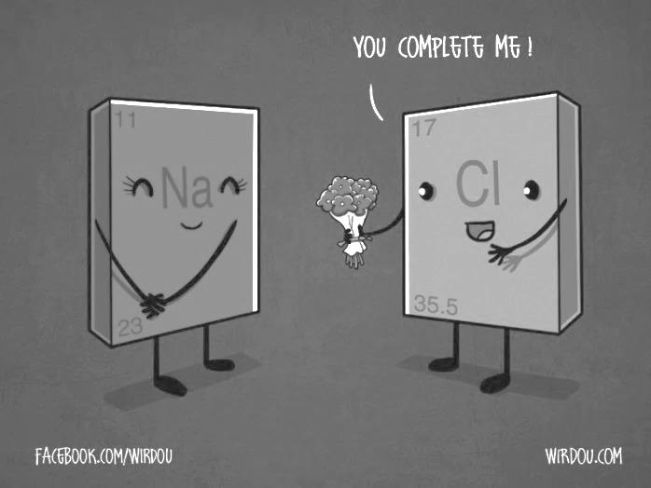
Introduction to Bonding

SUBSTANCE GROUP #1:

For each of the following substances, place the symbol of the first element in its spot on the periodic table using red ink. Then, place the symbol of the second element in the substance in its spot on the periodic table using black ink.
NaCl LiBr KF ZnCl₂ Fe₂O₃ CuI₂ Al₂S₃

QUESTIONS FOR SUBSTANCE GROUP #1:
- Where are all the first elements located on the periodic table (red symbols)?

- Based on your knowledge about the periodic table, what “classification” would you give these elements? Metal or Non-Metal?

- Where are all the second elements located on the periodic table (black symbols)?

- Based on your knowledge about the periodic table, what “classification” would you give these elements? Metal or Non-Metal?
SUBSTANCE GROUP #2

For each of the following substances, place the symbol of the first element in its spot on the periodic table using a red ink. Then, place the symbol of the second element in the substance in its spot on the periodic table using black ink.
CCl₄ P₂O₅ N₂O₄ NI₃ PBr₃ F₂Se

QUESTIONS FOR SUBSTANCE GROUP #2:
- Where are all the first elements located on the periodic table (red symbols)?

- Based on your knowledge about the periodic table, what “classification” would you give these elements? Metal or Non-Metal?

- Where are all the second elements located on the periodic table (black symbols)?

- Based on your knowledge about the periodic table, what “classification” would you give these elements? Metal or Non-Metal?
TYING IT TOGETHER:
- Group 1 substances are called ionic compounds and Group 2 substances are called covalent molecules. Write a simple rule that will allow you to classify compounds as ionic or covalent on the basis of what you have learned from the model.

- Did the subscripts (the little numbers shown in the compound formulas) provide any insight into determining whether a substance is ionic or covalent? Why or why not?

ELEMENT EVALUATION:
Fill in the following tables identifying the type of element present in the substance. Use “M” for metal, and “NM” for non-metal.

FORMULA | 1ST ELEMENT (M or NM) | 2ND ELEMENT(M or NM) | CLASSIFICATION  (Ionic or Covalent?)
NaBr
SF₆
CoBr₂
BaS
NO₂
C₆H₆
CrCl₃
CO₂
MnO₂
PbCl₂
OF₂
CsF

Types of Bonds
Complete the Venn diagram below with properties of ionic and Covalent Bonds:
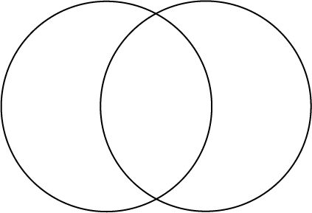
Covalent Bonds
Ionic Bonds

Bonds formed between two nonmetals are _______________ and involve the ____________ of electrons.
Bonds formed between two metals are _______________ and involve the ____________ of electrons.
Bonds formed between metals and nonmetals are ____________ and involve the ___________ of electrons.
Describe the following as ionic, metallic, or covalent:
NaCl _____ Al _____ Lithium _____
CO₂ _____ C₆H₁₂O₆ _____ Strontium bromide _____
Au _____ Ti _____ Tin (II) chloride _____
MgBr₂ _____ K₂O _____ Nitrogen (IV) oxide _____
Fe _____ CH₄ _____ Hydrogen selenide _____
H₂O _____ H₂S _____ Copper (II) phosphate _____
Ca₃(PO₄)₂ _____ PI₃ _____ Lead (IV) nitrate _____
Geometry of the Ionic Crystals Introduction
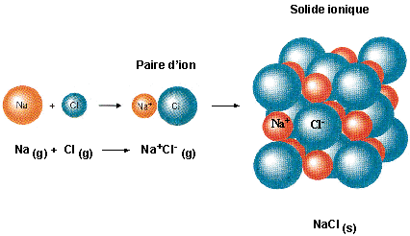
- What is the electrical charge on the Na and Cl atoms in these crystals?
- The diagrams only show a portion of the crystal. What is the entire crystals’ charge?
- What force holds the crystals together?
- Can you identify any specific, singular NaCl molecules in the crystal? Why?
- NaCl is shaped like a cube. Would BaCl₂ be shaped the same? Why?
- Ionic crystals are hard, shatter easily and are bad conductors with high melting points. Contrast ionic crystals with metallic crystals.

Ionic Compound Review
All compounds form because elements want to form a stable _____________ of valence electrons.
Ionic compounds form when __________ and _____________ ________________ electrons.
An example of an ionic crystal found at home is: ________________________________
Circle the properties of ionic compounds:
Hard or soft High or Low melting point Crystalline or not crystalline
Transfer or share High or Low boiling point Conductive or nonconductive
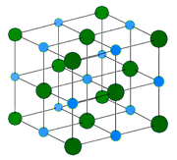
Ionic Lewis Structures Introduction
Element | Metal or Nonmetal? | Lewis Dot Structure  as an ATOM | Gain or lose electrons? | How many e⁻? | Lewis Dot Structure  of Stable ION | Becomes like which noble gas?
Fluorine
Lithium
Aluminum
Sulfur
Radium
Phosphorous

Using your chart, draw Lewis structures for the following compounds:
Lithium Phosphide
Lithium Sulfide
Lithium Fluoride
Radium Phosphide
Aluminum Phosphide
Radium Sulfide
Aluminum Sulfide
Radium Fluoride
Aluminum Fluoride
Summarize:
-Why do metals bond with nonmetals?

-What determines how many atoms of the metal and nonmetal will combine to form the compound?
Lewis Dot Structures Practice
How many valence electrons do cations show in the Lewis dot diagrams? ____ anions? ____
Draw the following ionic compounds and give their formula and/or name:
Lewis Diagram | Formula | Lewis Diagram | Name
Sodium fluoride |  | CsCl
Potassium oxide |  | MgO
Rubidium nitride |  | SrI₂
Calcium bromide |  | BaS
Strontium sulfide |  | Fe₂O₃
Magnesium phosphide |  | Ag₂S
Aluminum iodide |  | CuO
Copper (I) sulfide |  | NiCl₃
Chromium (III) nitride |  | TiO₂
Manganese (IV) oxide |  | PtCl₂
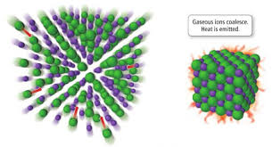
Lattice Energy
Ionic bonds contain cations and anions that have _________________ electrons and attracted each other due to their __________ charges. The strength of the ionic bond is largely due to the lattice energy. Lattice Energy is the energy released when gaseous ions create a solid ionic compound. Lattice energy depends on the charge and radii of the ions. The lattice energy will be a large value if the charges are _____________ and the radii are ___________, making the ionic compound stronger.
- Why will ionic compounds formed with large positive and large negative ions be stronger than those formed with +1 and -1 ions?

- Why will ionic compounds formed with smaller cations and anions be stronger than those formed with large ions?

- Which is more important: the ionic charge or the radii? Why?

- Draw a particle view (ions attracting) to describe your answers to questions 1-3.

- Circle the compound in each set that has a stronger ionic bond. Explain your answer.
  - LiF versus KF
  - CaO vesus MgO
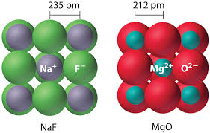
  - Li₂O versus LiCl
  - AlCl₃ versus LiF
- Describe which lattice will have a higher lattice energy
in the picture on the right.

Properties of Bonds Review
1. Use information in the table below to identify each compound as Ionic or Covalent Compounds.
Compound | Phase at Room Temperature | Conductivity as a pure solid | Conductivity as a liquid  (aq or molten) | Melting Point | Ionic or Covalent
A | solid | no | yes | 1049ºC
B | solid | no | no | 223ºC
C | liquid | no | no | 20ºC
D | solid | no | yes | 378ºC
E | liquid | no | no | -94ºC
F | solid | no | yes | 650ºC

List the properties of Ionic compounds: _________________________________________________________
List the properties of Covalent compounds: ______________________________________________________
2. For each example, check if it describes breaking or forming bonds:
 | Breaking bonds | Forming bonds
The stability of the system increases
N₂ N + N
Endothermic
I + I I₂
The stability of the system decreases
Exothermic

3. For each example provide the molecule, bond and determine when and if it conducts electricity:
 | Type of Bond  (Metallic, ionic, covalent, both ionic and covalent) | Type of Molecule  (metallic, ionic, molecular) | Conducts electricity?  (check all that apply)  No (s) (l) (aq)
- Li₂O
- AlCl₃
- F₂
- CH₄
- HI
- Fe
- Na₃PO₄
- CaO
- C (diamond)
- C (graphite)
- H₂
- Na
- NH₄Br
- KNO₃
- O₃
- SiO₂
- NH₃
- FeBr₂
- Hg
- CO₂

4. Indicate which type of substance is described by each statement.
 |  | Type of substance
a. | Can conduct electricity in the solid and liquid phases
b. | A soft substance whose atoms are held together by covalent bonds
c. | Low melting point and poor electrical conductor
d. | Can conduct electricity when aqueous or molten (liquid)
e. | Can be polar or nonpolar
f. | Can dissolve in water to produce mobile ions

- Explain the following in terms of charged particles:
  - liquid mercury is a good electrical conductor

  - molten NaCl conducts electricity while solid NaCl does not

  - an aqueous solution of KBr conducts electricity while solid KBr does not

  - CH₄ is a poor electrical conductor

Covalent Lewis Dot Diagrams Introduction

1. All nonmetals (with the exception of H and He) will have between ______ and _____ valence electrons. Nonmetals tend to ________ valence electrons to obtain a stable octet. When two nonmetals react they form _________________ bonds. Draw Lewis dot diagrams for the following species:
F Cl Br I O S

Se Te N P C

2. Can these atoms create ionic bonds with one another? Will they transfer electrons to one another? Why or why not?

3. If these nonmetals need 8 valence electrons to become stable, how can they obtain electrons other than transferring electrons to one another? (Think about what you would do in your life if you needed a pencil for a lab but only one member of the lab group had a pencil.)

4. Show how a fluorine atom might bond with a chlorine atom in order for them both to obtain an octet.

5. Show how a fluorine atom might bond with an iodine atom in order for them both to obtain an octet. How is this similar to fluorine bonding with chlorine?

6. Show how a fluorine atom might bond with an oxygen atom in order for them both to obtain an octet. Compare this bond with the previous bonds.

Covalent Lewis Dot Diagrams
Compound | Total valence electrons | Lewis Diagram | Shape | Shared pairs | Unshared pairs | Bond Angle
H₂
F₂
O₂
H₂O
OF₂
NH₃
BCl₃
CH₄
SiF₄
SCl₂
CCl₄
AsF₃
Compound | Total valence electrons | Lewis Diagram | Shape | Shared Pairs | Unshared Pairs | Bond Angle
N₂
H₂S
SiBr₄
PH₃
Cl₂
BF₃
HF
H₂Te
I₂
CI₄
CO₂
HCN

Covalent Lewis Diagrams Summary
- Compounds with 2 atoms are always ___________________shaped.
- Compounds with 3 atoms are either _____________ or ________ shaped.
- What determines which shape the molecule will take? ______________________________________
- Compounds with 4 atoms are ______________________ shaped.
- Compounds with 5 atoms are ____________________ shaped.
- Single bonds share _____ electrons and are the ______________ bonds.
- Double bonds share _____ electrons.
- Triple bonds share _____ electrons and are the ______________ bonds.
- Halogens always bond _______ time(s) because they have _____ valence and need ____ electrons to fill the valence.
- Chalcogens (oxygen’s group) always bond _______ time(s) because they have _____ valence and need ____ electrons to fill the valence.
- Nitrogen’s group always bond _______ time(s) because they have _____ valence and need ____ electrons to fill the valence.
- Carbon’s group always bond _______ time(s) because they have _____ valence and need ____ electrons to fill the valence.
- Hydrogen always bonds _______ time(s) because they have _____ valence and need ____ electrons to fill the valence.
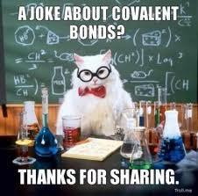

Bond Polarity Introduction
1 2 13 14 15 16 17 18
In the empty spaces of the chart above, fill in the element symbols and electronegativity values. Notice the transition metals are absent.
- Electronegativity values generally _______________ down a group and ____________ across a period.
- Metals tend to have ____________ electronegativity values and nonmetals are _____________ values.
- When lithium bonds with fluorine they form an ________________ bond.
  - What is the electronegativity difference of lithium and fluorine that might help characterize the properties they have? _____
  - List some of the properties:

- When fluorine bonds with another fluorine atom they form a ________________ bond.
  - What is the electronegativity difference of the two fluorine atoms that might help characterize the properties they have? _____
  - List some of the properties:

- When hydrogen bonds with fluorine atom they form a ________________ bond.
  - What is the electronegativity difference of the hydrogen and fluorine atoms that might help characterize the properties they have? _____
  - List some of the properties:
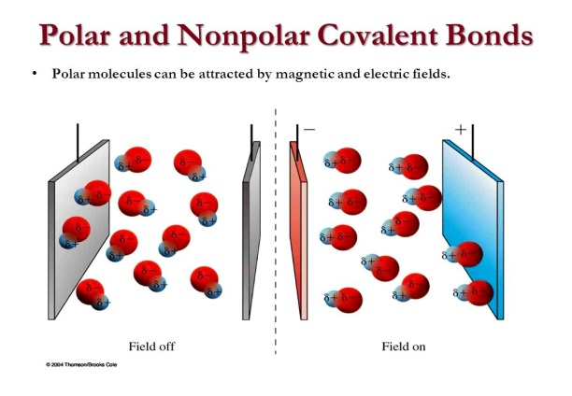
- HF and F₂ are both ________ compounds, but they actually have some slightly different properties. F₂ is not attracted to an electromagnetic field, where HF is. HF has a high boiling point, but F₂ is very low. Based on the information you obtained so far, what characteristic might cause these differences?

Bonding Rules:
- All diatomic elements such as ____, will have an electronegativity difference of ____ and have low boiling points and weak attractions with one another. These will be considered nonpolar covalent compounds. Since both atoms have the same electronegativity value, they share the electrons equally.
- Compounds created using nonmetals that have the same electronegativity value such as ____ and ____ will also be nonpolar covalent compounds. Since both atoms have the same electronegativity values, they share the electrons equally.
- Compounds created using nonmetals with similar electronegativity values in which the difference rounds to zero, (0-0.4) such as elements ____ and ____ will also be nonpolar covalent compounds. Since both atoms have similar electronegativity values, they share the electrons equally.
- Compounds created using nonmetals with different electronegativity values in which the difference rounds to one, (0.5-1.4) such as elements ____ and ____ will have higher boiling points and attract to each other more. These will be known as polar covalent compounds. Since the atoms have different electronegativity values, they share the electrons unequally; the ____(more/less) electronegative element wil have the electrons more of the time and obtain a slightly ____ charge.
- Compounds created using metals and nonmetals will have large electronegativity differences in which the difference rounds to two, such as elements ____ and ____. These will be known as ionic compounds.

- Fill in the chart below:
Electronegativity Difference | Type of Bond
0.0-0.4
0.5-1.4
1.5-4.0

Using your table above find the electronegativity difference for each substance. If more than one bond is formed, find all differences. Then, check which bonds are present.

Substance | Electronegativity difference(s) | Ionic | Covalent | Polar | Nonpolar
I₂
PCl₃
SiO₂
Br₂
CO₂
NaCl
CH₄
N₂O₅
NH₃
KCl
NaNO₃
KClO₃
Ca(ClO₃)₂

Bonding Polarity Practice

- Indicate which atom will have the positive charge and which will have the negative charge in the following polar bonds:
H-Cl H-F S-F N-O
- Organize the following in order from least to most polar bonds: HCl, HF, H₂O, NH₃, HI

- Identify and explain each bond drawn below:
 | Type of Bond | Explanation

- For each statement check if it describes ionic, polar covalent, nonpolar covalent, or metallic bonds:
 | Ionic | Polar Covalent | Nonpolar Covalent | Metallic
A transfer of electrons between two atoms
Positive nuclei dispersed in a sea of mobile electrons
Metals and nonmetals bonding
One atom loses, and another atom gains electrons
Two atoms share electrons equally
Metals bonding only
Electronegativity differences under 0.4
A bond resulting from electrostatic charges between opposite charged particles
Two atoms share elecrons unequally
Nonmetals bonding only
Electronegativity differences over 1.7
Molecular Polarity
Fill in the chart below.

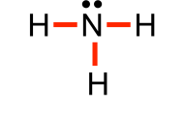
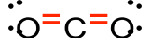
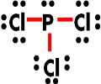
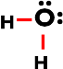
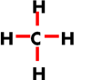

Molecule
Distribution of charge? (symmetrical or asymmetrical)
- In terms of lone pair electrons, how can you determine if a molecule is polar?

- What molecular shapes are always polar?

- What molecular shapes are always nonpolar?

- How can a molecule be nonpolar if it contains polar bonds?

Go back to the Covalent Lewis diagrams you drew on pages 9 and 10. Determine if the molecules were polar or nonpolar and place P or NP in the margin to the left of the name.

Molecular Polarity (polar or nonpolar molecule)
Molecular Shape (linear, pyramidal, tetrahedral, or bent)
Bond Polarity (polar or nonpolar covalent)

Bond Energy Introduction
- When bonds are formed, the new substance is ____(more/less) stable and therefore the reaction will _______(absorb/release) energy.
- When bonds are broken, the new substances are ____(more/less) stable and therefore the reaction will _______(absorb/release) energy.
- When energy is released the value is ___(+/-) and labeled _________________(endo/exo)thermic.
- When energy is absorbed the value is ___(+/-) and labeled _________________(endo/exo)thermic.

Bond Energy Practice
For each of the reactions, draw the structure of the compounds and then find the change in enthalpy of reaction (ΔHrxn). Assume all elements and compounds are in the gas phase unless noted otherwise.
- H₂ + Cl₂ 2HCl

- N₂ + 3H₂ 2NH₃

- N₂H₄ + 2F₂ N₂ + 4HF

Bond Order
- Which species used above has the highest bond order? Why?

- Which species used above has the shortest bond length? Explain your answer.

- Compare the bond strengths of N₂ and H₂. Justify your answer.
Intermolecular Forces Notes
Define the words to complete the following chart:
London Dispersal:

Strength:

Example:

Dipole-Dipole:

Strength:

Example:
Hydrogen “Bonds”:

Strength:

Example:
Ion- Dipole:

Strength:

Example:
Covalent Bonds:

Properties:

Example:
Metallic Bonds:

Properties:

Example:
Ionic Bonds:

Properties:

Example:

Intermolecular Forces:
Intramolecular Forces:
Compound:

Intermolecular Forces
 | London Forces/VDW | Dipole Forces | Hydrogen Bonds
Type of molecule
Strength
Example

- Generally, all physical changes involve changes ____________________ and chemical changes involve changes in _____________________________.

Use forces to explain the following phenomenon:
- List the noble gases with their boiling points in order. They all do not bond, so why are they not all the same value?

- Why does gasoline (C₈H₁₈) remain in the liquid phase but our Bunsen burner gas made out of the same elements (CH₄) remain in the gas phase?

- Why does dry ice sublime at room temperature but sugar and salt don’t even melt?

- Why is sodium chloride’s melting point much higher than sugar’s (C₆H₁₂O₆)?

- Explain why this data makes sense for the last three compounds, but not the first?
 | Molar mass | Boiling Point (˚C)
H₂O | 18.0 | 100
H₂S | 34.1 | -62
H₂Se | 81.0 | -42
H₂Te | 129.6 | -2

- What is the exception for the first compound?

- Explain why this data makes sense for the last three compounds, but not the first?
 | Molar mass | Boiling Point (˚C)
HF | 20.0 | 19
HCl | 36.5 | -84
HBr | 80.9 | -67
HI | 12.9 | -35

- What is the exception for the first compound?

- Identify the intermolecular forces that exist in the following molecules.
Compound | Type of IMF
H₂O
N₂
HCl
LiCl

- Surface tension is a result of strong intermolecular forces. Which of the compounds in question 10 has the strongest surface tension?

- Some perfumes only last a short time while others have lasting odors.

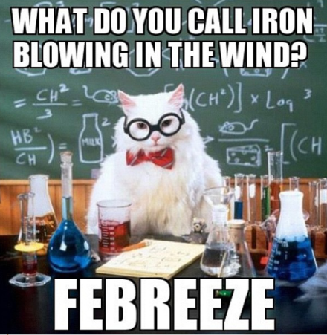

Unit 5 Bonding Chemistry Review
INTRODUCTION TO BONDING
Elements are the simplest form of matter and cannot be decomposed. Compounds can be formed between two or more elements. They can be decomposed chemically.

a. Which of the following is a compound? Ne H₂O Be F

b. Which of the following cannot be decomposed by chemical means?

C₁₂H₂₄ NH₃ Li CS₂

Atoms bond in order to obtain a stable electron configuration, like noble gases, called the octet. Most atoms will gain or lose electrons in order to have eight valence electrons. However, small elements such as H, Li, and Be will settle for two valence electrons. Obtaining an octet makes the atoms more stable and they can release energy. The electrons obtain the octet by sharing or transferring electrons.

a. Draw the Lewis dot diagram of the following elements:

Na Mg Al Si

P S Cl Ar

b. Draw the Lewis dot diagram of the following ions:

Na⁺ Mg⁺² Al⁺³

P⁻³ S⁻² Cl⁻

c. Explain why the metals lost electrons but the nonmetals gained electrons. _____________________

____________________________________________________________________________________

d. Explain why Ar doesn’t form an ion. ____________________________________________________

e. Fill the blanks with release or absorb: “When atoms bond they ____________ energy. In order to break a bond, energy must be __________________.

IONIC BONDING

Compounds that form between a metal and a nonmetal contain ionic bonds, transferring electrons. Ionic bonds are strong. Ionic compounds have high melting points, are generally solids at room temperature, and conduct in the liquid phase.

a. Which of the following has ionic bonds? NaCl NH₃ Mg

b. Which of the following transfers electrons? MgBr₂ Li CO₂

c. Which of the following has a higher melting point? Cu C₆H₁₂ LiF

d. Which of the following can conduct in the aqueous phase? NO KI Ne

COVALENT BONDING

Compounds that form between two nonmetals have covalent bonds, sharing electrons. Covalent bonds are weaker than ionic bonds. Covalent compounds have low melting points, are generally gases, liquids, or powdery solids at room temperature, and never conduct. These are also known as molecular compounds.

a. Which of the following has covalent bonds? HF LiCl Rb

b. Which of the following shares electrons? H₂O Ag CaCl₂

c. Which of the following can never conduct electricity? Kr Rb₂O H₂O

d. Which of the following has both ionic and covalent bonds? Li NH₃ CaCO₃

e. Which of the following is a molecular compound? H₂O Mg LiBr

METALLIC BONDING

Metallic Bonds form when a metal loses their valence electrons and a “sea of mobile electrons” form that allows the metal to conduct electricity in the solid or liquid phase.

a. Which of the following is metallic? NaCl NH₃ Mg

b. Which of the following has a sea of mobile electrons? Cu C₆H₁₂ LiF

c. Which of the following can conduct in the solid phase? Ne Ag CaCl₂

LEWIS STRUCTURES/GEOMETRY
Ionic Lewis diagrams show the ions involve in the bond, but no arrangement. Covalent Lewis diagrams show the sharing of electrons with lines representing two electrons. They form shapes such as linear, bent, pyramidal, and tetrahedral.

- Draw the following and give the number of shared pairs, unshared pairs, and the shape if applicable.

LiF NH₃

MgF₂ CH₄

Cl₂ H₂O

POLARITY
Bonds are polar when two atoms have different electronegativities and share unevenly. The more electronegative atom has the electrons more of the time. Nonpolar bonds form when two atoms have the same electronegativity values and share equally.

- Label the bonds as polar or nonpolar:
NH₃ CH₄ Cl₂ H₂O

Molecules are polar when the molecule is asymmetrical. They are nonpolar if the molecule is symmetrical.

- Label the bonds as polar or nonpolar (Use your drawing to help you):
NH₃ CH₄ Cl₂ H₂O

INTERMOLECULAR FORCES
Intermolecular forces are what keeps molecules together (not atoms-that’s bonds) and are responsible for phases, phase changes, surface tension and various other properties. Nonpolar molecules have the weakest attractive forces dependent on their size (the bigger the stronger). Polar molecules have stronger forces dependent on their polarity. Hydrogen bonds are a special case of polar forces between H and either F,O, or N. Molecules that are hydrogen bonded have high melting and boiling points, strong surface tension, and have closely packed particles.

- Which of the following has the highest melting point? ______
HF HCl HBr HI
- Which of the above has the lowest boiling point? _____
Chemistry Unit 5: Bonding
 | Key Idea Question | Justify your answer  with an explanation or calculation. | Confidence Level  None Moderate Fully  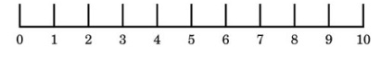
1 | Which describes: Br + Br Br₂  - Bonds broken energy released  - Bonds broken energy absorbed  - Bonds formed energy released  - Bonds formed energy absorbed |  | Pre-discussion:  Post discussion:
2 | Which compound contains both ionic and covalent bonds?  - CH₃OH c. LiOH  - MgF₂ d. CO₂ |  | Pre-discussion:  Post discussion:
3 | Which compound transfers electrons to form a crystal lattice structure that can be an electrolyte in solution?  - NaCl c. Mg  - C₆H₁₂O₆ d. HCl |  | Pre-discussion:  Post discussion:
4 | Multiple covalent bonds are described as  - Sharing 2 electrons  - Transferring 2 electrons  - Sharing 4-6 electrons  - Transferring 4-6electrons |  | Pre-discussion:  Post discussion:
5 | Which is a nonpolar molecule with polar bonds?  - CO₂ c. LiF  - CH₄ d. NH₃ |  | Pre-discussion:  Post discussion:
6 | Boiling Point Solubility  XO 20C No  YO 2500C Yes  State evidence confirming YO has stronger forces than XO. |  | Pre-discussion:  Post discussion:
7 | Show how water orients itself around the ion:  Na+ |  | Pre-discussion:  Post discussion:
8 | Draw the Lewis dot diagram for Cs₂S. |  | Pre-discussion:  Post discussion:
9 | Draw Lewis dot diagrams for the following and provide their shape:  Cl₂ H₂S PCl₃ CBr₄ |  | Pre-discussion:  Post discussion:
10 | Explain why CH₄ is nonpolar and H₂O is polar in terms of distribution of electrons. |  | Pre-discussion:  Post discussion:
Common Sense Chemistry Review Volume 5
I am transferring my knowledge to you. Isn’t it ionic?

- Charlie knows that melting sugar can create delicious caramel. Charlie also loves salty foods. He has an idea: melt salt and use it as a drizzle as well!
  - Explain to Charlie- in terms of bond strength, melting points, and electrons- why melting the salt isn’t feasible.

  - Charlie doesn’t believe you. He tries to melt salt in another pot anyway and thinks adding water will help. And then drops an electric mixer into the pot. Is it safe to pull out? Why or why not?

  - If he dropped the mixer in the sugar melting, would he be more or less safe than the salt solution?

- Explain why all salts are not compressible, hard structures whereas sugar can be powdery.

- Nitrogen gas is a major component in the air. The amount of water vapor varies. Explain in terms of bond strength, why nitrogen gas is always present in the air and mainly non-reactive, while water vapor varies. Draw diagrams to elaborate.

- Sometimes it takes forever to dry off from a shower or pool, but nail polish remover dries instantly. Explain this phenomenon.

- Why won’t my oil and vinegar just mix already?

- Explain in terms of bonds and forces, why methane (CH₄, cow farts) is gaseous, but a compound made of the same elements, octane (C₈H₁₈, gasoline) is a liquid.

- Explain why water is attracted to itself creating strong surface tension allowing lizards to run across the surface of lakes. Would water be as strong if oxygen has no lone pairs?

