Vocabulary
For each word, provide a short but specific definition from YOUR OWN BRAIN! No boring textbook definitions. Write something to help you remember the word. Explain the word as if you were explaining it to an elementary school student. Give an example if you can. Don’t use the words given in your definition!
Potential Energy: ___________________________________________________________________________
Kinetic Energy: _____________________________________________________________________________
Heat: _____________________________________________________________________________________
Specific Heat: ______________________________________________________________________________
Heat of Fusion: _____________________________________________________________________________
Heat of Vaporization: ________________________________________________________________________
Kinetic Molecular Theory: ____________________________________________________________________
Endothermic: ______________________________________________________________________________
Exothermic: ________________________________________________________________________________
Calorimeter: _______________________________________________________________________________

Video 6.1 q=mcΔT

- Heat is a transfer of energy (usually thermal energy) from a body of ________________ temperature to a body of ______________ temperature. Thermal energy is the energy associated with the random motion of atoms and molecules.
- Temperature is a measurement of the average ________________________________ of the particles in a sample of material. Temperature is not a form of energy.
- The concepts of potential and kinetic energy can be used to explain physical processes that include: fusion (melting), solidification (freezing), vaporization (boiling, evaporation), condensation, sublimation, and ___________________.

Exothermic reactions _______________ heat and have ______________ values.
Endothermic reactions ______________ heat and have ______________ values.
- Write the equation for the reaction on Table I that becomes the least stable: ____________________

- What type of reaction (endo or exo) is the dissolving of LiBr? _____________________________

- If 3 moles of C₃H₈ burn in oxygen, how many kilojoules of heat are released? (show work)

- Define the following: q: _____________________________________
m: ____________________________________
c: _____________________________________
ΔT: ___________________________________

- Using q=mcT, calculate the following: (show work)
  - How much heat is needed to raise the temperature of 50.0 grams of water 78C?

  - How many grams of water can be heated 10C by the addition of 1000J?

  - What is the specific heat of substance X if 1200J of heat are added to 25.0g of X and the temperature raises from 25 to 65C?

Video 6.2 Phase Diagrams

- Which phase(s) have no definite volume? __________________
- Which phase(s) have no definite shape? __________________
- Which phase(s) have a geometric pattern? __________________
- Which phase(s) can be compressed? __________________
- Which phase(s) have molecules/atoms the furthest apart? __________________
- Which phase(s) have the weakest IMF? __________________
- Which phase(s) have the strongest IMF? __________________
- Which energy is the energy of motion and is measured by temperatures? __________________
- Which energy is the stored energy? __________________

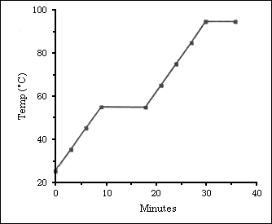
Video 6.3 q=mHf and q=mHv
On the diagram to the left, label the following:

- Solid
- Liquid
- Gas
- Solid/liquid equilibrium
- Liquid/gas equilibrium
- Darken the line(s) where kinetic energy is increasing
- Squiggle on the lines where potential energy is increasing.

What is this substance’s boiling point?
What is this substance’s melting point?
Could this be water?
- On the diagram to the left, which line segment(s) can q=mcΔT be used?

- Which line segment(s) can q=mH_{f} be used?

- Which line segment(s) can q=mH_{v} be used?

F

B

A

E

D

C

4. Calculate the heat needed to change 25.0 grams of water from liquid to steam at 100C. (show work)

5. Calculate the heat needed to change 25.0 grams of water from ice to liquid at 0C. (show work)

6. Why aren’t the answers to questions 4 and 5 the same even though their substance and mass is the same?

Multiple Choice Review

1. Which statement best describes the shape and volume of an aluminum cylinder at STP?
A) It has a definite shape and a definite volume.
B) It has a definite shape and no definite volume.
C) It has no definite shape and a definite volume.
D) It has no definite shape and no definite volume.

2. Which grouping of the three phases of bromine is listed in order from left to right for increasing distance between bromine molecules?
A) gas, liquid, solid C) liquid, solid, gas
B) solid, gas, liquid D) solid, liquid, gas

3. Which 5.0-milliliter sample of NH3 will take the shape of and completely fill a closed 100.0-milliliter container?
A) NH3(s) B) NH3(g) C) NH3(aq)

4. Which phase change results in the release of energy?
A) H2O(s) H2O(l) B) H2O(s)H2O(g)
C) H2O(s) H2O(g) D) H2O(g) H2O(l)

5. As ice melts at standard pressure, its temperature remains at 0°C until it has completely melted. Its potential energy
A) Decreases C) increases
B) remains the same

6. Which kind of energy is stored within a chemical substance?
A) free energy C) activation energy
B) kinetic energy D) potential energy

7. When a quantity of electricity is converted to heat, the heat energy produced is measured in
A) volts C) amperes
B) joules D) degrees
8. Which term is defined as a measure of the average kinetic energy of the particles in a sample?
A) Temperature C) pressure
B) thermal energy D) chemical energy

9. At which temperature would atoms of a He(g) sample have the greatest average kinetic energy?
A) 25°C B) 37°C C) 273 K D) 298 K

10. Solid A at 80ºC is immersed in liquid B at 60ºC. Which statement correctly describes the energy changes between A and B?
A) A releases heat and B absorbs heat.
B) A absorbs heat and B releases heat.
C) Both A and B absorb heat.
D) Both A and B release heat.

11. Which phase change is accompanied by the release of heat?
A) H2O(s) H2O(g) C) H2O(s) H2O(l)
B) H2O(l) H2O(g) D) H2O(l) H2O(s)

12. Which change of phase is exothermic?
A) solid to liquid C) gas to liquid
B) solid to gas D) liquid to gas

13. The table below shows the data collected by a student as heat was applied at a constant rate to a solid below its freezing point.
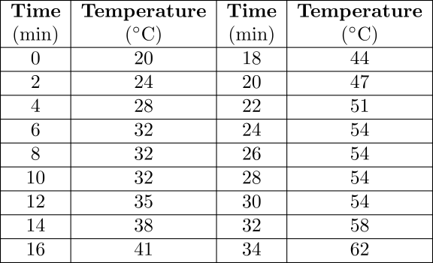

What is the boiling point of this substance?
A) 32°C B) 54°C C) 62°C D) 100°C

Base your answers to questions 14 and 15 on the graph below, which represents uniform cooling of a sample of a pure substance, starting as a gas.
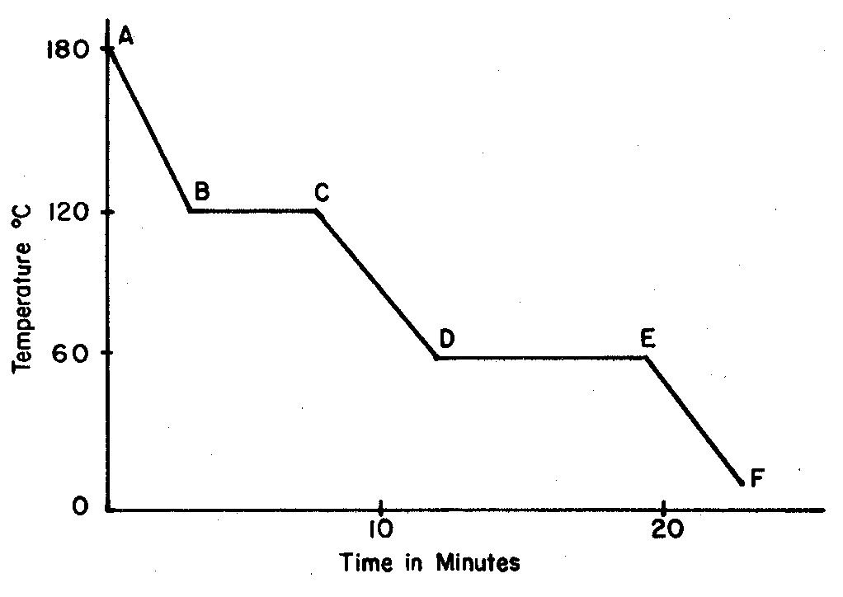
14. Solid and liquid phases can exist in equilibrium between points
A) E and F C) B and C
B) C and D D) D and E

15. The boiling point of the substance is
A) 10°C B) 60°C C) 120°C D) 180°C

16. The diagram below represents the uniform heating of a substance that is a solid at Time A.
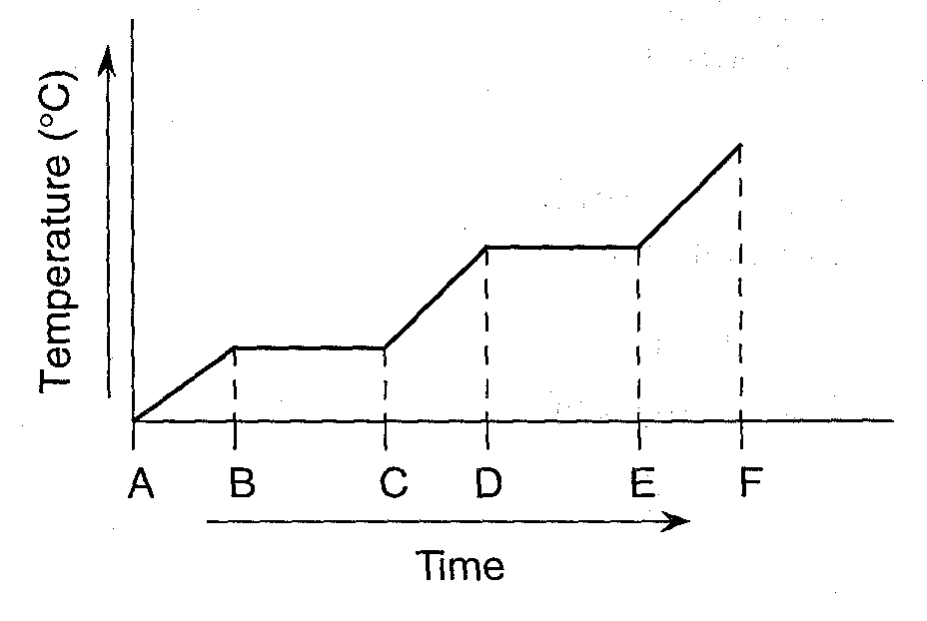
Between which times could the heat of fusion be determined?
A) A and B C) B and C
B) C and D D) E and F

17. A 36-gram sample of water has an initial temperature of 22°C. After the sample absorbs 1200 joules of heat energy, the final temperature of the sample is
A) 8.0°C B) 14°C C) 30.°C D) 55°C
18. The temperature of a sample of water changes from 10°C to 20°C when the sample absorbs 418 joules of heat. What is the mass of the sample?
A) 1 g B) 10 g C) 100 g D) 1000 g

19. When 200 grams of water cools from 50.°C to 25°C, the total amount of heat energy released by the water is
A) 42 kJ B) 21 kJ C) 34 J D) 17 J

20. When a 500. gram sample of water at 19.0ºC absorbs 8.40 kiloJoules of heat, the temperature of the water will change to
A) 23.0ºC B) 19.0ºC C) 15.0ºC D) 4.00ºC

21. The number of Joules needed to raise the temperature of 10 grams of water from 20ºC to 30ºC
A) 42 B) 84 C) 420 D) 1680

22. At which Celsius temperature does lead change from a solid to a liquid?
A) 874°C B) 601°C C) 328°C D) 0°C

23. What amount of heat is required to completely melt a 29.95-gram sample of H2O(s) at 0°C?
A) 334 J C) 2260 J
B) 1.00 × 103 J D) 1.00 × 104 J

Base your answers to questions 24 and 25 on the graph below. The graph shows heat being added at a constant rate to substance A and to substance B, which begin as solids below their melting point temperatures.
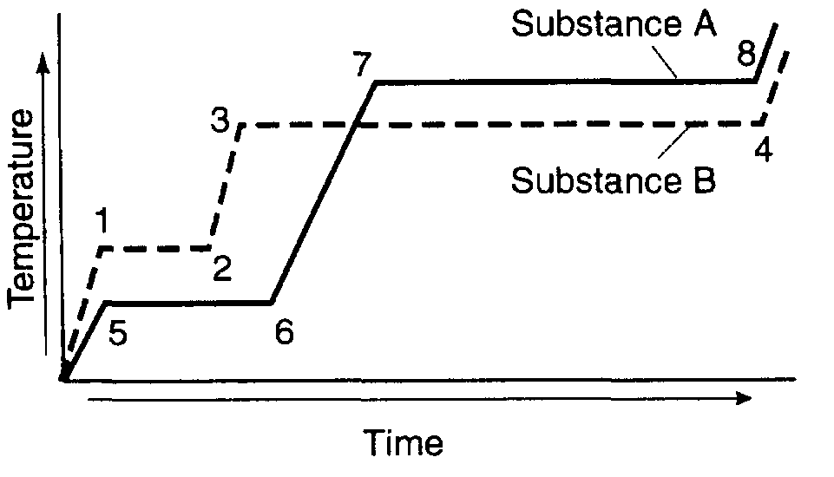
24. During which interval is the greatest amount of energy absorbed?
A) 1-2 B) 2-3 C) 3-4 D) 7-8

25.Compared to substance B, substance A has a
A) lower melting point and a lower boiling point
B) lower melting point and a higher boiling point
C) higher melting point and a lower boiling point
D) higher melting point and a higher boiling point

26. In which process does a solid change directly into a vapor?
A) condensation C) sublimation
B) deposition D) solidification

Base your answers to questions 27 through 33 on the information below.

The temperature of a sample of a substance is increased from 20.°C to 160.°C as the sample absorbs heat at a constant rate of 15 kilojoules per minute at standard pressure. The graph below represents the relationship between temperature and time as the sample is heated.
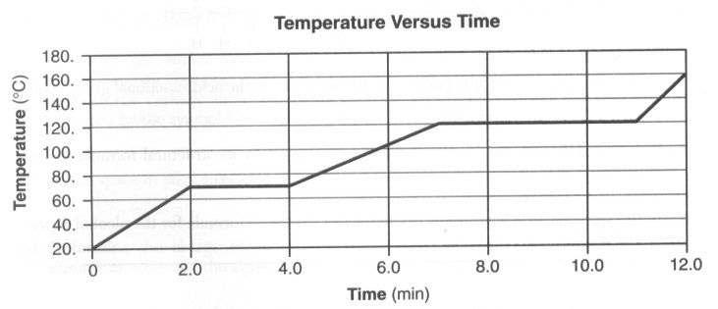

27. Determine the total amount of heat required to completely melt this sample at its melting point.

28. What is the total time this sample is in the liquid phase, only?

29. Use the key below to draw at least nine particles in the box, showing the correct particle arrangement of this sample during the first minute of heating.
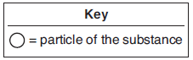

30. What is the boiling point of this sample?

31.Base your answer to the following question on the information below

A 5.00-gram sample of liquid ammonia is originally at 210. K. The diagram of the partial heating curve below represents the vaporization of the sample of ammonia at standard pressure due to the addition of heat. The heat is not added at a constant rate.
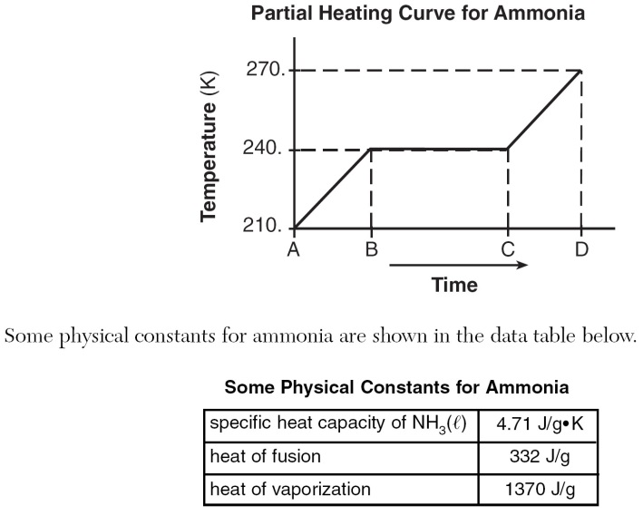

Calculate the total heat absorbed by the 5.00-gram sample of ammonia during time interval AB. Your response must include both a correct numerical setup and the calculated result.
