Key Ideas
- Energy released or absorbed during a chemical reaction (heat of reaction) is equal to the difference between the potential energy of the products and the potential energy of the reactants. (4.1d)
- Heat is a transfer of energy (usually thermal energy) from a body of higher temperature to a body of lower temperature. Thermal energy is the energy associated with the random motion of atoms and molecules. (4.2a)
- Temperature is a measurement of the average kinetic energy of the particles in a sample of material. Temperature is not a form of energy. (4.2b)
- The concepts of potential and kinetic energy can be used to explain physical processes that include: fusion (melting), solidification (freezing), vaporization (boiling, evaporation), condensation, sublimation, and deposition. (4.2c)
- Entropy is a measure of the randomness or disorder of a system. A system with greater disorder has greater entropy. (3.1ll)
- Systems in nature tend to undergo changes toward lower energy and higher entropy. (3.1mm)
Heating Curves Review
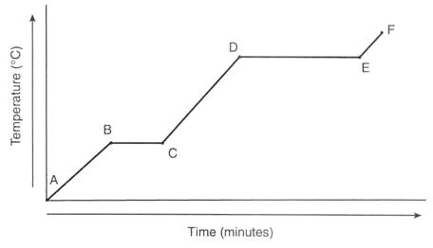
- Identify the phase(s) represented by the following line segments:
  - AB ___________________ d. DE ___________________
  - BC ___________________ e. EF ___________________
  - CD ___________________
- What line segment(s) represent the melting point? _____________________
- What line segment(s) represent the boiling point? _____________________
- What takes more energy: to melt this substance or to vaporize it? Give evidence to support your answer. _____________________________________________________________________________
- What is the first temperature where you could see one drop of a liquid? ___________
- What is the first temperature where you could see the last crystal of a solid? ___________
- What is the first temperature where you could see one bubble of a gas? ___________
- What is the first temperature where you could see the last drop of a liquid? ___________
- During which segments are there phase changes occurring? ___________
- What type of energy is being used during the line segments mentioned in question 9?___________
- During which segments is the temperature rising? ___________
- What type of energy is being used during the line segments mentioned in question 11?___________
- At what point will the particles be moving the slowest? ___________
- During which line segments does temperature increase? ___________
- During which line segments is there no change in temperature? __________________
- If this substance were water, at what temperature would segment BC occur?
- If this substance were water, at what temperature would segment DE occur?
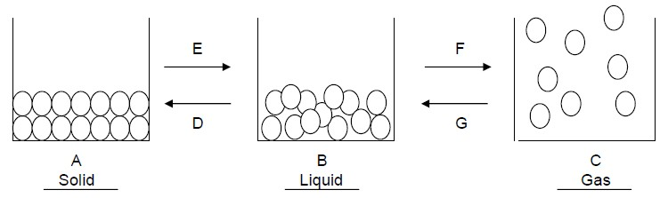
- Which arrows in the model indicate the addition of energy?
- Which term, endothermic or exothermic, is used to describe the situation when energy is added into a system from the surroundings?
- Which arrows in the model indicate the release of energy? ______________
- What are the names of the phase changes that involve a release of energy to the surroundings by the system?
- In terms of particle attraction, explain why gases such as propane and butane are in liquid form in their containers but are released as gas when they come out of their containers.
- Which statement is true?
  - At a given temperature, the temperature value is a measure of the total kinetic energy of all the molecules.
  - At a given temperature, all the particles have the same amount of kinetic energy.
  - At a given temperature, the average kinetic energy of the molecules is constantly changing.
  - At a given temperature, the temperature value is a measure of the average kinetic energy of all the molecules.

- Which term is defined as a measure of the average kinetic energy of the particles in a sample?
(1) activation energy (2) potential energy (3) temperature

- In which sample do the particles have the highest average kinetic energy?
(1) H₂O(l) @55oC (2)Br₂ @75oC (3) NaCl(aq) @30oC (4) Mg(s) @17oC

- Which sample has particles with the lowest average kinetic energy?
(1) 1.0g of I₂ at 50.°C (2) 2.0g of I₂ at 30.°C (3) 7.0g of I₂ at 40.°C (4) 9.0g of I₂ at 20.°C

Heating and Cooling Curves Repair
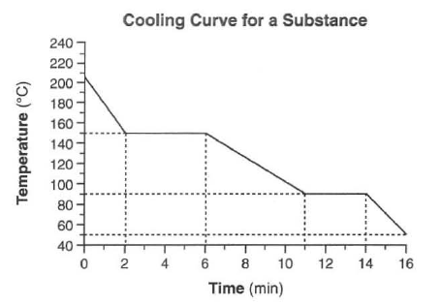
- Label the line segments with their phase(s).
- What is this substance’s melting point? _________
- What is this substance’s boiling point? __________
- Does this represent an endothermic or exothermic reaction?
- Heat is being released at 60.0 kilojoules per minute.
How much heat is released when the substance freezes?

- Label the point with the most kinetic energy with a star.
_________________________________________________________________________________________________________________________

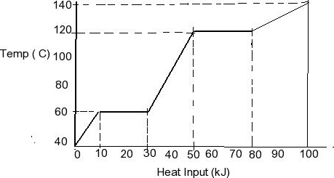
- Draw six particles of this substance as it looks for the
first line segment in the box below.

- Draw six particles of this substance as it looks for the
last line segment in the box below.

- At which point is the potential energy the highest? Label it with a star.
- What is the boiling point of this substance? _____________
- What is the melting point of this substance? _____________
- What would you expect the graph to do if the substance continued to be heated?

Heat Table I

1. Are the following endo or exothermic?
CH₄ + 2O₂ CO₂ + 2H₂O _____ 2CH₃OH + 3O₂ 2CO₂ + 4H₂O + 1452kJ _____
H₂ + I₂ 2HI _____ The dissolving of NaOH _____
25.69kJ + NH₄NO₃ NH₄⁺ + NO₃⁻ _____ The dissolving of LiBr _____

2. Circle the more stable compound in each pair:
H₂O_{(g)} OR H₂O_{(l)} NH₃ OR Al₂O₃
HI OR NO C₂H₆ OR C₂H₄

3. Circle the compound which is more likely to form in each pair:
CO₂ from elements OR CO₂ from CO NO OR NO₂
C₂H₆ OR C₂H₂ NH₃ OR HI

4. Will the following feel hot or cold?
Dissolving KNO₃ _____________ Dissolving LiBr _____________
Burning CH₄ in O₂ _____________ Forming Al₂O₃ _____________

5. Write a balanced equation for the following reactions including the heat as a reactant or product:
The formation of H₂O from its elements __________________________________________
The decomposition of C₂H₆ __________________________________________
The dissolving of NH₄Cl __________________________________________
The evaporation of water from Li⁺ and Br⁻ __________________________________________

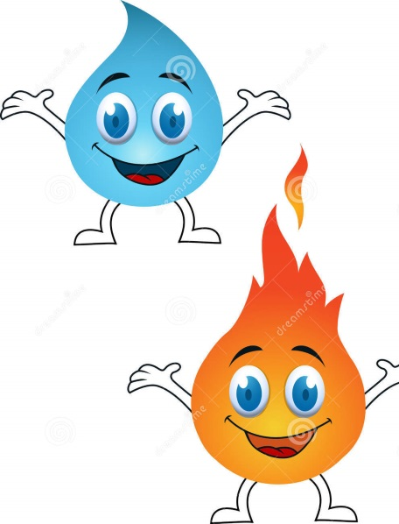

Heat Introduction

Two students are heating substances on separate hot plates. They want to determine what factors affect how hot the substances can get. What factors should the students hold constant?

Scenario 1: Student A heats 400 grams of water in the saucepan and Student B heats 800 grams of water in the stockpot, each made out of the same material, on the same setting of a hot plate. Which student’s water will be hotter after 5 minutes? Why?

Scenario 2: Student A heats 100 grams of water on a low heat setting and Student B heats 100 grams of water on a high heat setting, each for 5 minutes in a saucepan. Which student’s water will be hotter after 5 minutes? Why?

Scenario 3: Student A heats 250 grams of water from 0 to 100C and Student B heats 250 grams of water from 30 to 70C on the same setting of a hot plate in the stock pot. Which student will require more time? Why?

Scenario 4: Student A heats 200 grams of water and Student B heats 200 grams of copper, each for 5 minutes on the same setting of a hot plate. Which student’s substance will be hotter after 5 minutes? Why?

Summary: What factors directly affect the amount of heat needed to raise the temperature of a substance?

Specific Heat

Specific heat is defined as the amount of heat (in ____) needed to raise ____ gram of a substance ___˚C.
Every substance has its own specific heat depending on the bonds and forces it has.

- When you wake up in the morning and touch the floor, at first the carpet feels warm. The wood floor in the hallway is a bit chilly, but the tile floor in the bathroom is FREEZING! However, your whole house is probably 68˚F. What quality is different about each of these surfaces? Which has the highest specific heat?

- At the park, why do you tend to steer clear of metal benches and prefer wooden picnic benches? Which has a lower specific heat?

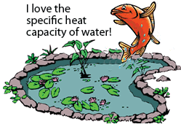
- Water has a high specific heat due to its hydrogen bonds. Explain why the fish is so happy in the picture below.

- Based on the specific heat values in the table below, why do Al, Cu, Au, Fe and Hg have very low values? (What do they have in common?)
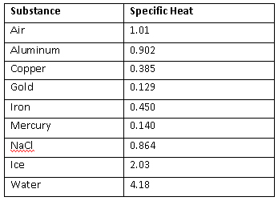

- Based on your answer to question 2 do you expect wood to have a higher or lower specific heat than these substances and why?

- Glass is often called an insulator because it has a ___________ specific heat.
Heat Calculations

Define the following terms with units: q: ________________ c: ____________________
m: ________________ ΔT: ___________________

Answer the following questions using the heat formula. Show work with units and significant figures.
- How many Joules of energy are needed to change the temperature of 100.0 grams of water from 20.0C to 40.0C?

- How many kilojoules of energy are needed to change the temperature of 15.0 grams of water from 35.0C to 75.0C?

- If the temperature of water is changed from 10.0C to 35.0C by the addition of 350.0J, how many grams were heated?

- If the temperature of water is changed from 100.0C to 250.0C by the addition of 5000.0J, how many grams were heated?

- If 3500.0J of energy are applied to 150.0 grams of water at 50.0C, what is the final temperature?

- If 425J of energy are released from 25.0 grams of water at 25.0C, what is the final temperature?

- Look at the rearranged equation for heat, solved for specific heat. What are the units of specific heat based on this rearranged equation?
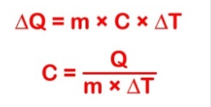

- What is the specific heat of silver if an 80.0 gram sample is heated from 24.0C to 49.0C by adding 468.2J?

- What is the specific heat of copper if a 75.0 gram sample of copper is heated from 20.0C to 24.0C by adding 117J?
- The specific heat of aluminum is 0.88J/gC. How many joules of heat does it take to heat 50.0 grams of aluminum from 20.0 to 70.0C?

- What is the change in temperature when 3.00 grams of Iron (specific heat = 0.45J/gC) is subjected to 350.0.J of energy?

- What mass of Aluminum (specific heat = 0.902 J/gC) can be heated from 25.0C to 90.0C with the addition of 100.0J of heat?

- How many joules of heat must be released in order to change the temperature of 50.0 grams of air (specific heat 1.01 J/gC) from 35.0C to 25.0C?

________________________________________________________________________________________________________________

Base answers to questions 14-17 on the diagram:

- How much heat is added to change the
substance from the coldest to the warmest
pure liquid state?

- If the specific heat of this substances in the liquid
phase is 3.56 J/gC calculate how many grams were
heated in question 11?

- If the same sample is heated as a solid at 40C to 60C will it have the same specific heat? Show work to support your answer.

- How much heat will need to be added to the same sample in order to raise the temperature from 20.0C to 40.0C? (Notice this is not on the graph, you must calculate it based on your answers above.)
Heat of Vaporization and Fusion

Heat of Fusion of water: 334 J/g
Heat of Vaporization of water: 2260 J/g
Specific Heat Capacity of gaseous water: 1.84 J/gC
Specific Heat Capacity of liquid water: 4.18 J/gC
Specific Heat Capacity of solid water: 2.09 J/gC

Show all work and answers with three significant figures and proper units. Write the formula(s) you used first then show your work.

1. How many Joules of heat are required to change the temperature of 200.0 grams of solid water from -20.0C to 0.0C?

2. How many Joules of heat are needed to change 200.0 grams of water from solid to liquid?

3. How many Joules of heat are required to change the temperature of 200.0 grams of liquid water from 0.0C to 100.0C?

4. How many Joules of heat are needed to change 200.0 grams of water from liquid to gas?

5. How many Joules of heat are required to change the temperature of 200.0 grams of gaseous water from 100.0C to 120.0C?

6. How many Joules of heat are required to change the temperature of 200.0 grams of solid water from -20.0C to 0.0C and then melt it?

7. How is your answer to question 6 related to your answers to questions 1 and 2?

8. Using the rule you obtained in question 7 and your answers to questions 1-5, how much heat is required to heat 200.0 grams of water from -20.0 to 120.0C?

9. Draw a heating curve to show the phase changes that occurred during the processes described in questions 1-5. Label each segment with the phase(s) on the top of the line and the formula you used to determine the amount of heat added on the bottom of the line. Keep in mind the x axis should be the TOTAL heat used in the reaction and the y axis should be temperature in degrees Celsius.

Additional Questions:
10. How much heat is absorbed by 550.0g block of ice to raise the temperature from -15.0 to 0.0C?

11. How much heat is needed to vaporize 250.0 grams of water?

12. How much heat is released when 25.0 grams of water freezes?

13. Calculate the heat needed to change 50.0 grams of liquid water to gas at 100.0C.

14. Calculate the heat released when 125 grams of liquid water solidifies.

15. How much heat energy must be absorbed to raise the temperature of a 200.0 gram block of ice from -10.0 to 0.0C and then completely melt it to a liquid at the same temperature?

16. How much energy would be required to heat the same 200.0 grams of liquid water in #15 (at 0.0C) to the normal boiling point of water and then vaporize it?

17. If the temperature of the 200.0 grams of steam generated in #16 were heated to a new temperature of 120.0C, how much energy would be absorbed?

18. What is the total amount of energy needed to heat 200.0 grams of ice at -10C to gas at 120.0C?

19. What is the total amount of energy needed to heat 125g of ice at -25C to gas at 135.0C? (Use a heating curve to help you).

20. The heat of vaporization of substance X is 250.0J/g. How much heat is needed to change 10.0 grams of X from liquid to gas?

21. The heat of fusion of substance Y is 125 J/g. How much heat is needed to change 25.0 grams of Y from solid to liquid?

22. The heat of sublimation of substance XY₂ is 780.0 J/g. calculate the heat required to sublime 200.0 grams of XY₂.

23. Hypothesize a possible heat of sublimation for water and give your reasoning.

Review of Intermolecular Forces
24. Given the following information, which solid substance has the strongest IMF? The weakest? Explain your answers.
25. Given the following information, which gaseous substance has the strongest IMF? The weakest? Explain your answers.
Enthalpy of Formation
- The thermite reaction is highly exothermic and is used for welding :
2Al(s) + Fe₂O₃ 2Fe(s) + Al₂O₃(s)
Calculate the heat of this reaction using enthalpies of formation.

- Calculate the enthalpy of these reactions using enthalpies of formation:
  - 4FeO(s) + O₂(g) 2Fe₂O₃(s)

  - SiCl₄(l) + 2H₂O(l) SiO₂(s) + 4HCl(aq)

  - NH₃(g) + HCl(g) NH₄Cl(s)

  - MgO(s) + H₂O(l) Mg(OH)₂ (s)

  - C₂H₅OH(l) + 3O₂ (g) 2CO₂ (g) + 3H₂O(g)

Reminder of an old Enthalpy Question:
- Calculate the change in energy that accompanies the following reaction given the data below.
H₂(g) + F₂(g) → 2 HF(g) Bond Type Bond Energy H−H 432 kJ/mol F−F 154 kJ/mol H−F 565 kJ/mol

Hess’ Law
Hess’ Law states that two or more thermochemical equations can be summed to give a final heat of reaction. Sometimes, the reactions need to be modified before summing. Rules include:
- If a reaction is reversed the heat of reaction will be ______________________.
- If a reaction is doubled the heat of reaction will be _______________________.
- If a reaction is halved the heat of reaction will be _______________________.
- Sum the reactions and cancel species on ______________ sides of the reaction.
- Sum the heat values.

- Given: C(graphite) + O₂(g) CO₂(g) ΔH = -393.5 kJ/mol
C(diamond) + O₂(g) CO₂(g) ΔH = -395.4 kJ/mol
Find the heat of: C(diamond) C(graphite)

- Given: 2Al(s) + 3/2 O₂(g) Al₂O₃(s) ΔH = -1669.8 kJ/mol
2Fe(s) + 3/2 O₂(g) Fe₂O₃(s) ΔH = -824.2 kJ/mol
Find the heat of: 2Al(s) + Fe₂O₃(s) 2Fe(s) + Al₂O₃(s)

- Given: 2PCl₃(g) + 2Cl₂(g) 2PCl₅(s) ΔH = -176.0 kJ/mol
2P(s) + 3Cl₂(g) 2PCl₃(g) ΔH = -574.0kJ/mol
Find the heat of: 2P(s) + 5Cl₂(g) 2PCl₅(s)

- Why is Hess’ Law useful?

Entropy Introduction
Entropy is the degree of disorder or randomness in a substance. The symbol for change in entropy is ΔS.
- Which phase may have the most disorder: Solid liquid or gas? Demonstrate your answer using particle diagrams.

- Which will have more disorder: a container with 2 gas molecules, or a container with 100 gas molecules? Demonstrate your answer using particle diagrams.

- Which will have more disorder: A container filled with a polar molecule such as HCl, or a container filled with a non-polar molecule such as H₂. Demonstrate your answer using particle diagrams.

- According to the Second Law of Thermodynamics, nature is always proceeding to a state of higher entropy. Give an example from your life that proves the second law.

Entropy Practice
Determine whether the following reactions show an increase or decrease in entropy.
- 2KClO_{3(s)} → 2KCl_{(s)} + 3O_{2(g)} ________________________
- H₂O_{(l)} → H₂O_{(s)} ________________________
- N_{2(g)} + 3H_{2(g)} → 2NH_{3(g)} ________________________
- 2NaCl_{(s)} → 2Na_{(s)} + Cl_{2 (g)} ________________________
- KCl_{(s)} → KCl_{(l)} ________________________
- CO_{2(s)} → CO_{2(g)} ________________________
- C_{(s)} + O_{2(g)} → CO_{2(g)} ________________________
- H_{2(g)} + Cl_{2(g)} → 2HCl_{(g)} ________________________
- Ag⁺_{(aq)} + Cl⁻_{(aq)} → AgCl_{(s)} ________________________
- 2Al_{(s)} + 3I_{2(s)} → 2AlI_{3(s)} ________________________
- 2NO_{(g)} → N_{2(g)} + O_{2(g)} ________________________
Gibbs Free Energy
Why is it important to know if a reaction in endothermic or exothermic?

Why is it important to know if a reaction leads to more or less entropy?

For a physical or chemical reaction to be spontaneous, the sign of ΔG (Gibbs Free Energy) must be negative. The mathematical formula for this value is:
ΔG = ΔH – TΔS
where ΔH = change in enthalpy or heat of reaction
ΔS = change in entropy or randomness
T = temperature in Kelvin

ΔH | ΔS | ΔG
- | +
+ | -
- | -
+ | +
Complete the table for the sign of ΔG; +, - or undetermined. When conditions allow for an undetermined sign of ΔG, temperature will decide spontaneity. (temp. dependent)
- The conditions in which ΔG is always negative is when ΔH is _________________ and ΔS is _________________.
- The conditions in which ΔG is always positive is when ΔH is _________________ and ΔS is _________________.
- When the situation is indeterminate, a low temperature favors the ( entropy / enthalpy ) factor, and a high temperature favors the ( entropy / enthalpy ) factor.

Answer Problems 4-6 with endo or exothermic, always, sometimes or never and at high, low, or all temperatures.
- The reaction: C₂H₆(g) + 5/2O₂(g) 2CO₂(g) +3H₂O(l) + heat has ___ entropy and is ____ thermic. It is _____________ spontaneous.
- The reaction: heat + C₆H₁₂O_{6(s)} 6C(s) + 6H₂O(g) has _____ entropy and is ____ thermic. It is _____________ spontaneous.
- The reaction: 2KClO_{3(s)} + heat → 2KCl_{(s)} + 3O_{2g)} will _______________ be spontaneous at ______ temperatures.
- The reaction: 2H_{2(g)} + O_{2(g)} → 2H₂O_{(l)} + heat will _______________ be spontaneous at _____ temperatures.
- The reaction: heat + H₂O_{(s)} → H₂O_{(l)} will _________________ be spontaneous at ____ temperatures.
Unit 6: Heat Review
HEAT CURVES
Heating and cooling curves show the phases and changes they undergo as a sample is heated or cooled. The coldest phase is a solid and the hottest is gas for any substance. Kinetic energy is directly related to the temperature. Potential energy increases as a phase change occurs on a heating curve, and decreases on the cooling curve.
- Draw a heat curve for water, including all phases and phase changes with temperatures.

- Draw a cooling curve for Bromine including phase changes with temperatures, and label the parts where kinetic energy is decreasing.

TABLE I
Reactions are reported with their net heats of reaction. Exothermic reactions release heat, have a negative value, and become more stable.
- Which reaction on table I becomes the most stable?

- What is the heat of reaction for the following:
CO₂ + 2H₂O CH₄ + 2O₂

8Al + 6O₂ 4Al₂O₃

HEAT EQUATIONS
If a substances changes temperature, use the q=mcΔT equation. If the substance undergoes evaporation or condensation use q=mHv. If the substance undergoes freezing or melting use q=mHf. Equations are found on table S and values are found on table B.
- Find the heat needed to change 50.0g of water from 0 to 25C.

- Find the mass of water that was heated from 50 to 75C by 2500J.

- Find the temperature change of 100.0g of water heated by the addition of 678 J.

- Find the specific heat of a 75.0g substance that changes 45 to 89C with the addition of 5600J.

- Find the heat needed to vaporize 50.0g of water at 100C.

- Find the heat needed to melt 100.0g of ice at OC.

- Find the heat of vaporization of a 100.0g substance that evaporates with the addition of 890J.

ENTROPY
The randomness or disorder of a sample is referred to as entropy. Gases at high temperatures have high entropy.
- Which substance has the highest entropy?
Cu(s) He(g) Br₂(l)

- Which substance has the lowest entropy?
H₂O at 0C H₂O at 100C

 | Key Idea Question | Justify your answer  with an explanation or calculation. | Confidence Level  None Moderate Fully  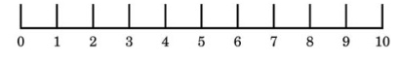
1 | A metal changes temperature from 80C to 120C. Which is the temperature change in Kelvin?  - 40 b. 273 c. 313 |  | Pre-discussion:  Post discussion:
2 | Calculate the heat released when 200.0g of water cools from 90.C to 70.C.  - 16700J c. 17000J  - 16720J d. 20000J |  | Pre-discussion:  Post discussion:
3 | What mass of water can be heated from 60.C to 90.C using 980J of heat?  - 234g b. 33g c. 7.8g |  | Pre-discussion:  Post discussion:
4 | Calculate the heat change by the following reaction:  4NO 2N₂ + 2O₂  - +182.6kJ c. -182.6kJ  - +364.0kJ d. -364.0kJ |  | Pre-discussion:  Post discussion:
5 | Which is the normal boiling point of water?  - 0C c. 273K  - 50C d. 373K |  | Pre-discussion:  Post discussion:
6 | Calculate the temperature change that occurs when 120.0 grams of a substance with a specific heat of 1.23J/gC absorbs 560.0J of heat. |  | Pre-discussion:  Post discussion:
7 | Calculate the heat required to melt 500.0g of water at its melting point. Report your answer in kJ. |  | Pre-discussion:  Post discussion:
8 | Calculate the heat of vaporization of a 60.0 grams sample if it vaporizes by absorbing 7120J of heat. |  | Pre-discussion:  Post discussion:
9 | Draw a heat curve labeling the places where Kinetic Energy changes and Potential Energy changes. |  | Pre-discussion:  Post discussion:
10 | Draw a cooling curve labeling the phases and phase changes that occur. |  | Pre-discussion:  Post discussion:
Common Sense Chemistry Review Volume 6
Beat the heat!

- Identify a reaction that may be used in cool packs at sports games to relieve injury without worrying about melting ice.

- Identify a reaction that may be used in heat packs to warm you up at a cold outdoor event.

- After watching a sci-fi movie, your friend is convinced that placing your hand in melting substances in always worse than putting your hand in boiling ones. His evidence is that he can put his hand over boiling water without really being hurt, but when the character in the movie seemed to have melted his hand, they were irreparably hurt. Do you agree or disagree? Explain using more examples.

- Candace feels it takes FOREVER to boil water for her pasta. It also seems to take a while for ice to melt. Which takes longer if they are applied heat at the same rate?

- It’s not fair! According to our fitness trackers, my workout buddy is always able to burn significantly more calories than I do during the same workout. How is that possible?

- Chelsea doesn’t understand how it is possible that her pots and pans can get super-hot on the bottoms but the handles remain cool. What crazy sorcery science is that?

- Why are metal thermoses coated in plastic or have a Styrofoam or air layer between its metal layers? Why aren’t they just metal?

