Handwriting analysis of Serial Killers

BY Anna Koren

The Serial Murderer, Mass Murderer, or as he is commonly called - The Serial Killer does not act on impulse. His brain must be extremely organized and his plans well thought out in order for him to be able to commit his heinous crimes time & time again, as well as cover up all evidence of his actions. I found it to be inconceivable that Serial Killers do not share some sort of common ground. I had then reflected on that fact that the human soul is so complex, diverse and consists within itself many elaborate facets. Furthermore - I found that the motives differ. Apparently there is great difficulty in trying to construct a serial killers profile. Nevertheless, I had managed to find some reoccurring phenomenon in the handwriting samples:
In many cases, these killers possess a high level of intelligence, Ted Bundy, and in some cases even genius, Carlton Gary. Many of the serial killers had suffered separation or abandonment from either one or both of their parents. In many cases we hear of friends and neighbors who cannot believe their friend / neighbor was in fact the notorious serial killer terrorizing the area. Prior to his capture, John Wayne Gacy, was very much involved in his community and volunteered to entertain children in hospitals. At the same time he had murdered his victims and buried them in the foundations of the house he was building.
It seems these killers possess within themselves multiple personalities, much like the story of Dr. Jekyll & Mr. Hyde, based on the story of a life-saving physician during the day and an infamous murderer by night. An additional similarity which further proves the connection between serial killers and the Schizoid personality is the fact that many of these killers initially seduce their victims in various fashions.
Serial killers tend to prey on women and children of their own race. Prostitutes, drifters and hitchhikers are a preferable choice of prey. Some homosexual killers enjoy hunting young boys and gay men. Female serial killers tend to be "black widows" that kill a succession of husbands, lovers, or other family members. They can also be nurses or other medical professionals who become self-appointed "angels of death" murdering babies, elderly, or the desperately ill in a misguided effort to relieve their suffering. Most serial killers grew up in violent households. As youngsters they enjoyed torturing animals, setting fires and were chronic bed-wetters. As adults, many serial have some type of brain damage and are addicted to alcohol and/or drugs.
With respect to killers who have killed without having any relation to the victim and without any apparent reason, although their background is different, research indicate that many sociopaths have experienced severe abuse during their childhood and developed self-hatred. At the same time, among the killers there are also many individuals with narcissistic tendencies, which may cause feelings of omnipotence that can produce evil acts. Such individuals often take the role of God and are convinced they have the right to choose who may live and who may die.
Biological psychologists found that abuse leaves behind it physical tracks on the brain. A "screen" of hormones is created which prevents an abused child from feeling certain emotions. The child may lose a sense of empathy or the ability to assume the emotional role of others. One of the surprising findings in a biological research of violence was that many sadists and killers do not respond to stress. They lack the typical characteristics of elevated heartbeat, increased perspiration, or increased levels of adrenaline. Each serial killer has a different life story and varied motives. The similarities between them are not necessarily in their handwriting; the overwhelming majority is diagnosed with an acute schizoid personality.

The Schizoid Murderer
Out of tens of handwritings of murderers which I have examined so far, more than 80% were schizoids at the highest level. It is important to state that I only related to murderers who murdered in cold blood and who planned their action in advance and not to those who murdered passionately due to either a love affair gone sour, a sudden fit of rage or an unbearable insult. I had mainly examined assassination style serial murderers. Most of them show lack of judgment and yet possess well developed planning skills and good self-control. All the schizoid murderers share something in common with the rest of the schizoid types.
- The charming type - they usually have personal charm through which they manage to contact their victims and gain trust.
- The ambitious type - They have strong ambitions otherwise they would not risk their lives and freedom.
- The security man - They have the ability to keep their secret to themselves, often they follow their victim, plan the murder or the assault almost always on their own without sharing it with others.
- The obsessive - All the serial murderers obsessively repeat their horrible crimes.
- The criminal - They have a captivating charm and an ability to pretend and conceal their true intentions. They can lie without even a blink and completely lack conscience.
- The destructive type - Their destructive instinct causes them to murder and by killing they destroy their victims and in most cases themselves as well.
- We can conclude that the murderer share characteristics with all the types. Their characteristics are at a high leveled and extremely twisted.

Graphic signs of the Schizoid
- Vigilant and tense handwriting
- Extremely strong pressure
- Angles
- Separation
- Narrowness
- Extremely wide spaces between words or identical to the spaces between letters
- Left of upright slant
- Frozen
- Tense strokes
- High upper zone
- Large or extreme height differentials
- At times - a weak stroke randomly
- Angular connections
- Emphasize of the beginning
- Rhythmic writing
- Covering the whole page
- Strange ending of letters
- "Invented" letters
- Twisted letters
- Broken letters
- Corrections, especially "artistic corrections"
- Abundance of punctuation marks or lack of them
- Slow writing
- Peculiarities and exaggeration
- Printed letters

Use the reference sheets to answer the following questions:
- How many of the killers have exceptionally narrow handwriting?

- How many of the killers show strange separation or gaps in their writing samples?

- Give an example of the killer with heavy pen pressure.

- Which direction do most sample slant?

- Give an example of a killer with large height differentials in their sample.

- Give an example of a killer with strange ending of letters in their sample.

- Give an example of a killer with “invented letters” in their sample.

- Give an example of a killer with “broken letters” in their sample.

- Give an example of a killer with “artistic corrections” in their sample.

- How many of the killers created printed letters?

- Which killer seems to have taken the most time in executing his letter?

Gerald Eugene Stano
Pudgy, short, and not what one would categorize as a looker. In his mind, he most definitely felt the opposite, referring to himself as a, "real Italian stallion". In reality, he was a cold blooded psychopath.
He confessed to 33 gruesome murders. The number has ascended to 41. Twenty-two of the bodies were found and identified. Note the sharp, needle point like lines which cut through the lower part like a knife, as well as loops, complicating the shapes and creating strange looking letters, much like strange, unconventional behavior.

Albert De Salvo
Violent and abusive home. At the age of 31 killed first several elderly women, then younger women. In 1973 he was stabbed to death in prison. Notice the extremely narrow letters and the long horizontal bars which are written with greater pressure than the rest.

Kevin Haley
Two-man team with his brother, consisting rapes, sodomy, oral copulation, sexual assaults and kidnapping. In 1979 committed eight murders of elderly and young women over a five-year period. An example of a strange and deformed handwriting. The writer invents his own original letters with complete disregard of the norm.

William Heirens
The only child of affluent parents, heard from his mother that "all sex is dirty". During his adolescence used to dress up in women's garments while looking at photos of Hitler and the Nazis. At 16 he started killing, (3 women, one 6 years old). This is yet another example of a frozen, deformed, compulsively separated and tense handwriting. There are some originally invented letters as well.

David Berkowitz - "Son Of Sam"
Began his murdering rampage at the age of 23. Murdered 6 and injured 7 in one year. Ended up being sentenced to 365 years.
Berkowitz was given up for adoption and subsequently adopted by Nathan and Pearl Berkowitz. Despite the fact that the couple reportedly adored him, Berkowitz grew up feeling abandoned and rejected due to the fact that his birth mother had abandoned him. His adoptive parents did not help matters when they falsely told him that his mother had died giving birth to him, leaving Berkowitz with feelings of intense guilt as a child. After a troubled childhood and a disastrous stint in the Army, he found out his birth mother was still alive.
His mother wanted little to do with him. It wasn't long after this that he began his murders that until his arrest would be attributed to the fearsome "Son of Sam". The handwriting is strange in the beginnings and endings, as well as an abundant amount of strange letters and covering strokes. It is also slow and tense.

Ted Bundy
Brutally raped and murdered more than 30 women. One of the most famous killers of all time, Ted Bundy vented his rage on women, mostly college girls, all the while maintaining the facade of a perfectly normal, intelligent, model citizen. His traveling ways, clever tactics, and thorough body disposal methods make it difficult to even say how many women Bundy killed during his reign, but he was definitely one of the most prolific and frightening serial killers of all time. Note the emphasized lower zone and the deformed letters.

Jeffrey Dahmer
After his parents divorced at the age of 18, he began to murder. The trial was stock full of gruesome details of cannibalism and necrophilia, with police and the defense attorney telling of how Dahmer drilled holes in some of his victims' heads and poured acid into their skulls while they were still alive. He wanted zombies that could not resist and could not leave him. Murdered 17 people. The son of a chemist, Dahmer should have had a normal life. But his childhood in Bath, Ohio, where he and his family moved in 1968, was marked by a growing obsession with severe cruelty to animals, bizarre behavior, and alcoholism. Most Schizoid characteristics appear in Dahmer's handwriting.

Wayne Williams - The "Atlanta Child Murders"
Murdered over 25 children. The killings of young black children, mostly males, almost immediately became a nationwide media frenzy as Atlanta police struggled to keep up with an ever-mounting number of victims. An example of a high level Schizoid type handwriting. Strange beginnings, very narrow.

Randy Woodfield
In addition to a suspected sixty or more sexual assaults, it is estimated that Woodfield committed as many as eighteen murders of women along Interstate 5 in the late 1970's and early 1980's. Strange letters, angles, tension and compulsion.

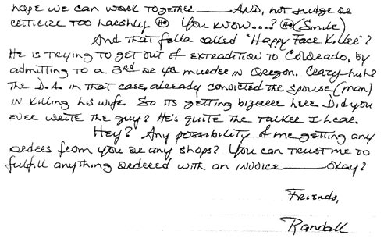

Douglas Clark - "The Sunset Strip Slayer"
Preying on blonde prostitutes and hunting primarily on the well-known Sunset Strip. Murdered 6 people. Douglas Clark coerced his girlfriend Carol Bundy to pick up the women and bring them to him. He then would strike a deal for oral sex and during the act shoot them through the head and engage in sexual acts with their dead bodies. Another example odd strange beginnings & endings, deformed lower zone, sharp angles, covering strokes and a signature that looks as if two people had written it.
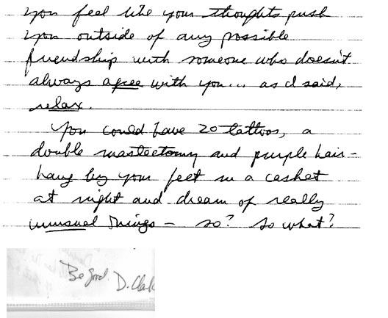

Paul John Knowles
Killed brutally at least 15 people in a 4 months period in 1975. Was shot dead while trying to escape.
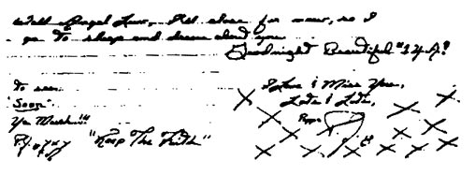
There is an abundance of Schizoid characteristics as well as invented letters.

Charles Manson
Leader of a brutal killers-family together with 3 girls. Was tried for 7 murders in 1969. Manson's handwriting possesses only a few schizoid signs, however, there are strange unnecessary lines. His signature is buried underneath covering lines and it looks like a signatures.

The Zodiac Murder
The anonymous murderer sent letters to newspapers with a zodiac cross, until 1974. During a 9 months period in 1969, 5 murders, amongst them 2 teenagers. This handwriting also possesses most of the Schizoid characteristics.
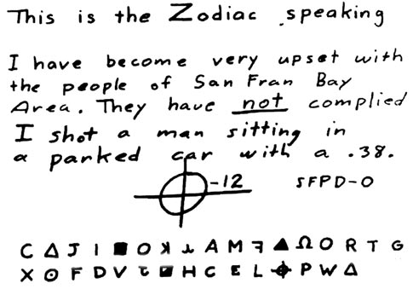

John Wayne Gacy
John Wayne Gacy was married twice, had a job, and was involved and respected in the community. 29 bodies of men in the ages between 9 and mid-twenties , endured savage sexual torture were found in his crawlspace. Gacy was sentenced to death and executed.
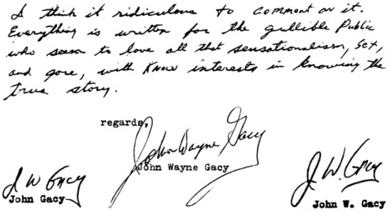

George Putt
George Putt, physically and emotionally abused was one of 7 children, emotionally abused beaten by his drunk father, sustained permanent brain damage due to a game accident. He got married. Putt was found guilty of 5 killings and given death penalty.
Gregg Putt is a high-leveled schizoid. However, weakness can be detected in the apparent under developed, narrow handwriting.

William Suff
(1984-1993), aka "the Riverside Prostitute Killer" or "The Lake Elsinore Killer" was a 41-year old government stock clerk from Riverside County, California who liked to impersonate police officers, write books, drive fancy cars, and do community service work. His neighbors described him as "a friendly nerd who was always doing things to help people". He had, however, spent some time in prison during the 1970s in Texas for beating his 2-month-old daughter to death along with his wife. In the orange groves of Riverside County, he dumped the bodies of 13 victims, all prostitutes, and authorities suspected he may have been responsible for as many as 22 deaths in the local area. Another schizoid with an emphasis on the lower part, strange shapes and cover strokes. Narrow, frozen and tense handwriting. Notice the difference between the upper and lower zone. That may explain the difference between his demeanor at work and as a serial killer.

