HANDWRITING ANALYSIS LAB #1:

COMPARISON OF HANDWRITING SAMPLES: USING THE FOURTH AMENDMENT

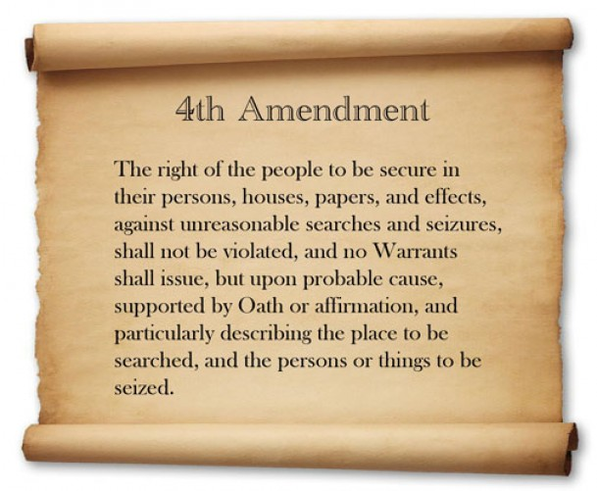

Data Table 1: Analysis of Handwriting Student 1 Name: __________________________

Characteristic # | Yes | No | Comments (and measurements in mm) If required
1. Is line quality smooth?
2. Are words and margins evenly spaced? |  |  | Margins:
 |  |  | Words:
3. Is ratio of small letters to capital letters consistent?
4. Is the writing continuous?
5. Are letters connected between capitals and lowercase letters?
6. Are letter formations complete? |  |  | (Be specific, which letters?)
7. Is all of the writing cursive? |  |  | (Be specific, which words?)
8. Is the pen pressure the same?
9. Do all letters slant to the right?
10. Are all letters written on the line?
11. Are there fancy curls or loops? |  |  | (Which letters?)
12. Are all “i”s dotted and “t”s crossed? (top, middle, or not) |  |  | “i”s
 |  |  | “t”s

Data Table 2: Analysis of Handwriting Student 2_______________________________

Characteristic # | Yes | No | Comments (and measurements in mm) if required
1. Is line quality smooth?
2. Are words and margins evenly spaced? |  |  | Margins:
 |  |  | Words:
3. Is ratio of small letters to capital letters consistent?
4. Is the writing continuous?
5. Are letters connected between capitals and lowercase letters?
6. Are letter formations complete? |  |  | (Be specific, which letters?)
7. Is all of the writing cursive? |  |  | (Be specific, which words?)
8. Is the pen pressure the same?
9. Do all letters slant to the right?
10. Are all letters written on the line?
11. Are there fancy curls or loops? |  |  | (Which letters?)
12. Are all “i”s dotted and “t”s crossed? (top, middle or not) |  |  | “i”s
 |  |  | “t”s

After completing the handwriting analysis of your own handwriting and that of your partner’s handwriting, answer the following questions:

- Were the handwritings samples similar, or could you easily tell that the two samples of handwriting were not from the same person by simply glancing at them? Explain your answer.

- Review your data tables of the two handwriting analyses. Did the two handwriting samples have any characteristics that were the same?

- Review your data tables and state what characteristics were very different.

- Reviewing your data tables, were any handwriting traits found in either of the two samples that seem to be very unique and could easily be used to help identify any other handwriting samples written by either you or your classmate? If so, describe the trait below:

