Name: ___________________________________ BUBBLE GUM: CALCULATING PERCENT SUGAR

Have you ever looked on a package of bubble gum to see what it was made of? The gum in bubble gum is made of sugar, flavorings and two different kinds of saps collected from the chicle and gutta siak trees. The chicle comes from the sap of the Manilkara, which is an evergreen tree grown in Mexico, Central America, and tropical sections of South America. Cuts are made at the base of the tree, and cups are hung below the cuts to collect the sap. This sap was found to be fun to chew—you could probably even blow bubbles with this sap just as it comes from the tree!

PURPOSE: The percent by mass of sugar and flavoring in gum will be measured. Compare brands of gum.

MATERIALS: Balance, Bubble gum

PROCEDURE:
- Obtain one piece of bubble gum of the same brand and flavor for each member of your lab group. Do not unwrap the gum. Record the brand name and flavor on your data sheet.
- While it is still wrapped, measure the total mass of all pieces of gum in your lab group. Record this on your data sheet.
- Without touching the gum, remove the wrapper and place the gum in your mouth and chew it. Save your wrapper. While you are chewing the gum, measure the total mass of all gum wrappers in your group.
- Calculate the total mass of the gum without the wrapper by subtraction. Show work below and record your answer in your data table.

- Calculate the average mass of one piece of gum. Show work below and record your answer on your data table.

- After fifteen minutes of chewing, remove the gum from your mouth with as little moisture as possible and without touching it place it back in its own gum wrapper. Measure the total mass of the gum and wrappers for your group.
- Calculate the total mass of chewed gum in your lab group without wrapping. Show work below and record your answer on your data table.

- Calculate the average mass of one piece of chewed gum without wrapping. Show work below and record your answer on your data table.

- Calculate the percentage of sugar and flavorings in the gum using the following formula: Show work below and record your answer on your data table.

Percentage sugar & flavorings = Average mass sugar & flavorings x 100%
Average mass of gum before chewing

- Share percent of sugar and flavoring with groups that had different gum. Record the brand and percent sugar in data table 2.

DATA TABLE 1:
 | Before Chewing | After Chewing
1. Brand Name and Flavor
2. Total Mass of Gum in Lab Group with Wrapping
3. Total Mass of Wrapping in Lab Group
4. Total mass of Gum in lab Group without Wrapping
5. Average Mass of one piece of Gum without Wrapping
6. Total mass of Gum in lab group with Wrapping
7. Total mass of Gum in Lab group without Wrapping
8. Average mass of one piece of Gum without Wrapping
9. Percent of Sugar and Flavorings in Gum

DATA TABLE 2:
Brand Name | Percent

CONCLUSIONS: Explain if gum samples from different brands have the same or different percent of sugar and flavorings in them using evidence from the lab.

THE BUBBLE GUM STORY
In 1928, bubble gum was invented by a man named Walter E. Diemer. Here's what Walter Diemer, the inventor himself, said about it just a year or two before he died: "It was an accident." "I was doing something else," Mr. Diemer explained, "and ended up with something with bubbles." And history took one giant pop forward. What Mr. Diemer was supposed to be doing, back in 1928, was working as an accountant for the Fleer Chewing Gum Company in Philadelphia; what he wound up doing in his spare time was playing around with new gum recipes. But this latest brew of Walter Diemer's was -- unexpectedly, crucially -- different. It was less sticky than regular chewing gum. It also stretched more easily. Walter Diemer, 23 years old, saw the bubbles. He saw the possibilities. One day he carried a five-pound glop of the stuff to a grocery store; it sold out in a single afternoon. Before long, the folks at Fleer were marketing Diemer's creation and Diemer himself was teaching cheeky salesmen to blow bubbles, to demonstrate exactly what made this gum different from all other gums. The only food coloring in the factory was pink. Walter used it. That is why most bubble gum today is pink. Gilbert Mustin, President of Fleer named the gum Dubble Bubble and it controlled the bubble-gum market unchallenged for years, at least until Bazooka came along to share the wealth. Walter Diemer stayed with Fleer for decades, eventually becoming a senior vice president. He never received royalties for his invention, his wife told the newspapers, but he didn't seem to mind; knowing what he'd created was reward enough. Sometimes he'd invite a bunch of kids to the house and tell them the story of his wonderful, accidental invention. Then he'd hold bubble-blowing contests for them.
DID YOU KNOW?
- Dubble Bubble gum was so successful that the Fleer Company sold over a million and a half dollars worth of gum in the first year.
- Today, the average American chews 300 sticks of gum a year.
- Chewing gum has been around for over 900 years.
- A leading columnist on the subject of etiquette tells a reader asking about chewing gum in public that it is perfectly all right to do so as long as it isn’t done with too much gusto.
- In the United States alone, there are about 20 chewing gum manufacturers, with the Wrigley Company being the largest.
- In the United States, total retail sales of chewing gum (including bubble gum) is over $2.0 billion.
- They can't make chocolate-flavored chewing gum. Unfortunately, the cocoa butter in chocolate acts as an emulsifier on chewing gum base, making it extremely soft, negatively affecting the chewing quality of the product.
- During WW1, US military personnel spread the popularity of chewing gum by trading it and giving it as gifts to people in Europe, Africa, Asia and around the world.
- The first patent for chewing gum was issued in 1869 to William F. Semple, a dentist from Mount Vernon, Ohio.
- There are more than 1,000 varieties of gum manufactured and sold in the Untied States.
- Cinnamon, Spearmint, and Peppermint are the most popular flavors of gum.
- The largest bubble ever blown was 23 inches in diameter.
- Tips for getting gum unstuck from clothing: try scraping off any excess gum with a dull knife and then rubbing the area with ice until the remaining gum rolls off into a ball.
- How gum is made: The gum's ingredients are melted and filtered. Powered sugar, glucose syrup, flavoring and the other ingredients are slowly added to the gum base until the warm mix thickness like dough. Machines called extruders are used to blend, smooth, and form the gum. It's time for gum to be shaped. Gum can be flattened and cut into sticks, or squeezed into a rope shape and cut into chunks, or molded into shapes, and candy coated. After the gum is cut or molded into the appropriate shape, it's lightly sprinkled with powdered sweetener to keep it from sticking to machinery. In carefully temperature controlled room, the gum is cooled for up to 48 hours. This allows the gum to properly set. If the gum is candy coated, like most gum balls or pellet gum, it's sprayed again. This process is repeated several times until the candy shell reaches the proper thickness.
- Some cool facts about gum from the past. Ancient Greeks chewed a gum like substance called mastic. Women especially liked gum because it cleaned their teeth and it exercised their jaw muscles.
- The longest gum wrapper chain on record was 7,400 feet in length and was made by Cathy Ushler of Redmond,
- Although the exact recipes of the different types of gum vary, they are all made of the same basic ingredients: gum base, corn syrup, sugar. The gum's precise flavoring is also added.
- Have you ever been told that if you swallow a piece of gum it'll get stuck inside your digestive track for years? It's actually not true! Research shows that this is simply wrong and just an old wives tale. The gum you chew is an indigestible substance, which means that it cannot be broken down in our bodies. However, this doesn't mean that the gum you swallow is forever stuck in the pits of your stomach. It's just going to leave your body in the same condition that it came!
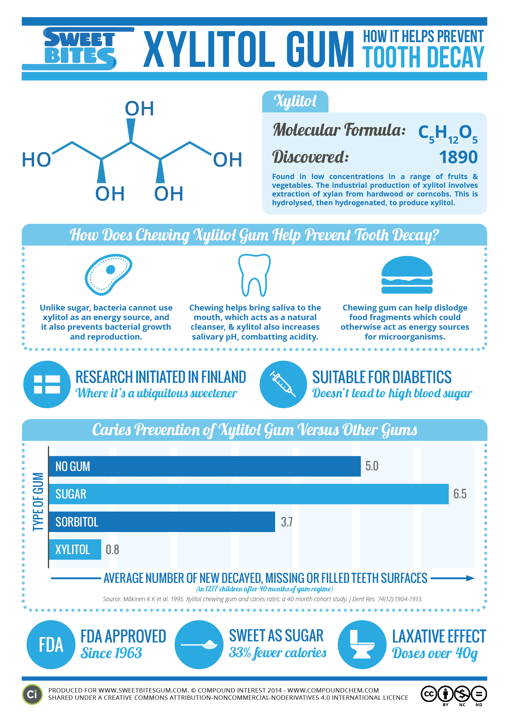
- What is the most interesting fact that you learned about gum?

- What did you already know before you read this article?

