Vocabulary
For each word, provide a short but specific definition from YOUR OWN BRAIN! No boring textbook definitions. Write something to help you remember the word. Explain the word as if you were explaining it to an elementary school student. Give an example if you can. Don’t use the words given in your definition!
Kinetic Molecular Theory: ____________________________________________________________________
Pressure: __________________________________________________________________________________
Volume: ___________________________________________________________________________________
Temperature: ______________________________________________________________________________
Boyle’s Law: _______________________________________________________________________________
Charles’s Law: ______________________________________________________________________________
Gay-Lussac’s Law: ___________________________________________________________________________
Combined Gas Law: _________________________________________________________________________
Graham’s Law: _____________________________________________________________________________
Dalton’s Law: ______________________________________________________________________________
Avogadro’s Law: ____________________________________________________________________________

Video 7.1 Gas Properties
- The concept of an ideal gas is a model to explain the behavior of gases. A real gas is most like an ideal
gas when the real gas is at _____________ pressure and ____________temperature.
- _____________ _______________ _______________ expresses the relationship between pressure, volume, temperature, velocity, and frequency and force of collisions among gas molecules.
- Kinetic molecular theory (KMT) for an ideal gas states that all gas particles are in random, constant, straight-line motion, are separated by great distances relative to their size; the volume of the gas particles is considered____________; have no attractive forces between them; have collisions that may result in the transfer of energy between particles, but the total energy of the system remains constant.
- Equal volumes of different gases at the ___________ temperature and pressure contain an equal number of particles.

- What are the properties of ideal gases?
_______________________ _______________________ _______________________
- When do real gases behave like ideal gases? _______________________________________________
- When do real gases deviate from ideal gases? ______________________________________________
- What is the relationship between pressure and volume of an ideal gas? __________________________
- Sketch a graph with pressure on the x axis and volume on the y axis:

- What is the relationship between volume and temperature of an ideal gas? ______________________
- Sketch a graph with temperature on the x axis and volume on the y axis:

- What is the relationship between pressure and temperature of an ideal gas? _____________________
- Sketch a graph with temperature on the x axis and pressure on the y axis:

- If a balloon at constant temperature increases in pressure by 3 times, how does the volume change?
- If a gas, at constant pressure, increases volume by 5 times, how does the temperature change?
- What change in temperature must be made to increase the volume of a gas by 10 times at constant pressure?

Video 7.2 Combined Gas Law

1. A gas changes from 35 to 25mL in volume. Its original temperature was at STP (LOOK AT TABLE A OF YOUR REFERENCE TABLES FOR STP VALUES). Calculate the final temperature.

2. A bubble rises from the bottom of a lake at 8C with a pressure of 6.4 atm and a volume of 2.1 mL. Calculate the new volume of the bubble at STP.

3. A gas evolved during the fermentation of glucose has a volume of 0.78 L at 20.1C and 1 atm. What is the volume of this gas if the temperature changes to 40C and 1.2 atm?

Video 7.3 Other Gas Laws
Avogadros’ Law: Two different gases at the same temperature, volume, and pressure have the ______________ number of molecules.
Gas B:
Pressure : 1.0 atm
Volume: ?
Temperature: 273K
Molecules: 6.02x10²³

Gas A:
Pressure : 1.0 atm
Volume: 22.4L
Temperature: 273K
Molecules: 6.02x10²³

- What is the volume of gas B?

- What is the pressure of gas 2?
Gas 2:
Pressure : ?
Volume: 44.8L
Temperature: 500K
Molecules: 1.20x10²⁴

Gas 1:
Pressure : 1.0 atm
Volume: 44.8L
Temperature: 500K
Molecules: 1.20x10²⁴

- How many molecules of gas Y?
Gas Y:
Pressure : 2.0 atm
Volume: 11.2L
Temperature: 373K
Molecules: ?

Gas X:
Pressure : 2.0 atm
Volume: 11.2L
Temperature: 373K
Molecules: 6.02x10²³

Graham’s Law: __________ gases move faster.
- Which gas moves the fastest? (Circle one) H₂ He CH₄ SO₂

- Which gas moves just as fast as Sulfur(S) gas? (Circle one) H₂ O₂ N₂

Dalton’s Law: The total pressure of a system equals the sum of each of the individual gas pressures.
- A container holds hydrogen, oxygen and nitrogen gas. The total pressure of the container is 3.75 atm. The pressure of hydrogen is 1.25 atm and the pressure of oxygen is 0.75 atm. What is the pressure of nitrogen gas?

- A mixture of gases contains 25kPa of nitrogen, 50kPa of oxygen, and 20kPa moles of carbon dioxide. If the total pressure is at STP, what is the partial pressure of the unknown gas?

Regents Questions

1. At which temperature would atoms of a He(g) sample have the greatest average kinetic energy?
A) 25°C B) 37°C C) 273 K D) 298 K

2. The temperature of a sample of a substance changes from 10.°C to 20.°C. How many Kelvin does the temperature change?
A) 10. B) 20. C) 283 D) 293

3. The temperature 30. K expressed in degrees Celsius is
A) 243ºC B) –243ºC C) 303ºC D) –303ºC

4. A gas is contained in a rigid cylinder. According to kinetic molecular theory, what occurs when the gas inside the cylinder is heated?
A) The number of gas molecules increases.
B) The number of collisions between gas molecules
per unit time decreases.
C) The average velocity of the gas molecules
increases.
D) The volume of the gas decreases.

5. Under which conditions of temperature and pressure would helium behave most like an ideal gas?
A) 50 K and 20 kPa B) 50 K and 600 kPa
C) 750 K and 20 kPa D) 750 K and 600 kPa

6. The kinetic molecular theory assumes that the particles of an ideal gas
A) are in random, constant, straight-line motion
B) are arranged in a regular geometric pattern
C) have strong attractive forces between them
D) have collisions that result in the system losing
energy

7. An assumption of the kinetic theory of gases is that the particles of a gas have
A) little attraction for each other and a significant volume
B) little attraction for each other and an insignificant volume
C) strong attraction for each other and a significant volume
D) strong attraction for each other and an insignificant volume

8. Under which conditions of temperature and pressure would a sample of H2(g) behave most like an ideal gas?
A) 0°C and 100 kPa B) 0°C and 300 kPa
C) 150°C and 100 kPa D) 150°C and 300 kPa

9. Which of the following gases behaves most like an ideal gas?
A) H2(g) B) O2(g)
C) NH3(g) D) CO2(g)

10. As the space between molecules in a gas sample decreases, the tendency for the behavior of this gas to deviate from the ideal gas laws
A) decreases C) increases
B) remains the same

11. The table below shows mass and volume data for four samples of substances at 298 K and 1 atmosphere.
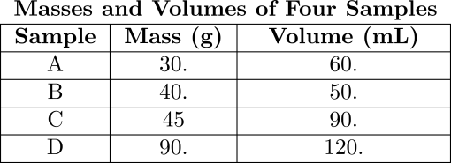
Which two samples could consist of the same substance?
A) A and B B) A and C
C) B and C D) C and D

12. A sample of oxygen gas is sealed in container X. A sample of hydrogen gas is sealed in container Z. Both samples have the same volume, temperature, and pressure. Which statement is true?
A) Container X contains more gas molecules than container Z.
B) Container X contains fewer gas molecules than container Z.
C) Containers X and Z both contain the same number of gas molecules.
D) Containers X and Z both contain the same mass of gas.

13. A gas occupies a volume of 40.0 milliliters at 20°C. If the volume is increased to 80.0 milliliters at constant pressure, the resulting temperature will be equal to
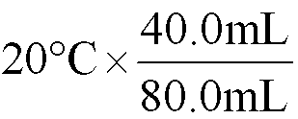
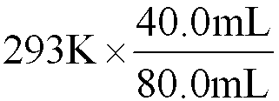
A) 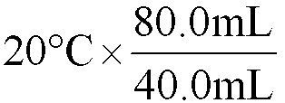 B)

C) 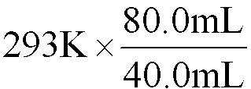 D)

14. Which gas diffuses most rapidly at STP?
A)Ne B) Ar C) Cl₂ D) F₂

15. The data table below gives the temperature and pressure of four different gas samples, each in a 2-liter container.
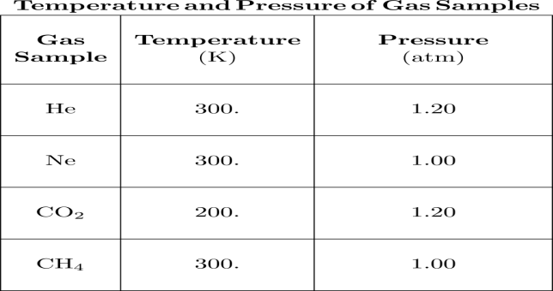
Which two gas samples contain the same total number of particles?
A) CH₄ and CO₂ C) CH₄ and Ne
B) He and CO₂ D) He and Ne
16. A sample of gas is held at constant pressure. Increasing the kelvin temperature of this gas sample causes the average kinetic energy of its molecules to
A) decrease and the volume of the gas sample to decrease
B) decrease and the volume of the gas sample to increase
C) increase and the volume of the gas sample to decrease
D ) increase and the volume of the gas sample to increase

17. As the temperature of a gas increases at constant pressure, the volume of the gas
A) decreases B) increases C) remains the same

18. Standard temperature and a pressure of 0.5 atmosphere are equal to
A) 0°C and 51.6 kPa B) 32°C and 51.6 kPa C) 0°C and 101.3 kPa D) 32°C and 101.3 kPa

19. Under the same conditions of temperature and pressure, which gas will diffuse at the slowest rate?
A) He B) Ne C) Ar D) Rn

20. A 2.5 liter sample of gas is at STP. When the temperature is raised to 273ºC and the pressure remains constant, the new volume of the gas will be
A) 1.25 L B) 2.5 L
C) 5.0 L D) 10. L

21. What is the difference in pressure between a gas at 50.0 kPa and a gas at standard pressure?
A) 0.0 kPa B) 51.3 kPa
C) 101.3 kPa D) 223 kPa

22. A sample of oxygen gas in a closed system has a volume of 200 milliliters at 600 K. If the pressure is held constant and the temperature is lowered to 300 K, the new volume of the gas will be
A) 100 ml B) 200 ml
C) 300 ml D) 400 ml

23. Base your answer to the following question on the graphs shown below.
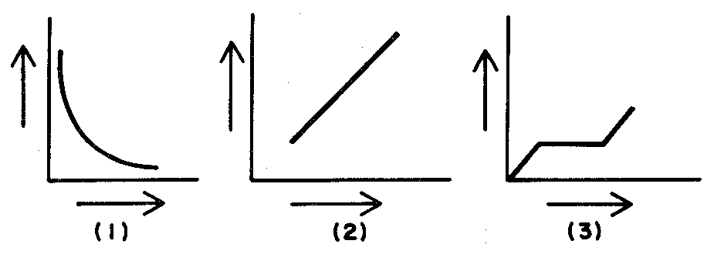
Which graph best represents how the volume of a given mass of a gas varies with the pressure exerted on it at constant temperature?
A) 1 B) 2 C) 3

24. A sample of gas has a volume of 2.0 liters at a pressure of 1.0 atmosphere. When the volume increases to 4.0 liters, at constant temperature, the pressure will be
A) 1.0 atm B) 2.0 atm
C) 0.50 atm D) 0.25 atm

25. A sealed container of nitrogen gas contains 6 × 1023 molecules at STP. As the temperature increases, the mass of the nitrogen will
A) decrease B) increase
C) remain the same

