Key Ideas
- The concept of an ideal gas is a model to explain the behavior of gases. A real gas is most like an ideal
gas when the real gas is at low pressure and high temperature. (3.4a)
- Kinetic Molecular Theory expresses the relationship between pressure, volume, temperature, velocity, and frequency and force of collisions among gas molecules. (3.4c)
- Kinetic molecular theory (KMT) for an ideal gas states that all gas particles (3.4b): are in random, constant, straight-line motion, are separated by great distances relative to their size; the volume of the gas particles is considered negligible; have no attractive forces between them; have collisions that may result in the transfer of energy between particles, but the total energy of the system remains constant.
- Equal volumes of different gases at the same temperature and pressure contain an equal number of particles. (3.4e)
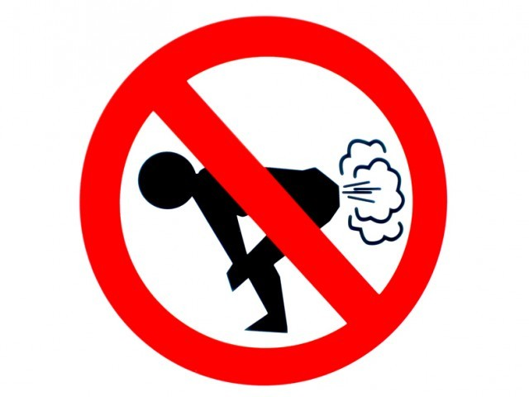

Kinetic Molecular Theory

KMT is the study of how ideal or _____________ gases behave. Real gases behave most like ideal gases under ________ pressure and ________ temperature.

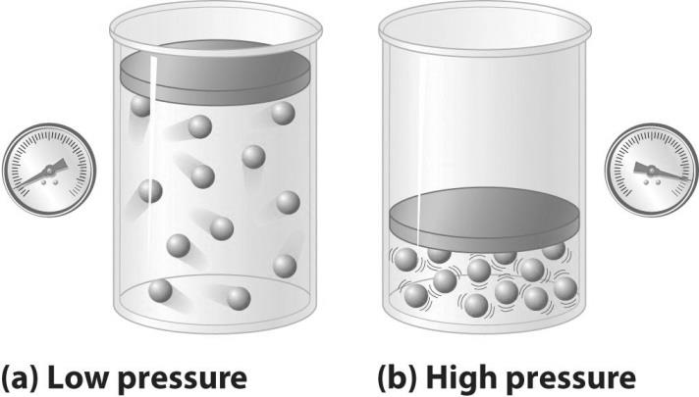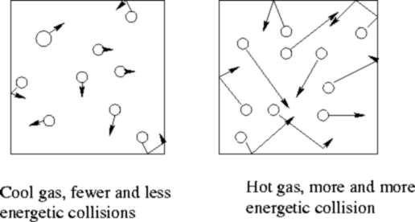

- Based on the demonstration performed by your teacher, describe how gas molecules behave:
Motion: ___________________________________________________________
Collisions: __________________________________________________________
Volume: ___________________________________________________________
Attractions: ________________________________________________________

- How can you get a real gas to behave the LEAST like an ideal gas?
- Of the following: H₂, He, CO₂, which would behave least like and ideal gas and why?
- Which of the gases in question 3 behaves the most like ideal gases/ Why?
- Compared to other gases, why doesn’t water vapor behave ideally?
- Why do gases behave the least like ideal gases at low temperatures and high pressures?

Gas Laws
FILL IN THE BLANKS WITH INCREASE(S) OR DECREASE(S).

Boyle’s Law relates pressure and volume. When pressure is increased on a gas at constant temperature, the volume _____________________. This is an indirect relationship.
- Pilots suffer from intestinal pain when they fly because at higher altitudes, the pressure is decreased so the air volume in their body _______________________.
- Your lungs suck in air when the diaphragm is enlarged. When the diaphragm opens, the lung expands, the volume _______________ and the pressure ________________ which allows air in. When the diaphragm collapsed, there is less room so the volume ___________ and the pressure _____________.
- Scuba divers need to be careful when checking their air tanks. When they descend in the water the water pressure increases and pushes on the tank. The tank air pressure increases and the volume of the air _______________. When they ascend to the surface, the pressure decreases and the volume of the gas in their tank and body _______________________.
- Why do you ears pop on an airplane? (Hint: the air pressure decreases at high altitudes.) explain in terms of pressure and volume.

Charles’ Law relates volume and temperature. When temperature is increased on a gas at constant pressure, the volume _____________________. This is a direct relationship.
- Hot air balloons work based on density changes affected by Charles law. To rise, the temperature is __________________ and the volume ____________________ to make the density low. To come back down the fire is turned off so the temperature _______________ and volume ________________ so the density increases. The balloon is always inflated so the pressure is relatively constant.
- To un-dent ping pong balls submerge them in hot water. Explain this phenomenon in terms of volume and temperature.

- A balloon outside in the winter seems to deflate but inside it re-inflates. However the number of gas molecules stays constant. How does that happen? Explain in terms of volume and temperature.
Gay Lussac’s Law relates pressure and temperature. When temperature is increased on a gas at constant volume (in a rigid container), the pressure ______________ because the gas molecules move more. This is a direct relationship.
- Drivers need to check the air pressure on their tires during change of seasons. In the winter the temperatures are decreased, the pressure inside the tires is ____________________ and the tires are flat. In the summer temperatures are increased and pressures are__________________ so the tires are swollen. But the volume the tires air can occupy stays the same.
- Don’t put aerosol spray cans in direct heat or flames because they explode. Explain this phenomenon in terms of pressure and temperature.

Gases Review Regents Questions
- Which term is defined as a measure of the average kinetic energy of the particles in a sample?
  - temperature B) pressure C) thermal energy D) chemical energy

- At which temperature would atoms of a He(g) sample have the greatest average kinetic energy?
A) 25°C B) 37°C C) 273 K D) 298 K

- The average kinetic energy of water molecules is greatest in which of these samples?
  - 10 g of water at 35°C C) 10 g of water at 55°C
  - 100 g of water at 25°C D) 100 g of water at 45°C

- Which change in the temperature of a 1-gram sample of water would cause the greatest increase in the average kinetic energy of its molecules?
  - 1°C to 10°C B) 10°C to 1°C C) 50°C to 60°C D) 60°C to 50°C

- What is the equivalent of 0 Kelvin on the Celsius scale?
A) –100º B) 100º C) –273º D) 273º

- The temperature of a sample of a substance changes from 10.°C to 20.°C. How many Kelvin does the temperature change? A) 10. B) 20. C) 283 D) 293

- The temperature 30. K expressed in degrees Celsius is
A) 243ºC B) –243ºC C) 303ºC D) –303ºC

- Which temperature is equal to +20 K?
A) –253ºC B) –293ºC C) 253°C D) 293°C
- Which Kelvin temperature is equal to –73ºC?
A) 100 K B) 173 K C) 200 K D) 346 K

- A sample of a gas is contained in a closed rigid cylinder. According to kinetic molecular theory, what occurs when the gas inside the cylinder is heated?
  - The number of gas molecules increases.
  - The number of collisions between gas molecules per unit time decreases.
  - The average velocity of the gas molecules increases.
  - The volume of the gas decreases.

- Under which conditions of temperature and pressure would He behave most like an ideal gas?
  - 50 K and 20 kPa B) 50 K and 600 kPa C) 750 K and 20 kPa D) 750 K and 600 kPa

- The kinetic molecular theory assumes that the particles of an ideal gas
  - are in random, constant, straight-line motion
  - are arranged in a regular geometric pattern
  - have strong attractive forces between them
  - have collisions that result in the system losing energy

- The concept of an ideal gas is used to explain
  - the mass of a gas sample C) why some gases are diatomic
  - the behavior of a gas sample D) why some gases are monatomic

- Under which conditions does a real gas behave most like an ideal gas?
  - at low temperatures and high pressures C) at low temperatures and low pressures
  - at high temperatures and high pressures D) at high temperatures and low pressures

- Two basic properties of the gas phase are
  - a definite shape and a definite volume C) a definite shape but no definite volume
  - no definite shape but a definite volume D) no definite shape and no definite volume

- An assumption of the kinetic theory of gases is that the particles of a gas have
  - little attraction for each other and a significant volume
  - little attraction for each other and an insignificant volume
  - strong attraction for each other and a significant volume
  - strong attraction for each other and an insignificant volume

- According to the kinetic theory of gases, which assumption is correct?
  - Gas particles strongly attract each other.
  - Gas particles travel in curved paths.
  - The volume of gas particles prevents random motion.
  - Energy may be transferred between colliding particles.

- When a sample of a gas is heated at constant pressure, the average kinetic energy of its molecules
  - decreases, and the volume of the gas increases
  - decreases, and the volume of the gas decreases
  - increases, and the volume of the gas increases
  - increases, and the volume of the gas decreases

- Under which conditions of temperature and pressure would a sample of H2(g) behave most like an ideal gas?
  - 0°C and 100 kPa B) 0°C and 300 kPa C) 150°C and 100 kPa D) 150°C and 300 kPa

- A real gas behaves more like an ideal gas when the gas molecules are
  - close and have strong attractive forces between them
  - close and have weak attractive forces between them
  - far apart and have strong attractive forces between them
  - far apart and have weak attractive forces between them

- A real gas differs from an ideal gas because the molecules of real gas have
  - some volume and no attraction for each other
  - some volume and some attraction for each other
  - no volume and no attraction for each other
  - no volume and some attraction for each other

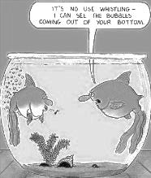
Combined Gas Law

Remember constant can be crossed out in the equation. You should have three numbers and one x.

- If the temperature of a 50mL sample of a gas is changed from 200K to 400K under constant pressure, what is the new volume of the gas?

- The volume of a gas is 204mL when the pressure is 925kPa. At constant temperature, what is the final pressure if the volume increases to 306ml?

- When extended, a bike pump has a volume of 0.952dm³ at standard pressure. Assuming the temperature is constant, what is the new pressure if the volume changes to 0.225dm³?

- A balloon has a volume of 1.75L at a temperature of 298K. What will be the volume of the balloon if you take it out into the winter cold air at 258K? Assume pressure is constant.

- A 1.53L sample of sulfur (IV) oxide at a pressure of 5.60kPa. If the pressure is changed to 15.0kPa at constant temperature, what will be the new volume of the gas? Assume temperature is constant.

- The Hindenburg exploded in 1937. It held 2.0x10⁵ m³ of hydrogen gas at 23C at standard pressure. How much gas would that be at standard pressure on a warm day of 45C?

Now problems with all three variables…. Uh oh

- An aerosol spray can with a volume of 456mL contains 3.18g of propane gas as a propellant. If the can is at 23C, and 0.50atm, what volume would the propane occupy at STP?

- Suppose the P and T was tripled on a 6.0L sample of a gas. What is the new volume?

- A gas has a volume of 50. mL at a temperature of 10.0 K and a pressure of 760. kPa. What will be the new volume when the temperature is changed to 20.0 K and the pressure is changed to 380. kPa?

- The volume of a sample of a gas at 273 K is 100.0 L. If the volume is decreased to 50.0 L at constant pressure, what will be the new temperature of the gas?

- A gas has a volume of 2.00 L at 323 K and 3.00 atm. What will be the new volume if the temperature is changed to 273 K and the pressure is changed to 1 atm?

- What will be the new volume of 100. mL of gas if the Kelvin temperature and the pressure are both halved?

- A gas occupies a volume of 500. mL at a pressure of 380. kPa and a temperature of 298 K. At what temperature will the gas occupy a volume of 250. mL and have a pressure of 760. kPa?

- A gas at STP has a volume of 1.00 L. If the pressure is doubled and the temperature remains constant, what is the new volume of the gas?

- A 2.5 L sample of gas is at STP. When the temperature is raised to 373°C and the pressure remains constant what will the new volume of the gas be?

- A cylinder of a car’s engine has a volume of 0.725 L when the piston is at the bottom of the cylinder. When the piston is at the top of the cylinder it has a volume of 0.050L. If the cylinder is filled with air at a pressure of 1 atm when the piston is at the bottom, what is the pressure when the piston is at the top if the temperature remains constant?

- A sample of gas is held at constant pressure. Increasing the kelvin temperature of this gas sample causes the average kinetic energy of its molecules to
  - decrease and the volume of the gas sample to decrease
  - decrease and the volume of the gas sample to increase
  - increase and the volume of the gas sample to decrease
  - increase and the volume of the gas sample to increase

- A sample of helium gas has a volume of 900. milliliters and a pressure of 2.50 atm at 298 K. What is the new pressure when the temperature is changed to 336 K and the volume is decreased to 450. milliliters?
  - 0.177 atm b. 4.43 atm c. 5.64 atm d. 14.1 atm

- A gas occupies a volume of 444 mL at 273 K and 79.0 kPa. What is the final kelvin temperature when the volume of the gas is changed to 1880 mL and the pressure is changed to 38.7 kPa?
  - 31.5 K b. 292 K c. 566K d. 2360K

Pressure

1 atmosphere is equal to ________ kPa = __________ mmHg = _________ torr

Convert the following to atmospheres: Convert the following to kilopascals:
- 560.0 mmHg 7. 1.2 atm

- 7600 mmHg 8. 0.86 atm

- 250.0 mmHg 9. 3.25 atm

- 202.6 kPa 10. 850 mmHg

- 50.6 kPa 11. 450.0 mmHg

- 150.0 kPa 12. 1560 mmHg

Ideal Gas Law
- A 7.8g piece of solid carbon dioxide is placed in a 4.0L container at 27 degrees Celsius. What is the pressure in atmospheres in the container after all the carbon dioxide vaporizes?

- The Hindenburg exploded in 1937. It held 2.0x10⁵ m³ of hydrogen gas at 23C and standard pressure what mass of hydrogen was present? (1m³ = 1000L)

- A scuba diver's tank contains 0.29kg of oxygen compressed into a volume of 2.3L. What is the pressure in the tank a 9C?

- Compare and contrast the two gas laws:

Combined Ideal
Graham’s Law

- At STP, which gas diffuses at the faster rate?
A) H2 B) N2 C) CO2 D) NH3

- Which gas diffuses most rapidly at STP?
  - Ne B) Ar C) Cl₂ D) F₂

- Under the same conditions of temperature and pressure, which gas will diffuse at the slowest rate?
  - He B) Ne C) Ar D) Rn

- Which of the following gases would have the slowest rate of diffusion when all of the gases are held at the same temperature and pressure?
- N2 B) NO C) O2 D) CO2

- Which gas would diffuse most rapidly under the same conditions of temperature and pressure?
  - gas A, molecular mass = 4 C) gas B, molecular mass = 16
  - gas C, molecular mass = 36 D) gas D, molecular mass = 49

Avogadro’s Law

- The table below shows mass and volume data for four samples of substances at 298 K and 1 atm.
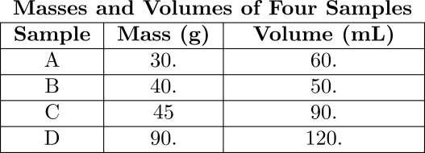
Which two samples could consist of the same substance?
  - A and B C) A and C
  - B and C D) C and D

- A sample of oxygen gas is sealed in container X. A sample of hydrogen gas is sealed in container Z. Both samples have the same volume, temperature, and pressure. Which statement is true?
  - Container X contains more gas molecules than container Z.
  - Container X contains fewer gas molecules than container Z.
  - Containers X and Z both contain the same number of gas molecules.
  - Containers X and Z both contain the same mass of gas.

- At the same temperature and pressure, 1.0 liter of CO(g) and 1.0 liter of CO2(g) have
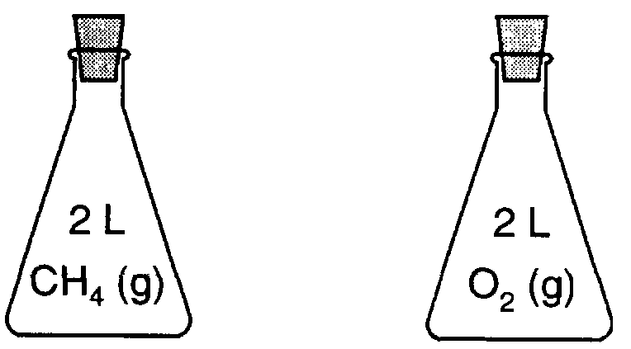
  - equal masses and the same number of molecules
  - different masses and a different number of molecules
  - equal volumes and the same number of molecules
  - different volumes and a different number of molecules

- Each stoppered flask to the right contains 2 liters of a gas at STP. Each gas sample has the same
  - Density B) mass C) number of molecules D) number of atoms

- A sample of H2(g) and a sample of N2(g) at STP contain the same number of molecules. Each sample must have
  - the same volume, but a different mass
  - the same mass, but a different volume
  - both the same volume and the same mass
  - neither the same volume nor the same mass

- The diagrams below represent three 1-liter containers of gas, A, B, and C. Each container is at STP.
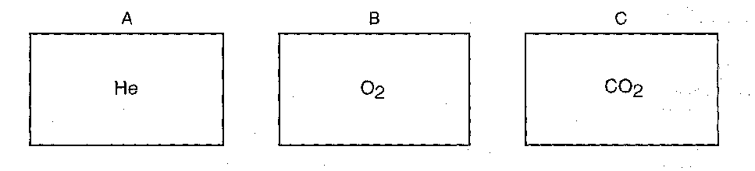
Which statement correctly compares the number of molecules in the containers?
  - Container A has the greatest number of molecules.
  - Container B has the greatest number of molecules.
  - Container C has the greatest number of molecules.
  - All three containers have the same number of molecules.

Dalton’s Law

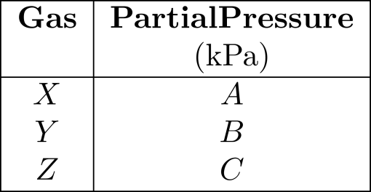
- Gases X, Y, and Z, in a closed system at constant temperature, have a total pressure of 80 kPa. The partial pressure of each gas is shown below.

The partial pressure of gas X, in kPa, is equal to
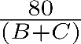
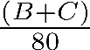
  - B)
C) D)

- What is the pressure of a mixture of CO2, SO2, and H2O gases, if each gas has a partial pressure of 25 kPa?
  - 25 kPa B) 50 kPa C) 75 kPa D) 101 kPa

- A flask contains a mixture of N2(g) and O2(g) at STP. If the partial pressure exerted by the N2(g) is 40.0 kPa, the partial pressure of the O2(g) is
  - 21.3 kPa B) 37.3 kPa C) 61.3 kPa D) 720 kPa

- Gas samples A, B, and C are contained in a system at STP. The partial pressure of sample A is 38.0 kPa and the partial pressure of sample B is 19.0 kPa. What is the partial pressure of sample C?
  - 19.0 kPa B) 38.0 kPa C) 44.3 kPa D) 63.3 kPa

- The partial pressures of gases A, B, and C in a mixture are 0.750 atmosphere, 0.250 atmosphere, and 1.25 atmospheres, respectively. What is the total pressure of the gas mixture in kPa?
  - 2.25 kPa B) 202 kPa C) 228 kPa D) 301 kPa

- The diagram below shows two flasks connected by a stopcock. Flask A contains helium gas. Flask B contains a vacuum.
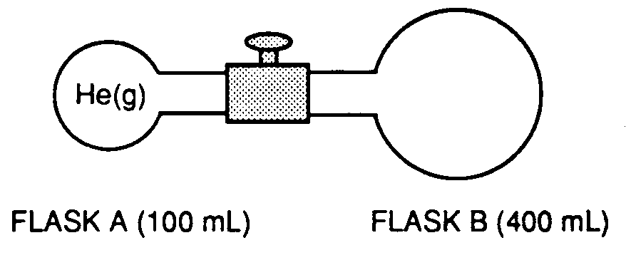
What final volume will the gas occupy after the stopcock is opened?
  - 100 ml B) 300 ml C) 400 ml D) 500 ml

- A mixture of oxygen, nitrogen, and hydrogen gases exerts a total pressure of 74 kPa at 0ºC. The partial pressure of the oxygen is 20 kPa and the partial pressure of the nitrogen is 40 kPa. What is the partial pressure of the hydrogen gas in this mixture?
  - 14 kPa B) 20 kPa C) 40 kPa D) 74 kPa

Unit 7 Gases Chemistry Review

Kinetic Molecular Theory

Gases are spread out and constantly moving in random straight line motion. Ideal gases have no mass, no volume, and no attractive forces.

- Give an example of the most ideal gas on the periodic table : _____________

- Under what conditions of temperature and pressure will a gas behave ideally? _________________

- Draw five particles of He in the gas phase:

Combined Gas Law

Volume is the amount of space a substance takes up. Pressure is the amount of force that substance has on another object measured in atmospheres or kilopascals. Temperature is the measure of kinetic energy a sample has measured in degrees Celsius or Kelvin. Standard temperature and pressures are listed on Table A. The calculation formula is on table T.

- What are the possible values for standard temperature? _____________ and _______________

- What are the possible values for standard pressure? _____________ and _______________

- When pressure increases, volume ____________________.

- When pressure increases, temperature _______________________.

- When temperature increases, volume ____________________.

- The pressure of a gas is 1.2 atm at 300K. Calculate the pressure at 250K if the gas is in a rigid container.

- The volume of a gas at 500K is 50.6L. Calculate the volume at 750K.

- A 1.5L sample of a gas at 150kPa and 250K is changed to STP. What is the new volume?

- Sketch graphs to represent the following relationships:

  - Pressure and volume

  - Pressure and temperature

  - Volume and temperature

Avogadro’s Law states that two different gases at the same temperature, pressure and volume must have the same number of molecules. (Molecules also could mean moles. Not the same atoms or grams!)

- Which sample would have the same number of molecules as 11.2L of He (g) at 273K and 202kPa?
- 11.2L of N₂(g) at 300K and 202kPa
- 22.4L of Ne(g) at 546K and 404K
- 11.2L of CH₄(g) at 273K and 202kPa

- At what volume will 22.4L of O₂ (g) at 303K and 1.2atm have the same number of molecules as Neon gas at 303K and 1.2atm? _________________

Grahams Law states that light gases diffuse the fastest. Diffuse means to spread out and travel.

  - Which gas on the periodic table diffuses the fastest? _______________

  - Circle the two gases that diffuse at a similar speed: H₂O Ne H₂ SO₂

