Directions:  - Organize the chemicals into categories of your choosing. Pay less attention to the number of carbon atoms, and more attention to the new elements that make these compounds not hydrocarbons and their properties.  - Think about how these chemicals will be named. For each category, decide if they need one organic prefix (meth-, eth-) or two separate prefixes. | 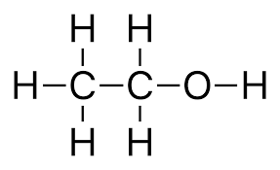  Boiling Point: 78°C  Melting Point: -114°C  Water Soluble  Flammable
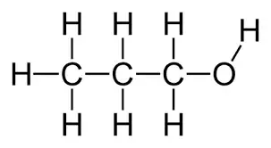  Boiling Point: 97°C  Melting Point: -126°C  Water Soluble  Flammable | 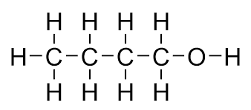  Boiling Point: 117°C  Melting Point: -90°C  Water Soluble  Flammable
Boiling Point: -24°C  Melting Point: -141°C  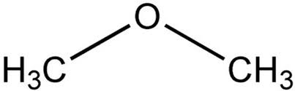  Water Insoluble  Anesthetic | 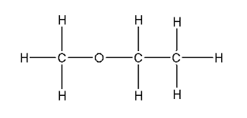  Boiling Point: 34°C  Melting Point: -116°C  Water Insoluble  Anesthetic
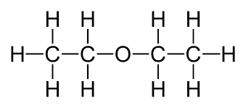  Boiling Point: 34°C  Melting Point: -116°C  Water Insoluble  Anesthetic | 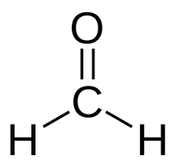  Boiling Point: -19°C  Melting Point: -92°C  Water Soluble  Preservative  Carcinogen
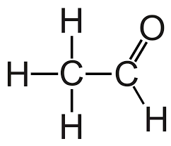  Boiling Point: 20°C  Melting Point: -123°C  Water Soluble  Preservative  Carcinogen | Boiling Point: 49°C  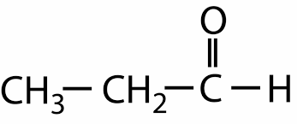  Melting Point: -81°C  Water Soluble  Preservative  Carcinogen
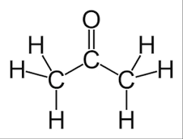  Boiling Point: 56°C  Melting Point: -95°C  Water Soluble  Industrial solvent | 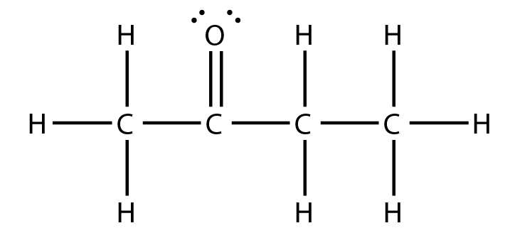  Boiling Point: 80°C  Melting Point: -86°C  Water Soluble  Industrial solvent
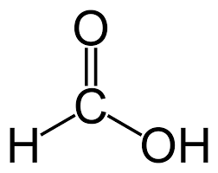  Boiling Point: 101°C  Melting Point: 8.4°C  Water Soluble  Low pH | 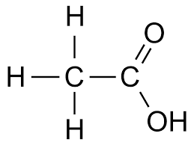  Boiling Point: 118°C  Melting Point: 17°C  Water Soluble  Low pH
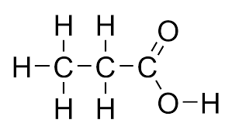  Boiling Point: 164°C  Melting Point: -8°C  Water Soluble  Low pH | 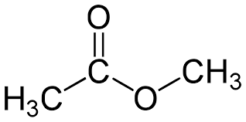  Boiling Point: 57°C  Melting Point: -98°C  Water Insoluble  Pleasant odor
Boiling Point: 99°C  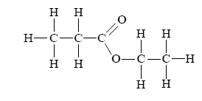  Melting Point: -74°C  Water Insoluble  Pleasant odor | Boiling Point: 77°C  Melting Point: -84°C  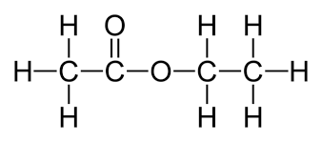  Water Insoluble  Pleasant odor
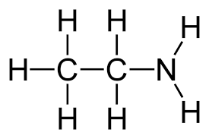  Boiling Point: 17°C  Melting Point: -80°C  Water Soluble  Basic  Bad odor  In proteins | 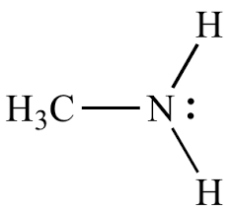  Boiling Point: -6°C  Melting Point: -93°C  Water Soluble  Basic  Bad odor  In proteins
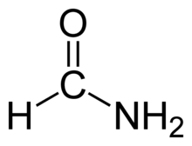  Boiling Point: 210 °C  Melting Point: 2°C  Water Soluble  Used in dyes, pesticides, fuel,  and cleaning agents. | 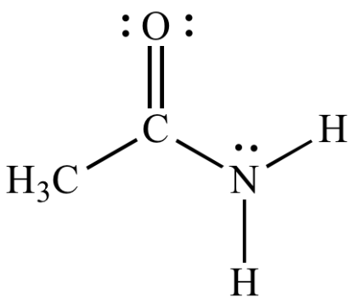  Boiling Point: 222°C  Melting Point: 176°C  Water Soluble  Used in dyes and creating plastics.

