Directions:  - Organize the chemicals into categories of your choosing. Pay less attention to the number of carbon atoms, and more attention to the new elements that make these compounds not hydrocarbons and their properties.  - Think about how these chemicals will be named. For each category, decide if they need one organic prefix (meth-, eth-) or two separate prefixes. | 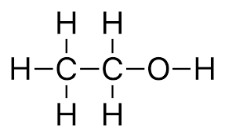  Water Soluble  Flammable
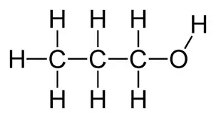  Water Soluble  Flammable | 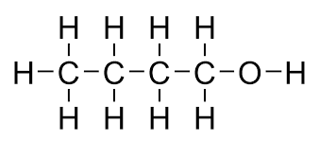  Water Soluble  Flammable
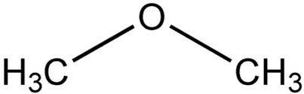  Water Insoluble  Anesthetic | 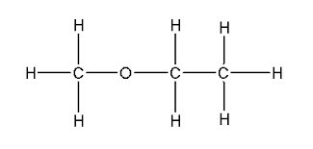  Water Insoluble  Anesthetic
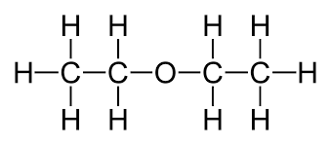  Water Insoluble  Anesthetic | 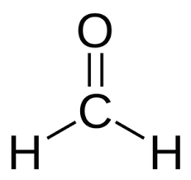  Water Soluble  Preservative  Carcinogen
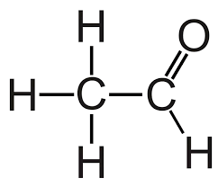  Water Soluble  Preservative  Carcinogen | 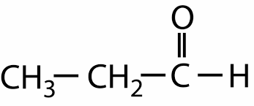  Water Soluble  Preservative  Carcinogen
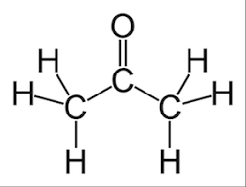  Water Soluble  Industrial solvent | 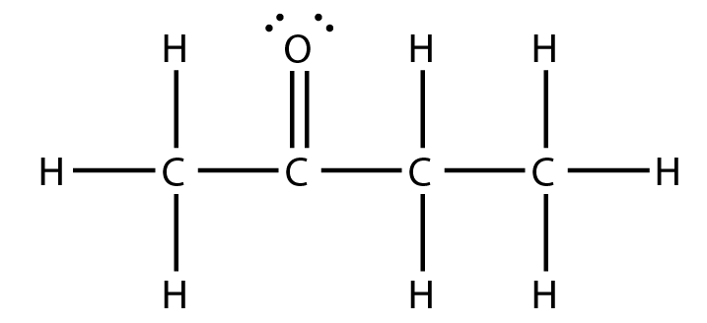  Water Soluble  Industrial solvent
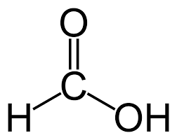  Water Soluble  Low pH | 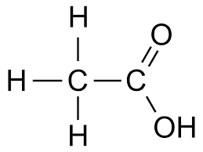  Water Soluble  Low pH
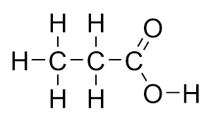  Water Soluble  Low pH | 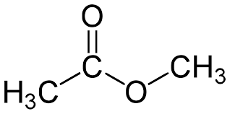  Water Insoluble  Pleasant odor
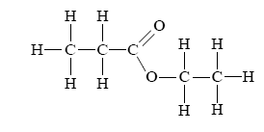  Water Insoluble  Pleasant odor | 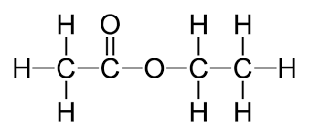  Water Insoluble  Pleasant odor
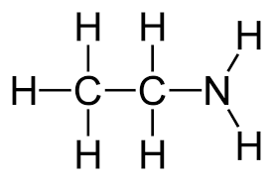  Water Soluble  Basic  Bad odor  In proteins | 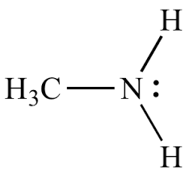  Water Soluble  Basic  Bad odor  In proteins
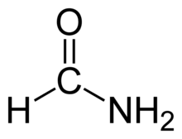  Water Soluble  Used in dyes, pesticides, fuel,  and cleaning agents. | 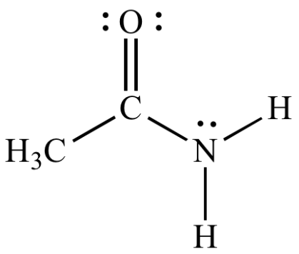  Water Soluble  Used in dyes and creating plastics.
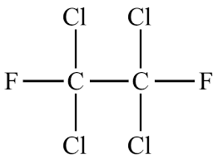  Greenhouse gas  Used in strong plastics like teflon and kevlar | 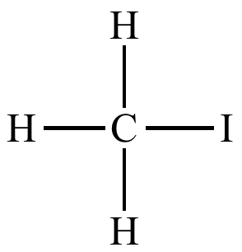  Greenhouse gas  Used in strong plastics like teflon and kevlar

