Name: _______________________________________ Food Chemistry Review

- Label the following as a Carbohydrate, lipid, or protein.
  - explain how you knew
  - give an example of foods with this primary food group

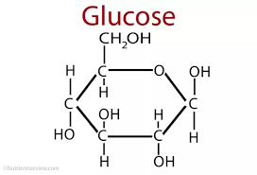

- Explain the major structural difference between each carbohydrate and give an example of each in our foods.

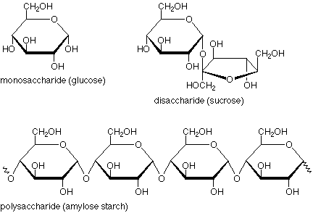

- How do we obtain energy from carbohydrates?

- When carbs are immersed in water they may bloat via a process known as osmosis. Explain this process.

- When other foods are placed in salt water they may shrivel. Explain this process in terms of osmosis.

- What is the major difference between saturated and unsaturated fats?
- Why are lipids essential in the body?

- Explain what observations you would see if a protein was denatured.
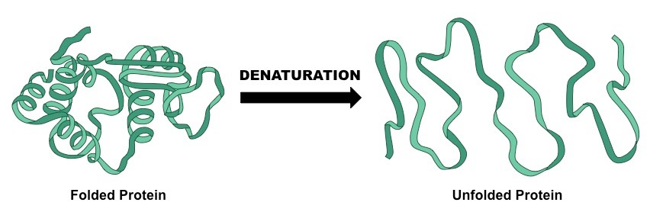
- What does the Maillard Reaction refer to?

- What are examples of additives and why are they added to our foods?

- Physical or chemical? Explain:
  - What occurs when carbohydrates are cooked?
  - What occurs when fats are cooked?
  - What occurs when proteins are cooked?
  - What is the function of Nitrates in food?
  - What is Baking Soda used for in cooking?

- What are GMOs?

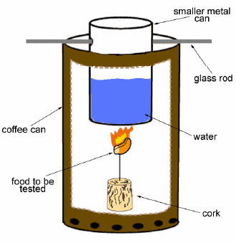
- What do calories on the food packages refer to?

- How are the calories calculated?

- A piece of food is burned under 30.0grams of water, like the picture below. The water changes from 20.0C to 38.0C. How many calories were in the food?

- A student eats the outside of a tootsie pop, leaving the chocolate behind. Calculate the mass of the sugar the student ate, and the percent of sugar in the pop.

Mass of tootsie pop: 4.00g
Mass of tootsie: 0.50g

