Name: _________________________ Flame Test & Spectroscopy

Background: Electrons are said to be in the ground state under stable conditions. When electrons are given energy from sources such as heat or electricity they absorb that energy and temporarily jump to a higher energy level (excited state). When they return to ground state they give off that energy in the form of electromagnetic radiation. If the electromagnetic radiation falls between 400 and 700 nanometers (nm) in wavelength, it is given off in the form of visible light. When common metal ions are heated they give off a distinct color of visible light (this is how fireworks get their color). These ions emit a unique color of light because they consist of atoms that have a unique electron configuration. Chemists can identify these elements with a flame test. The unique color that is observed during a flame test is actually a mixture of several different wavelengths of visible light. Chemists can use a spectroscope to identify these various wavelengths. The spectroscope splits light to form an emission line spectrum (see figure 1).
Figure 1: Electromagnetic Spectrum

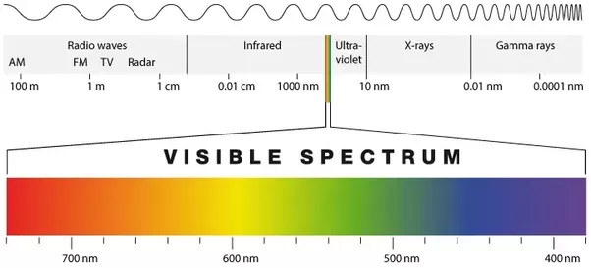

Guiding Question: What metal ion causes fireworks to be red?

Task: Use a flame test to determine which ion salt produces the red color. Using a spectroscope, match the bright line spectra from red fireworks to a substance in your material list. Then make your final determination of what ion in the material list causes red fireworks.

Procedure:
- Watch the video to collect your flame test data. Write down the flame color for each metal ion in Table 1.
- Click here to view the bright line emission spectra for the metal ions listed in Table 2. Draw a line for each wavelength of light shown in the emission spectra (see example below)
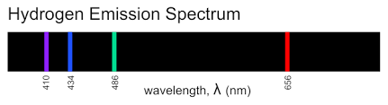

- Click here to view the bright line emission spectra for the red firework. Record data in Table 2.
- Based on your results from the flame test and the bright line spectra for the firework, determine which metal ion is present in the red firework.

Table 1: Flame Test
Metal Ion (Cations) | Flame Color
Calcium (Ca⁺)
Copper (Cu⁺)
Lithium (Li⁺)
Potassium (K⁺)
Sodium (Na⁺)
Strontium (Sr⁺)
Unknown (firework) | Red

Table 2: Bright Line Spectra
Metal Ion (Cations) | Line Spectra
Calcium (Ca⁺) | 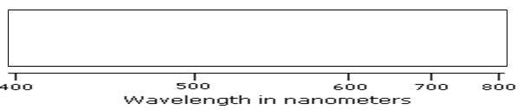
Copper (Cu⁺)
Lithium (Li⁺)
Potassium (K⁺)
Sodium (Na⁺)
Strontium (Sr⁺)
Unknown (firework)

Questions:
- Answer the Guiding Question: What metal ion causes fireworks to be red? Explain how you arrived at your answer.

- Explain how the colors in the flame tests are produced (in terms of electrons and energy states).

- Street lights are yellow/orange in color and not white. Based on your flame test data, what gaseous element is present in street lights?

- Why are spectral lines from the bright line spectrum referred to as "fingerprints" of the atoms?

- Draw models that represent the excited and ground states of Na⁺ and how energy changes to produce the light seen in the flame test.

