Name: _______________________________________ Electrolytic Cell Simulation
upload full lab

Background Information: Electrolytic cells are not spontaneous because the elements used do not reduce or oxidize well on their own. Therefore, a battery (or voltaic cell) is used to force electrons across a wire and produce a chemical change.

Guiding Question: How do the movement of particles such as anions, cations, and electrons produce changes in an electrolytic cell observed at the macroscopic level?

Materials: 12 e- bingo chips, 4 red/yellow foam chips, 4 red/white foam chips, 4 NO₃⁻ bingo chips

Pre-Lab Questions:
- According to Table J, is silver good at oxidizing?

- Write the oxidation half reaction for silver.

- Write the reduction half reaction for silver.

Part A: Building an Electrolytic Cell: Using the template on page 4, and the materials provided, set up your initial battery conditions:
  - Place 4 chips labeled Ag(s) on the Ag electrode. Place a chip labeled 1e- over each Ag(s).
  - Place 4 chips labeled Zn(s) on the Zn spoon electrode. Place 2 chips labeled e- over each Zn(s).
  - Place 4 chips labeled Ag⁺ in the solution of the beaker.
  - Place 4 chips labeled NO₃⁻ in the beaker.
  - For simplicity, water is not represented in the model, but should be the beaker. Additionally, the relative sizes and amount of the atoms, electrons, and ions are inaccurate but scaled down for modeling purposes.

- What do the 1e- clear chips represent for the Silver atoms? Why does Zn need 2e-?

- If each chip counts as one (consider that the mass of electrons are negligible) record the mass of the:
  - Ag electrode:

  - Zn spoon electrode:

  - Overall mass of entire cell:

- What is the overall charge of this electrolytic cell?

- Have your instructor check your set up before proceeding.
- Draw an initial representation of this set up on page 3. Provide a key.
Part B: The Electrolytic Cell in Use: Using your electrolytic cell set up, perform the following steps:
- Force the silver electrode to undergo oxidation and remove its e-. When the e- is lost, the Ag will turn into Ag⁺ ions, so flip the chips over to reveal the new symbol and let it “dissolve” into the beaker’s solution.
- Move electrons through the wire (remember they are super tiny and can travel through the wire made out of conductive metal) and allow them to build up on the Zinc spoon electrode.
- Silver ions in the beaker solution will attract to the new electrons and reduce, gaining those electrons. Take one Ag⁺ ion, flip it to reveal the Ag(s) and place the e- chip on top to create the Ag atom on the spoon. Repeat.

- What is the new mass of the:
  - Ag electrode:

  - Zn spoon electrode:

  - Overall mass of entire cell:

- What is the overall charge of the electrolytic cell after use?

- A salt bridge isn’t needed, but nitrate ions are present. Why?

- Have your instructor check your set up before proceeding.
- Using your key, draw a representation of this new final cell on page 3. Include labels of the anode and cathode and show the direction of electron flow.
- Explain in terms of atoms and ions:
  - Why the anode loses mass:

  - Why the cathode gains mass:

  - Why the overall mass of the cell is conserved:

- The zinc wasn’t used in the reaction. Only silver was used. That is one major difference between voltaic and electrolytic cells.
  - Provide two more differences between the two cells.

  - Provide two similarities between the cells.

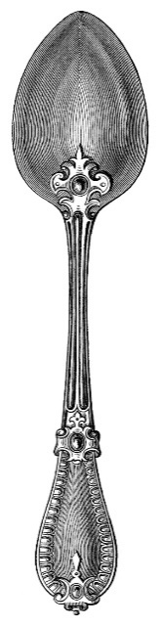
Initial:

Battery

Battery

Final:

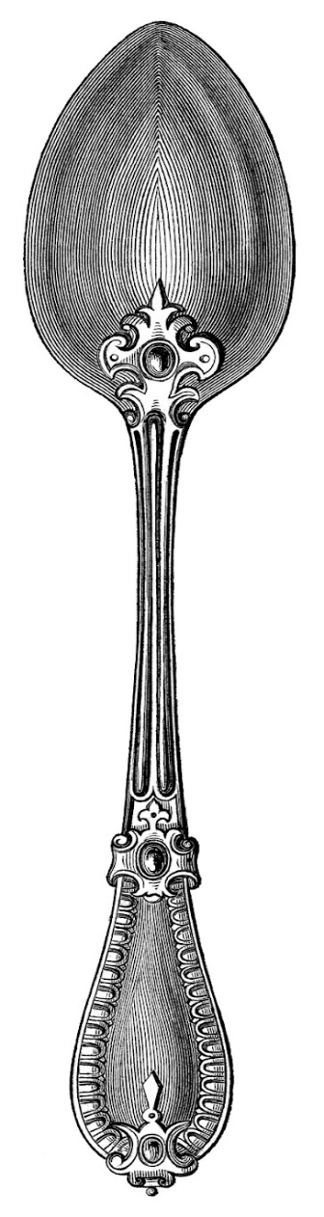

Battery
Ag electrode

